Agricultural Structures
Unit VI — Plumbing
Student Handout
Name_____________________

Use the Project Completion Checklist and Project Evaluation Checklist to track the progress of your project.

Project Completion Checklist
Procedure | Date Due
Master all competencies necessary to complete the project.
Review safety precautions for tools and materials to be used. You can lose points for not following safety precautions and other assigned procedures.
Complete project construction.
Use the Project Evaluation Checklist to perform a quality control inspection of the project following completion.
Turn in the completed project. Your final assessment score will be based on the overall quality of the work and your ability to safely and correctly complete the project within the available time.

Project Evaluation Checklist
Quality Control and Shop Procedures | Criteria
Quality of Work | - Fittings and pipe were properly cleaned and prepared.  - Assembly procedures—cementing, soldering, etc.—are correct for the materials being joined.  - Measurements are correct and project has the correct dimensions.  - Parts fit well for optimum strength.  - Work was completed on time.
Safety and Work Habits: Observe these safety procedures whenever you are in the shop. | - Know how to use the equipment before you attempt to use it. Only use tools and materials the instructor has approved you to use.  - Wear appropriate personal protective equipment.  - Follow safety guidelines from your instructor and safety information on labels, equipment, and signs in the work area.  - Follow assigned setup and cleanup procedures.  - Return equipment and materials to their assigned places.  - Do not use equipment that does not function properly.  - Do not use cleaners, cements, or other products with missing or unreadable labels.  - Tell the instructor about any damaged or malfunctioning equipment.
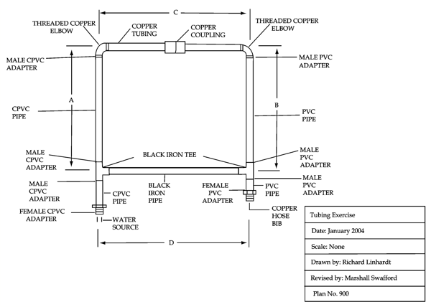
Plan adapted from Agricultural Mechanics Building Plans. University of Missouri-Columbia: Instructional Materials Laboratory.
Bill of Materials:

1 - 1/2" x 18" black iron pipe
1 - 1/2" x 18" copper tubing
1 - 1/2" x 2' PVC pipe
1 - 1/2" x 2' CPVC pipe
3 - 1/2" PVC male adapters
2 - 1/2" threaded copper elbows
1 - 1/2" copper coupling
3 - 1/2" CPVC male adapters
2 - 1/2" black iron tees
1 - 1/2" PVC female adapter
1 - 1/2"copper hose bib
1 - 1/2" CPVC female adapter
1 - can pipe primer
1 - can CPVC cement
1 - can PVC cement
1 - roll wire solder
1 - piece steel wool
1 - jar soldering flux
1 - propane torch
1 - roll 1/2" Teflon tape

Construction Procedure:

- Assemble the project as shown. The pieces should be lengths such that A equals B and C equals D.
- When connecting copper to copper:
- Clean the inside of the fitting and the outside of the tubing using steel wool or a similar abrasive.
- Apply a thin coat of soldering flux to the outside of the tubing and the inside of the fitting.
- Apply heat to the fitting until the solder flows.
- Touch the solder to the heated fitting and allow the solder to flow around the fitting to produce a leak proof seal.
- When connecting plastic to plastic:
- Clean the inside of the fitting and the outside of the tubing using pipe primer or a similar pipe cleaner.
- Apply a thin coat of pipe cement to the outside of the tubing and the inside of the fitting and connect the pipe and fitting.
- When connecting plastic to copper or iron:
- To ensure a leak-proof seal when connecting threaded materials, wrap the external threads of each connecting piece with Teflon tape and tighten the pieces with a pipe wrench.

