C# GUI Practice
You will create 3 forms. The first two will match the screens below EXACTLY. The last one will allow you to use your creativity.
When you have created the form, run the application using Ctrl-F5. Make sure to select the window and then press Alt-PrtScn. Open/Create a word document and press Ctrl-V. This will paste your screen image to the document. Put ALL screens in the same Word document and then turn in that document.
The images for your screens have been placed in a folder called GUIPractice on your Z drive. To get the correct sizing on the image, change the SizeMode property of the PictureBox to “StretchImage”
AM Class Screen 1 | PM Class Screen 1
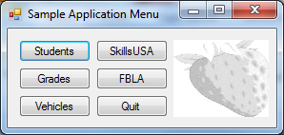 | 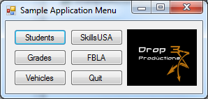
Screen 2
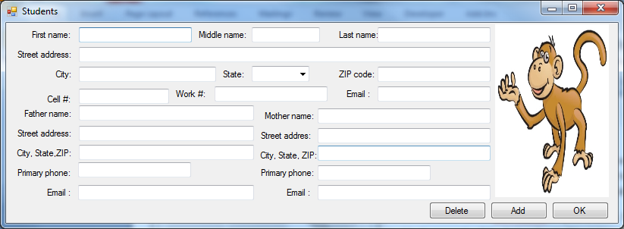
Screen 3
This screen is at your discretion. It should be storing car information including a picture of a car. It needs to have the Add, Delete, and OK buttons. It should also have at least: Student name, make, model, year, color, and license plate #.

