Name_______________________________

PROCEDURES

- Students will divide into groups of 3 and be assigned a company.

Groups will research information on the following topics listed below for their company and display the information on a PowerPoint, Prezi, Glogster, or tri-fold poster board.

**Make sure you include the dates or time period for each topic**

- Company Facts/History
- Ad Campaigns Used Through the Years
- Slogans Used Through the Years
- Logos Used Through the Years
- Celebrity Endorsements Used Through the Years
- Sample Commercials Used Through the Years
- Sample Print Ads Used Through the Years
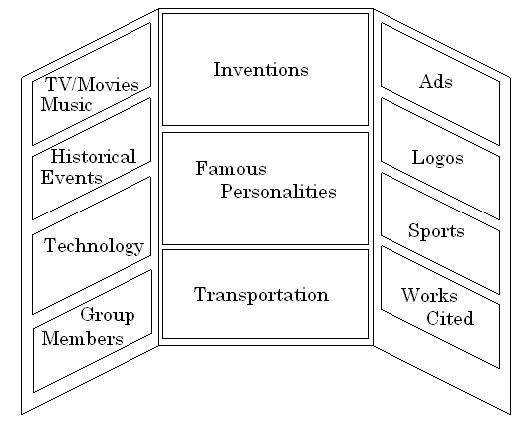

Name of Company and Picture
Ad
Campaigns
Logos

Ad
Campaigns
Celebrity
Endorsements
Company Facts and History

Slogans
Print
Ads

Group Member Names
Print
Ads

- Each group will have 5-7 minutes to present their company to the class. Please be prepared to talk about your company – not just read off your poster. Have your commercials ready to show the day of your presentation.

Company Facts/History……………………………………………………….______10pts

Ad Campaigns………………………………………………………………………_______10pts

Slogans…………………………………………………………………………………_______5pts

Logos……………………………………………………………………………………_______5pts

Celebrity Endorsements…………………………………………………….._______5pts

Sample Commercials…………………………………………………………._______10pts

Sample Print Ads……………………………………………………………….._______10pts

Organized Presentation………………………………………………………._______20pts

Class Time……………………………………………………………………………_______15pts

Overall Layout/Creativity/Neatness……………………………………_______10pts

TOTAL POINTS………………………………………………………………… _______100pts

