Sample Business Letter

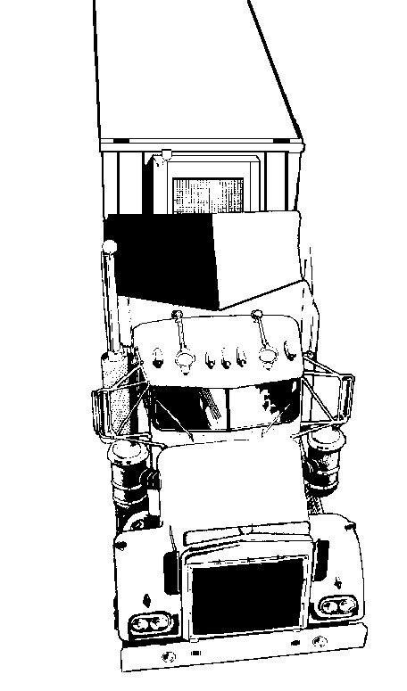
S t e e l e T r u c k i n g , I n c .

Sender’s address
1118 Elm Drive
Columbia, MO 65202

January 22, 2001
Date

Mr. Roger Martin
Midland Dairy Enterprises
Inside address
710 Locust Ave.
Kirksville, MO 63501

Salutation
Dear Mr. Martin:
Body
Thank you for your interest in Steele Trucking. Our company does offer refrigerated transportation of food products.

In response to your letter, I have included a brochure of our rates and the different services that we have available. Steele has a reputation for providing high-quality services to the dairy industry for the past 9 years and looks forward to having the opportunity to do business with Midland Dairy Enterprises.

If you have any further questions please do not hesitate to contact me at 1(800) 798-2914 extension 214. Thanks again for considering Steele.

Sincerely,
Close and writer’s identification

Daniel Browning
Account Representative

Enclosure

