Agricultural Construction
Unit IV — Metals
Student Handout
Making a Chipping Hammer

Objective: Use the proper metalworking procedures to fabricate a chipping hammer.

Equipment Needed:

Oxyacetylene outfit and heating tip
AC/DC or AC welder
Anvil
Ball peen hammer
Tape measure
Metal file
Wire brush
Bench grinder
Drill press
Pliers
Gloves
Safety goggles*
Welding goggles and helmet*

*Everyone participating in or observing this procedure must wear the proper eye protection. Safety practices should be followed at all times while in the shop area.

Materials Needed:
1" x 6" hexagon or round high-carbon rod
3/8" x 7" round rod
Bucket of water

Procedure:
1. Drill a 3/8" hole in the 1" x 6" rod. Make sure the hole is centered in the rod. This is where the handle will be connected to the rod.  2. Heat the lower 2" of the 1" x 6" rod until it reaches a cherry-red color, as shown in Figure 4.1. [will figure 4.1 be in color so as to see where it is “cherry red”?]  Caution: Hot metal should be handled with pliers. Gloves will not give adequate protection to pick up hot metal. | 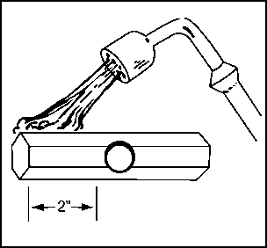  Figure 4.1
3. Use an anvil and a hammer to taper the heated end of the rod. The taper should begin on the chipping tip and end about 2" up the rod, as illustrated in Figure 4.2 [figure 4.2 needs dimensions to show scale for direction]. The end of the tip should be 3/16" thick. | Figure 4.2
4. Cool the hammer in water until the steam stops. As you are cooling the hammer, move it slightly up and down in the water to avoid causing cracks at the waterline, which can result from uneven cooling. See Figure 4.3. | 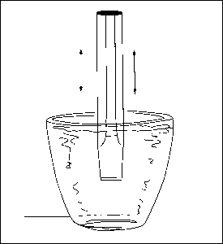  Figure 4.3
5. Remove the hammer from the water. Remove the oxides that have formed on the chipping end by using a wire brush or file.
6. Grind a 60º angle on the chipping end of the hammer, as shown in Figure 4.4. | 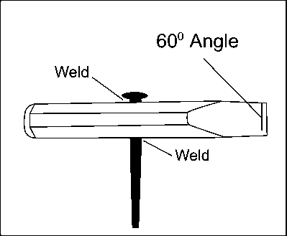  Figure 4.4
7. Insert the 3/8" round rod in the hole in the 1" rod, and weld it where it enters and exits the larger rod, as shown in Figure 4.4. [is the angle of the chipping end correct vis-à-vis where the 3/8” rod is positioned?]
8. Cool the weld, and clean and examine the hammer for accuracy.
9. Turn your completed chipping hammer in to the instructor for grading.

Name_____________________
Use the Project Completion Checklist and Project Evaluation Checklist to track the progress of your project.

Project Completion Checklist
Procedure | Date Due
Master all competencies necessary to complete the project.
Receive instructor approval to build the project.
Review safety precautions for equipment and materials to be used. You can lose points for not following safety precautions and other assigned procedures.
Complete project construction.
Perform a quality control inspection of the project following completion. Use the Project Evaluation Checklist.
Turn in the completed project. Your final assessment score will be based on the overall quality of the work and your ability to safely and correctly complete the project within the available time.

Project Evaluation Checklist
Quality Control and Shop Procedures | Criteria
Quality of Work | Chipping tip is properly tapered and ground.  Handle is centered.  Weld appearance indicates correct speed of travel, amperage setting, and arc length.  Welds are strong and sound.  Measurements are correct.  Project is good enough to sell.  Work was completed on time.
Safety and Work Habits: Observe these safety procedures whenever you are in the shop. | Know how to use the tools and materials before you attempt to use them. Only use tools and materials the instructor has approved you to use.  Wear appropriate personal protective equipment.  Follow safety guidelines from your instructor and safety information on labels, equipment, and signs in the work area.  Follow assigned setup and cleanup procedures.  Return equipment and materials to their assigned places.

