Project Evaluation Checklist

Quality Control and Shop Procedures | Criteria
Quality of Work | - Holes, cut edges, and surfaces are smooth.  - Measurements are correct.  - Cuts are accurate.  - Project is square and straight.  - Work was completed on time.
Safety and Work Habits: Observe these safety procedures whenever you are in the shop. | - Know how to use the equipment before you attempt to use it. Only use tools and materials the instructor has approved you to use.  - Wear appropriate personal protective equipment.  - Follow safety guidelines from your instructor and safety information on labels, equipment, and signs in the work area.  - Follow assigned setup and cleanup procedures.  - Return equipment and materials to their assigned places.  - Do not use equipment that does not function properly.  - Tell the instructor about any damaged or malfunctioning equipment.

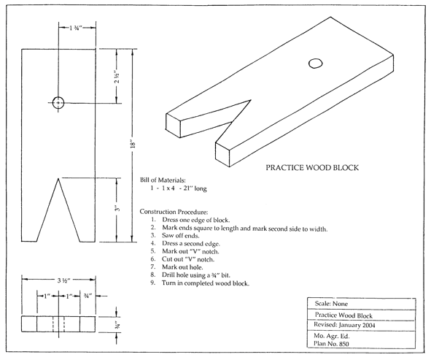
Plan adapted from Agricultural Mechanics Building Plans. University of Missouri-Columbia: Instructional Materials Laboratory.

Agricultural Construction
Unit III — Woodworking
Scoring Guide Name

Criteria | 0 Points | 1 Point | 2 Points | 3 Points | 4 Points | Weight | Total
Holes, cut edges, and surfaces are smooth | Failed | Poor | Fair | Good | Excellent | X 5
Measurements are correct | Failed | Poor | Fair | Good | Excellent | X 5
Cuts are accurate | Failed | Poor | Fair | Good | Excellent | X 5
Project is square and straight | Failed | Poor | Fair | Good | Excellent | X 5
Work was completed on time | Failed | Poor | Fair | Good | Excellent | X 5
Student followed all safety precautions | Passed |  |  |  | Failed | X (-25) | Negative  Points *
Student followed all assigned procedures | Excellent | Good | Fair | Poor | Failed | X (-10) | Negative  Points *
TOTAL
Final Assessment Total ________/100 pts.
* Overall combined score cannot be below 0.
Comments:

