UNIT I - OXY-GAS AND OTHER CUTTING/
WELDING PROCESSES

Arc Cutting and Plasma-Arc Cutting*

Objective

The student will be able to cut a piece of metal using air carbon-arc and plasma arc cutting processes.

Study Questions

1. What is air carbon-arc cutting?

2. What equipment is necessary for air carbon-arc cutting?

3. What different types of cutting can be done with air carbon-arc?

4. What are the advantages of air carbon-arc cutting?

5. What is plasma-arc cutting?

6. What equipment is necessary for plasma-arc cutting?

7. What types of metal can be cut with plasma-arc?

8. What are the advantages of plasma-arc cutting?

9. What safety precautions and maintenance considerations should be observed for air carbon-arc cutting?

10. What safety precautions and maintenance considerations should be observed for plasma-arc cutting?

References

1. Althouse, A.D.; Turnquist, C.H.; Bowditch, W.A.; Bowditch, K.E. Modern Welding. The Goodheart-Willcox Company, Inc., Tinley Park, IL: 2000.

2. Giachino, Joseph W.; William Weeks. Welding Skills. American Technical Publishers, Alsip, NY: 1986.

3. Hidden, Steve. Plasma Cutting Safety Makes Sense. Miller Electric Mfg. Co. http://www.millerwelds.com/pdf/techart/Plassaf.html accessed 6/12/02.

4. Jeffus, L. Welding Principles and Applications (4th ed). Delmar Publishers, Albany, NY: 1999.

5. Sacks, R.J. Essentials of Welding. Bennett Publishing Company, Peoria, IL: 1984.

6. Welding Theory and Application. Training Circular No. 9-237. Department of the Army, 1993, http://www.adtdl.army.mil/cgi-bin/atdl.dll/tc/9-237/toc.htm accessed 6/20/02.

7. What Is Plasma Cutting? PlasmaCAM Inc., 2000. http://www.plasmacam.com/cnchow.htm accessed 6/18/02.

8. Transparency Masters

a) TM 1.1: Schematic of Air Carbon-Arc Gouging
b) TM 1.2: Schematic of Plasma-Arc Cutting

9. Demonstration Sheets

a) DS 1.1: Air Carbon-Arc Cutting
b) DS 1.2: Plasma-Arc Cutting

10. Job Sheets

a) JS 1.1: Air Carbon-Arc Cutting
b) JS 1.2: Plasma-Arc Cutting

UNIT I - OXY-GAS AND OTHER CUTTING/
WELDING PROCESSES

Arc Cutting and Plasma-Arc Cutting

TEACHING PROCEDURES

A. Review

Review Unit I, Lesson 1 of Agricultural Construction (Volume I) for safe use of the AC-DC welder. Also review and discuss the previous lessons regarding cutting metal with oxy-gas.

B. Motivation

Some shops do not have an oxy-gas cutting unit available for use. With the use of an available AC-DC arc welding machine, the cutting process can be accomplished. Show the students the different pieces of metal cut with air carbon-arc and oxy-acetylene, and let them decide which piece was cut with which method.

C. Assignment

D. Supervised study

E. Discussion

There are several methods that can be used to cut metal. Ask the students to describe the different cutting methods they have used in the shop. Discuss the air carbon-arc cutting process as an alternative. Refer to TM 1.1.

1. What is air carbon-arc cutting? (Refer to TM 1.1 Schematic of Air Carbon-Arc Gouging.)

a) Air carbon-arc cutting, formerly called arc-air cutting, is a process in which metal is cut (melted) by the heat produced from the arc between a carbon electrode and the base metal.
b) The molten metal from the cut is removed by a stream of compressed air.
1) The air stream flows under the electrode (between the electrode and the base metal).
2) The air stream is directed to the arc.
c) No filler metal or shielding gas is used in air carbon-arc.

In order to use the air carbon-arc process with an arc welder, special equipment must be added. Show students the equipment necessary to accomplish air carbon-arc cutting?

2. What equipment is necessary for air carbon-arc cutting?

a) Arc welding machine
1) Voltage requirements for air carbon-arc are generally higher than voltage requirements for shielded metal arc welding (SMAW).
2) Check the manufacturer’s information for the welding machine to ensure the equipment is approved for air carbon-arc processes.
b) Air compressor or compressed air in cylinders
1) The air supply must be of sufficient pressure and airflow to remove the molten metal and produce a clean cut or gouge.
2) The air supply should have little or no abrasive particles or moisture.
3) Compressed air in cylinders can be used when portability is required.
c) Air carbon-arc torch (also called air carbon-arc electrode holder)
1) This torch is similar to the SMAW electrode holder, but the air carbon-arc torch has the following additional features:
a. Passageway for air
b. Air holes in the lower jaw of the torch
c. Only one groove for the electrode
d. Jaw that can pivot
e. Air valve for turning the air on and off
2) Torches are available for a variety of amperage settings.
d) Air carbon-arc electrodes
1) Features of air carbon-arc electrodes include the following:
a. Made of carbon and graphite
b. Available in round, flat, and semi-round shapes and various diameters
c. Designed for use with AC or DC current
d. Available with no coating (plain) and with a copper coating
e. Some designed to connect together to reduce waste of electrode stubs
2) The electrodes for direct current electrode positive (DCEP) are the most frequently used.
3) The diameter of the electrode determines the width of the cut or groove.
e) Air hose
1) The air hose and the electrode lead are frequently connected together. The connection is covered by an insulated boot.
2) The inside diameter of the hose must be approved for the type of torch being used.
f) Electrode lead - attached to the welding machine and the air hose
g) Ground lead with clamp - attached to the welding machine and the workpiece

Ask the students to list the different types of cutting that can be accomplished using the air carbon-arc torch. Show the students examples of each cutting process.

3. What different types of cutting can be done with air carbon-arc?

a) Gouging - cutting a groove in metal
b) All-purpose cutting - cutting all the way through metal
c) Washing - removing the surface area of metal
d) Beveling - cutting an angle on the edge of metal

Air carbon-arc cutting has several advantages over other cutting methods. Ask the students to list advantages of using air carbon-arc over other cutting methods.

4. What are the advantages of air carbon-arc cutting?

a) An arc welding machine may be used with a small investment for the additional equipment.
b) The process is a relatively inexpensive way to cut most metals.
c) Repair work, such as removing old welds, can be done quickly and easily with little or no cleanup required.
d) The chances of distortion or cracking are reduced, because the heat from air carbon-arc is limited to a small area of the metal and the molten metal is removed quickly.
e) The oxidation characteristics of metal are not a factor because the air stream removes the molten metal. As a result, many types of metal can be cut with air carbon-arc.

Plasma-arc cutting is regarded as one of the best and fastest methods for high-speed cutting of nonferrous metals and stainless steels. Ask the students to describe plasma-arc cutting.

5. What is plasma-arc cutting?

a) Plasma-arc cutting is a high-speed cutting process that uses an electric arc and fast-flowing ionized gases to cut metals.
b) The electric arc passes through a large quantity of gas that travels through a nozzle. Gases used include argon, hydrogen, nitrogen, shop air, or oxygen.
c) The electric arc heats the gas to such a high temperature that it turns into “plasma” - the fourth state of matter.
d) The heat of the plasma is released into the metal workpiece through the tip of an electrode that is located in the nozzle.
e) As the gas is heated, it is forced through the tip at a very high rate of speed.
f) The intense heat then cuts through the metal.

Special equipment is needed in order to cut metal with the plasma-arc process. Ask students to list the equipment needed. Use TM 9.2 to illustrate the equipment used in plasma-arc cutting.

6. What equipment is necessary for plasma-arc cutting? (Refer to TM 1.2 Schematic of Plasma-Arc Cutting.)

a) Power source to convert AC-line voltage into direct current (DC ) that the user can regulate
1) Up to 700 amperes (A) at 170 volts for cutting 5-in. piece of aluminum
2) 400 A to cut 1.5-in. piece of aluminum or 1-in. piece of steel
b) A control unit to automatically control the sequence of operations
c) Air compressor
d) Cooling water pumps and water-cooled leads
e) Shielding gas(es) under pressure
f) Plasma torch:
1) Nozzle
2) Nozzle insulator
3) Nozzle tip
4) Nozzle guide
5) Electrode tip
g) Gas regulator
h) Electric cables
i) Ground clamp

Ask the students to list the different types of metal that can be cut using plasma-arc. Show students examples of each.

7. What types of metal can be cut with plasma-arc?

a) Any nonferrous metal
b) Stainless steel
c) Carbon steel

Based on the characteristics discussed in previous questions, ask students what the advantages would be for plasma-arc cutting.

8. What are the advantages of plasma-arc cutting?

a) Very high speed - cuts faster than oxy-fuel
b) Clean - uses clean, dry air
c) Light (less than 50 lb), small, and portable
d) Used for stack cutting, shape cutting, gouging, beveling, and piercing
e) Equal quality to other operations
f) Economical to use when needing a lot of precise cuts
g) Safer than oxy-fuel gas cutting

Safety precautions and maintenance are very important to follow when air carbon-arc cutting. Discuss with students additional precautions and maintenance considerations that should be observed to prevent injury.

9. What safety precautions and maintenance considerations should be observed for air carbon-arc cutting?

a) Observe all safety precautions that are appropriate for SMAW. Review safety precautions for SMAW in Agricultural Construction (Volume I), Unit I, Lesson 1, as needed. Additional safety precautions specific to air carbon-arc cutting are listed below.
b) Protect the body from the sparks produced by the process. In addition, protect others in the work area, equipment, and other materials from sparks.
c) Protect the body, others in the work area, equipment, and other materials from flying molten metal.
1) Cut away from the operator.
2) Use a metal deflection plate to block the travel of molten metal.
3) Remove all combustible materials from the work area.
d) Wear ear protection to prevent hearing damage. A high level of sound is generated from the high amperage and air pressure used.
e) Wear additional protective clothing to protect the body from arc light burns. The chance of being burned by arc light during air carbon-arc cutting is higher than during SMAW because the light is more intense. Clothing recommendations are as follows:
1) Thicker clothing
2) Leather jacket
3) Leather apron
f) Wear a welding helmet with a #12 to #14 lens shade to protect the eyes from arc light burns. The lens shade necessary for air carbon-arc cutting is darker than the one needed for SMAW. Consult the manufacturer’s recommendations for the appropriate lens.
g) Avoid the hazardous fumes given off by air carbon-arc cutting.
1) Work in an adequately ventilated area.
2) Wear an appropriate respirator, if needed.
3) Clean the workpiece to remove paint, grease, chemicals, or other contaminants that could create hazardous fumes.
h) Do not use oxygen instead of air for air carbon-arc cutting. Oxygen is flammable.
i) Replace worn leads, cables, and hoses and broken connections to prevent electrical shock. Repairing leads, cables, and hoses with tape is not acceptable.
j) Inspect the air carbon-arc torch frequently to be sure it is not damaged or in need of repair.
k) Protect leads, cables, and hoses from fire or other damage.
1) Keep leads, cables, and hoses free of oil and grease.
2) Run leads, cables, and hoses so that they will not be damaged or cause a tripping hazard.
l) Keep the arc welding machine, electrodes, and work area dry.
m) Do not allow the electrode to come in contact with any metal parts while the arc welding machine is on. If the electrode touches metal, a short could occur.

Continue the discussion about safety precautions and maintenance for plasma-arc cutting.

10. What safety precautions and maintenance considerations should be observed for plasma-arc cutting?

a) Observe all safety procedures. Always point the torch away from the body and toward the workpiece.
b) Protect eyes by wearing safety glasses with a side shield and also use a face shield or helmet.
c) Wear the proper lens shade based on the machine’s amperage capabilities.
1) Up to 300 A - #9 lens shade
2) 300-400 A - #12 lens shade
3) 400-800 A - #14 lens shade
d) Because plasma can cut anything that conducts electricity, extremities (hands, fingers, toes) can be severely burned or injured if not protected.
1) Wear leather gloves that are hole-free and dry.
2) Wear high-top leather shoes or boots.
e) Select clothing made of tightly woven material, such as wool, heavy denim, or leather. Keep clothing dry at all times.
f) Button shirt collars, cuffs, and front pockets. Do not wear cuffed pants.
g) Protect against excessive noise.
1) Add room acoustics.
2) Reduce intensity of noise.
3) Wear ear muffs or ear plugs.
4) Cut under water.
h) Stay away from flammable gases, vapors, dust, and liquids. All flammable materials must be at least 35 ft away from the cutting area or encased in flame-proof containers.
i) Keep the work area dry.
j) Avoid inhaling fumes (hold head to the side of the torch). Keep work area well ventilated. If necessary, wear an air-supplied respirator.
k) Remove coatings from the cutting areas of galvanized steel, cadium- or lead-plated steel because they contain elements that emit toxic fumes.
l) Replace - do not repair - worn cables or broken connections to prevent electrical shock.
m) Ensure the cutting equipment is properly grounded.
n) If using cylinders of compressed nitrogen, be sure to chain them to an upright, stable support.
1) When moving the cylinder, place a threaded protector cap on top.
2) Remove faulty regulators and send them to the manufacturer for repair.
o) To connect hoses to fittings, use only recommended wires or ferrules, never ordinary wire or other replacements.
p) Keep hoses off of the ground to prevent damage.
1) Examine all hoses for leaks.
2) Do not let hoses become tangled.
3) Replace worn or leaky hoses. Do not splice them with tape because this does not provide a safe seal.
q) When the electrode and nozzle wear out, replace them.

F. Other activities

1. Check with area equipment/service dealers to see if there are any films available on air carbon-arc cutting.

2. Make a bulletin board showing all the different methods available for cutting metal.

G. Conclusion

Air carbon-arc cutting is another option for cutting metal. This process uses an arc to heat
metal to its melting point and then removes the molten metal with a stream of compressed
air. Air carbon-arc cutting equipment is used in combination with an arc welding machine
and can be installed for a small investment. Plasma-arc cutting is a procedure in which the
heat of the electric arc reaches such a high temperature that the gas converts into plasma,
the fourth state of matter. The operation may be automatic or semi-automatic. It is used
when multiple cuts must be made identically or when a clean cut is desired. Cuts made with this process are much smoother and safer than those made with oxy-fuel gas cutting or air carbon-arc processes. In addition, it is economical.

H. Competency

Perform cutting with air carbon-arc.

* Only air carbon-arc cutting is listed on the Agricultural Construction competency list. An additional competency for plasma-arc cutting may be added in the blank space at the end of the list.

I. Answers to Evaluation

1. a
2. e
3. e
4. d
5. Three of the following: an arc welding machine may be used with a small investment for the additional equipment; the process is a relatively inexpensive way to cut most metals; repair work can be done quickly and easily with little or no cleanup required; the chances of distortion or cracking are reduced with air carbon-arc cutting; many types of metal can be cut with air carbon-arc because the oxidation characteristics of metal are not a factor
6. Six of the following: observe all safety precautions that are appropriate for SMAW; protect the body, others in the work area, equipment, and other materials from sparks; protect the body, others in the work area, equipment, and other materials from flying molten metal; wear ear protection to prevent hearing damage; wear additional protective clothing to protect the body from arc light burns; wear a welding helmet with a #12 to #14 lens shade to protect the eyes from arc light burns; avoid the hazardous fumes given off by air carbon-arc cutting; do not use oxygen instead of air for air carbon-arc cutting.
7. Work in an adequately ventilated area; wear an appropriate respirator, if needed; clean the workpiece to remove paint, grease, chemicals, or other contaminants that could create hazardous fumes
8. Three of the following: replace worn leads, cables, and hoses and broken connections to prevent electrical shock; inspect the air carbon-arc torch frequently to be sure it is not damaged or in need of repair; protect leads, cables, and hoses from fire or other damage; keep the arc welding machine, electrodes, and work area dry; do not allow the electrode to come in contact with any metal parts while the arc welding machine is on
9. Four of the following: very high speed; clean; light, small, and portable; used for stack cutting, shape cutting, gouging, beveling, and piercing; equal quality to other operations; economical; safer than oxy-fuel gas cutting
10. Any nonferrous metal, stainless steel, carbon steel
11. Six of the following: observe all safety procedures; protect eyes by wearing safety glasses with a side shield and also use a face shield or helmet; wear the proper lens shade; protect extremities; wear tightly woven clothes; button shirt collars, cuffs, and front pockets; do not wear cuffed pants; protect against excessive noise; stay away from flammable gases; keep the work area dry; avoid inhaling fumes; remove coating from the cutting areas of galvanized steel, cadium- or lead-plated steel
12 Three of the following: add room acoustics, reduce intensity of noise, wear ear muffs or ear plugs; cut under water
13. Five of the following: replace - do not repair - worn cables or broken connections; ensure the cutting equipment is properly grounded; chain nitrogen cylinders to upright, stable support; when moving cylinder, place a threaded protector cap on top; remove faulty regulators and send them to the manufacturer for repair; to connect hoses to fittings, use only recommended wires or ferrules; keep hoses off of the ground; examine all hoses for leaks; do not let hoses become tangled; replace worn or leaky hoses, but do not splice them with tape; when electrode and nozzle wear out, replace them
14. When the electric arc heats gas to an extremely high temperature
15. #14

UNIT I - OXY-GAS AND OTHER CUTTING/
WELDING PROCESSES

Arc Cutting and Plasma-Arc Cutting

EVALUATION

Circle the letter that corresponds to the best answer.

1. Which type of cutting is used to make an angle on the edge of metal?

a. Beveling
b. Cutting
c. Gouging
d. Shearing
e. Washing

2. Which of the following statements is correct about the equipment used for air carbon-arc cutting?

a. An oxygen cylinder can be used for the air supply.
b. Electrodes are available in round, square, and oval shapes.
c. The air hose and ground lead are frequently connected together.
d. The torch has the same design as the electrode holder used in SMAW.
e. The ground lead is attached to the welding machine and the workpiece.

3. One way that air carbon-arc differs from other cutting processes is that it uses:

a. argon gas.
b. special fillers.
c. compressed nitrogen.
d. carbon electrodes and filler.
e. no filler metal or shielding gas.

4. When comparing air carbon-arc cutting to SMAW, air carbon-arc cutting:

a. generates less noise.
b. uses more filler metal.
c. does not produce sparks.
d. requires a darker lens shade.
e. produces less hazardous fumes.

Complete the following short answer questions.

5. What are three advantages of air carbon-arc cutting?

a.

b.

c.

6. List six safety precautions to follow when using air carbon-arc cutting.

a.

b.

c.

d.

e.

f.

7. What are three ways to avoid hazardous fumes from the air carbon-arc process?

a.

b.

c.

8. What are three maintenance considerations for air carbon-arc equipment?

a.

b.

c.

9. What are four advantages of plasma-arc cutting?

a.

b.

c.

d.

10. What are three types of metal that can be cut with plasma-arc?

a.

b.

c.

11. What are six safety precautions to follow when plasma-arc cutting?

a.

b.

c.

d.

e.

f.

12. What are three ways to reduce noise during plasma-arc cutting?

a.

b.

c.

13. What are five ways to maintain equipment used during plasma-arc cutting?

a.

b.

c.

d.

e.

14. How is plasma created?

15. When working on a machine with an amperage of 400-800, what is the recommended lens shade number for plasma-arc cutting?

TM 1.1
SCHEMATIC OF AIR CARBON-ARC GOUGING

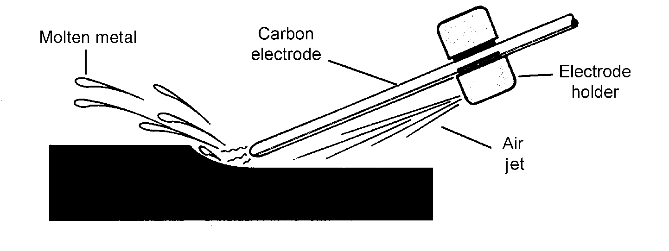

TM 1.2
SCHEMATIC OF PLASMA-ARC CUTTING

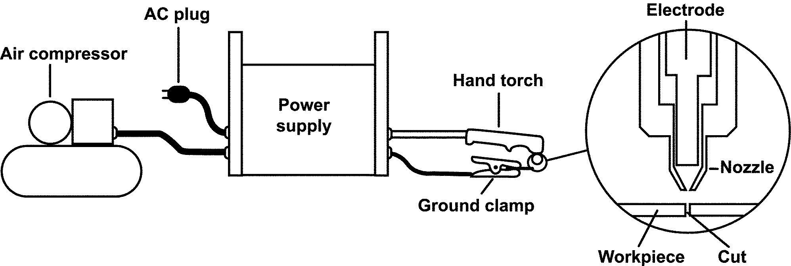

UNIT I - OXY-GAS AND OTHER CUTTING/
WELDING PROCESSES

Demonstration Sheet 1.1: Air Carbon-Arc Cutting

Objective

At the completion of this demonstration, the student will be ready to begin the job sheet on cutting metal using the air carbon-arc cutting process.

Tools and Equipment Needed

1. Arc welding machine
2. Electrode lead
3. Ground lead with clamp
4. Air carbon-arc torch
5. Compressed air supply with regulator
6. Air hose
7. Chipping hammer
8. Equipment and supplies for cleaning metal
9. Protective clothing
10. Safety glasses*
11. Welding helmet*

* CAUTION: Welding helmets and safety glasses must be worn by the operator and all students observing the demonstration. Safety practices should be followed at all times while in the shop area.

Materials Needed

1. Mild steel plate - size to be determined by the instructor
2. Air carbon-arc cutting electrode

Precutting Procedure

1. Clean all dirt, grease, and foreign materials from the surface of the metal.

2. Remove all flammable materials from the work area. Provide proper ventilation.

3. Expose the air and power connections by pushing back the insulated boot on the air
carbon-arc torch.

4. Attach the torch to the power assembly. The air hose should be attached to the air hose
connection. Replace the insulated boot over the air and power connections.

5. Attach the regulator to the compressed air supply and attach the air hose to the regulator.
* CAUTION: Do not use oxygen as the compressed air supply because it is flammable.

6. Adjust the regulator to 60-100 psi. Spray air on a piece of metal to make sure the air is free
of moisture and abrasive particles. If moisture collects on the metal or if abrasive particles
are present, the compressed air supply should be checked.

7. Insert the electrode into the jaws of the torch with approximately 6" of electrode extending
beyond the torch. Note: Burning the electrode to less than 2" in length can damage the
torch.

8. Attach the clamp on the ground lead to the workpiece.

9. Set the arc welding machine to DC, reverse polarity. Adjust the amperage according to the
electrode diameter.

Cutting Procedure

1. Position the air jets on the torch between the electrode and the base metal.

2. Position the electrode at a 90-degree work angle and a 45-degree travel angle, opposite the
direction of travel.

3. Turn the arc welding machine on.

4. Turn on the air jet with the air valve located on the torch. Make sure the welding helmet is
lowered over the face.

5. Strike an arc and move the electrode in the direction of the cut, just as the arc exits the
back side of the base metal. Make sure to keep the torch at a consistent angle and speed.

6. Finish the cut. Turn off the air jet by using the air valve on the torch. Place the torch in a
safe position where the electrode will not come in contact with metal.

Postcutting Procedure

1. Turn off the air supply and the arc welding machine.

2. Remove the air carbon-arc torch from the air hose.

3. Clean the work area.

4. When the metal is cool, chip slag and remove other residue from the cut.

5. Examine the cut for accuracy and appearance.

6. Assign JS 1.1 to be completed by students.
UNIT I - OXY-GAS AND OTHER CUTTING/
WELDING PROCESSES

Demonstration Sheet 1.2: Plasma-Arc Cutting

Objective

At the completion of this demonstration, the student will be ready to begin the job sheet on cutting metal using the plasma-arc cutting process.

Tools and Equipment Needed

1. Plasma power sources
2. Plasma torch and leads
3. Gases (as required by manufacturer)
4. Safety glasses*
5. Welding helmet*
6. Protective clothing
7. Straightedge

*CAUTION: Welding helmets and safety glasses must be worn by all students observing the demonstration. Safety practices should be followed at all times while in the shop area.

Materials Needed

1. Piece of ferrous or nonferrous metal
2. Electrode

Precutting Procedure

1. Connect the torch to the power source.

2. Attach gas lines from the machine to the required cylinder or gas line. (Some machines
operate on compressed air while others require gases stored in cylinders or bulk storage
tanks.)

3. Set the power level on the machine to the required level.

4. Set the regulators or flow meter to the required amount.

5. If applicable, attach the torch coolant lines to water or radiator sources.

6. Using a straightedge, mark lines on the metal to be cut.

7. Align the straightedge with the mark so that the plasma torch will cut evenly along the line.

Cutting Procedure

1. Start the machine and move along the side of the straightedge for the complete length of
the desired cut.

2. Stop the cutting action and position the tip of the plasma torch in a safe direction.

Postcutting Procedure

1. Turn the machine off.

2. Check the cut for slag, burn-through, and accuracy.

3. Assign JS 1.2 to be completed by students.

UNIT I - OXY-GAS AND OTHER CUTTING/
WELDING PROCESSES

Job Sheet 1.1: Air Carbon-Arc Cutting

Objective

At the completion of this job sheet, the student will be able to cut metal using the air carbon-arc cutting processes.

Tools and Equipment Needed

1. Arc welding machine
2. Electrode lead
3. Ground lead with clamp
4. Air carbon-arc torch
5. Compressed air supply with regulator
6. Air hose
7. Chipping hammer
8. Equipment and supplies for cleaning metal
9. Protective clothing
10. Safety glasses*
11. Welding helmet*

* CAUTION: Welding helmets and safety glasses must be worn by the operator and all students observing the demonstration. Safety practices should be followed at all times while in the shop area.

Materials Needed

1. Mild steel plate - size to be determined by the instructor
2. Air carbon-arc cutting electrode

Precutting Procedure

1. Clean all dirt, grease, and foreign materials from the surface of the metal.
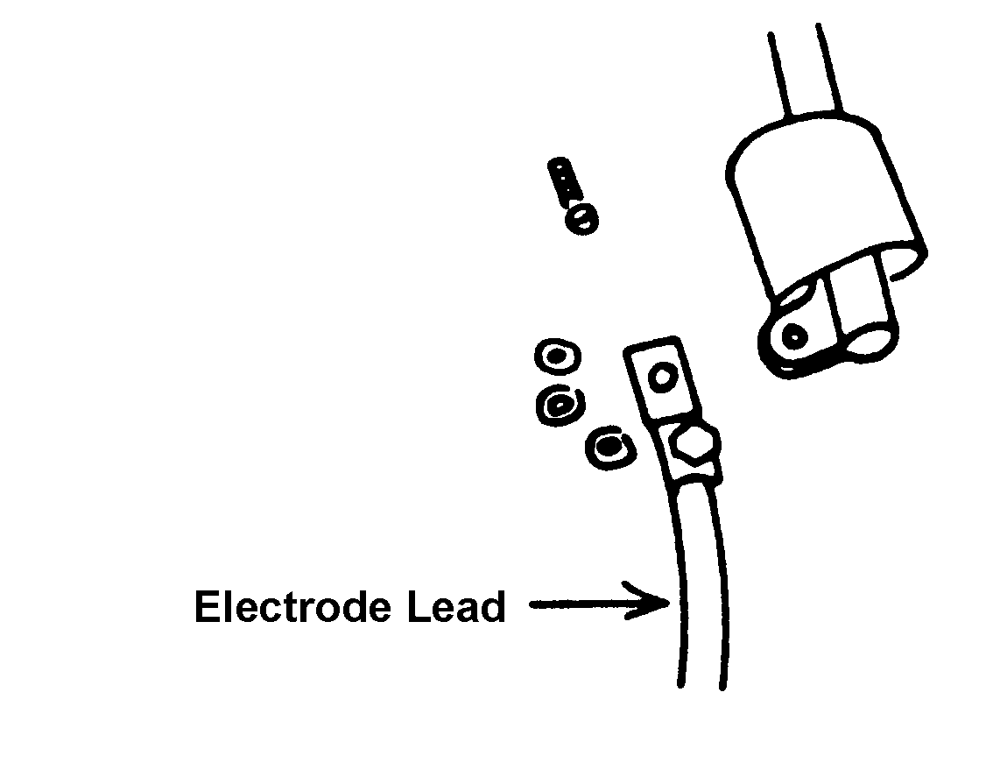
Figure 1.1

2. Remove all flammable materials from the work area. Provide proper ventilation.

3. Expose the air and power connections by pushing back the insulated boot on the air carbon-arc torch. See Figure 1.1.

4. Attach the torch to the power assembly. The air hose should be attached to the air hose connection. Replace the insulated boot over the air and power connections. See Figure 1.2.
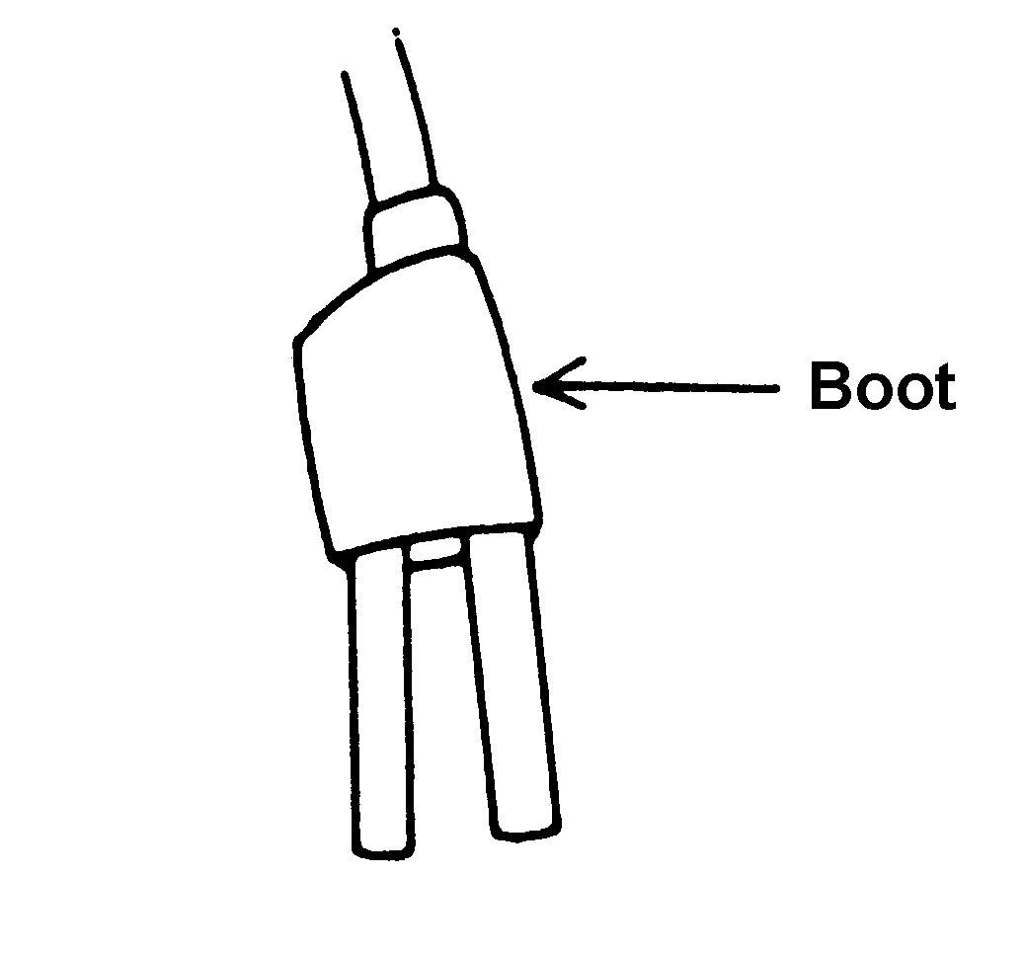
Figure 1.2
5. Attach the regulator to the compressed air supply and attach the air hose to the regulator. CAUTION: Do not use oxygen as the compressed air supply because it is flammable.

6. Adjust the regulator to 60-100 psi. Spray air on a piece of metal to make sure the air is free of moisture and abrasive particles. If moisture collects on the metal or if abrasive particles are present, the compressed air supply should be checked.

7. Insert the electrode into the jaws of the torch with approximately 6" of electrode extending
beyond the torch. Note: Burning the electrode to less than 2" in length can damage the
torch.

8. Attach the clamp on the ground lead to the workpiece.

9. Set the arc welding machine to DC, reverse polarity. Adjust the amperage according to the
electrode diameter.

Cutting Procedure
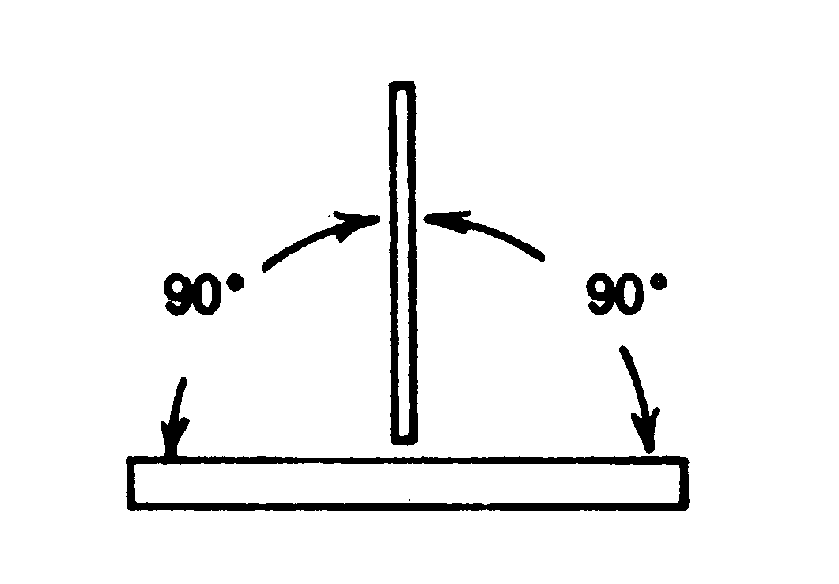
Figure 1.3

1. Position the air jets on the torch between the electrode and the base metal.

2. Position the electrode at a 90-degree work angle and a 45-degree travel angle, opposite the direction of travel. See Figures 1.3 and 1.4.

3. Turn the arc welding machine on.
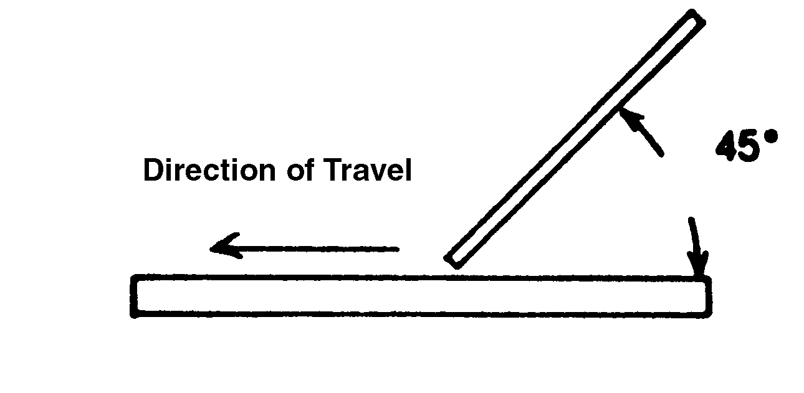
Figure 1.4
4. Turn on the air jet with the air valve located on the torch. Make sure the welding helmet is lowered over the face.

5. Strike an arc and move the electrode in the direction of the cut, just as the arc exits the back side of the base metal. Make sure to keep the torch at a consistent angle and speed.

6. Finish the cut. Turn off the air jet by using the air valve on the torch. Place the torch in a
safe position where the electrode will not come in contact with metal.

Postcutting Procedure

1. Turn off the air supply and the arc welding machine.

2. Remove the air carbon-arc torch from the air hose.

3. Clean the work area.

4. When the metal is cool, chip slag and remove other residue from the cut.

5. Examine the cut for accuracy and appearance.

6. Give the cut to the instructor for grading.

UNIT I - OXY-GAS AND OTHER CUTTING/
WELDING PROCESSES

Job Sheet 1.2: Plasma-Arc Cutting

Objective

At the completion of this job sheet, the student will be able to cut metal using the plasma-arc cutting process.

Tools and Equipment Needed

1. Plasma power sources
2. Plasma torch and leads
3. Gases (as required by manufacturer)
4. Safety glasses*
5. Welding helmet*
6. Protective clothing
7. Straightedge

* CAUTION: Welding helmet and safety glasses must be worn by all students performing the job sheet. Safety practices should be followed at all times while in the shop area.

Materials Needed

1. Piece of ferrous or nonferrous metal

Precutting Procedure

1. Connect the torch to the power source.

2. Attach the gas lines from the machine to the required cylinder or gas line. (Some machines
operate on compressed air while others require gases stored in cylinders or bulk storage
tanks.)

3. Set the power level on the machine to the required level.

4. Set the regulators or flow meter to the required amount.

5. If applicable, attach the torch coolant lines to water or radiator sources.

6. Using a straightedge, mark several lines on the metal to be cut.

7. Align the straightedge with the mark so that the plasma torch will cut evenly along the line.

Cutting Procedure
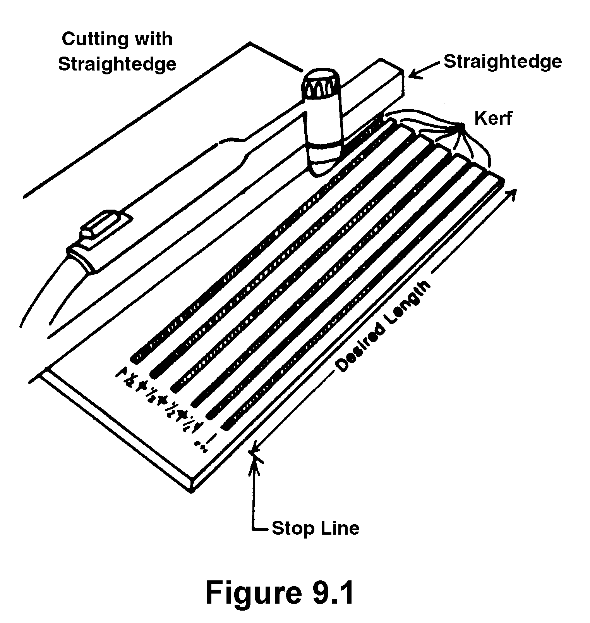
Figure 1.1

1. Start the machine and move along the side of the straightedge for the complete length of the desired cut, as shown in Figure 1.1.

2. Stop the cutting action and position the tip of the plasma torch in a safe direction. Repeat the cutting procedure for each line.

Postcutting Procedure

1. Turn the machine off.

2. Examine the cut for accuracy and appearance.

3. Give the cut to the instructor for grading.

4. Clean the work area.

* Plasma-arc cutting is not listed on the competency profile for Agricultural Construction. If this skill is taught, it should be added in one of the blanks provided on the profile.

