UNIT I - OXY-GAS AND OTHER CUTTING/
WELDING PROCESSES

Job Sheet 1.1: Air Carbon-Arc Cutting

Objective

At the completion of this job sheet, the student will be able to cut metal using the air carbon-arc cutting processes.

Tools and Equipment Needed

1. Arc welding machine
2. Electrode lead
3. Ground lead with clamp
4. Air carbon-arc torch
5. Compressed air supply with regulator
6. Air hose
7. Chipping hammer
8. Equipment and supplies for cleaning metal
9. Protective clothing
10. Safety glasses*
11. Welding helmet*

* CAUTION: Welding helmets and safety glasses must be worn by the operator and all students observing the demonstration. Safety practices should be followed at all times while in the shop area.

Materials Needed

1. Mild steel plate - size to be determined by the instructor
2. Air carbon-arc cutting electrode

Precutting Procedure

1. Clean all dirt, grease, and foreign materials from the surface of the metal.
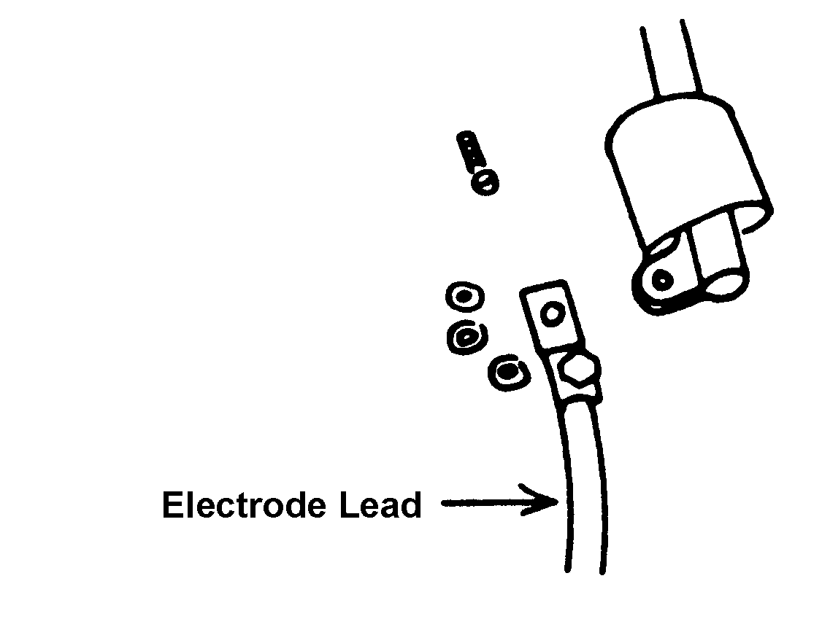
Figure 1.1

2. Remove all flammable materials from the work area. Provide proper ventilation.

3. Expose the air and power connections by pushing back the insulated boot on the air carbon-arc torch. See Figure 1.1.

4. Attach the torch to the power assembly. The air hose should be attached to the air hose connection. Replace the insulated boot over the air and power connections. See Figure 1.2.
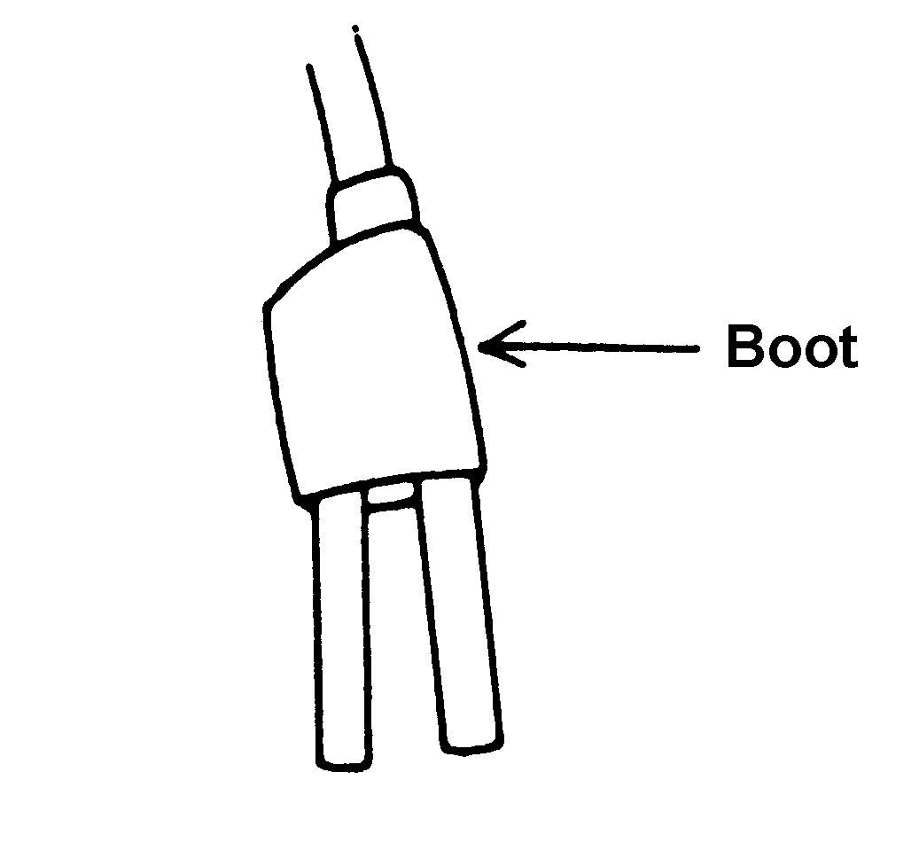
Figure 1.2
5. Attach the regulator to the compressed air supply and attach the air hose to the regulator. CAUTION: Do not use oxygen as the compressed air supply because it is flammable.

6. Adjust the regulator to 60-100 psi. Spray air on a piece of metal to make sure the air is free of moisture and abrasive particles. If moisture collects on the metal or if abrasive particles are present, the compressed air supply should be checked.

7. Insert the electrode into the jaws of the torch with approximately 6" of electrode extending
beyond the torch. Note: Burning the electrode to less than 2" in length can damage the
torch.

8. Attach the clamp on the ground lead to the workpiece.

9. Set the arc welding machine to DC, reverse polarity. Adjust the amperage according to the
electrode diameter.

Cutting Procedure
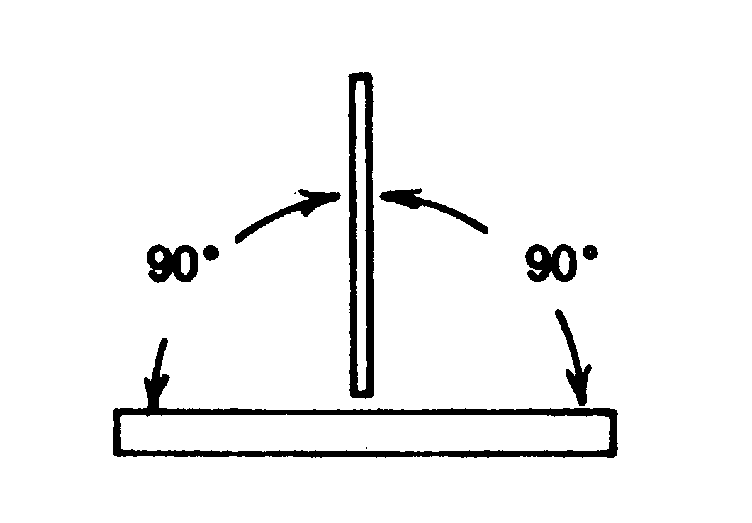
Figure 1.3

1. Position the air jets on the torch between the electrode and the base metal.

2. Position the electrode at a 90-degree work angle and a 45-degree travel angle, opposite the direction of travel. See Figures 1.3 and 1.4.

3. Turn the arc welding machine on.
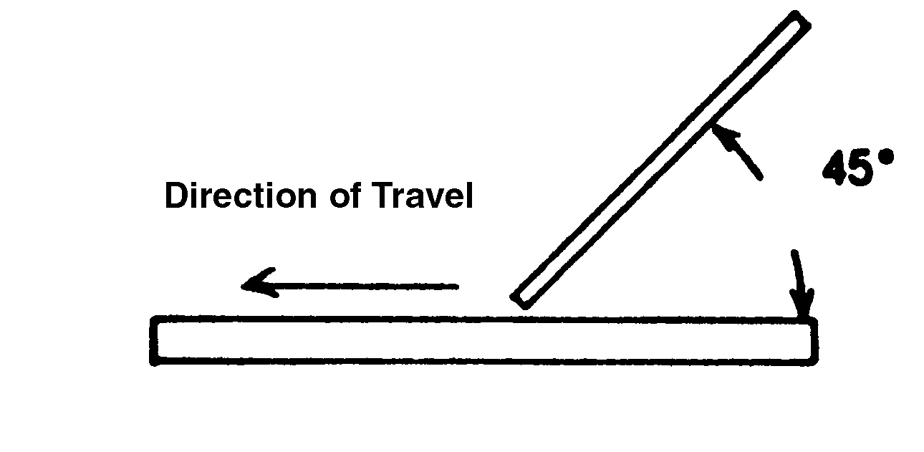
Figure 1.4
4. Turn on the air jet with the air valve located on the torch. Make sure the welding helmet is lowered over the face.

5. Strike an arc and move the electrode in the direction of the cut, just as the arc exits the back side of the base metal. Make sure to keep the torch at a consistent angle and speed.

6. Finish the cut. Turn off the air jet by using the air valve on the torch. Place the torch in a
safe position where the electrode will not come in contact with metal.

Postcutting Procedure

1. Turn off the air supply and the arc welding machine.

2. Remove the air carbon-arc torch from the air hose.

3. Clean the work area.

4. When the metal is cool, chip slag and remove other residue from the cut.

5. Examine the cut for accuracy and appearance.

6. Give the cut to the instructor for grading.

UNIT I - OXY-GAS AND OTHER CUTTING/
WELDING PROCESSES

Job Sheet 1.2: Plasma-Arc Cutting

Objective

At the completion of this job sheet, the student will be able to cut metal using the plasma-arc cutting process.

Tools and Equipment Needed

1. Plasma power sources
2. Plasma torch and leads
3. Gases (as required by manufacturer)
4. Safety glasses*
5. Welding helmet*
6. Protective clothing
7. Straightedge

* CAUTION: Welding helmet and safety glasses must be worn by all students performing the job sheet. Safety practices should be followed at all times while in the shop area.

Materials Needed

1. Piece of ferrous or nonferrous metal

Precutting Procedure

1. Connect the torch to the power source.

2. Attach the gas lines from the machine to the required cylinder or gas line. (Some machines
operate on compressed air while others require gases stored in cylinders or bulk storage
tanks.)

3. Set the power level on the machine to the required level.

4. Set the regulators or flow meter to the required amount.

5. If applicable, attach the torch coolant lines to water or radiator sources.

6. Using a straightedge, mark several lines on the metal to be cut.

7. Align the straightedge with the mark so that the plasma torch will cut evenly along the line.

Cutting Procedure
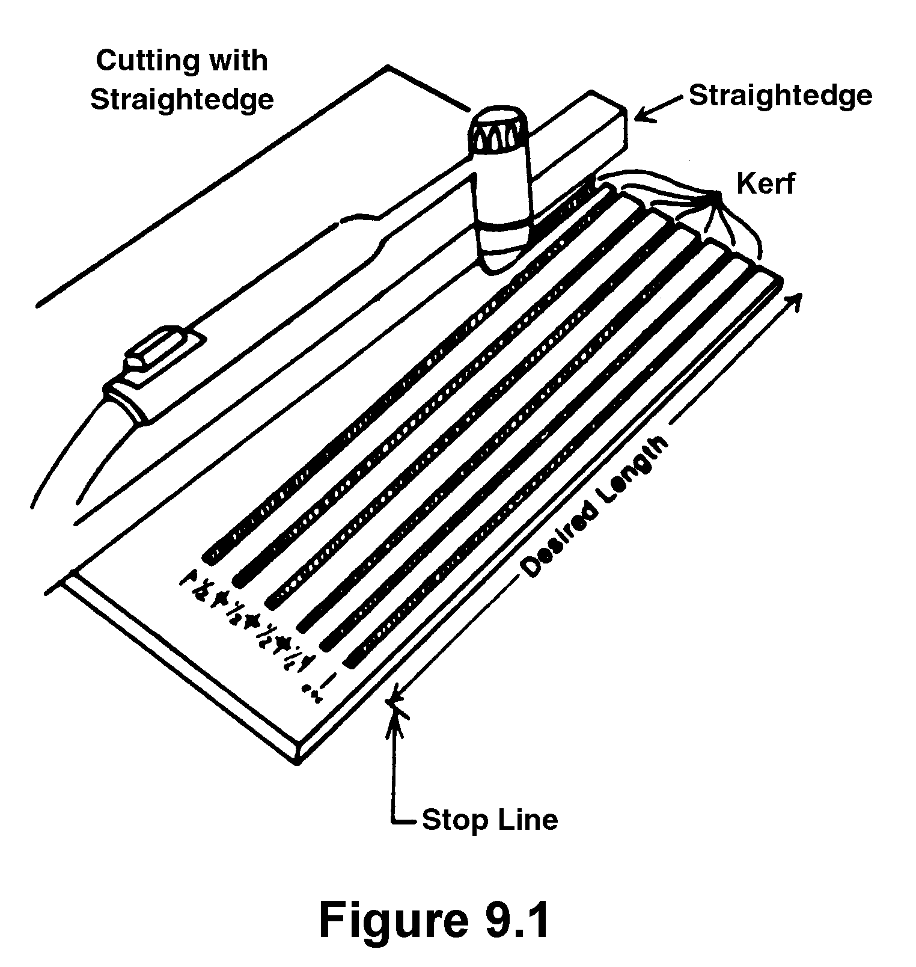
Figure 1.1

1. Start the machine and move along the side of the straightedge for the complete length of the desired cut, as shown in Figure 1.1.

2. Stop the cutting action and position the tip of the plasma torch in a safe direction. Repeat the cutting procedure for each line.

Postcutting Procedure

1. Turn the machine off.

2. Examine the cut for accuracy and appearance.

3. Give the cut to the instructor for grading.

4. Clean the work area.

