UNIT II - ARC WELDING

Gas Metal Arc Welding (GMAW)/MIG

Objective

The student will be able to make a series of welds in a variety of positions using GMAW or MIG welding.

Study Questions

1. What are the principles of GMAW?

2 What are the primary ways that metal is transferred using GMAW?

3. What are the advantages and limitations of GMAW?

4. What safety and maintenance precautions need to be followed for GMAW?

5. What are the steps for GMAW setup?

6. What are the steps for GMAW shutdown?

References

1. Giachino, J.W.; W. Weeks. Welding Skills Alsip, NY: American Technical Publishers, 1985.

2. Minnick, William H. Gas Metal Arc Welding Handbook Tinley Park, Il: Goodheart-Willcox Company, Inc. 2000.

3. Demonstration Sheets
a) DS 2.1: Prewelding and Postwelding Procedures for GMAW
b) DS 2.2: Welds in the Flat Position
c) DS 2.3: Welds in the Horizontal Position
d) DS 2.4: Welds in the Vertical Position
e) DS 2.5: Welds in the Overhead Position

4. Job Sheets
a) JS 2.1: Prewelding and Postwelding Procedures for GMAW
b) JS 2.2: Welds in the Flat Position
c) JS 2.3: Welds in the Horizontal Position
d) JS 2.4: Welds in the Vertical Position
e) JS 2.5: Welds in the Overhead Position

UNIT II - ARC WELDING

Gas Metal Arc Welding (GMAW)/MIG

TEACHING PROCEDURES

A. Review

Review the previous lesson on shielded metal arc welding. Emphasize its application for agricultural uses.

B. Motivation

Ask students what type of farm equipment could be created or repaired using GMAW. Show them one or two pieces. Why is this method preferable to SMAW?

C. Assignment

D. Supervised study

E. Discussion

Gas metal arc welding (GMAW) is also known as metal inert gas (MIG) welding in the industry. GMAW is the more apt name because the shielding gas is not always inert. Given the two popular names for this type of arc welding, how do students think a weld is made?

1. What are the principles of GMAW?

a) An electric arc between a continuously fed metal electrode (wire) and the base metal produces heat.
b) A gas, usually argon, helium, or carbon dioxide, shields the electric arc.
c) The welder performs the following procedures:
1) Selects electrode size
2) Sets desired voltage
3) Adjusts gas flow
4) Adjusts rate of electrode feed
5) Controls gun movement
6) Control selectrode extension.
d) One machine can regulate the power supply and rate of electrode feed and gas volume, or separate machines can run a specific aspect of the weld. The following equipment is required for GMAW.
1) A power source
a. A constant voltage machine sets the arc voltage by establishing the output voltage.
b. A constant current power supply sets the arc by an automatic electrode feed rate.
2) DC rectifier or motor generator
3) Shielding gas supply
4) An electrode-feeding device to supply electrodes continuously
5) Welding gun to carry wire, electricity, and gas to the arc, with a trigger switch for controlling the electrode feed and gas flow

The way the filler comes in contact with the workpiece is called the process mode. Four process modes are listed below. Ask the students how many ways they think this could take place.

2. What are the primary ways that metal is transferred using GMAW?

a) Short circuiting-arc or short arc
1) The electrode is fed until it touches the workpiece.
2) The circuit shorts and burns off the tip of the electrode.
3) Melted metal is deposited into the weld joint.
b) Globular
1) The electrode burns off above or in contact with the workpiece.
2) The molten metal falls in an erratic pattern around the weld site.
c) Spray arc
1) The electrode is melted above the workpiece.
2) The metal drops into the joint.
d) Pulse-spray arc or spray-arc pulse
1) The electrode is melted above the workpiece.
2) The melted metal is released with a pulsing action.
3) The filler is dropped at a controlled time in the weld cycle.
4) This is the most popular method because it causes the least splatter.

GMAW is useful for a number of jobs. Ask students to consider the advantages and limitations of the GMAW process. List them on the board and discuss them.

3. What are the advantages and limitations of GMAW?

a) Advantages
1) Easy type of welding to learn
2) Produces high-quality welds because of better heat control at weld zone
3) Adaptable for a variety of thickness of ferrous and non ferrous metals
4) Easily adaptable to either automatic or semi-automatic operations
5) Very little cleanup necessary; not much slag formed
6) A faster process than both tungsten inert gas (TIG) and SMAW
b) Limitations
1) Requires more equipment than SMAW
2) Expensive because of equipment requirements
3) Not as adaptable as SMAW because weld gun must be close to work
4) Easily contaminated by windy conditions

Show students a GMAW machine. How does the GMAW machine compare to the shielded metal arc welder?

4. What safety and maintenance precautions need to be followed for GMAW?

a) Electrical safety and maintenance
1) The welder must have an earth ground.
2) All electrical connections must be tight, clean, and dry.
3) Keep work area, equipment, and clothing dry.
4) Never dip a gun in water to cool it.
5) In multiple-machine operations do not touch hot parts of gun because open-circuit voltages are increased and can cause severe shock.
6) Disconnect and lock all electrical power sources before performing work on any electrical equipment.
7) Do not connect cables to building framework.
8) When working in high places, check area for electrical hazards because a shock could cause a fall.
b) Safety and maintenance with cables and hoses
1) Never drag cables or hoses.
2) Never pull on cable to force it over an obstruction.
3) Use only clean rags to clean cables and hoses. Never use gas or oily rags to clean cables or hoses.
4) Keep cables and hoses free of kinks at all times.
5) Do not drape welding cables over any type of gas cylinder.
c) Safety and maintenance with gas cylinders
1) Always store cylinders in an upright position in a well-ventilated or outdoor area.
2) Secure cylinders upright with chains or straps.
3) Do not roll other objects on horizontal cylinders.
4) Keep the protective valve in place except when cylinder is in use.
5) To clean the valve and check outlet threads, crack the cylinder open briefly.
6) Regulator should register no pressure when first attached. Do not stand in front of gauges when opening a cylinder.
7) Never strike an arc on a gas cylinder.
d) Safety with electrode wire
1) Always wear safety glasses when handling wire.
2) Always keep wire clean and dry.
3) Position coils close to reel before lifting and use the legs to lift coil, not the back.
4) Never look into a gun while feeding wire through it.
5) Never point the gun at anyone.
6) Never place a finger over a contact tip to determine if wire is feeding.
e) Personal safety equipment
1) Wear welding hood or helmet with shaded lens to protect head from flying sparks and eyes from ultraviolet and infrared radiation.
a. Lens shade requirements are based on wire size, amperage range, and base metal properties.
b. Select lens shade according to lens manufacturer’s selection card. Never select less than a No. 11 lens shade for GMAW.
2) Wear gloves, long sleeved shirt, long pants without cuffs, and work boots to avoid radiation and hot metal burns.
a. Wear a leather jacket and apron for additional protection.
b. Clothing should be dark and made of cotton or wool. Avoid synthetic clothing. No flammable materials should be carried in the pockets of clothing.
3) Work stations and work areas should be shielded to prevent nearby workers or visitors from an arc flash injury.
f) Environmental safety
1) Equip every work station with a ventilation or exhaust system capable of safely removing dangerous fumes and vapors.
2) Welders should wear respirators when welding in confined areas. The respirator should be the air-supplied type or a self-contained breathing apparatus.
3) Argon is heavier than air and will quickly displace oxygen. Heed precautions, especially in confined areas.
4) Wear ear plugs or earmuffs in areas subject to high noise levels, especially those levels that are continuous.
5) Provide lighting that is bright enough to provide good visibility free of glare. Poorly lit areas contribute to eye fatigue, irritation, and poor work.

It is necessary to know how to start and shut down GMAW equipment. Ask students why proper setup is necessary. What problems may result with missed steps?

5. What are the steps for GMAW setup?

a) Check the power cable connections for reverse polarity.
b) Connect gun to the medium slope welding terminal.
c) Connect ground cable to the negative terminal.
d) Connect ground clamp to either work or work table.
e) Start power source: welding machine.
f) Switch wire feeder to the “on” position.
g) Set the wire feed speed control on zero.
h) Check gas shielding supply system.
i) Open gas cylinder outlet valve.
j) Open flow meter valve slowly and squeeze the gun trigger simultaneously.
j) Adjust the gas flow rate as desired. See instructions for specific machine and release the gun trigger.
k) Set wire feed speed to intermediate setting. Wire speed determines welding current in constant voltage systems.
l) Control the electrode stickout distance appropriately for each process. Stickout is the distance from the tip of the electrode to the surface of the workpiece.
m) Adjust welding current as desired.
n) To stop welding, release the gun trigger and withdraw from the work.

Performing the correct shutdown procedure is important for the user’s safety and for the life of the equipment. Ask students what steps should be included in shutdown. Use DS 5.1 and JS 5.1

6. What are the steps for GMAW shutdown?

a) Close gas outlet valve at the top of the gas cylinder.
b) Close gun trigger with wire feed speedcontrol on zero to bleed gas line or use the purge button.
c) Close gas flow meter valve so it is finger tight.
d) Turn off wire feed switch.
e) Turn off welding machine.
f) Clean the work area.

F. Other Activities

1. Determine when the purchase of a GMAW machine is justified for typical farm shop work. Determine the break-even point.

2. Put together a safety checklist card for GMAW equipment.

G. Conclusion

Gas metal arc welding has many applications on and off the farm. It involves a continuous rod, a shielding gas, and the heat of electricity for easy and excellent welds.

H. Competency

Weld in all positions with MIG welder (gas metal arc welding).
a. Weld in flat position using E-70S-3 & E-71S-3
b. Weld in vertical position using E-70S-3 & E-71S-3
c. Weld in horizontal position using E-70S-3 & E-71S-3
d. Weld in overhead position using E-70S-3 & E-71S-3

I. Answers to Evaluation

1. d
2. d
3. d
4. c
5. Four of the following: easy type of welding to learn; produces high quality welds because of better heat control at weld zone; adaptable for a variety of thickness of ferrous and non ferrous metals; easily adaptable to either automatic or semi-automatic operations; very little cleanup necessary - not much slag formed; faster process than both tungsten inert gas (TIG) and SMAW.
6. Three of the following: requires more equipment than SMAW’s, expensive because of equipment requirements, not as adaptable as SMAW because weld gun must be close to work, is easily contaminated by windy conditions
7. Also called metal inert gas welding, GMAW is the use of an electric arc, shielded by gas (usually argon, helium or carbon dioxide) to heat and melt a continuous feed of wire/electrode. The melted wire becomes the filler for the weld.
8. d
9 e
10. c
11. b
12. a and f
13. f
14. a
15. e
16. b
17. d and f

UNIT II - ARC WELDING

Gas Metal Arc Welding Name___________________
(GMAW)/MIG Date____________________

Evaluation

Multiple Choice. Circle the letter that corresponds to the best answer.

1. What is the most popular GMAW process?

a. Globular
b. Spray arc
c. Short-circuit
d. Pulse-spray

2. What is the minimum lens shade number for gas metal arc welding?

a. 2
b. 4
c. 7
d. 11

3. Which of the following is a step for setting up GMAW?

a. Rolling gas cylinders across the shop.
b. Disconnect and lock power before repairing equipment.
c. Clean work area.
d. Check the power cable connections for reverse polarity.

4. Which of the following is a step for shutting down GMAW?

a. Strike an arc on a gas cylinder.
b. Adjust gas flow rate.
c. Clean work area.
d. Connect ground clamp to either work or work table.

Complete the following short-answer questions.

5. What are four advantages of GMAW?

a.

b.

c.

d.

6. What are three limitations of GMAW?

a.

b.

c.

7. What is Gas Metal Arc Welding?

Match the statement on the left with the category of safety on the right. Write the

letter in the space provided. Letters may be used more than once.

8. Keep fingers away from tip of wire gun

9. Store cylinders upright

10. Use clean rags to keep hoses free of grime

11. Have an earth ground

12. Earmuffs and earplugs reduce noise pollution

13. Clothing made of natural fibers onl

14. Lighting that provides good visibility, free of glare

15. Crack a cylinder to clean a valve

16. Keep connections dry, clean, and tight

17. Always wear safety glasses when handling wire
A. Environmental safety

B. Electrical safety

C. Safety with cables and hoses

D. Safety with electrodes

E. Safety with gas

F. Personal safety equipment

UNIT II - ARC WELDING

Demonstration Sheet 2.1: Prewelding and Postwelding
Procedures for GMAW

Objective

At the completion of this demonstration, the student will be prepared to begin the job sheet in setting up, adjusting, and shutting down the gas metal arc welding machine.

Tools and Equipment Needed

1. GMAW welder
2. Protective clothing
3. Safety goggles*
4. Pliers
5. Helmet*

* CAUTION: The welder and all students observing this demonstration must wear the proper eye protection. Safety precautions should be observed while in the shop area.

Materials Needed

1.E-70S-3 & E-71S-3 wire - .035 inch diameter
2. Mild steel plates - size to be determined by the instructor

Prewelding Procedure

1. Set the machine to Direct Current Reverse Polarity. Straight polarity should be used only when a shallow penetration is needed.
2. Plug the welding gun cable into the medium slope terminal located on the welding machine.
3. Plug the ground cable into the negative terminal on the welding machine.
4. Connect the ground cable to the table or metal to be welded.
5. Turn the welding machine power switch to “on.”
6. Turn the wire feed control mechanism power switch to “on.”
7. Adjust the wire feed speed to zero while setting gas flow, amperage, and voltage. This will prevent wasting wire while making adjustments to gas flow.
8. Open the cylinder valve on top of the gas tank.
9. Gas flow should be adjusted to 20 to 25 cubic feet/hour (cfh). Slowly open the flow meter valve located at the top of the cylinder to adjust the amount of shielding gas being delivered to the weld area. The trigger on the welding gun should be depressed while turning the valve on the flow meter to obtain a reading.
10. Voltage should be adjusted to 19 to 21.
11. Adjust the wire feed control to provide 100 to 120 amps. A trial setting of 5 should be used for wire feed speed and adjusted accordingly in a constant voltage machine.
a) In a machine that provides constant current, the amperage is adjusted through the voltage setting. Check the manufacturer’s manual to determine if your machine provides constant current or constant voltage.
b) Run a practice bead to check if the correct amperage is being received.
c) To strike an arc, squeeze the trigger on the gun at the same time that the tip of the wire touches the metal to be welded. The assistance of another person will be required to take a reading of the amperage while you are welding.
d) You should also check for the correct voltage at this time. Increasing the wire speed will increase the amount of current provided for welding. Decreasing the wire speed will decrease the amount of current.
e) When running a test bead, the arc should make a sizzling sound if the proper amount of shielding gas is being used.
12. Adjust the wire stickout to 1/4 to 3/8 inches. The length of stickout is measured from the welding tip to the surface of the metal to be welded.
13. Explain any additional features of your gas metal arc welding machine.

Postwelding Procedure

1. When welding is complete, shut off the valve on the top of the gas cylinder.
2. Bleed the gas from the line by depressing the trigger on the welding gun. If the machine you are using has a button, pressing it will also bleed the gas from the line.
3. Close the flow meter valve on the top of the gas cylinder to finger tight. This prevents damage to the flow meter the next time the cylinder valve is opened.
4. Turn off the wire feed speed switch.
5. Turn off the power switch on the welding machine.
6. Return cables to the proper storage position.
7. Clean the work area of scrap metal.

UNIT II - ARC WELDING

Demonstration Sheet 2.2: Welds in the Flat Position

Objective

At the completion of the demonstration, the student will be prepared to begin the job sheet in performing butt, lap, and T-fillet welds in the flat position using a GMAW welder.

Tools and Equipment Needed

1. GMAW welder
2. Protective clothing
3. Safety goggles*
4. Pliers
5. Helmet*

* CAUTION: The welder and all students observing this demonstration must wear the proper eye protection. Safety precautions must be observed while in the shop area.

Materials Needed

1. E-70S-3 & E-71S-3 wire - .035 inch diameter
2. Mild steel plates - size to be determined by the instructor

Prewelding Procedure

Refer to DS 2.1 for prewelding procedures needed to prepare for welding in a flat position.

Welding Procedure

BUTT JOINT
1. Lower the helmet. Before striking an arc, tell persons in the area to cover themselves. Tack weld two pieces of mild steel together to form a butt joint. If the metal is thicker than 1/8 inch, the edges of the joint should be beveled to increase penetration. A space, no more than 1/8 inch, should be left between the metal plates to increase penetration of the weld.
2. Position the metal so that the joint to be welded is in flat position.
3. The electrode should be positioned at a 90° work angle and a 25° to 30° drag angle to perform the weld.
4. Lower the helmet. Strike the arc and adjust the length of wire stickout to provide the desired penetration. Lengthening wire stickout will decrease penetration, whereas decreasing wire stickout will increase the amount of penetration.
5. Maintain the proper electrode angle while using a slight weaving motion to produce the desired weld.
6. Examine the weld for penetration and bead appearance.
7. Discuss possible improvements with students and how these improvements might be accomplished.

LAP JOINT
1. Lower the helmet. Before striking an arc, tell persons in the area to cover themselves. Tack weld two pieces of mild steel together to form a lap joint. If the metal is thicker than 1/8 inch, the edges of the joint should be beveled to increase penetration.
2. Position the metal so that the joint to be welded is in the flat position.
3. The electrode should be positioned at a 90° work angle and a 25° to 30° drag angle to perform the weld.
4. Lower the helmet. Strike the arc and adjust wire stickout to provide the desired penetration. Lengthening wire stickout will decrease penetration, while decreasing wire stickout will increase the amount of penetration received.
5. Maintain the proper electrode angle while using a slight weaving motion to produce the desired weld.
6. Examine the weld for penetration and bead appearance.
7. Discuss possible improvements with students and how these improvements might be accomplished.

T-FILLET JOINT
1. Lower the helmet. Before striking an arc, tell persons in the area to cover themselves. Tack weld two pieces of mild steel together to form a T-joint. If the metal exceeds 1/8 inch in thickness, the edge of the vertical plate should be beveled to increase penetration.
2. Position the metal so that the joint to be welded is in the flat position.
3. The electrode should be positioned at a 45° work angle and a 10° drag angle to perform the weld.
4. Lower the helmet. Strike the arc and adjust wire stickout to provide the desired penetration. Lengthening wire stickout will decrease penetration, whereas decreasing wire stickout will increase the amount of penetration.
5. Maintain the proper electrode angle while using a slight weaving motion to produce the desired weld.
6. Examine the weld for penetration and bead appearance.
7. Discuss possible improvements in the welds with the students and how these improvements might be accomplished.

Postwelding Procedure

Refer to DS 2.1 for correct postwelding procedures.

UNIT II -ARC WELDING

Demonstration Sheet 2.3: Welds in the Horizontal Position

Objective

At the completion of this demonstration, the student will be ready to begin the job sheet in performing butt and T-fillet welds in the horizontal position using a GMAW welder.

Tools and Equipment Needed

1. GMAW welder
2. Protective clothing
3. Safety goggles*
4. Pliers
5. Helmet*

* CAUTION: The welder and all students observing this demonstration must wear proper eye protection. Safety precautions should be observed while working in the shop area.

Materials Needed

1. E-70S-3 & E-71S-3 wire - .035 inch diameter
2. Mild steel plates - size to be determined by the instructor

Prewelding Procedure

Refer to Shop Demonstration 2.1 for prewelding procedures needed to prepare for horizontal position welding.

Welding Procedure

BUTT JOINT
1. Lower the helmet. Before striking an arc, tell persons in the area to cover themselves. Tack weld two pieces of mild steel together to form a butt joint. If the metal is thicker than 1/8 inch, the edges of the joint should be beveled to increase penetration. A space, no more than 1/8 inch, should be left between the metal plates to increase penetration of the weld.
2. Position the metal so that the joint to be welded is in the horizontal position.
3. The electrode should be positioned at an 85° work angle and a 5° drag angle to perform the weld.
4. Lower the helmet. Strike the arc and adjust wire stickout to provide the desired penetration. Lengthening wire stickout will decrease penetration, whereas decreasing wire stickout will increase the amount of penetration.
5. Maintain the proper electrode angle while using a slight weaving motion to produce the desired weld.
6. Examine the weld for penetration and bead appearance.
7. Discuss possible improvements with students and how these improvements might be accomplished.

T-FILLET JOINT
1. Lower the helmet. Before striking an arc, tell persons in the area to cover themselves. Tack weld two pieces of mild steel together to form a T-joint.
2. Position the metal so that the joint to be welded is in the flat position.
3. The electrode should be positioned at a 45° work angle and a 10° to 15° drag angle to perform the weld.
4. Lower the helmet. Strike an arc and adjust wire stickout to provide the desired penetration. Lengthening wire stickout will decrease penetration, whereas decreasing wire stickout will increase the amount of penetration.
5. Maintain the proper electrode angle while using a slight weaving motion to produce the desired weld.
6. Examine the weld for penetration and bead appearance.
7. Discuss with students possible improvements that could be made and how these improvements might be accomplished.

Postwelding Procedure

Refer to DS 2.1 for correct postwelding procedures.

UNIT II -ARC WELDING

Demonstration Sheet 2.4: Welds in the Vertical Position

Objective

At the completion of this demonstration, the student will be ready to begin the job sheet in performing butt, lap, and T-fillet welds in the vertical position using a GMAW welder.

Tools and Equipment Needed

1. GMAW welder
2. Protective clothing
3. Safety goggles*
4. Pliers
5. Helmet*

* CAUTION: The welder and all students observing this demonstration must wear proper eye protection. Safety precautions must be observed while in the shop area.

Materials Needed

1. E-70S-3 & E-71S-3
2. Mild steel plates - size to be determined by the instructor

Prewelding Procedure

Refer to DS 2.1 for prewelding procedures needed to prepare for vertical position welding.

Welding Procedure

BUTT JOINT - VERTICAL UP
1. Lower the helmet. Before striking an arc, tell persons in the area to cover themselves. Tack weld pieces of mild steel together to form a butt joint. If the metal is thicker than 1/8 inch, the edges of the joint should be beveled to increase penetration. A space, no more than 1/8 inch, should be left between the metal plates to increase penetration of the weld.
2. Position the metal so that the joint to be welded is in the vertical position.
3. The electrode should be positioned at a 90° work angle and a 10° to 15° push angle to perform the weld.
4. Lower the helmet. Strike an arc and adjust wire stickout to provide the desired penetration. Lengthening wire stickout will decrease penetration, whereas decreasing wire stickout will increase the amount of penetration.
5. Maintain the proper electrode angle while using a slight weaving motion to produce the desired weld.
6. Examine the weld for penetration and bead appearance.
7. Discuss possible improvements with students and how these improvements might be accomplished.

BUTT JOINT - VERTICAL DOWN
1. Lower the helmet. Before striking an arc, tell persons in the area to cover themselves. Tack weld two pieces of mild steel together to form a butt joint. The vertical-down position should only be used when welding thin gauge metal since the speed of welding required will not allow for adequate penetration of thicker metals.
2. Position the metal so that the joint to be welded is in the vertical position.
3. The electrode should be positioned at a 90° work angle and a 10° to 15° drag angle to perform the weld.
4. Lower the helmet. Strike an arc and adjust the wire stickout to provide the desired penetration. Lengthening wire stickout will decrease penetration, whereas decreasing wire stickout will increase the amount of penetration.
5. Maintain the proper electrode angle while using a slight weaving motion to produce the desired weld. A faster welding speed should be used than when making a vertical up weld. Welding too slowly will result in loss of control of the weld puddle and will increase the chance of burnthrough. Welding too quickly will make it difficult to maintain a stable arc, resulting in poor penetration.
6. Examine the weld for penetration and bead appearance.
7. Discuss possible improvements with students and how these improvements might be accomplished.

LAP JOINT - VERTICAL UP
1. Lower the helmet. Before striking an arc, tell persons in the area to cover themselves. Tack weld two pieces of mild steel together to form a lap joint.
2. Position the metal so that the joint to be welded is in the vertical position.
3. The electrode should be positioned at a 45° work angle and a 10° to 15° push angle to perform the weld.
4. Lowe the helmet. Strike an arc by squeezing the trigger on the gun at the same time that the tip of the wire touches the metal to be welded. Adjust the length of wire stickout to provide the desired penetration. Lengthening wire stickout will decrease penetration, whereas decreasing wire stickout will increase the amount of penetration.
5. Maintain the proper electrode angle while using a slight weaving motion to produce the desired weld.
6. Examine the weld for penetration and bead appearance.
7. Discuss possible improvements with students and how these improvements might be accomplished.

LAP JOINT - VERTICAL DOWN
1. Lower the helmet. Tack weld two pieces of mild steel together to form a lap joint. “Cover” should be said before striking the arc. The vertical-down position should only be used when welding thin gauge metal, since the speed of welding required will not allow for penetration of thicker metals.
2. Position the metal so that the joint to be welded is in the vertical position.
3. The electrode should be positioned at a 45° work angle and a 10° to 15° drag angle to perform the weld.
4. Lower the helmet. Strike the arc and adjust the wire stickout to provide the desired penetration. Lengthening wire stickout will decrease penetration, whereas decreasing wire stickout will increase the amount of penetration.
5. Maintain the proper electrode angle while using a slight weaving motion to produce the desired weld. A faster welding speed should be used than when making a vertical up weld. Welding too slowly will result in loss of control of the weld puddle and will increase the chance of burnthrough. Welding too quickly will make it difficult to maintain a stable arc, resulting in poor penetration.
6. Examine the weld for penetration and bead appearance.
7. Discuss possible improvements with students and how these improvements might be accomplished.

T-FILLET JOINT - VERTICAL UP
1. Lower the helmet. Before striking an arc, tell persons in the area to cover themselves. Tack weld two pieces of mild steel together to form a T-joint.
2. Position the metal so that the joint to be welded is in the vertical position.
3. The electrode should be positioned at a 45° work angle and a 10° to 15° push angle to perform the weld.
4. Lower the helmet. Strike an arc and adjust the length of wire stickout to provide the desired penetration. Lengthening wire stickout will decrease penetration, whereas decreasing wire stickout will increase the amount of penetration.
5. Maintain the proper electrode angle while using a slight weaving motion to produce the desired weld.
6. Examine the weld for penetration and bead appearance.
7. Discuss with students possible improvements that could be made to the weld and how these improvements might be accomplished.

T-FILLET JOINT - VERTICAL DOWN
1. Lower the helmet. Before striking an arc, tell persons in the area to cover themselves. Tack weld two pieces of mild steel together to form a T-joint. The vertical-down position should only be used when welding thin-gauge metal, because the speed of welding required will not allow for adequate penetration of thicker metals.
2. Position the metal so that the joint to be welded is in the vertical down position.
3. The electrode should be positioned at a 45° work angle and a 10° to 15° drag angle to perform the weld.
4. Lower the helmet. Strike an arc and adjust the wire stickout to provide the desired penetration. Lengthening wire stickout will decrease penetration, whereas decreasing wire stickout will increase the amount of penetration.
5. Maintain the proper electrode angle while using a slight weaving motion to produce the desired weld. A faster welding speed should be used than when making a vertical up weld. Welding too slowly will result in loss of control of the weld puddle and will increase the chance of burnthrough. Welding too quickly will make it difficult to maintain a stable arc, resulting in poor penetration.
6. Examine the weld for penetration and bead appearance.
7. Discuss possible improvements with students and how these improvements might be accomplished.

Postwelding Procedure

Refer to DS 2.1 for correct postwelding procedures.

UNIT II -ARC WELDING
Demonstration Sheet 2.5: Welds in the Overhead Position

Objective

At the completion of this demonstration, the student will be ready to begin the job sheet in performing butt, lap, and T-fillet welds in the overhead position using a GMAW welder.

Tools and Equipment Needed

1. GMAW welder
2. Protective clothing
3. Safety goggles*
4. Pliers
5. Helmet*
6. Weld positioner

* CAUTION: The welder and all students observing this demonstration must have the proper eye protection. Safety precautions should be observed while in the shop area.

Materials Needed

1. E-70S-3 & E-71S-3 wire - .035 inch diameter
2. Mild steel plates - size to be determined by the instructor

Prewelding Procedure

Refer to DS 2.1 for prewelding procedures needed to prepare for welding in the overhead position.

Welding Procedure

BUTT JOINT
1. Lower the helmet. Before striking an arc, tell persons in the area to cover themselves. Tack weld two pieces of mild steel together to form a butt joint. If the metal is thicker than 1/8 inch, the edges of the joint should be beveled to increase penetration. A space, no more than 1/8 inch, should be left between the metal plates to increase penetration of the weld.
2. Position the metal so that the joint to be welded is in the overhead position.
3. The electrode should be positioned at a 90° work angle and a 10° to 15° drag angle to perform the weld.
4. Lower the helmet. Strike an arc and adjust the length of wire stickout to provide the desired penetration. Lengthening wire stickout will decrease penetration, whereas decreasing wire stickout will increase the amount of penetration.
5. Maintain the proper electrode angle while using a slight weaving motion to produce the desired weld.
6. Examine the weld for penetration and bead appearance.
7. Discuss possible improvements with students and how these improvements might be accomplished.

LAP JOINT
1. Lower the helmet. Before striking an arc, tell persons in the area to cover themselves. Tack weld two pieces of mild steel together to form a lap joint. If the metal is thicker than 1/8 inch, the edges of the joint should be beveled to increase penetration.
2. Position the metal so that the joint to be welded is in the overhead position.
3. The electrode should be positioned at a 45° work angle and a 10° to 15° drag angle to perform the weld.
4. Lower the helmet. Strike an arc and adjust the length of wire stickout to provide the desired penetration. Lengthening wire stickout will decrease penetration, whereas decreasing wire stickout will increase the amount of penetration.
5. Maintain the proper electrode angle while using a slight weaving motion to produce the desired weld.
6. Examine the weld for penetration and bead appearance.
7. Discuss possible improvements with students and how these improvements might be accomplished.

T-FILLET JOINT
1. Lower the helmet. Before striking an arc, tell persons in the area to cover themselves. Tack weld pieces of mild steel together to form a T-joint.
2. Position the metal so that the joint to be welded is in the overhead position.
3. The electrode should be positioned at a 45° work angle and a 10° to 15° drag angle to perform the weld.
4. Lower the helmet. Strike an arc and adjust the length of wire stickout to provide the desired penetration. Lengthening wire stickout will decrease penetration, whereas decreasing wire stickout will increase the amount of penetration.
5. Maintain the proper electrode angle while using a slight weaving motion to produce the desired weld.
6. Examine the weld for penetration and bead appearance.
7. Discuss possible improvements with the students and how these improvements might be accomplished.

Postwelding Procedure

Refer to DS 2.1 for correct postwelding procedures.
UNIT II - ARC WELDING

Job Sheet 2.1: Prewelding and Postwelding Procedures for GMAW

Objective

At the completion of this job sheet, the student will be able to set up, adjust, and shut down the machine used for gas metal arc welding.

Tools and Equipment Needed

1. GMAW welder
2. Protective clothing
3. Safety goggles*
4. Pliers
5. Helmet*

* CAUTION: All students performing and observing this procedure must wear proper eye protection. Safety precautions must be observed while working in the shop.

Materials Needed

1. E-70S-3 & E-71S-3 wire - .035 inch diameter
2. Mild steel plates - size to be determined by the instructor

Prewelding Procedure

1. Set the machine to Direct Current Reverse Polarity.
2. Plug the welding gun cable into the medium slope terminal located on the welding machine.
3. Plug the ground cable into the negative terminal on the welding machine.
4. Connect the ground cable to the table or metal to be welded.
5. Turn the welding machine power switch to “on.”
6. Turn the wire feed control mechanism power switch to “on.”
7. Adjust the wire feed speed to zero while setting gas flow, amperage, and voltage.
8. Open the cylinder valve on top of the gas tank.
9. Gas flow should be adjusted to 20 to 25 cubic feet/hour (cfh). Slowly open the flow meter valve located at the top of the cylinder to adjust the amount of shielding gas being delivered to the weld area. The trigger on the welding gun should be depressed while turning the valve on the flow meter to get a reading.
10. Voltage should be adjusted to 19 to 21.
11. Adjust the wire feed control to provide 100 to 120 amps. A trial setting of 5 should be used for wire feed speed and adjusted accordingly in a constant voltage machine.
a) In a machine that provides constant current, the amperage is adjusted through the voltage setting. Check the manufacturer’s manual to determine if your machine provides constant current or constant voltage.
b) Run a practice bead to check if the correct amperage is being received.
c) To strike an arc, squeeze the trigger on the gun at the same time that the tip of the wire touches the metal to be welded. The assistance of another person will be required to take a reading of the amperage while you are welding.
d) You should also check for the correct voltage at this time. Increasing the wire speed will increase the amount of current provided for welding. Decreasing the wire speed will decrease the amount of current.
e) When running a test bead, the arc should make a sizzling sound if the proper amount of shielding gas is being used.
12. Adjust the wire stickout to 1/4 to 3/8 inches. The length of stickout is measured from the welding tip to the surface of the metal to be welded.
13. Be sure all equipment is in safe working condition and that proper safety precautions are followed at all times.

Postwelding Procedure

1. When welding is complete, shut off the valve on the top of the gas cylinder.
2. Bleed the gas from the line by depressing the trigger on the welding gun. If the machine you are using has a button, depressing it will also bleed the gas from the line.
3. Close the flowmeter valve on the top of the gas cylinder to finger tight. This prevents damage to the flow meter the next time the cylinder valve is opened.
4. Turn off the wire feed speed switch.
5. Turn off the power switch on the welding machine.
6. Return cables to the proper storage position.
7. Clean the work area of scrap metal.
UNIT II - ARC WELDING

Job Sheet 2.2: Welds in the Flat Position

Objective

At the completion of this job sheet, the student will be able to perform butt, lap, and t-fillet welds in the flat position using a GMAW welder.

Tools and Equipment Needed

1. GMAW welder
2. Protective clothing
3. Safety goggles*
4. Pliers
5. Helmet*

* CAUTION: All students performing and observing this procedure must wear proper eye protection. Safety precautions must be observed while in the shop area.

Materials Needed

1. E-70S-3 & E-71S-3 wire - .035 inch diameter
2. Mild steel plates - size to be determined by the instructor

Prewelding Procedure

Refer to JS 2.1 for prewelding procedures needed to prepare for welding in a flat position.

Welding Procedure
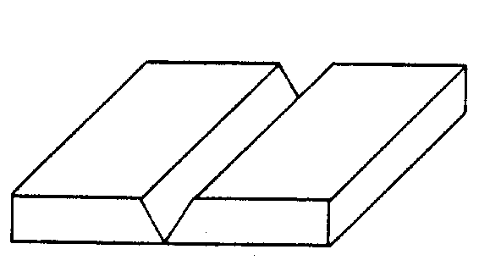
Figure 2.1
BUTT JOINT
1. Lower the helmet. Before striking an arc, tell persons in the area to cover themselves. Tack weld two pieces of mild steel together to form a butt joint. If the metal is thicker than 1/8 inch, the edges of the joint should be beveled to increase penetration. A space of no more than 1/8 inch should be left between the metal plates to increase penetration of the weld.
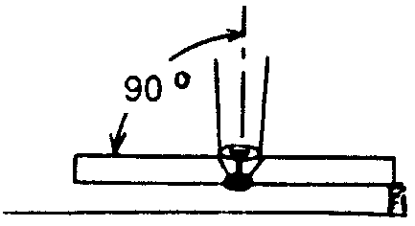
Figure 2.2
2. Position the metal so that the joint to be welded is in the flat position. (See Figure 2.1.)
3. The electrode should be positioned at a 90° work angle and a 25° to 30° drag angle to perform the weld. (See Figure 2.2.)
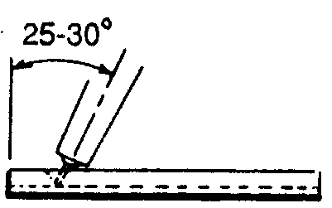
Figure 2.3
4. Lower the helmet. Strike an arc and adjust the length of wire stickout to provide the desired penetration. Lengthening wire stickout will decrease penetration, whereas decreasing wire stickout will increase the amount of penetration.
5. Maintain the proper electrode angle while using a slight weaving motion to produce the desired weld.
6. Examine the weld for penetration and bead appearance.
7. Give the weld to the instructor for grading.

LAP JOINT
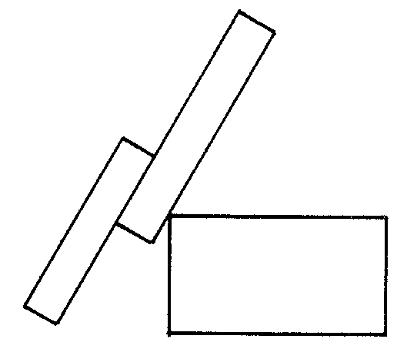
Figure 2.4
1. Lower the helmet. Before striking an arc, tell persons in the area to cover themselves. Tack weld two pieces of mild steel together to form a lap joint. If the metal exceeds 1/8 inch in thickness, the edges of the joint should be beveled to increase penetration.
2. Position the metal so that the joint to be welded is in the flat position. (See Figure 2.4.)
3. The electrode should be positioned at a 90° work angle and a 25° to 30° drag angle to perform the weld. (See Figures 2.5 and 2.6.)
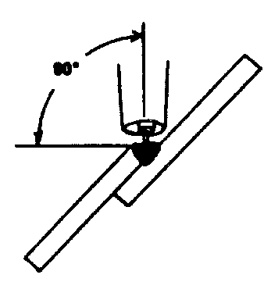
Figure 2.5
4. Lower the helmet. Strike an arc and adjust the length of wire stickout to provide the desired penetration. Lengthening wire stickout will decrease penetration, whereas decreasing wire stickout will increase the amount of penetration.
5. Maintain the proper electrode angle while using a slight weaving motion to produce the desired weld.
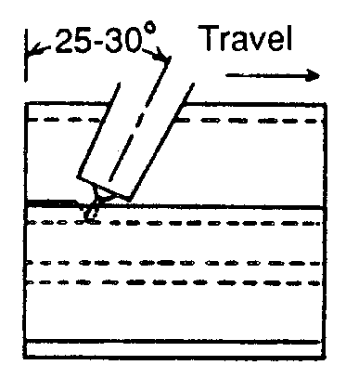
Figure 2.6
6. Examine the weld for amount of penetration and bead appearance.
7. Give the weld to the instructor for grading.

T-FILLET JOINT
1. Lower the helmet. Before striking an arc, tell persons in the area to cover themselves. Tack weld two pieces of mild steel together to form a T-joint. If the metal exceeds 3/8 inch in thickness, the edge of the vertical plate should be beveled to increase penetration.
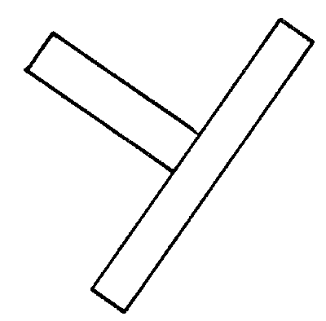
Figure 2.7
2. Position the metal so that the joint to be welded is in the flat position. (See Figure 2.7)
3. The electrode should be positioned at a 45° work angle and a 10° drag angle to perform the weld. (See Figures 2.8 and 2.9.)
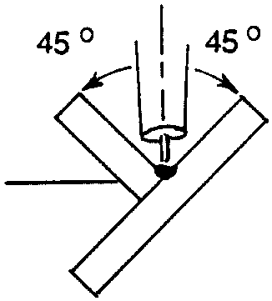
Figure 2.8
4. Lower the helmet. Strike the arc and adjust the length of wire stickout to provide the desired penetration. Lengthening wire stickout will increase penetration, whereas decreasing wire stickout will decrease the amount of penetration.
5. Maintain the proper electrode angle while using a slight weaving motion to produce the desired weld.
6. Examine the weld for amount of penetration and bead appearance.
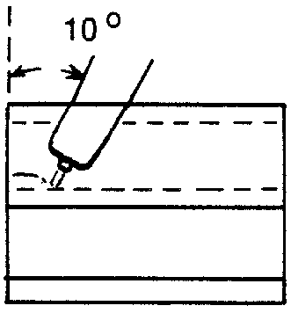
Figure 2.9
7. Give the weld to the instructor for grading.

Postwelding Procedure

Refer to JS 2.1 for correct postwelding procedures.

UNIT II -ARC WELDING

Job Sheet 2.3: Welds in the Horizontal Position

Objective

At the completion of this job sheet, the student will be able to perform a butt and T-fillet weld in the horizontal position using a GMAW welder.

Tools and Equipment Needed

1. GMAW welder
2. Protective clothing
3. Safety goggles*
4. Pliers
5. Helmet*

* CAUTION: All students performing and observing this procedure must wear proper eye protection. Safety precautions must be observed while in the shop area.

Materials Needed

1. E70S-3 & E71S-3 wire - .035 inch diameter
2. Mild steel plates - size to be determined by the instructor

Prewelding Procedure

Refer to JS 2.1 for prewelding procedures needed to prepare for welding in the horizontal position.

Welding Procedure

BUTT JOINT
1. Lower the helmet. Before striking an arc, tell persons in the area to cover themselves. Tack weld two pieces of mild steel together to form a butt joint. If the metal is thicker than 1/8 inch, the edges of the joint should be beveled to increase penetration. A space, no more than 1/8 inch, should be left between the metal plates to increase penetration of the weld.
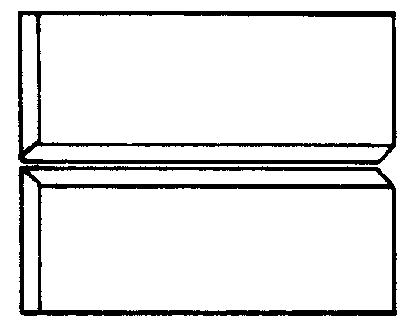
Figure 2.1
2. Position the metal so that the joint to be welded will be in the horizontal position. (See Figure 2.1.)
3. The electrode should be positioned at an 85° work angle and a 5° drag angle to perform the weld. (See Figure 2.2.)
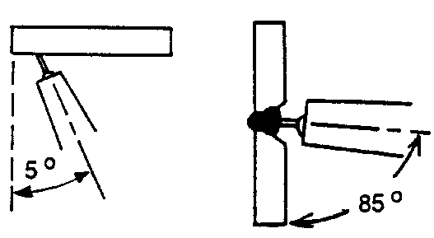
Figure 2.2
4. Lower the helmet. Strike an arc and adjust the length of wire stickout to provide the desired penetration. Lengthening wire stickout will decrease penetration, whereas decreasing wire stickout will increase the amount of penetration.
5. Maintain the proper electrode angle while using a slight weaving motion to produce the desired weld.
6. Examine the weld for penetration and bead appearance.
7. Give the weld to the instructor for grading.

T-FILLET JOINT
1. Lower the helmet. Before striking an arc, tell persons in the area to cover themselves. Tack weld two pieces of mild steel together to form a T-joint.
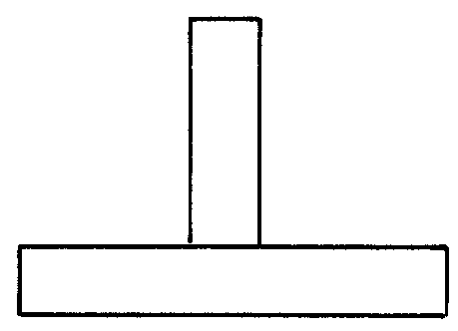
Figure 2.3
2. Position the metal so that the joint to be welded will be in the horizontal position. (See Figure 2.3.)
3. The electrode should be positioned at a 45° work angle and a 10° to 15° drag angle to perform the weld. (See Figures 2.4 and 2.5.)
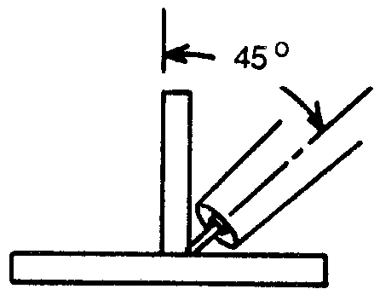
Figure 2.4
4. Lower the helmet. Strike an arc and adjust the length of wire stickout to provide the desired penetration. Lengthening wire stickout will decrease penetration, whereas decreasing wire stickout will increase the amount of penetration.
5. Maintain the proper electrode angle while using a slight weaving motion to produce the desired weld.
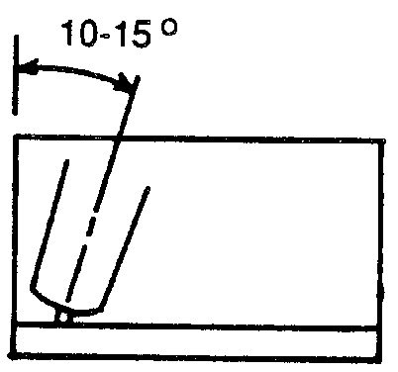
Figure 2.5
6. Examine the weld for amount of penetration and bead appearance.
7. Give the weld to the instructor for grading.

Postwelding Procedure

Refer to JS 2.1 for correct postwelding procedures.
UNIT II - ARC WELDING

Job Sheet 2.4: Welds in the Vertical Position

Objective

At the completion of this job sheet, the student will be able to perform a butt, lap, and T-fillet weld in the vertical position using a GMAW welder.

Tools and Equipment Needed

1. GMAW welder
2. Protective clothing
3. Safety goggles*
4. Pliers
5. Helmet*

* CAUTION: All students performing and observing this procedure must wear proper eye protection. Safety precautions must be observed while in the shop area.

Materials Needed

1. E-70S-3 & E-71S-3 wire - .035 inch diameter
2. Mild steel plates - size to be determined by the instructor

Prewelding Procedure

Refer to JS 2.1 for prewelding procedures needed to prepare for welding in the vertical position.
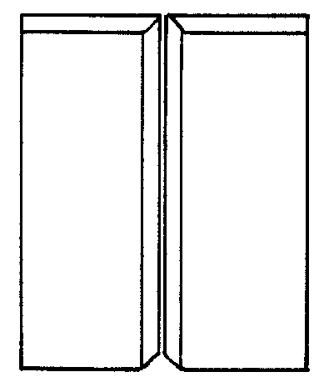
Figure 2.1

Welding Procedure

BUTT JOINT - VERTICAL UP
1. Lower the helmet. Before striking an arc, tell persons in the area to cover themselves. Tack weld two pieces of mild steel together to form a butt joint. If the metal is thicker than 1/8 inch, the edges of the joint should be beveled to increase penetration. A space, no more than 1/8 inch, should be left between the metal plates to increase penetration of the weld.
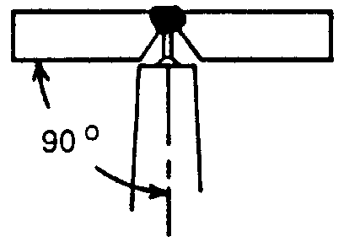
Figure 2.2
2. Position the metal so that the joint to be welded is in the vertical position. (See Figure 2.1.)
3. The electrode should be positioned at a 90° work angle and a 10° to 15° push angle to perform the weld. (See Figure 2.2 and 2.3.)
4. Lower the helmet. Strike an arc and adjust the length of wire stickout to provide the desired penetration. Lengthening wire stickout will decrease penetration, while decreasing wire stickout will increase the amount of penetration received.
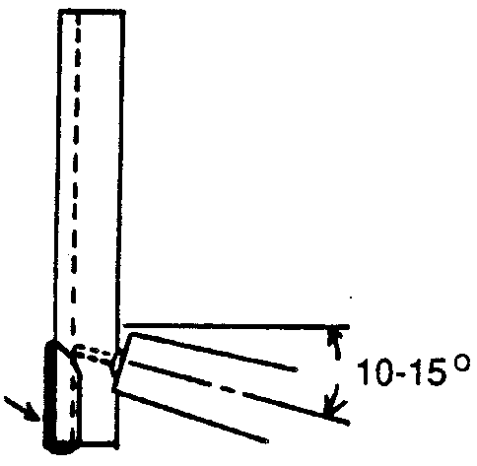
Figure 2.3
5. Maintain the proper electrode angle while using a slight weaving motion to produce the desired weld.
6. Examine the weld for penetration and bead appearance.
7. Give the weld to the instructor for grading.

BUTT JOINT - VERTICAL DOWN
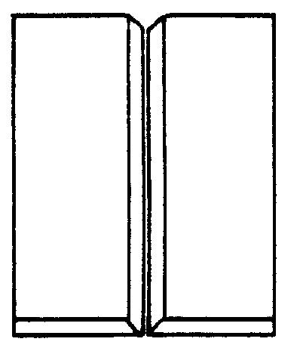
Figure 2.4
1. Lower the helmet. Before striking an arc, tell persons in the area to cover themselves. Tack weld two pieces of mild steel together to form a butt joint. The vertical-down position should only be used when welding thin-gauge metal because the speed of welding required will not allow for adequate penetration of thicker metals.
2. Position the metal so that the joint to be welded is in the vertical position. (See Figure 2.4)
3. The electrode should be positioned at a 90° work angle and a 10° to 15° drag angle to perform the weld. (See Figures 2.5 and 2.6.)
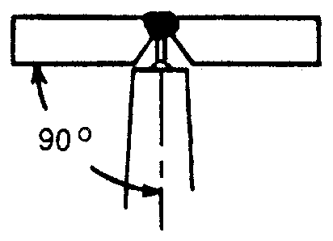
Figure 2.5
4. Lower the helmet. Strike an arc and adjust the wire stickout to provide the desired penetration. Lengthening wire stickout will decrease penetration, whereas decreasing wire stickout will increase the amount of penetration.
5. Maintain the proper electrode angle while using a slight weaving motion to produce the desired weld. A faster welding speed should be used when making a vertical-up weld. Welding too slowly will result in loss of control of the weld puddle and will increase the chance of burnthrough. Welding too quickly will make it difficult to maintain a stable arc, resulting in poor penetration.
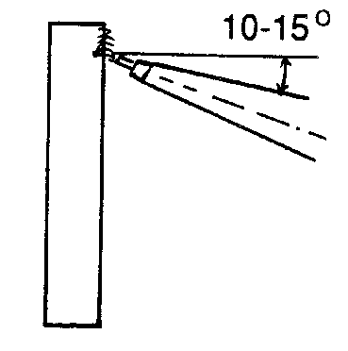
Figure 2.6
6. Examine the weld for penetration and bead appearance.
7. Give the weld to the instructor for grading.

LAP JOINT - VERTICAL UP
1. Lower the helmet. Before striking an arc, tell persons in the area to cover themselves. Tack weld two pieces of mild steel together to form a lap joint.
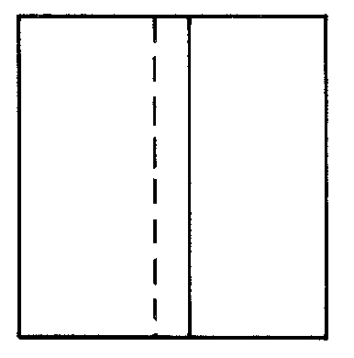
Figure 2.7
2. Position the metal so that the joint to be welded is in the vertical position. (See Figure 2.7.)
3. The electrode should be positioned at a 45° work angle and a 10° to 15° push angle to perform the weld. (See Figures 2.8 and 2.9.)
4. Lower the helmet. Strike an arc and adjust the length of wire stickout to provide the desired penetration. Lengthening wire stickout will decrease penetration, whereas decreasing wire stickout will increase the amount of penetration.
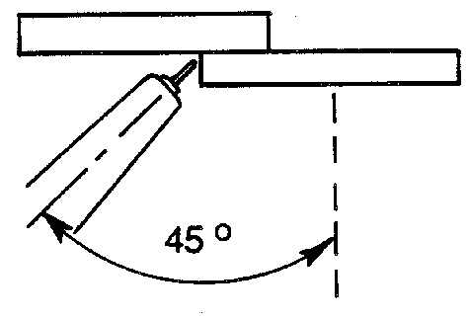
Figure 2.8
5. Maintain the proper electrode angle while using a slight weaving motion to produce the desired weld.
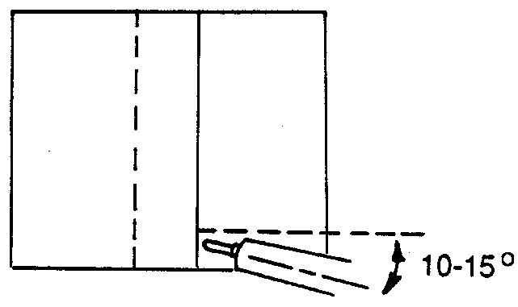
Figure 2.9
6. Examine the weld for penetration and bead appearance.
7. Give the weld to the instructor for grading.

LAP JOINT - VERTICAL DOWN
1. Lower the helmet. Before striking an arc, tell persons in the area to cover themselves. Tack weld two pieces of mild steel together to form a lap joint. The vertical-down position should only be used when welding thin-gauge metal because the speed of welding required will not allow for adequate penetration of thicker metals.
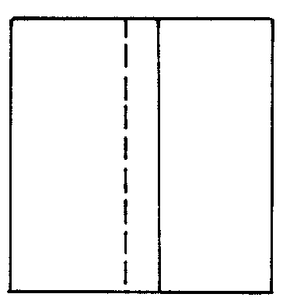
Figure 2.10
2. Position the metal so that the joint to be welded is in the vertical position. (See Figure 2.10.)
3. The electrode should be positioned at a 45° work angle and a 10° to 15° drag angle to perform the weld. (See Figures 2.11 and 2.12.)
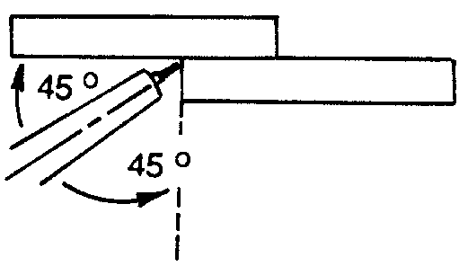
Figure 2.11
4. Lower the helmet. Strike an arc and adjust the wire stickout to provide the desired penetration. Lengthening wire stickout will decrease penetration, whereas decreasing wire stickout will increase the amount of penetration.
5. Maintain the proper electrode angle while using a slight weaving motion to produce the desired weld. A faster welding speed should be used than when making a vertical up weld. Welding too slowly will result in loss of control of the weld puddle and will increase the chance of burnthrough. Welding too quickly will make it difficult to maintain a stable arc, resulting in poor penetration.
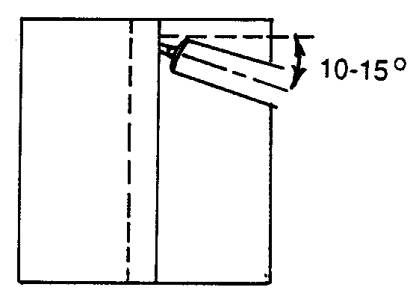
Figure 2.12
6. Examine the weld for penetration and bead appearance.
7. Give the weld to the instructor for grading.
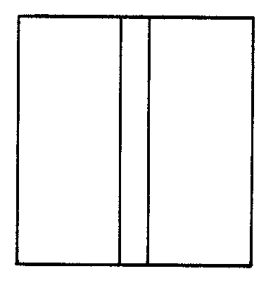
Figure 2.13

T-FILLET JOINT - VERTICAL UP
1. Lower the helmet. Before striking an arc, tell persons in the area to cover themselves. Tack weld two pieces of mild steel together to form a T-joint.
2. Position the metal so that the joint to be welded will be in the vertical position. (See Figure 2.13.)
3. The electrode should be positioned at a 45° work angle and a 10° to 15° push angle to perform the weld. (See Figures 2.14 and 2.15.)
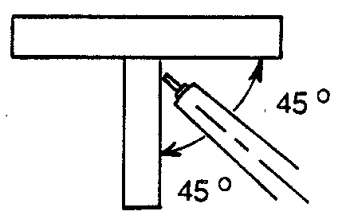
Figure 2.14
4. Lower the helmet. Strike an arc and adjust the length of wire to provide the desired penetration. Lengthening wire stickout will decrease penetration, whereas decreasing wire stickout will increase the amount of penetration.
5. Maintain the proper electrode angle while using a slight weaving motion to produce the desired weld.
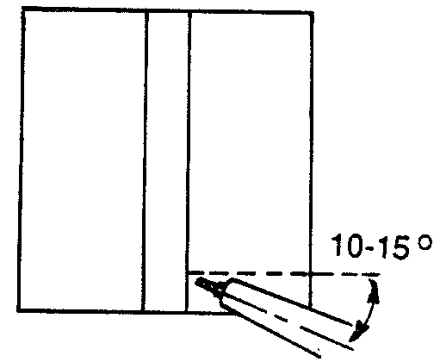
Figure 2.15
6. Examine the weld for penetration and bead appearance.
7. Give the weld to the instructor for grading.

T-FILLET JOINT - VERTICAL DOWN
1. Lower the helmet. Before striking an arc, tell persons in the area to cover themselves. Tack weld two pieces of mild steel together to form a T-joint. The vertical-down position should only be used when welding thin-gauge metal because the speed of welding required will not allow for adequate penetration of thicker metals.
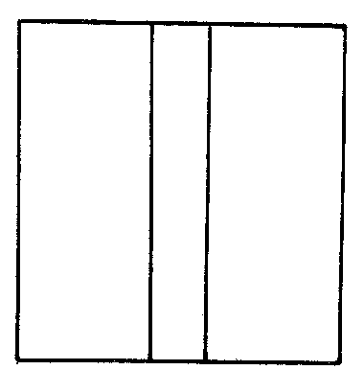
Figure 2.16
2. Position the metal so that the joint to be welded is in the vertical position. (See Figure 2.16.)
3. The electrode should be positioned at a 45° work angle and a 10° to 15° drag angle to perform the weld. (See Figures 2.17 and 2.18.)
4. Lower the helmet. Strike an arc and adjust the wire stickout to provide the desired penetration. Lengthening wire stickout will decrease penetration, whereas decreasing wire stickout will increase the amount of penetration.
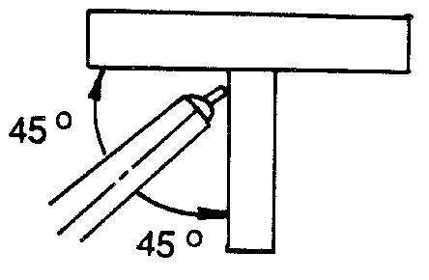
Figure 2.17
5. Maintain the proper electrode angle while using a slight weaving motion to produce the desired weld. A faster welding speed should be used than when making a vertical-up weld. Welding too slowly will result in loss of control of the weld puddle and will increase the chance of burnthrough. Welding too quickly will make it difficult to maintain a stable arc, resulting in poor penetration.
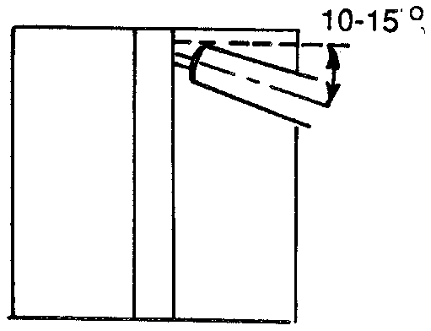
Figure 2.18
6. Examine the weld for penetration and bead appearance.
7. Give the weld to the instructor for grading.

Postwelding Procedure

Refer to JS 2.1 for correct postwelding procedures.

UNIT II - ARC WELDING

Job Sheet 2.5: Welds in the Overhead Position

Objective

At the completion of this job sheet, the student will be able to perform a butt and T-fillet weld in the overhead position using a GMAW welder.

Tools and Equipment Needed

1. GMAW welder
2. Protective clothing
3. Safety goggle*
4. Pliers
5. Helmet*
6. Weld positioner

* CAUTION: All students performing and observing this procedure must wear the proper eye protection. Safety precautions must be observed while in the shop area.

Materials Needed

1. E-70S-3 & E71S-3 wire - .035 inch diameter
2. Mild steel plates - size to be determined by the instructor

Prewelding Procedure

Refer to JS 2.1 for prewelding procedures needed to prepare for welding in the overhead position.

Welding Procedure
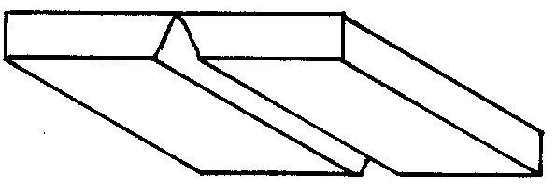
Figure 2.1

BUTT JOINT
1. Lower the helmet. Before striking an arc, tell persons in the area to cover themselves. Tack weld two pieces of mild steel together to form a butt joint. If the metal is thicker than 1/8 inch, the edges of the joint should be beveled to increase penetration. A space, no more than 1/8 inch, should be left between the metal plates to increase penetration of the weld.
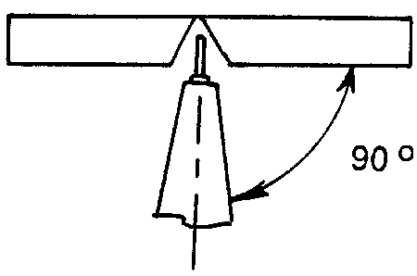
Figure 2.2
2. Position the metal so that the joint to be welded is in the overhead position. (See Figure 2.1.)
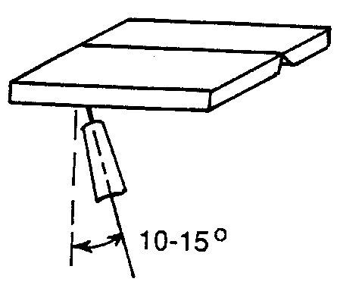
Figure 2.3
3. The electrode should be positioned at a 90° work angle and a 10° to 15° drag angle to perform the weld. (See Figures 2.2 and 2.3.)
4. Lower the helmet. Strike the arc and adjust the length of wire stickout to provide the desired penetration. Lengthening wire stickout will decrease penetration, whereas decreasing wire stickout will increase the amount of penetration.
5. Maintain the proper electrode angle while using a slight weaving motion to produce the desired weld.
6. Examine the weld for penetration and bead appearance.
7. Give the weld to the instructor for grading.

LAP JOINT
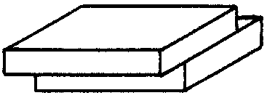
Figure 2.4
1. Lower the helmet. Before striking an arc, tell persons in the area to cover themselves. Tack weld two pieces of mild steel together to form a lap joint. If the metal is thicker than 1/8 inch, the edges of the joint should be beveled to increase penetration.
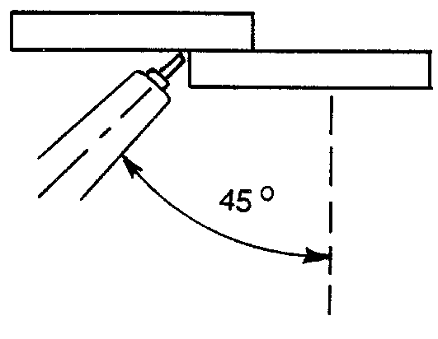
Figure 2.5
2. Position the metal so that the joint to be welded is in the overhead position. (See Figure 2.4.)
3. The electrode should be positioned at a 45° work angle and a 10° to 15° drag angle to perform the weld. (See Figures 2.5 and 2.6.)
4. Lower the helmet. Strike an arc and adjust the length of wire stickout to provide the desired penetration. Lengthening wire stickout will decrease penetration, whereas decreasing wire stickout will increase the amount of penetration.
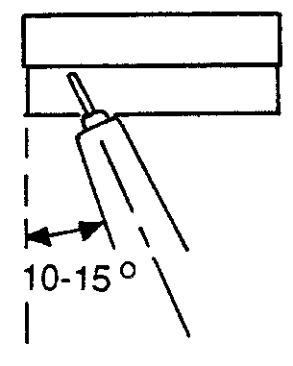
Figure 2.6
5. Maintain the proper electrode angle while using a slight weaving motion to produce the desired weld.
6. Examine the weld for penetration and bead appearance.
7. Give the weld to the instructor for grading.

T-FILLET JOINT
1. Lower the helmet. Before striking an arc, tell persons in the area to cover themselves. Tack weld two pieces of mild steel together to form a T-joint.
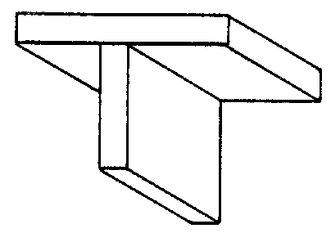
Figure 2.7
2. Position the metal so that the joint to be welded is in the overhead position. (See Figure 2.7.)
3. The electrode should be positioned at a 45° work angle and a 10° to 15° drag angle to perform the weld. (See Figures 2.8 and 2.9.)
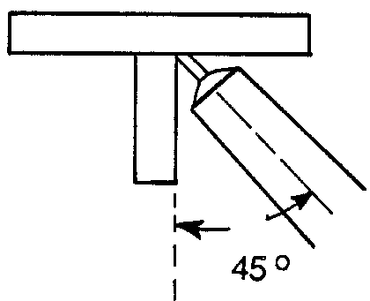
Figure 2.8
4. Lower the helmet. Strike an arc and adjust the length of wire stickout to provide the desired penetration. Lengthening wire stickout will decrease penetration, whereas decreasing wire stickout will increase the amount of penetration.
5. Maintain the proper electrode angle while using a slight weaving motion to produce the desired weld.
6. Examine the weld for amount of penetration and bead appearance.
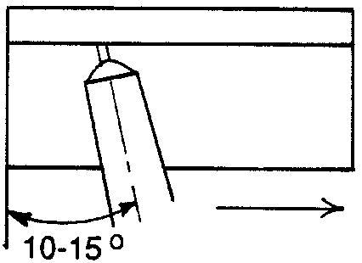
Figure 2.9
7. Give the weld to the instructor for grading.

Postwelding Procedure

Refer to JS 2.1 for correct postwelding procedures.

