UNIT II - ARC WELDING

Job Sheet 2.1: Prewelding and Postwelding Procedures for GMAW

Objective

At the completion of this job sheet, the student will be able to set up, adjust, and shut down the machine used for gas metal arc welding.

Tools and Equipment Needed

1. GMAW welder
2. Protective clothing
3. Safety goggles*
4. Pliers
5. Helmet*

* CAUTION: All students performing and observing this procedure must wear proper eye protection. Safety precautions must be observed while working in the shop.

Materials Needed

1. E-70S-3 & E-71S-3 wire - .035 inch diameter
2. Mild steel plates - size to be determined by the instructor

Prewelding Procedure

1. Set the machine to Direct Current Reverse Polarity.
2. Plug the welding gun cable into the medium slope terminal located on the welding machine.
3. Plug the ground cable into the negative terminal on the welding machine.
4. Connect the ground cable to the table or metal to be welded.
5. Turn the welding machine power switch to “on.”
6. Turn the wire feed control mechanism power switch to “on.”
7. Adjust the wire feed speed to zero while setting gas flow, amperage, and voltage.
8. Open the cylinder valve on top of the gas tank.
9. Gas flow should be adjusted to 20 to 25 cubic feet/hour (cfh). Slowly open the flow meter valve located at the top of the cylinder to adjust the amount of shielding gas being delivered to the weld area. The trigger on the welding gun should be depressed while turning the valve on the flow meter to get a reading.
10. Voltage should be adjusted to 19 to 21.
11. Adjust the wire feed control to provide 100 to 120 amps. A trial setting of 5 should be used for wire feed speed and adjusted accordingly in a constant voltage machine.
a) In a machine that provides constant current, the amperage is adjusted through the voltage setting. Check the manufacturer’s manual to determine if your machine provides constant current or constant voltage.
b) Run a practice bead to check if the correct amperage is being received.
c) To strike an arc, squeeze the trigger on the gun at the same time that the tip of the wire touches the metal to be welded. The assistance of another person will be required to take a reading of the amperage while you are welding.
d) You should also check for the correct voltage at this time. Increasing the wire speed will increase the amount of current provided for welding. Decreasing the wire speed will decrease the amount of current.
e) When running a test bead, the arc should make a sizzling sound if the proper amount of shielding gas is being used.
12. Adjust the wire stickout to 1/4 to 3/8 inches. The length of stickout is measured from the welding tip to the surface of the metal to be welded.
13. Be sure all equipment is in safe working condition and that proper safety precautions are followed at all times.

Postwelding Procedure

1. When welding is complete, shut off the valve on the top of the gas cylinder.
2. Bleed the gas from the line by depressing the trigger on the welding gun. If the machine you are using has a button, depressing it will also bleed the gas from the line.
3. Close the flowmeter valve on the top of the gas cylinder to finger tight. This prevents damage to the flow meter the next time the cylinder valve is opened.
4. Turn off the wire feed speed switch.
5. Turn off the power switch on the welding machine.
6. Return cables to the proper storage position.
7. Clean the work area of scrap metal.
UNIT II - ARC WELDING

Job Sheet 2.2: Welds in the Flat Position

Objective

At the completion of this job sheet, the student will be able to perform butt, lap, and t-fillet welds in the flat position using a GMAW welder.

Tools and Equipment Needed

1. GMAW welder
2. Protective clothing
3. Safety goggles*
4. Pliers
5. Helmet*

* CAUTION: All students performing and observing this procedure must wear proper eye protection. Safety precautions must be observed while in the shop area.

Materials Needed

1. E-70S-3 & E-71S-3 wire - .035 inch diameter
2. Mild steel plates - size to be determined by the instructor

Prewelding Procedure

Refer to JS 2.1 for prewelding procedures needed to prepare for welding in a flat position.

Welding Procedure
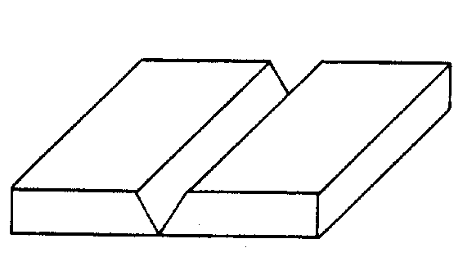
Figure 2.1
BUTT JOINT
1. Lower the helmet. Before striking an arc, tell persons in the area to cover themselves. Tack weld two pieces of mild steel together to form a butt joint. If the metal is thicker than 1/8 inch, the edges of the joint should be beveled to increase penetration. A space of no more than 1/8 inch should be left between the metal plates to increase penetration of the weld.
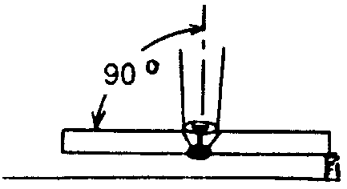
Figure 2.2
2. Position the metal so that the joint to be welded is in the flat position. (See Figure 2.1.)
3. The electrode should be positioned at a 90° work angle and a 25° to 30° drag angle to perform the weld. (See Figure 2.2.)
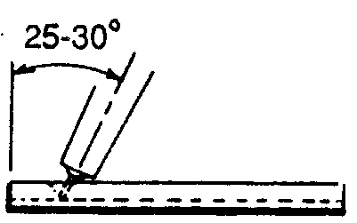
Figure 2.3
4. Lower the helmet. Strike an arc and adjust the length of wire stickout to provide the desired penetration. Lengthening wire stickout will decrease penetration, whereas decreasing wire stickout will increase the amount of penetration.
5. Maintain the proper electrode angle while using a slight weaving motion to produce the desired weld.
6. Examine the weld for penetration and bead appearance.
7. Give the weld to the instructor for grading.

LAP JOINT
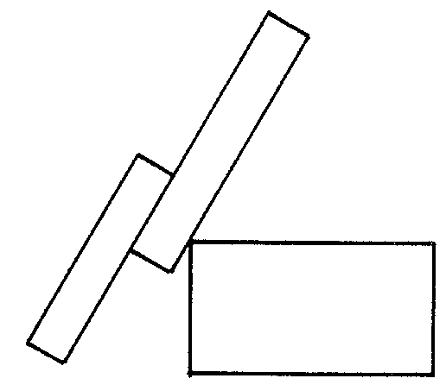
Figure 2.4
1. Lower the helmet. Before striking an arc, tell persons in the area to cover themselves. Tack weld two pieces of mild steel together to form a lap joint. If the metal exceeds 1/8 inch in thickness, the edges of the joint should be beveled to increase penetration.
2. Position the metal so that the joint to be welded is in the flat position. (See Figure 2.4.)
3. The electrode should be positioned at a 90° work angle and a 25° to 30° drag angle to perform the weld. (See Figures 2.5 and 2.6.)
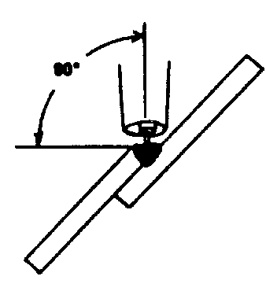
Figure 2.5
4. Lower the helmet. Strike an arc and adjust the length of wire stickout to provide the desired penetration. Lengthening wire stickout will decrease penetration, whereas decreasing wire stickout will increase the amount of penetration.
5. Maintain the proper electrode angle while using a slight weaving motion to produce the desired weld.
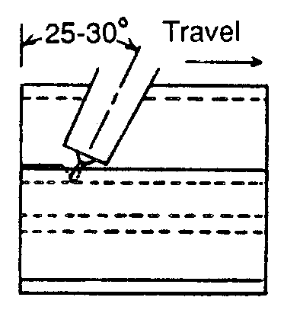
Figure 2.6
6. Examine the weld for amount of penetration and bead appearance.
7. Give the weld to the instructor for grading.

T-FILLET JOINT
1. Lower the helmet. Before striking an arc, tell persons in the area to cover themselves. Tack weld two pieces of mild steel together to form a T-joint. If the metal exceeds 3/8 inch in thickness, the edge of the vertical plate should be beveled to increase penetration.
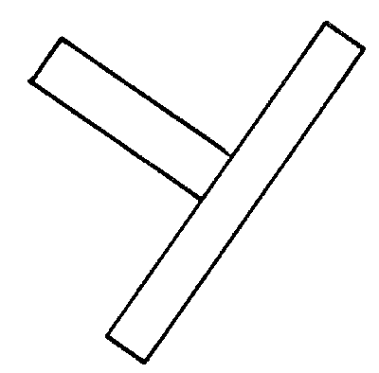
Figure 2.7
2. Position the metal so that the joint to be welded is in the flat position. (See Figure 2.7)
3. The electrode should be positioned at a 45° work angle and a 10° drag angle to perform the weld. (See Figures 2.8 and 2.9.)
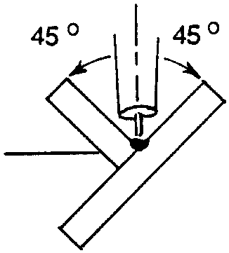
Figure 2.8
4. Lower the helmet. Strike the arc and adjust the length of wire stickout to provide the desired penetration. Lengthening wire stickout will increase penetration, whereas decreasing wire stickout will decrease the amount of penetration.
5. Maintain the proper electrode angle while using a slight weaving motion to produce the desired weld.
6. Examine the weld for amount of penetration and bead appearance.
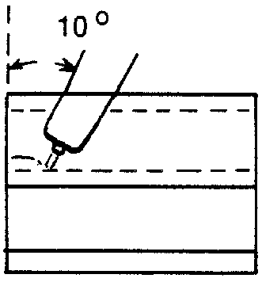
Figure 2.9
7. Give the weld to the instructor for grading.

Postwelding Procedure

Refer to JS 2.1 for correct postwelding procedures.
UNIT II -ARC WELDING

Job Sheet 2.3: Welds in the Horizontal Position

Objective

At the completion of this job sheet, the student will be able to perform a butt and T-fillet weld in the horizontal position using a GMAW welder.

Tools and Equipment Needed

1. GMAW welder
2. Protective clothing
3. Safety goggles*
4. Pliers
5. Helmet*

* CAUTION: All students performing and observing this procedure must wear proper eye protection. Safety precautions must be observed while in the shop area.

Materials Needed

1. E70S-3 & E71S-3 wire - .035 inch diameter
2. Mild steel plates - size to be determined by the instructor

Prewelding Procedure

Refer to JS 2.1 for prewelding procedures needed to prepare for welding in the horizontal position.

Welding Procedure

BUTT JOINT
1. Lower the helmet. Before striking an arc, tell persons in the area to cover themselves. Tack weld two pieces of mild steel together to form a butt joint. If the metal is thicker than 1/8 inch, the edges of the joint should be beveled to increase penetration. A space, no more than 1/8 inch, should be left between the metal plates to increase penetration of the weld.
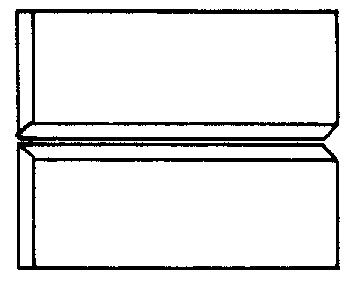
Figure 2.1
2. Position the metal so that the joint to be welded will be in the horizontal position. (See Figure 2.1.)
3. The electrode should be positioned at an 85° work angle and a 5° drag angle to perform the weld. (See Figure 2.2.)
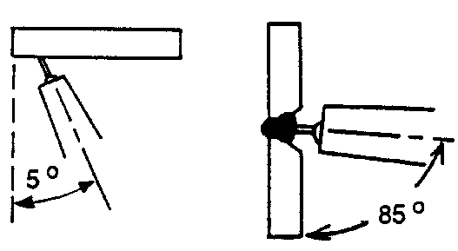
Figure 2.2
4. Lower the helmet. Strike an arc and adjust the length of wire stickout to provide the desired penetration. Lengthening wire stickout will decrease penetration, whereas decreasing wire stickout will increase the amount of penetration.
5. Maintain the proper electrode angle while using a slight weaving motion to produce the desired weld.
6. Examine the weld for penetration and bead appearance.
7. Give the weld to the instructor for grading.

T-FILLET JOINT
1. Lower the helmet. Before striking an arc, tell persons in the area to cover themselves. Tack weld two pieces of mild steel together to form a T-joint.
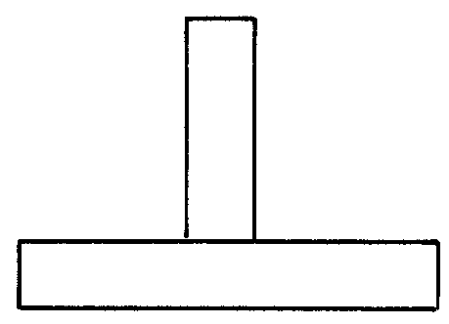
Figure 2.3
2. Position the metal so that the joint to be welded will be in the horizontal position. (See Figure 2.3.)
3. The electrode should be positioned at a 45° work angle and a 10° to 15° drag angle to perform the weld. (See Figures 2.4 and 2.5.)
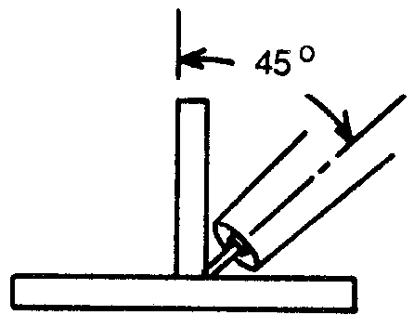
Figure 2.4
4. Lower the helmet. Strike an arc and adjust the length of wire stickout to provide the desired penetration. Lengthening wire stickout will decrease penetration, whereas decreasing wire stickout will increase the amount of penetration.
5. Maintain the proper electrode angle while using a slight weaving motion to produce the desired weld.
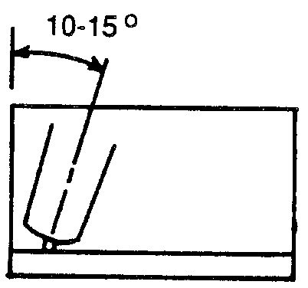
Figure 2.5
6. Examine the weld for amount of penetration and bead appearance.
7. Give the weld to the instructor for grading.

Postwelding Procedure

Refer to JS 2.1 for correct postwelding procedures.
UNIT II - ARC WELDING

Job Sheet 2.4: Welds in the Vertical Position

Objective

At the completion of this job sheet, the student will be able to perform a butt, lap, and T-fillet weld in the vertical position using a GMAW welder.

Tools and Equipment Needed

1. GMAW welder
2. Protective clothing
3. Safety goggles*
4. Pliers
5. Helmet*

* CAUTION: All students performing and observing this procedure must wear proper eye protection. Safety precautions must be observed while in the shop area.

Materials Needed

1. E-70S-3 & E-71S-3 wire - .035 inch diameter
2. Mild steel plates - size to be determined by the instructor

Prewelding Procedure

Refer to JS 2.1 for prewelding procedures needed to prepare for welding in the vertical position.
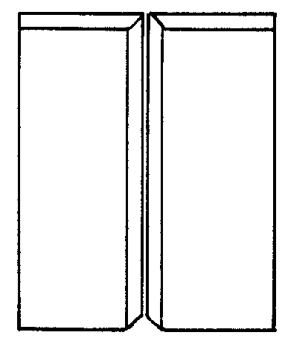
Figure 2.1

Welding Procedure

BUTT JOINT - VERTICAL UP
1. Lower the helmet. Before striking an arc, tell persons in the area to cover themselves. Tack weld two pieces of mild steel together to form a butt joint. If the metal is thicker than 1/8 inch, the edges of the joint should be beveled to increase penetration. A space, no more than 1/8 inch, should be left between the metal plates to increase penetration of the weld.
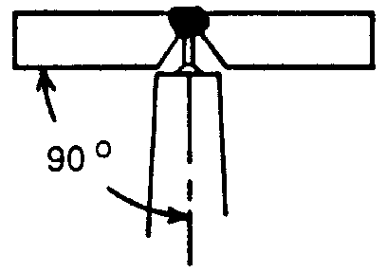
Figure 2.2
2. Position the metal so that the joint to be welded is in the vertical position. (See Figure 2.1.)
3. The electrode should be positioned at a 90° work angle and a 10° to 15° push angle to perform the weld. (See Figure 2.2 and 2.3.)
4. Lower the helmet. Strike an arc and adjust the length of wire stickout to provide the desired penetration. Lengthening wire stickout will decrease penetration, while decreasing wire stickout will increase the amount of penetration received.
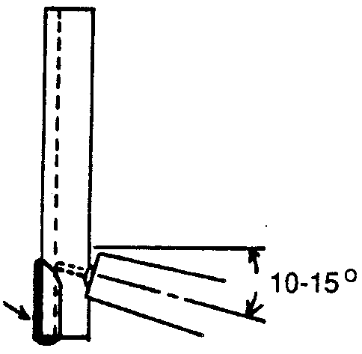
Figure 2.3
5. Maintain the proper electrode angle while using a slight weaving motion to produce the desired weld.
6. Examine the weld for penetration and bead appearance.
7. Give the weld to the instructor for grading.

BUTT JOINT - VERTICAL DOWN
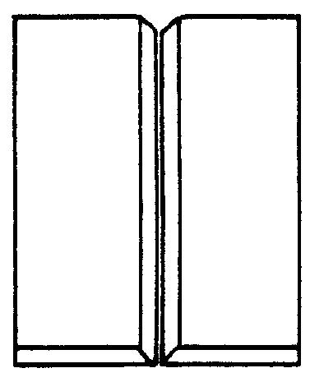
Figure 2.4
1. Lower the helmet. Before striking an arc, tell persons in the area to cover themselves. Tack weld two pieces of mild steel together to form a butt joint. The vertical-down position should only be used when welding thin-gauge metal because the speed of welding required will not allow for adequate penetration of thicker metals.
2. Position the metal so that the joint to be welded is in the vertical position. (See Figure 2.4)
3. The electrode should be positioned at a 90° work angle and a 10° to 15° drag angle to perform the weld. (See Figures 2.5 and 2.6.)
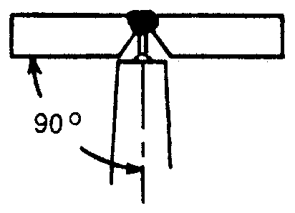
Figure 2.5
4. Lower the helmet. Strike an arc and adjust the wire stickout to provide the desired penetration. Lengthening wire stickout will decrease penetration, whereas decreasing wire stickout will increase the amount of penetration.
5. Maintain the proper electrode angle while using a slight weaving motion to produce the desired weld. A faster welding speed should be used when making a vertical-up weld. Welding too slowly will result in loss of control of the weld puddle and will increase the chance of burnthrough. Welding too quickly will make it difficult to maintain a stable arc, resulting in poor penetration.
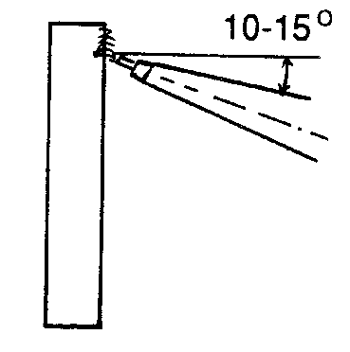
Figure 2.6
6. Examine the weld for penetration and bead appearance.
7. Give the weld to the instructor for grading.

LAP JOINT - VERTICAL UP
1. Lower the helmet. Before striking an arc, tell persons in the area to cover themselves. Tack weld two pieces of mild steel together to form a lap joint.
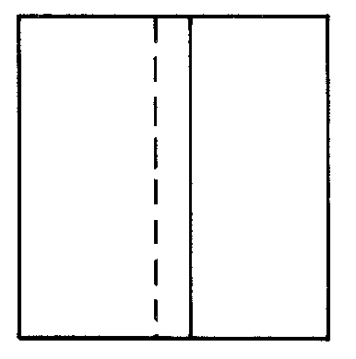
Figure 2.7
2. Position the metal so that the joint to be welded is in the vertical position. (See Figure 2.7.)
3. The electrode should be positioned at a 45° work angle and a 10° to 15° push angle to perform the weld. (See Figures 2.8 and 2.9.)
4. Lower the helmet. Strike an arc and adjust the length of wire stickout to provide the desired penetration. Lengthening wire stickout will decrease penetration, whereas decreasing wire stickout will increase the amount of penetration.
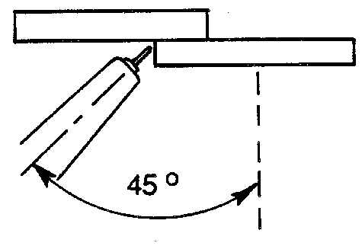
Figure 2.8
5. Maintain the proper electrode angle while using a slight weaving motion to produce the desired weld.
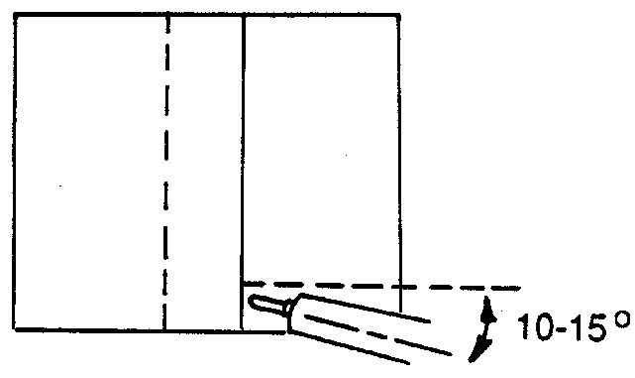
Figure 2.9
6. Examine the weld for penetration and bead appearance.
7. Give the weld to the instructor for grading.

LAP JOINT - VERTICAL DOWN
1. Lower the helmet. Before striking an arc, tell persons in the area to cover themselves. Tack weld two pieces of mild steel together to form a lap joint. The vertical-down position should only be used when welding thin-gauge metal because the speed of welding required will not allow for adequate penetration of thicker metals.
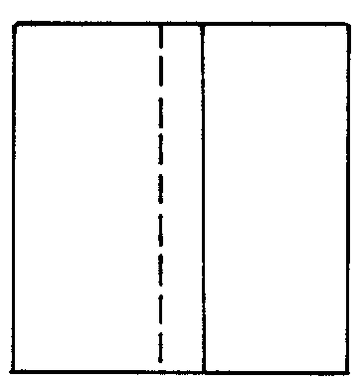
Figure 2.10
2. Position the metal so that the joint to be welded is in the vertical position. (See Figure 2.10.)
3. The electrode should be positioned at a 45° work angle and a 10° to 15° drag angle to perform the weld. (See Figures 2.11 and 2.12.)
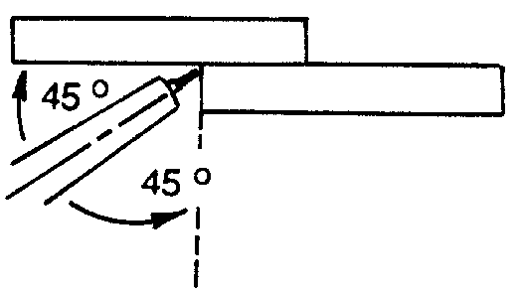
Figure 2.11
4. Lower the helmet. Strike an arc and adjust the wire stickout to provide the desired penetration. Lengthening wire stickout will decrease penetration, whereas decreasing wire stickout will increase the amount of penetration.
5. Maintain the proper electrode angle while using a slight weaving motion to produce the desired weld. A faster welding speed should be used than when making a vertical up weld. Welding too slowly will result in loss of control of the weld puddle and will increase the chance of burnthrough. Welding too quickly will make it difficult to maintain a stable arc, resulting in poor penetration.
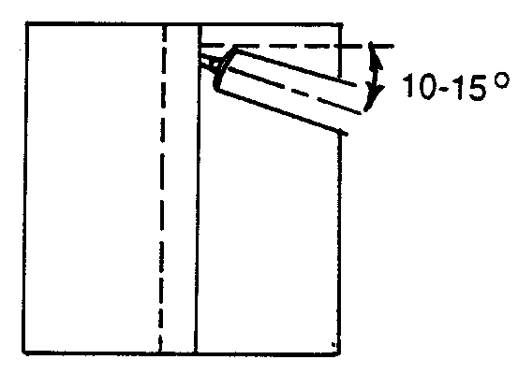
Figure 2.12
6. Examine the weld for penetration and bead appearance.
7. Give the weld to the instructor for grading.
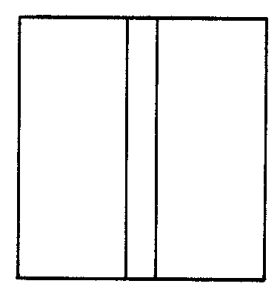
Figure 2.13

T-FILLET JOINT - VERTICAL UP
1. Lower the helmet. Before striking an arc, tell persons in the area to cover themselves. Tack weld two pieces of mild steel together to form a T-joint.
2. Position the metal so that the joint to be welded will be in the vertical position. (See Figure 2.13.)
3. The electrode should be positioned at a 45° work angle and a 10° to 15° push angle to perform the weld. (See Figures 2.14 and 2.15.)
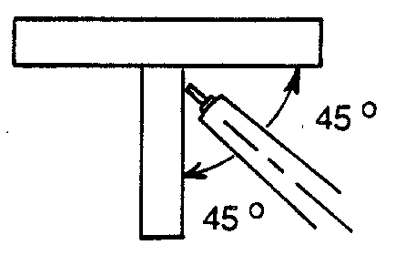
Figure 2.14
4. Lower the helmet. Strike an arc and adjust the length of wire to provide the desired penetration. Lengthening wire stickout will decrease penetration, whereas decreasing wire stickout will increase the amount of penetration.
5. Maintain the proper electrode angle while using a slight weaving motion to produce the desired weld.
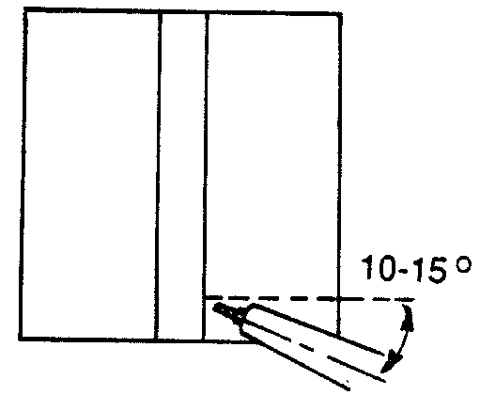
Figure 2.15
6. Examine the weld for penetration and bead appearance.
7. Give the weld to the instructor for grading.

T-FILLET JOINT - VERTICAL DOWN
1. Lower the helmet. Before striking an arc, tell persons in the area to cover themselves. Tack weld two pieces of mild steel together to form a T-joint. The vertical-down position should only be used when welding thin-gauge metal because the speed of welding required will not allow for adequate penetration of thicker metals.
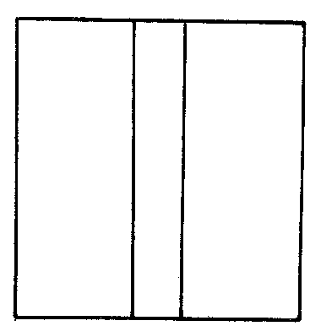
Figure 2.16
2. Position the metal so that the joint to be welded is in the vertical position. (See Figure 2.16.)
3. The electrode should be positioned at a 45° work angle and a 10° to 15° drag angle to perform the weld. (See Figures 2.17 and 2.18.)
4. Lower the helmet. Strike an arc and adjust the wire stickout to provide the desired penetration. Lengthening wire stickout will decrease penetration, whereas decreasing wire stickout will increase the amount of penetration.
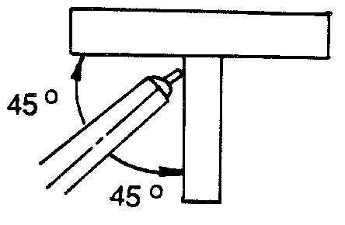
Figure 2.17
5. Maintain the proper electrode angle while using a slight weaving motion to produce the desired weld. A faster welding speed should be used than when making a vertical-up weld. Welding too slowly will result in loss of control of the weld puddle and will increase the chance of burnthrough. Welding too quickly will make it difficult to maintain a stable arc, resulting in poor penetration.
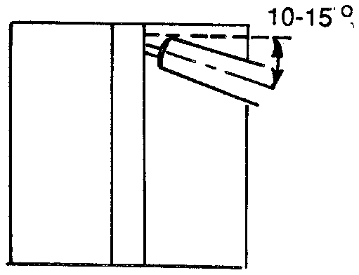
Figure 2.18
6. Examine the weld for penetration and bead appearance.
7. Give the weld to the instructor for grading.

Postwelding Procedure

Refer to JS 2.1 for correct postwelding procedures.

UNIT II - ARC WELDING

Job Sheet 2.5: Welds in the Overhead Position

Objective

At the completion of this job sheet, the student will be able to perform a butt and T-fillet weld in the overhead position using a GMAW welder.

Tools and Equipment Needed

1. GMAW welder
2. Protective clothing
3. Safety goggle*
4. Pliers
5. Helmet*
6. Weld positioner

* CAUTION: All students performing and observing this procedure must wear the proper eye protection. Safety precautions must be observed while in the shop area.

Materials Needed

1. E-70S-3 & E71S-3 wire - .035 inch diameter
2. Mild steel plates - size to be determined by the instructor

Prewelding Procedure

Refer to JS 2.1 for prewelding procedures needed to prepare for welding in the overhead position.

Welding Procedure
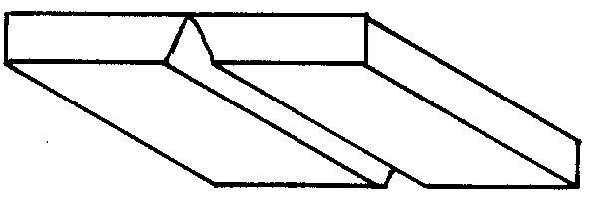
Figure 2.1

BUTT JOINT
1. Lower the helmet. Before striking an arc, tell persons in the area to cover themselves. Tack weld two pieces of mild steel together to form a butt joint. If the metal is thicker than 1/8 inch, the edges of the joint should be beveled to increase penetration. A space, no more than 1/8 inch, should be left between the metal plates to increase penetration of the weld.
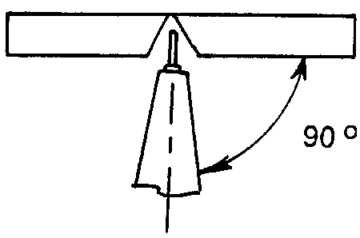
Figure 2.2
2. Position the metal so that the joint to be welded is in the overhead position. (See Figure 2.1.)
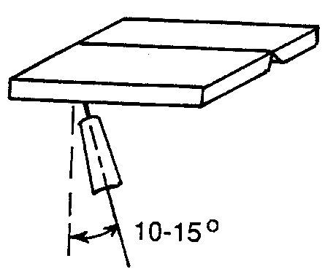
Figure 2.3
3. The electrode should be positioned at a 90° work angle and a 10° to 15° drag angle to perform the weld. (See Figures 2.2 and 2.3.)
4. Lower the helmet. Strike the arc and adjust the length of wire stickout to provide the desired penetration. Lengthening wire stickout will decrease penetration, whereas decreasing wire stickout will increase the amount of penetration.
5. Maintain the proper electrode angle while using a slight weaving motion to produce the desired weld.
6. Examine the weld for penetration and bead appearance.
7. Give the weld to the instructor for grading.

LAP JOINT
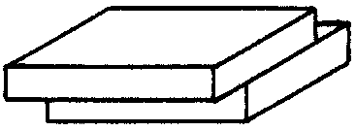
Figure 2.4
1. Lower the helmet. Before striking an arc, tell persons in the area to cover themselves. Tack weld two pieces of mild steel together to form a lap joint. If the metal is thicker than 1/8 inch, the edges of the joint should be beveled to increase penetration.
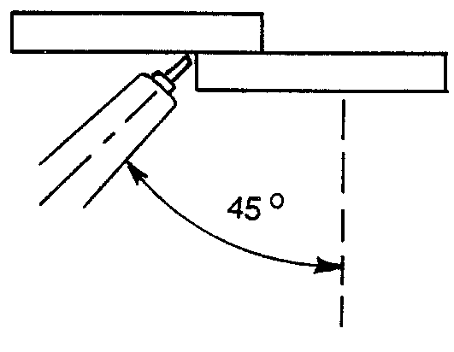
Figure 2.5
2. Position the metal so that the joint to be welded is in the overhead position. (See Figure 2.4.)
3. The electrode should be positioned at a 45° work angle and a 10° to 15° drag angle to perform the weld. (See Figures 2.5 and 2.6.)
4. Lower the helmet. Strike an arc and adjust the length of wire stickout to provide the desired penetration. Lengthening wire stickout will decrease penetration, whereas decreasing wire stickout will increase the amount of penetration.
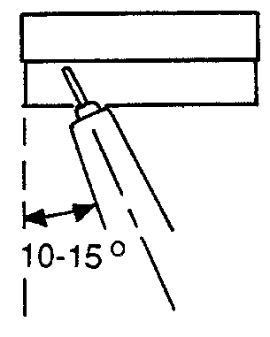
Figure 2.6
5. Maintain the proper electrode angle while using a slight weaving motion to produce the desired weld.
6. Examine the weld for penetration and bead appearance.
7. Give the weld to the instructor for grading.

T-FILLET JOINT
1. Lower the helmet. Before striking an arc, tell persons in the area to cover themselves. Tack weld two pieces of mild steel together to form a T-joint.
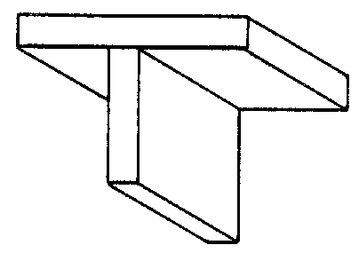
Figure 2.7
2. Position the metal so that the joint to be welded is in the overhead position. (See Figure 2.7.)
3. The electrode should be positioned at a 45° work angle and a 10° to 15° drag angle to perform the weld. (See Figures 2.8 and 2.9.)
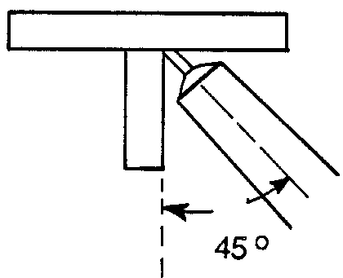
Figure 2.8
4. Lower the helmet. Strike an arc and adjust the length of wire stickout to provide the desired penetration. Lengthening wire stickout will decrease penetration, whereas decreasing wire stickout will increase the amount of penetration.
5. Maintain the proper electrode angle while using a slight weaving motion to produce the desired weld.
6. Examine the weld for amount of penetration and bead appearance.
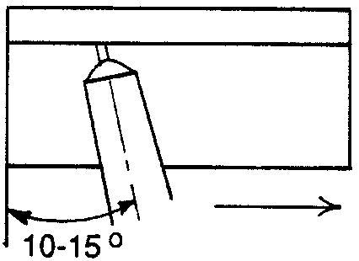
Figure 2.9
7. Give the weld to the instructor for grading.

Postwelding Procedure

Refer to JS 2.1 for correct postwelding procedures.

