Agricultural Construction

Curriculum Guide: Agricultural Construction Volume II

Unit: III. Woodworking

Unit Objective:
Students will apply basic woodworking skills to make an appropriate woodworking project.

Show-Me Standards: 2.5, CA3

References:
Agricultural Construction Volume II. University of Missouri-Columbia, Instructional Materials Laboratory, 1989.

Agricultural Mechanics Building Plans. University of Missouri-Columbia, Instructional Materials Laboratory, 1994.

Agricultural Mechanics Plans (Set). University of Missouri-Columbia, Instructional Materials Laboratory.

Instructional Strategies/Activities:
• Students will engage in study questions in lessons 1 through 6.
• Students will complete JS 5.1, Using a Shaper; JS 5.2, Using a Router;
JS 5.3, Using a Power Miter Box Saw; JS 5.4, Using a Reciprocating Saw; and JS 5.5, Using a Scroll Saw.
• Additional activities that relate to the unit objective can be found under the heading “Other Activities” in the following locations: p. III-5 (1, 2),
p. III-18 (1, 2, 3), p. III-27 (1), p. III-29 (2, 3), p. III-36 (1), and p. III-64 (1).

Performance-Based Assessment:
Students will use common woodworking tools to lay out, cut, drill, and dress a board.

Assessment will be based on the overall quality of the work and the ability to safely and correctly complete the project within the available time.

Agricultural Construction Volume II
Unit III—Woodworking
Instructor Guide

The instructor should assign the performance-based assessment activity at the beginning of the unit. Students will work toward completing the activity as they progress through the unit lessons. The assessment activity will be due at the completion of the unit.

1. Use or adapt the job sheets found in the unit to assess student competency at performing basic woodworking procedures. Review or supplement these activities as needed, based on student mastery of the procedures and the tools and materials the students will be using. NOTE: Students should only complete this performance-based activity if they have mastered all the relevant competencies and have the instructor’s permission to perform the activity.

2. For the performance-based assessment activity, have students apply the skills and procedures discussed in the unit to complete an appropriate woodworking project, such as the one that accompanies this enhancement. This plan requires students to lay out, cut, drill, and dress a board.
a. This project can be completed using hand tools, power tools, or a combination, as desired, depending on the tools students will use while working on their class projects.
b. If planing is added to the list of procedures, be sure that the boards used are at least the minimum required length for the planer in your shop. The board on the project plan is 21" long prior to cutting; its finished length is 18".

3. The student handout for this activity is a Project Completion Checklist and Project Evaluation Checklist that can be used with the project. Students can use the checklists to track the progress of their project and evaluate their work. Supplement or modify the student handout to reflect actual projects as needed.

4. Have students turn in their completed projects.

5. The final assessment score will be based on the overall quality of the work and the ability to safely and correctly complete the project within the available time.

Agricultural Construction Volume II
Unit III—Woodworking
Student Handout
Name_____________________

Use the Project Completion Checklist and Project Evaluation Checklist to track the progress of your project.

Project Completion Checklist

Procedure | Date Due
- Master all competencies necessary to complete the project.

- Review safety precautions for tools and materials to be used. You can lose points for not following safety precautions and other assigned procedures.

- Complete project procedures.

- Perform a quality control inspection of the project following completion. Use the Project Evaluation Checklist.

- Turn in the completed project. Your final assessment score will be based on the overall quality of the work and your ability to safely and correctly complete the project within the available time.

Project Evaluation Checklist

Quality Control and Shop Procedures | Criteria
Quality of Work | - Holes, cut edges, and surfaces are smooth.  - Measurements are correct.  - Cuts are accurate.  - Project is square and straight.  - Work was completed on time.
Safety and Work Habits: Observe these safety procedures whenever you are in the shop. | - Know how to use the equipment before you attempt to use it. Only use tools and materials the instructor has approved you to use.  - Wear appropriate personal protective equipment.  - Follow safety guidelines from your instructor and safety information on labels, equipment, and signs in the work area.  - Follow assigned setup and cleanup procedures.  - Return equipment and materials to their assigned places.  - Do not use equipment that does not function properly.  - Tell the instructor about any damaged or malfunctioning equipment.

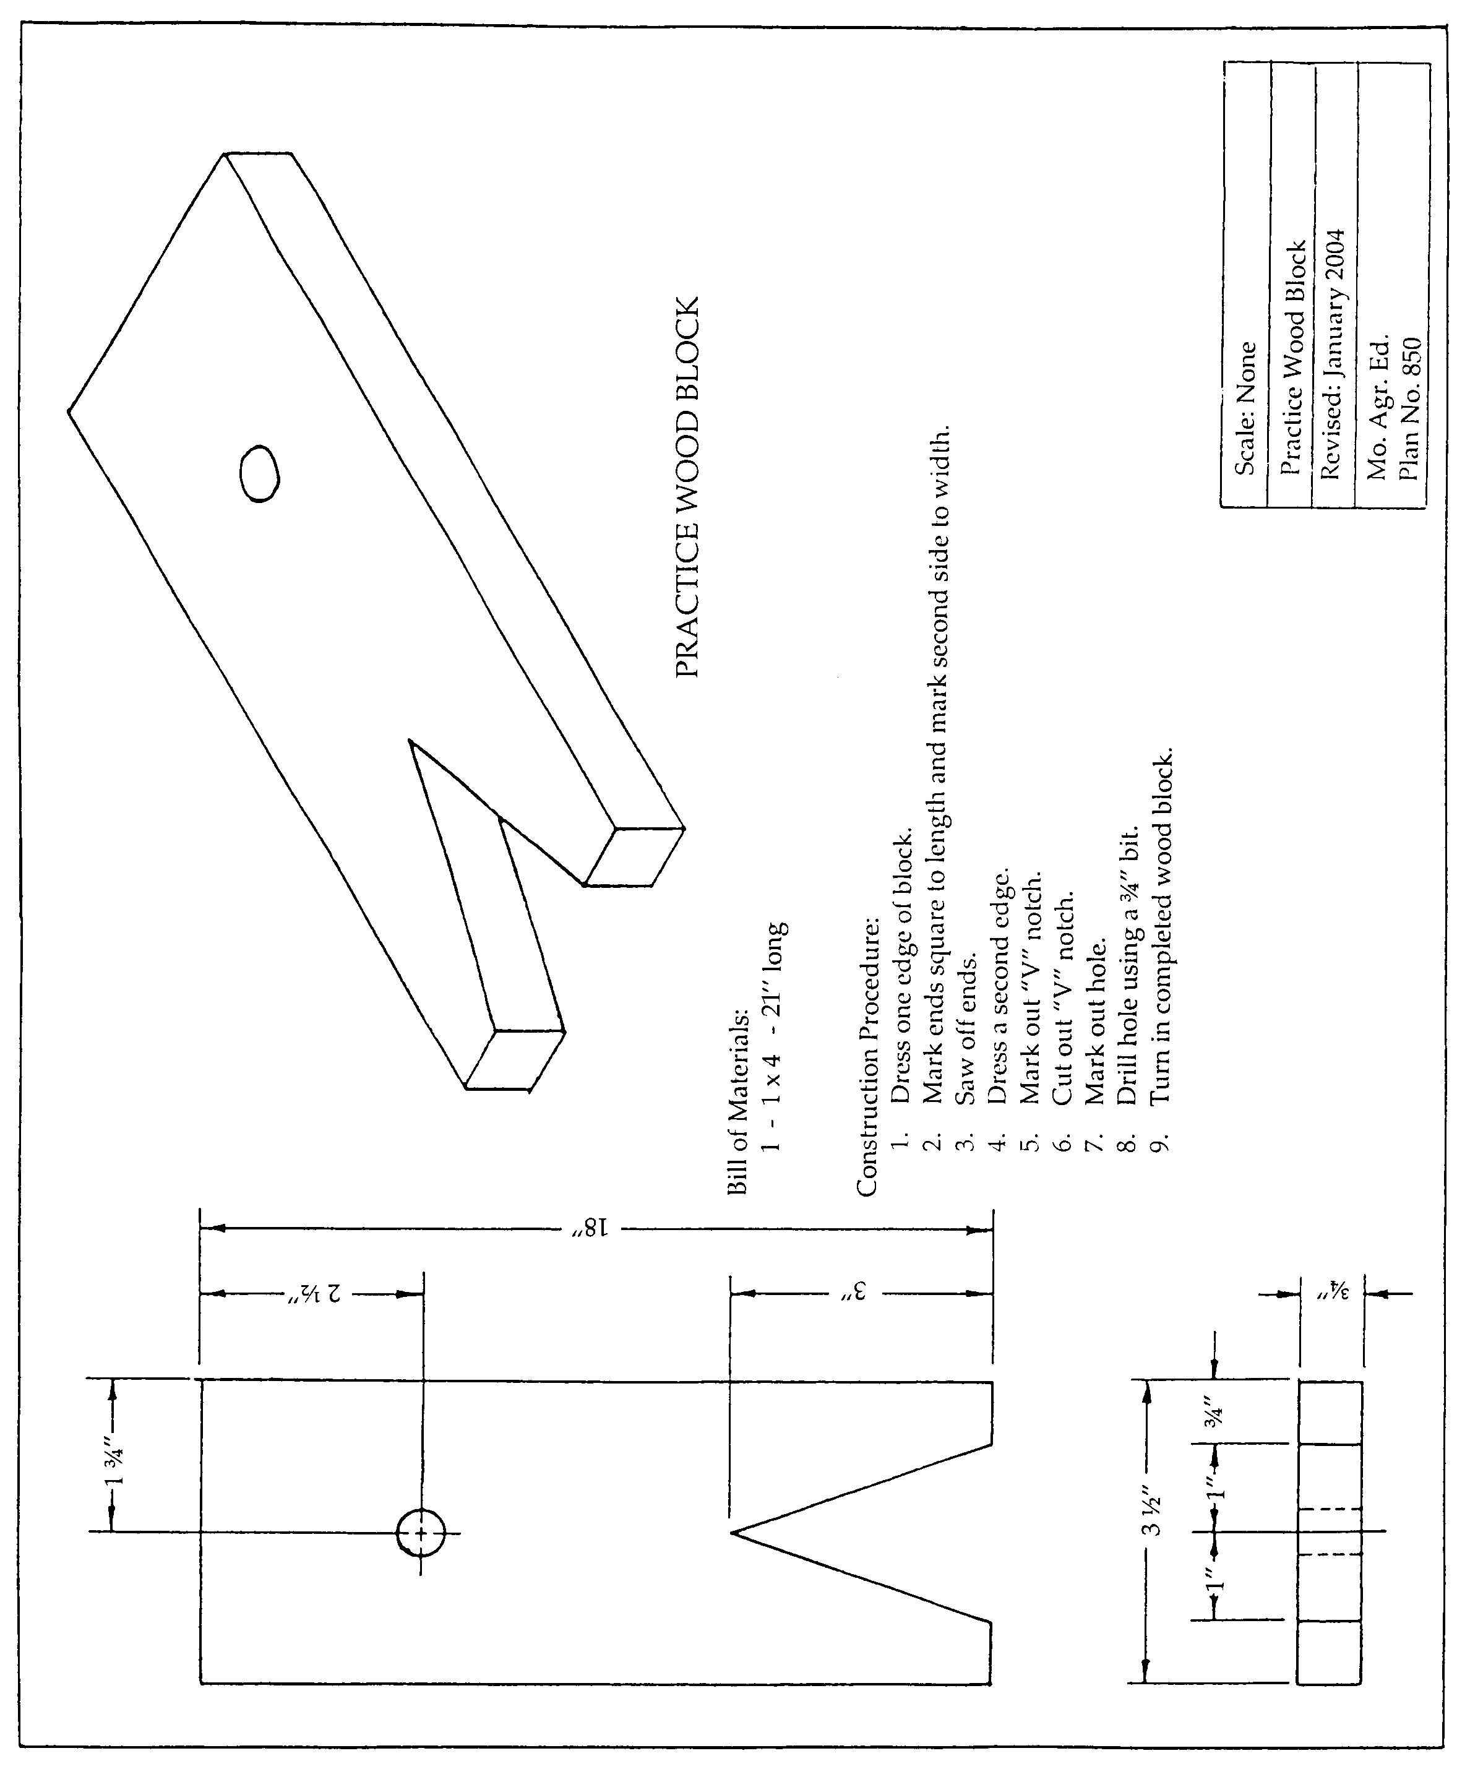
Plan adapted from Agricultural Mechanics Building Plans. University of Missouri-Columbia: Instructional Materials Laboratory.

Agricultural Construction

Agricultural Construction Volume II
Unit III—Woodworking
Scoring Guide Name
♦ Page 9 ♦
Criteria | 0 Points | 1 Point | 2 Points | 3 Points | 4 Points | Weight | Total
Holes, cut edges, and surfaces are smooth | Failed | Poor | Fair | Good | Excellent | X 5
Measurements are correct | Failed | Poor | Fair | Good | Excellent | X 5
Cuts are accurate | Failed | Poor | Fair | Good | Excellent | X 5
Project is square and straight | Failed | Poor | Fair | Good | Excellent | X 5
Work was completed on time | Failed | Poor | Fair | Good | Excellent | X 5
Student followed all safety precautions | Passed |  |  |  | Failed | X (-25) | Negative  Points *
Student followed all assigned procedures | Excellent | Good | Fair | Poor | Failed | X (-10) | Negative  Points *
TOTAL

Final Assessment Total ________/100 pts.
* Overall combined score cannot be below 0.
Comments:
♦ Page 10 ♦

