Agricultural Construction

Curriculum Guide: Agricultural Construction Volume II

Unit: IV. Metals

Unit Objective:
Students will apply basic metalworking skills by constructing an appropriate metalworking project.

Show-Me Standards: 2.5, CA3

References:
Agricultural Construction Volume I. University of Missouri-Columbia, Instructional Materials Laboratory, 1989.

Agricultural Construction Volume II. University of Missouri-Columbia, Instructional Materials Laboratory, 1989.

Machinery Safety: Welding. National Ag Safety Database. Accessed November 17, 2003, from http://www.cdc.gov/nasd/menu/topic/machinery_welding.html.

Instructional Strategies/Activities:
- Students will engage in study questions in lessons 1 through 10.
- Students will complete JS 9.3, Using the Drill Press as a Precision Guide for Tapping; JS 9.4, Tapping a Hole With a Drill Press; and JS 10.1, Making a Cold Chisel.
- Additional activities that relate to the unit objective can be found under the heading “Other Activities” in the following locations: p. IV-4 (1, 2),
p. IV-17, p. IV-32 (2), p. IV-64, p. IV-72 (1, 2), p. IV-80 (1, 3), and p. IV-125 (2).

Performance-Based Assessment:
Students will use common equipment, materials, and procedures discussed in class to lay out and construct an appropriate metalworking project.

Assessment will be based on the overall quality of the work and the ability to safely and correctly complete the project within the available time.

Agricultural Construction Volume II
Unit IV—Metals
Instructor Guide

The instructor should assign the performance-based assessment activity at the beginning of the unit. Students will work toward completing the activity as they progress through the unit lessons. The assessment activity will be due at the completion of the unit.

1. Use or adapt the activity sheets found in the unit to assess student competency at working with metal. Review or supplement these activities as needed, based on student mastery of the procedures and the equipment and materials students will be using. NOTE: Students should only complete this performance-based activity if they have mastered all the relevant competencies and have the instructor’s permission to perform the activity.

2. For the performance-based assessment activity, have students apply the skills and procedures discussed in the unit to make an appropriate project out of metal. The student handout includes a procedure for making a chipping hammer.

3. The student handout also includes a Project Completion Checklist and a Project Evaluation Checklist. Students can use the checklists to track the progress of their project and evaluate their work. Supplement or modify the student handout to reflect actual projects as needed.

4. Have students turn in their completed projects.

5. The final assessment score will be based on the overall quality of the work and the ability to safely and correctly complete the project within the available time.

Agricultural Construction Volume II
Unit IV—Metals
Student Handout

Making a Chipping Hammer

Objective: Use the proper metalworking procedures to fabricate a chipping hammer.

Equipment Needed:
Oxyacetylene outfit and heating tip
AC/DC or AC welder
Anvil
Ball peen hammer
Tape measure
Metal file
Wire brush
Bench grinder
Drill press
Pliers
Gloves
Safety goggles*
Welding goggles and helmet*

*Everyone participating in or observing this procedure must wear the proper eye protection. Safety practices should be followed at all times while in the shop area.

Materials Needed:
1" x 6" hexagon or round high-carbon rod
3/8" x 7" round rod
Bucket of water

Procedure:

1. Drill a 3/8" hole in the 1" x 6" rod. Make sure the hole is centered in the rod. This is where the handle will be connected to the rod.  2. Heat the lower 2" of the 1" x 6" rod until it reaches a cherry-red color, as shown in Figure 4.1.  Caution: Hot metal should be handled with pliers. Gloves will not give adequate protection to pick up hot metal. | 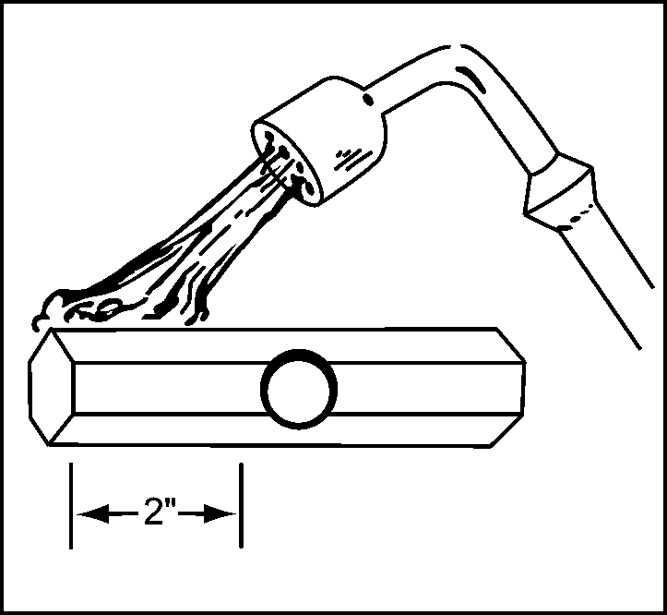  Figure 4.1
3. Use an anvil and a hammer to taper the heated end of the rod. The taper should begin on the chipping tip and end about 2" up the rod, as illustrated in Figure 4.2. The end of the tip should be 3/16" thick. | 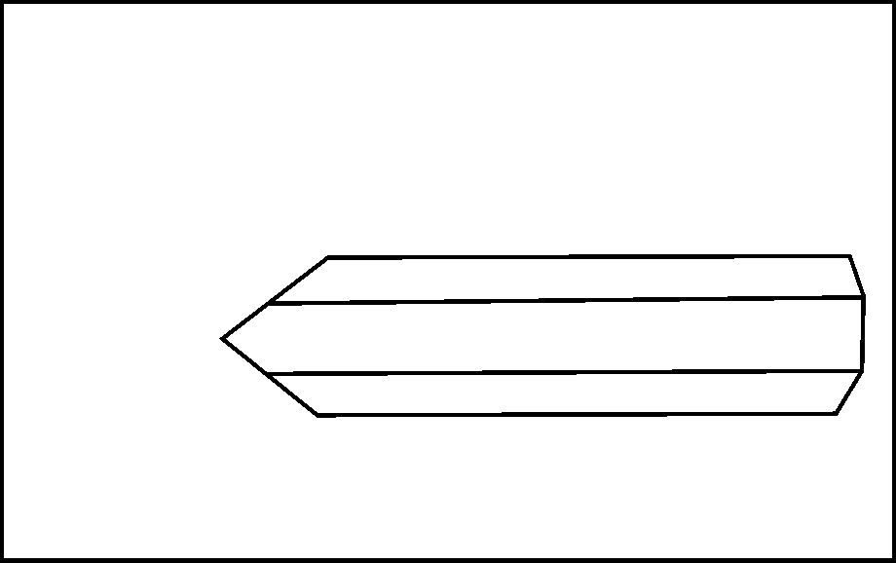  Figure 4.2
4. Cool the hammer in water until the steam stops. As you are cooling the hammer, move it slightly up and down in the water to avoid causing cracks at the waterline, which can result from uneven cooling. See Figure 4.3. | 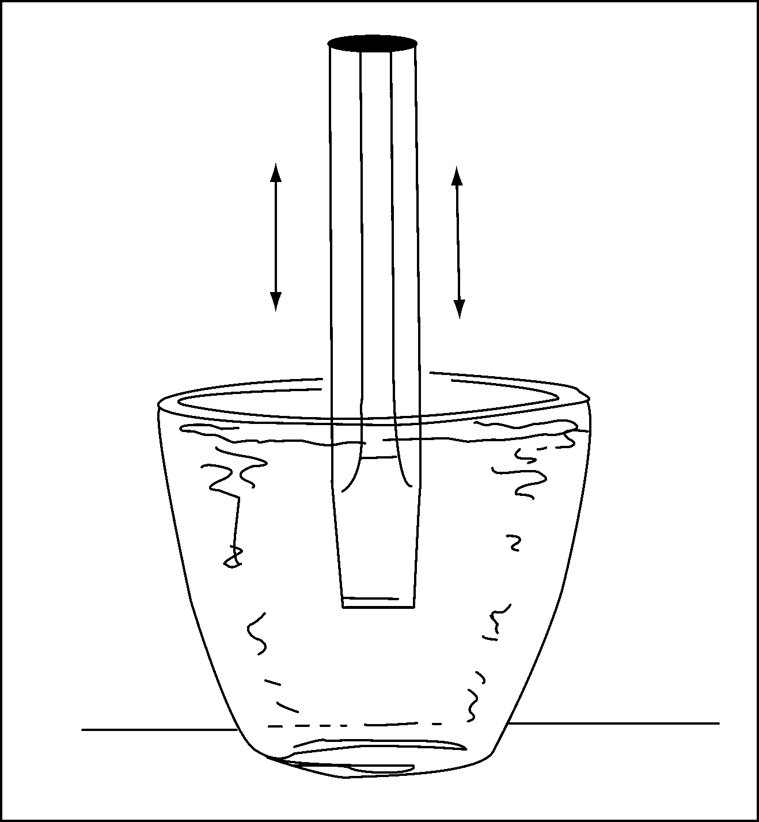  Figure 4.3
5. Remove the hammer from the water. Remove the oxides that have formed on the chipping end by using a wire brush or file.

6. Grind a 60º angle on the chipping end of the hammer, as shown in Figure 4.4. | 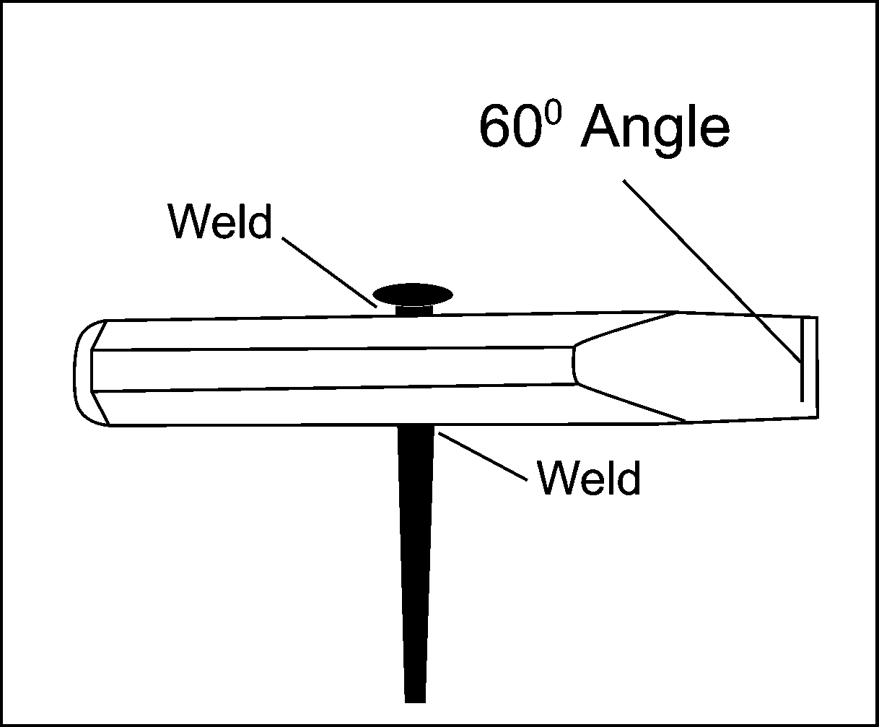  Figure 4.4
7. Insert the 3/8" round rod in the hole in the 1" rod and weld it where it enters and exits the larger rod, as shown in Figure 4.4.

8. Cool the weld and clean and examine the hammer for accuracy.

9. Turn your completed chipping hammer in to the instructor for grading.

Name_____________________

Use the Project Completion Checklist and Project Evaluation Checklist to track the progress of your project.

Project Completion Checklist

Procedure | Date Due
- Master all competencies necessary to complete the project.

- Receive instructor approval to build the project.

- Review safety precautions for equipment and materials to be used. You can lose points for not following safety precautions and other assigned procedures.

- Complete project construction.

- Perform a quality control inspection of the project following completion. Use the Project Evaluation Checklist.

- Turn in the completed project. Your final assessment score will be based on the overall quality of the work and your ability to safely and correctly complete the project within the available time.

Project Evaluation Checklist

Quality Control and Shop Procedures | Criteria
Quality of Work | - Chipping tip is properly tapered and ground.  - Handle is centered.  - Weld appearance indicates correct speed of travel, amperage setting, and arc length.  - Welds are strong and sound.  - Measurements are correct.  - Project is good enough to sell.  - Work was completed on time.
Safety and Work Habits: Observe these safety procedures whenever you are in the shop. | - Know how to use the tools and materials before you attempt to use them. Only use tools and materials the instructor has approved you to use.  - Wear appropriate personal protective equipment.  - Follow safety guidelines from your instructor and safety information on labels, equipment, and signs in the work area.  - Follow assigned setup and cleanup procedures.  - Return equipment and materials to their assigned places.

Agricultural Construction
Agricultural Construction Volume II
Unit IV—Metals
Scoring Guide Name
♦ Page 9 ♦
Criteria | 0 Points | 1 Point | 2 Points | 3 Points | 4 Points | Weight | Total
Chipping tip is properly tapered and ground | Failed | Poor | Fair | Good | Excellent | X 6
Handle is centered | Failed | Poor | Fair | Good | Excellent | X 3
Weld appearance indicates correct speed of travel, amperage setting, and arc length | Failed | Poor | Fair | Good | Excellent | X 2
Welds are strong and sound | Failed | Poor | Fair | Good | Excellent | X 4
Measurements are correct | Failed | Poor | Fair | Good | Excellent | X 5
Project is good enough to sell | Failed | Poor | Fair | Good | Excellent | X 3
Work was completed on time | Failed | Poor | Fair | Good | Excellent | X 2
Student followed all safety precautions | Passed |  |  |  | Failed | X (-25) | Negative  Points *
Student followed all assigned procedures | Excellent | Good | Fair | Poor | Failed | X (-10) | Negative  Points *
TOTAL

Final Assessment Total ________/100 pts.
* Overall combined score cannot be lower than 0.
Comments:
♦ Page 10 ♦

