Agricultural Structures

Curriculum Guide: Agricultural Structures

Unit: V. Electricity

Unit Objective:
Students will demonstrate an understanding of how to work with electricity and wiring by diagramming a wiring plan for an agricultural structure, identifying sources of electrical grounding in the structure, and completing a bill of materials for the project.

Show-Me Standards: 1.10, CA3

References:
Agricultural Structures. University of Missouri-Columbia, Instructional Materials Laboratory, 1999.

Cook, J. B., & Nickolaus, G. F. Basic Procedures in Administration of Zoning Regulations: Appeals. MU Extension. University of Missouri-Columbia. Accessed December 2, 2003, from http://muextension.missouri.edu/explore/commdm/dm7613.htm.

Cook, J. B., & Nickolaus, G. F. Basic Procedures in Administration of Zoning Regulations: Making Applications. MU Extension. University of Missouri-Columbia. Accessed December 2, 2003, from http://muextension.missouri.edu/explore/commdm/dm7612.htm.

Home Electrical Wiring. DoItYourself.com Inc. Accessed December 5, 2003, from http://doityourself.com/electric/index.htm.

Local regulatory agencies, such as the planning and development department, public works department, and county board of commissioners

NFPA Online. National Fire Protection Association. Accessed December 5, 2003, from http://www.nfpa.org/catalog/home/index.asp.

Students may use additional outside sources to complete this activity.

Instructional Strategies/Activities:
- Students will engage in study questions in lessons 1 through 12.
- Students will complete AS 1.1, Electricity on the Internet; AS 2.1, Electrical Terms; AS 3.1, Calculating Feeder Wire Size; AS 4.1, Grounding and GFCIs; AS 5.1, Evaluating Lights, Outlets, Switches, and Circuit Protection; AS 6.1, Diagramming Electrical Wiring; AS 7.1, Diagramming the Service Stack; AS 8.1, Identifying SEP Components; JS 9.1, Wiring a Three-Way Switch; AS 10.1, Calculating Electrical Costs; AS 11.1, Assessing Lightning Protection; and AS 12.1, Using Test Devices.
- Additional activities that relate to the unit objective can be found under the heading “Other Activities” in the following locations: p. V-14, p. V-28, p. V-47, p. V-61, p. V-71, p. V-119, p. V-150, and p. V-180.

Performance-Based Assessment:
Students will diagram a wiring plan for a machinery shed using the appropriate symbols and identify sources of electrical grounding in the building. They will also complete a bill of materials for the project.

Assessment will be based on the overall content and presentation of the work.
Unit V—Electricity
Instructor Guide

The instructor should assign the performance-based assessment activity at the beginning of the unit. Students will work toward completing the activity as they progress through the unit lessons. The assessment activity will be due at the completion of the unit.

1. Emphasize the importance of following local building codes and zoning laws when working with wiring and electricity. Discuss relevant local building codes and zoning laws.
a. Information regarding building codes and zoning laws is available from local regulatory agencies, such as the planning and development department, public works department, and county board of commissioners.
b. General information about Missouri building codes and zoning laws is also available from the MU Extension, University of Missouri-Columbia, accessed December 3, 2003, from http://muextension.missouri.edu/explore/agguides/.

2. The student handout includes an activity that can be used to assess student performance. For this activity, students will diagram a wiring plan for a machinery shed using the appropriate symbols, identify sources of electrical grounding in the building, and complete a bill of materials for the project.
a. Provide each student with two blank transparency sheets. Students will place the transparencies over the diagram of the machinery shed and develop their wiring plan in stages.
b. Provide students with dry-erase markers in assorted colors to add the fixtures, receptacles, switches, and wiring to the plan.

3. Have students turn in their completed activity sheets and transparencies. Answers will vary.

4. The final assessment score will be based on the overall content and presentation of the work.

Unit V—Electricity
Student Handout Name___________________________

Objective: Wire a machinery shed.

Materials Needed:
Diagram
Transparencies
Dry-erase markers

1. The instructor will give you a diagram of a machinery shed. Develop a wiring plan for the building using the steps below. Be sure to determine what local building and zoning codes apply to the structure and design a wiring plan that complies with all relevant codes.

2. Identify the best position for the electrical service panel and ground rod and mark the locations on the diagram using their symbols.

3. Place a transparency sheet over the diagram. Determine the best location for the fixtures, receptacles, and switches listed below and draw their symbols on the transparency using a dry-erase marker.
• 6 ceiling light fixtures
• 3 wall-mount light fixtures
• 9 duplex receptacles (3 must be GFCIs)
• Wall switches (You decide how many.)

4. Place a second transparency over the diagram and the first transparency. Determine how many circuits you need and draw in the circuits. Draw lines from the switches to the fixtures they control. Use different colors to make the wires easier to follow.

5. Complete a bill of materials for the project. See the back side of this sheet for a bill of materials form. Include all the materials that will be needed to complete the electrical work in the building—light bulbs, receptacles, cover plates, wire, etc.
Date_________

Project Title______________________

Bill of Materials

Determine the materials you will need for this project and complete the bill of materials below.

No. of Pieces or Amount of Material | Material or Electrical Hardware | Estimated Cost per Unit | Cost

Estimated Total Cost ______________

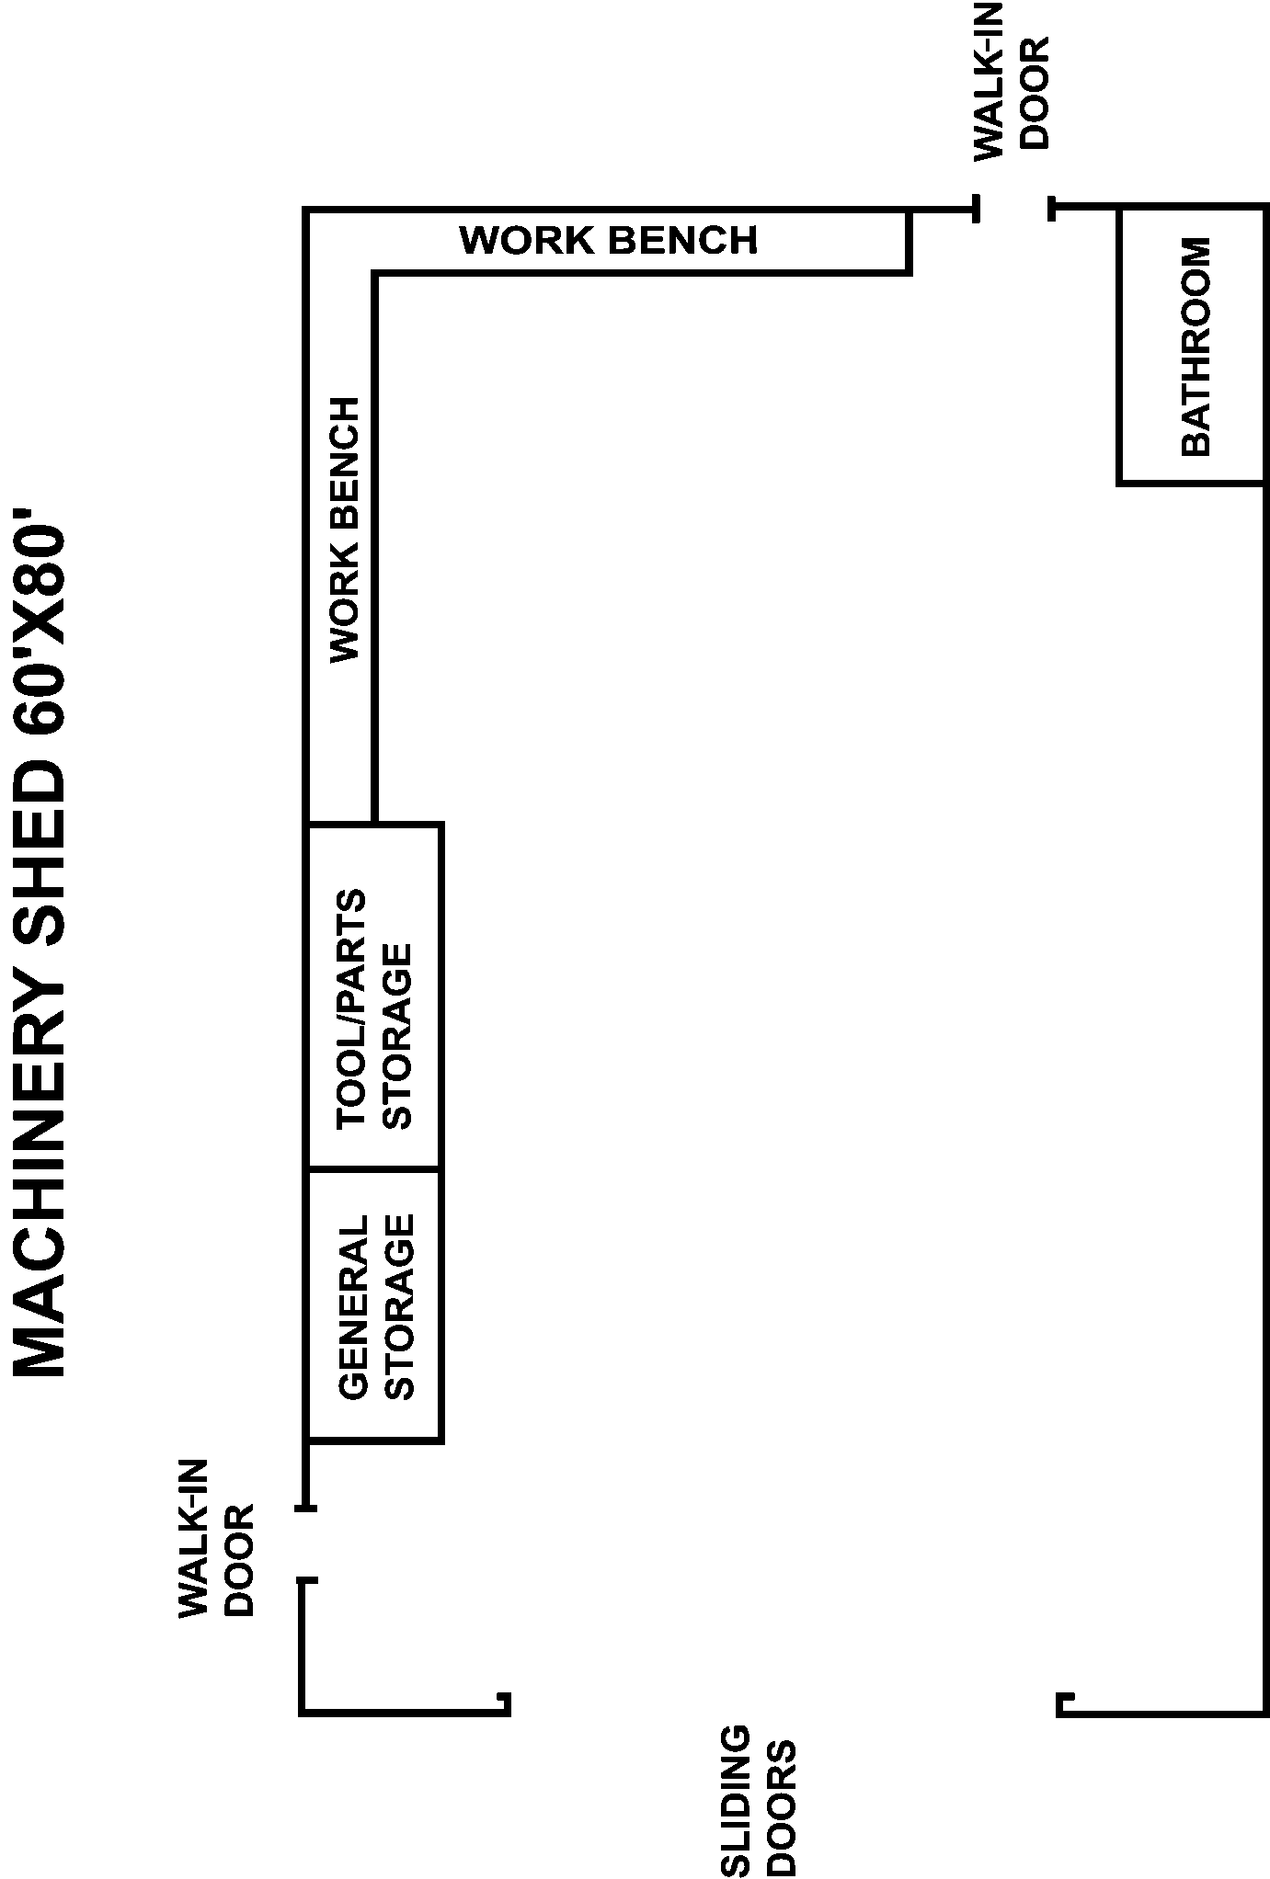

Agricultural Structures

Unit V—Electricity
Scoring Guide Name

♦ Page 9 ♦
Assessment Area | Criteria | 0 Points | 1 Point | 2 Points | 3 Points | 4 Points | Weight | Total
Wiring Diagram | - Electrical service panel and ground rod are properly positioned  - Fixtures, receptacles, and switches are well positioned  - Wiring is properly run  - Symbols are correct and plan is clear and easy to read | Failed | Poor | Fair | Good | Excellent | X 10
Bill of Materials | Bill of materials includes all materials needed, their cost, and the total cost of the project | Failed | Poor | Fair | Good | Excellent | X 7.5
Building and Zoning Codes | Wiring complies with all relevant building and zoning codes | Failed | Poor | Fair | Good | Excellent | X 7.5
TOTAL

Final Assessment Total ________/100 pts.
Comments:

♦ Page 10 ♦

