Agricultural Structures

Curriculum Guide: Agricultural Structures

Unit: VI. Plumbing

Unit Objective:
Students will demonstrate an understanding of plumbing equipment and procedures by applying different techniques to join dissimilar types of pipe—copper, PVC, CPVC, and black iron.

Show-Me Standards: 2.5, CA3

References:
Agricultural Mechanics Building Plans. University of Missouri-Columbia, Instructional Materials Laboratory, 1994.

Agricultural Structures. University of Missouri-Columbia, Instructional Materials Laboratory, 1999.

Agriculture Publications. MU Extension. University of Missouri-Columbia. Accessed August 25, 2003, from http://muextension.missouri.edu/explore/agguides/.

Cook, J. B., & Nickolaus, G. F. Basic Procedures in Administration of Zoning Regulations: Appeals. MU Extension. University of Missouri-Columbia. Accessed December 2, 2003, from http://muextension.missouri.edu/explore/commdm/dm7613.htm.

Cook, J. B., & Nickolaus, G. F. Basic Procedures in Administration of Zoning Regulations: Making Applications. MU Extension. University of Missouri-Columbia. Accessed December 2, 2003, from http://muextension.missouri.edu/explore/commdm/dm7612.htm.

Local regulatory agencies, such as the planning and development department, public works department, and county board of commissioners

Instructional Strategies/Activities:
• Students will engage in study questions in lessons 1 through 5.
• Students will complete AS 1.1, Determining Water Needs; AS 2.1, Working With Plumbing Safely; AS 3.1, Pipe Usage; AS 4.1, Cutting and Joining Plastic Pipe; and JS 4.1, Sweating Copper Pipe.
• Additional activities that relate to the unit objective can be found under the heading “Other Activities” in the following locations: p. VI-4 and
p. VI-47 (1, 2).

Performance-Based Assessment:
Students will use different techniques to join dissimilar types of pipe—copper, PVC, CPVC, and black iron.

Assessment will be based on the overall quality of the work and the ability to safely and correctly complete the project within the available time.
Unit VI—Plumbing
Instructor Guide

The instructor should assign the performance-based assessment activity at the beginning of the unit. Students will work toward completing the activity as they progress through the unit lessons. The assessment activity will be due at the completion of the unit.

1. Emphasize the importance of following local building codes and zoning laws when installing or repairing plumbing. Discuss relevant local building codes and zoning laws.
a. Information regarding building codes and zoning laws is available from local regulatory agencies, such as the planning and development department, public works department, and county board of commissioners.
b. General information about Missouri building codes and zoning laws is also available from the MU Extension, University of Missouri-Columbia, accessed December 3, 2003, from http://muextension.missouri.edu/explore/agguides/.

2. Use or adapt the activity sheets found in the unit to assess student competency at performing basic plumbing procedures. Review or supplement these activities as needed, based on student mastery of the procedures and the tools and materials the students will be using. NOTE: Students should only complete this performance-based activity if they have mastered all the relevant competencies and have the instructor’s permission to perform the activity.

3. For the performance-based assessment activity, have students apply the skills and procedures discussed in the unit to complete an appropriate plumbing project, such as the one that accompanies this enhancement. This plan requires students to join dissimilar types of pipe—copper, PVC, CPVC, and black iron.

4. The student handout for this activity is a Project Completion Checklist and Project Evaluation Checklist that can be used with the project. Students can use the checklists to track the progress of their project and evaluate their work. Supplement or modify the student handout to reflect actual projects as needed.

5. Have students turn in their completed projects.
6. Test the completed projects by attaching a water source to one side and a copper hose bib to the other. All joints should be watertight.

7. The final assessment score will be based on the overall quality of the work and the ability to safely and correctly complete the project within the available time.
Unit VI—Plumbing
Student Handout
Name_____________________

Use the Project Completion Checklist and Project Evaluation Checklist to track the progress of your project.

Project Completion Checklist

Procedure | Date Due
- Master all competencies necessary to complete the project.

- Review safety precautions for tools and materials to be used. You can lose points for not following safety precautions and other assigned procedures.

- Complete project construction.

- Perform a quality control inspection of the project following completion. Use the Project Evaluation Checklist.

- Turn in the completed project. Your final assessment score will be based on the overall quality of the work and your ability to safely and correctly complete the project within the available time.

Project Evaluation Checklist

Quality Control and Shop Procedures | Criteria
Quality of Work | - Fittings and pipe were properly cleaned and prepared.  - Assembly procedures—cementing, soldering, etc.—are correct for the materials being joined.  - Measurements are correct and project has the correct dimensions.  - Parts fit well for optimum strength.  - Work was completed on time.
Safety and Work Habits: Observe these safety procedures whenever you are in the shop. | - Know how to use the equipment before you attempt to use it. Only use tools and materials the instructor has approved you to use.  - Wear appropriate personal protective equipment.  - Follow safety guidelines from your instructor and safety information on labels, equipment, and signs in the work area.  - Follow assigned setup and cleanup procedures.  - Return equipment and materials to their assigned places.  - Do not use equipment that does not function properly.  - Do not use cleaners, cements, or other products with missing or unreadable labels.  - Tell the instructor about any damaged or malfunctioning equipment.

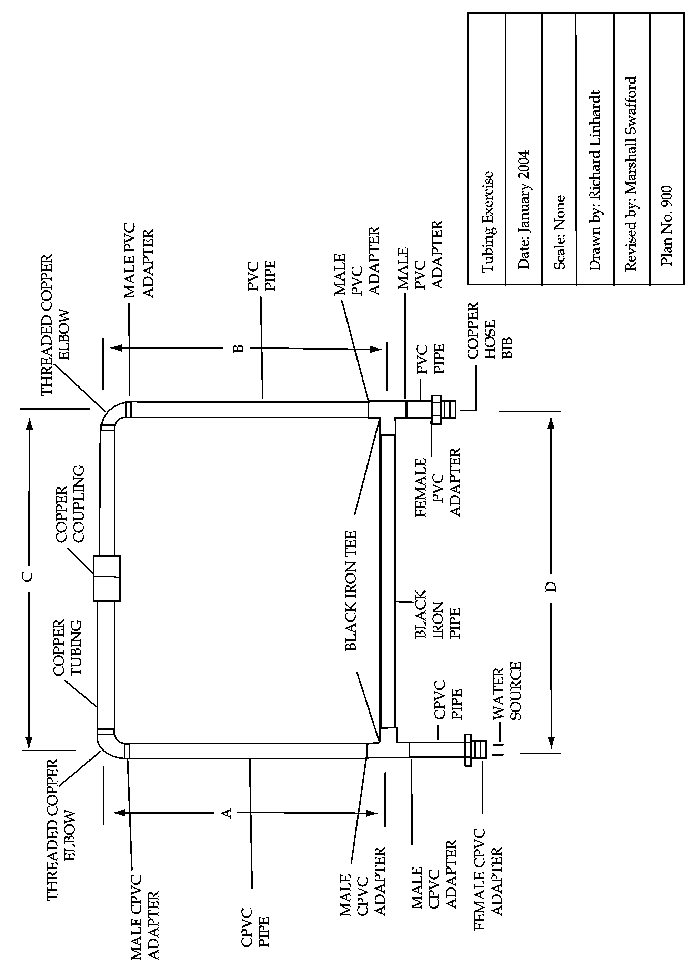
Plan adapted from Agricultural Mechanics Building Plans. University of Missouri-Columbia: Instructional Materials Laboratory.

Bill of Materials:

1 - 1/2" x 18" black iron pipe
1 - 1/2" x 18" copper tubing
1 - 1/2" x 2' PVC pipe
1 - 1/2" x 2' CPVC pipe
3 - 1/2" PVC male adapters
2 - 1/2" threaded copper elbows
1 - 1/2" copper coupling
3 - 1/2" CPVC male adapters
2 - 1/2" black iron tees
1 - 1/2" PVC female adapter
1 - 1/2"copper hose bib
1 - 1/2" CPVC female adapter
1 - can pipe primer
1 - can CPVC cement
1 - can PVC cement
1 - roll wire solder
1 - piece steel wool
1 - jar soldering flux
1 - propane torch
1 - roll 1/2" Teflon tape

Construction Procedure:

Assemble the project as shown. The pieces should be lengths such that A equals B and C equals D.

When connecting copper to copper: Clean the inside of the fitting and the outside of the tubing using steel wool or a similar abrasive. Apply a thin coat of soldering flux to the outside of the tubing and the inside of the fitting. Apply heat to the fitting until the solder flows. Touch the solder to the heated fitting and allow the solder to flow around the fitting to produce a leakproof seal.

When connecting plastic to plastic: Clean the inside of the fitting and the outside of the tubing using pipe primer or a similar pipe cleaner. Apply a thin coat of pipe cement to the outside of the tubing and the inside of the fitting and connect the pipe and fitting.

When connecting plastic to copper or iron: To ensure a leakproof seal when connecting threaded materials, wrap the external threads of each connecting piece with Teflon tape and tighten the pieces with a pipe wrench.
Agricultural Structures

Unit VI—Plumbing
Scoring Guide Name
♦ Page 9 ♦
Criteria | 0 Points | 1 Point | 2 Points | 3 Points | 4 Points | Weight | Total
Fittings and pipe were properly cleaned and prepared | Failed | Poor | Fair | Good | Excellent | X 5
Assembly procedures are correct for the materials being joined | Failed | Poor | Fair | Good | Excellent | X 5
Measurements are correct and project has the correct dimensions | Failed | Poor | Fair | Good | Excellent | X 3
Parts fit well for optimum strength | Failed | Poor | Fair | Good | Excellent | X 4
Project is watertight | Failed | Poor | Fair | Good | Excellent | X 6
Work was completed on time | Failed | Poor | Fair | Good | Excellent | X 2
Student followed all safety precautions | Passed |  |  |  | Failed | X (-25) | Negative  Points *
Student followed all assigned procedures | Excellent | Good | Fair | Poor | Failed | X (-10) | Negative  Points *
TOTAL

Final Assessment Total ________/100 pts.
* Overall combined score cannot be lower than 0.
Comments:

♦ Page 10 ♦

