Floristry

Curriculum Guide: Floristry

Unit: IV. Mechanics of Floral Design

Unit Objective:
Students will demonstrate an understanding of the nomenclature of floral design mechanics by associating terms with definitions, illustrations, and tools.

Show-Me Standards: 1.6, FA3

References:
Floristry. University of Missouri-Columbia, Instructional Materials Laboratory, 1996.

Missouri CDE Handbook. Accessed November 14, 2003, from http://www.dese.mo.gov/divcareered/ag_cde_guidelines.htm.

Instructional Strategies/Activities:
• Students will engage in study questions in lessons 1 through 5.
• Students will complete AS 1.1, Florist’s Tools; JS 2.1, Constructing a Bow; JS 3.1, Preparing Floral Foam; JS 4.1, Wiring Flowers; JS 4.2, Taping Flowers; and JS 5.4, Dressing Potted Plants.
• Additional activities that relate to the unit objective can be found under the heading “Other Activities” in the following locations: p. IV-27 and
p. IV-41.

Performance-Based Assessment:
Students will work individually in taking a test that includes matching, multiple-choice, and short-answer questions on the tools, supplies, materials, and procedures used in floral design.

Assessment will be based on the accuracy of each student’s response to each item on the test.

Unit IV—Mechanics of Floral Design
Instructor Guide

The instructor should assign the performance-based assessment activity after presenting the relevant lesson material outlined in the instructor guide. The assessment activity will be due at the completion of the unit.

1. Students will work individually to demonstrate their knowledge of the nomenclature of floral mechanics.

2. Have students complete a written assessment that covers the material presented during the course of the unit.
a. The student handout provides suggested test items. The teacher is not limited to these test items and is encouraged to devise many, if not all, of the items for the test to reflect the specific approach the teacher uses to teach this unit.
b. Answers to the written assessment as it is currently written are listed at the end of this instructor guide.

3. This activity will help prepare students for a portion of the Floriculture Career Development Event.
a. Refer to the Missouri CDE Handbook for guidelines regarding Career Development Events.
b. The Missouri CDE Handbook is available from the Missouri Department of Elementary and Secondary Education at http://www.dese.mo.gov/divcareered/ag_cde_guidelines.htm.

4. Assessment will evaluate the student’s knowledge of each of the items on the test. All the test items in this assessment activity are worth 1 point unless otherwise noted.

Answers to Written Assessment:
1. b
2. a
3. c
4. d
5. d
6. c
7. d
8. a
9. b
10. c
11. Students should provide seven of the answers listed below. (Each tip is worth 1 point for a maximum value of 7 points.)
a. Gather all materials before beginning.
b. Keep the right face of the ribbon turned outward.
c. Use the ribbon directly from the bolt.
d. Hold the bow in one hand while working the ribbon back and forth with the other hand.
e. Make the bow in proportion to the arrangement; it should not dominate the arrangement but serve as an accessory.
f. Make sure tail length is in proportion to ribbon width. The tail should generally be no longer than the longest loop of the bow.
g. Use a bow without a center loop to tuck under a flower or deep within an arrangement.
h. Construct bows used on church pews out of #40 ribbon.
i. Make some bows in advance.
j. Practice making bows.

12. Students should provide the answers listed below. (Each step is worth 1 point for a maximum value of 5 points.)
a. Lay a large sheet of green waxed tissue paper on the worktable.
b. Arrange a few leaves of foliage, such as leatherleaf, pointing toward one corner of the paper.
c. Place flowers on top of the foliage. If possible, avoid piling the heads of flowers on top of each other to keep them from being crushed.
d. Fold the lower corner of the paper up over the stems.
e. Fold in each side, then roll the paper around the flowers. The paper is then cone-shaped and needs to be tightened around the lower end of the stems and flared out at the flower end. Tie a ribbon around the wrap or staple the ends to secure the flowers.

13. Students should provide the answers listed below. (Each step is worth 1 point for a maximum value of 2 points.)
a. Wrap a light wire around the stem or cluster several times.
b. Bend the two wire ends down alongside the stem or stems.

14. Students should provide the answers listed below. (Each step is worth 1 point for a maximum value of 3 points.)
a. Insert the wire into the base of the flower head until it comes out the top.
b. Bend a small hook in the tip of the wire.
c. Pull the hook back into the center of the flower. Make sure the wire is not visible.
15. c
16. e
17. f
18. d
19. b

20. c
21. e
22. g
23. b
24. a
25. h
26. d

27.–31. Students should list the following, in any order.
Plastic – Come in a range of colors and shapes; often appear more expensive than they really are
Glass – Advantageous for use in cylindrical containers and bud vases
Ceramic – More expensive; best used for permanent arrangements
Wicker – Additional liner is necessary for holding fresh arrangements
Papier-mâché – Intended for temporary use; will eventually deteriorate and leak

32. Camellia; stitch
33. Daisy; hook
34. Rose; straight-wire or piercing
35. Carnation; piercing
36. Stephanotis; hairpin
37. Baby’s breath; clutch
38. Daffodil; insertion

39. 2
40. 5
41. 3
42. 1
43. 4

Unit IV—Mechanics of Floral Design
Student Handout Name _____________________

Written Assessment

Circle the letter that corresponds to the correct answer.

1. Which of the following is not a material commonly used to construct
containers?

a. Plastic
b. Cardboard
c. Glass
d. Ceramic

2. What should be used to secure floral foam in the container?

a. Waterproof tape
b. Staples
c. Cool melt glue
d. Wooden picks

3. A pin holder is also known as a:

a. pin cushion.
b. pin container.
c. frog.
d. bird.

4. Anchor pins are used to:

a. secure candles in floral foam.
b. hold enclosure cards.
c. secure moss to floral foam.
d. hold floral foam in a container.

5. Which of the following is a step in the hairpin wiring method?

a. Bend the wire end alongside the stem.
b. Push the wire up until it is in the flower head.
c. Bend a small hook in the top of the wire.
d. Bend the wire into a large U-shape.

6. Which type of pick is used to attach bows to potted plants?

a. Water
b. Knife
c. Wooden
d. Metal

7. The piercing wiring method is commonly used with which flowers?

a. Daisies
b. Asters
c. Daffodils
d. Roses

8. Which material is used to cushion flowers in a box?

a. Orchid grass
b. Bluegrass
c. Shredded newspaper
d. Recycled paper

9. Which of the following is used to construct a grid?

a. Wire
b. Foliage
c. Masking tape
d. Plastic strips

10. What is the first step when boxing cut flowers?

a. Mist the flowers lightly with water.
b. Arrange a layer of foliage on the bottom of the box.
c. Line the box with florist paper.
d. Place a pack of floral preservative in the box.

Complete the following short-answer questions.

11. List seven tips to remember when constructing bows. (Each tip is worth 1 point for a maximum value of 7 points.)

a.

b.

c.

d.

e.

f.

g.

12. What steps should be followed when wrapping cut flowers for sale? (Each step is worth 1 point for a maximum value of 5 points.)

a.

b.

c.

d.

e.

13. Describe the steps used to wire a flower using the clutch method. (Each step is worth 1 point for a maximum value of 2 points.)

a.

b.

14. Describe the steps used to wire a flower using the hook method. (Each step is worth 1 point for a maximum value of 3 points.)

a.

b.

c.

Match the following tools to the correct illustration. All the illustrations will not be used.

f.
e.
d.
a.
b.
c.
15. _____ Floral shears

16. _____ Glue gun

17. _____ Floral knife

18. _____ Rose stripper

19. _____ Wire cutters

Match the following tools with their function. All the functions will not be used.

20. _____ Floral knife a. Cut ribbon and fabric

21. _____ Glue gun b. Cuts group of flower stems at once

22. _____ Wire cutters c. Cuts stems

23. _____ Bunch cutter d. Removes thorns

24. _____ Ribbon scissors e. Attaches objects in designs
25. _____ Floral shears f. Attaches picks to stems for insertion in foam

26. _____ Rose stripper g. Cuts wire

h. Use serrated blades to cut stems and wire

i. Bends wire around flower stems

Identify the five varieties of containers and provide an advantage or disadvantage of each type.

Container variety Advantage/Disadvantage

27. ________________ _______________________

28. ________________ _______________________

29. ________________ _______________________

30. ________________ _______________________

31. ________________ _______________________

Identify each flower and label the correct wiring method used for each of the next seven items.

32. 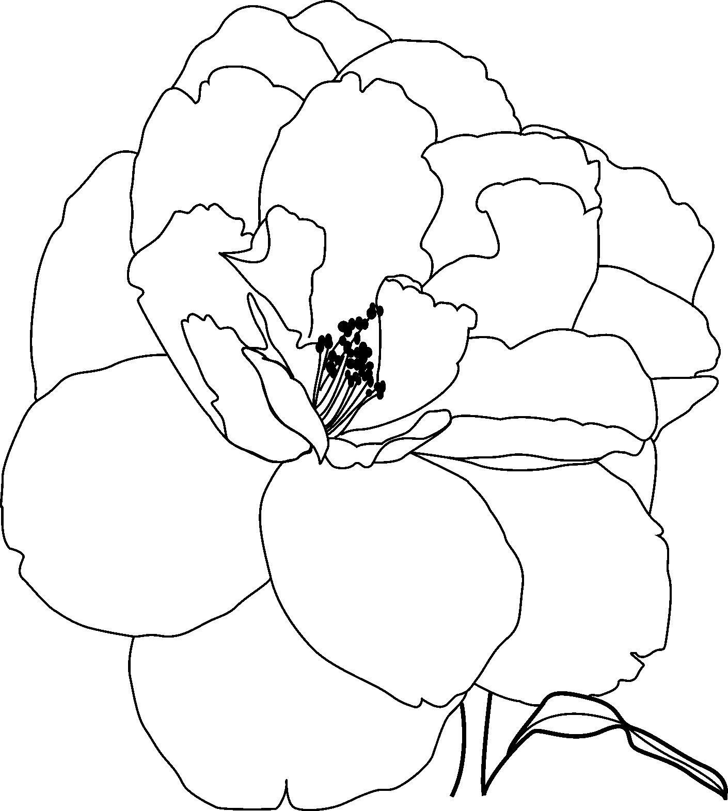  Flower name: ______________  Wiring method: ____________ | 33. 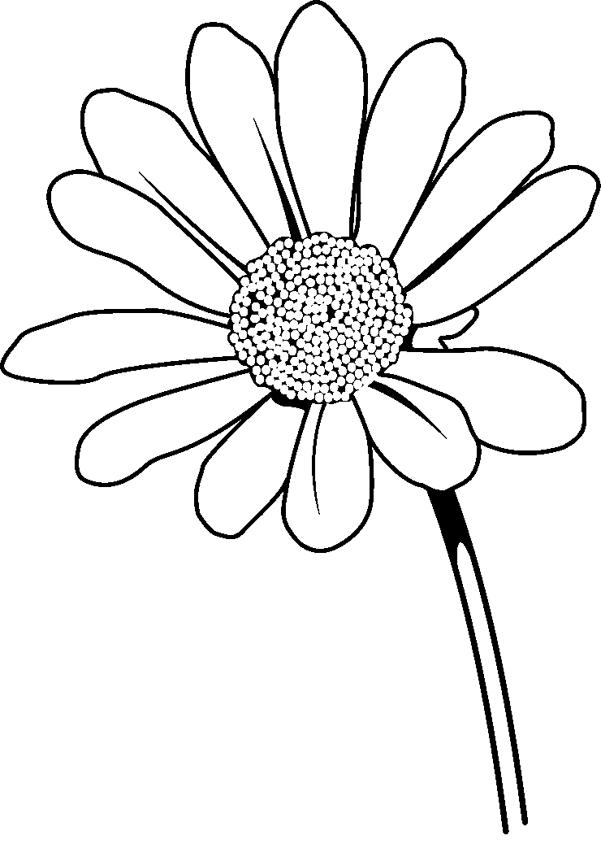  Flower name: ______________  Wiring method: ____________
34.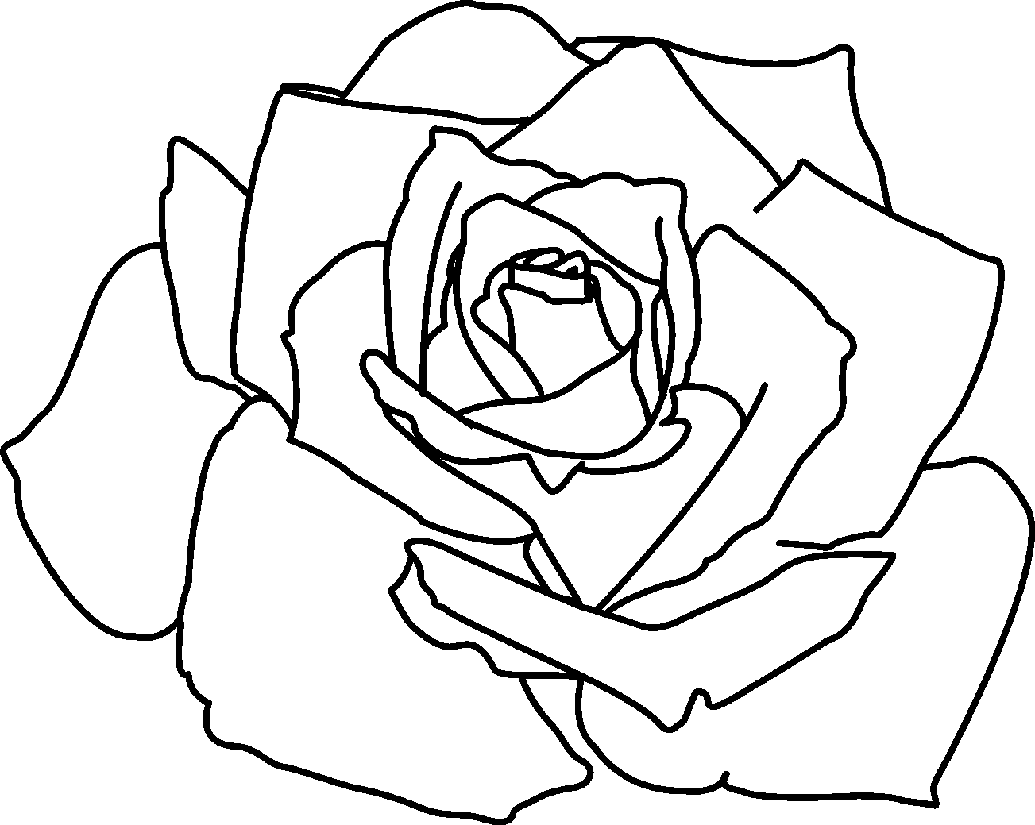  Flower name: ______________  Wiring method: ____________ | 35. 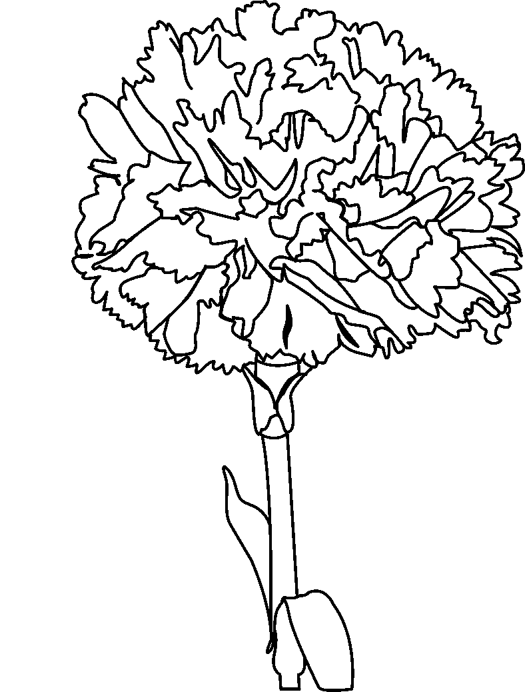  Flower name: ______________  Wiring method: ____________

36. 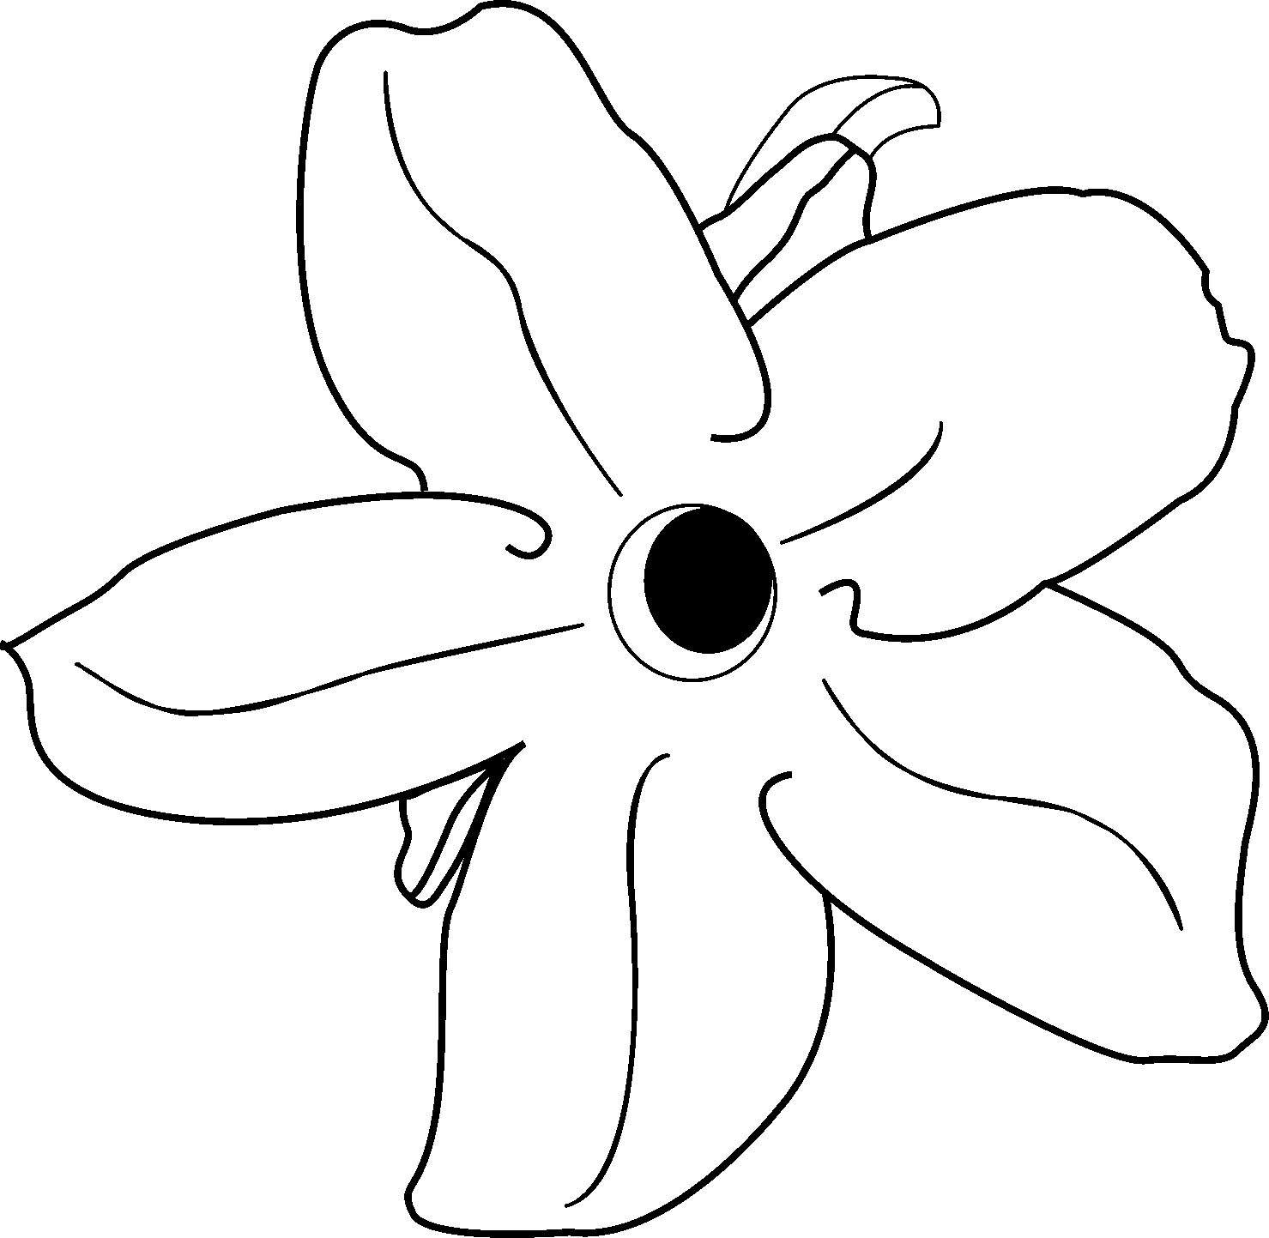  Flower name: ______________  Wiring method: ____________ | 37. 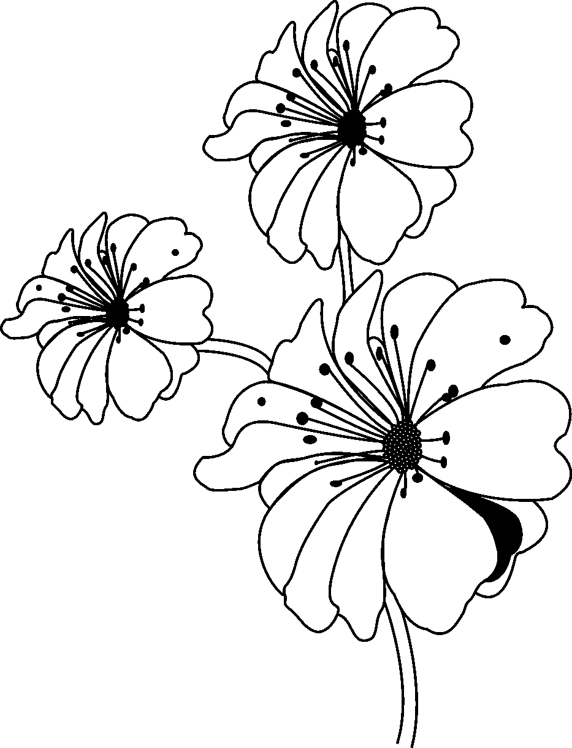  Flower name: ______________  Wiring method: ____________
38. 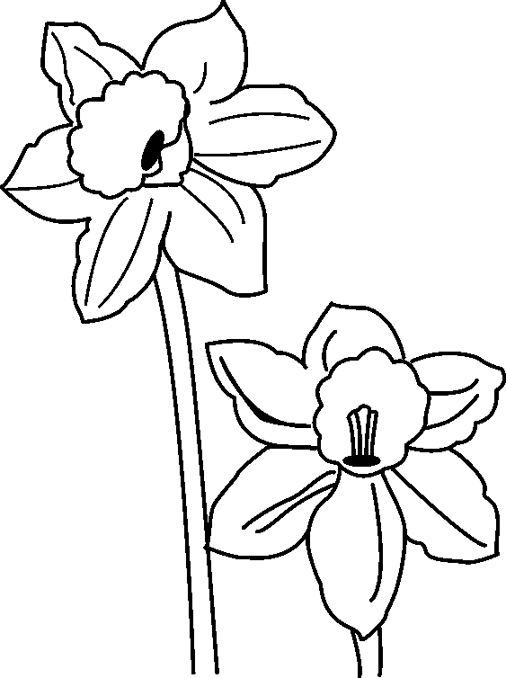

Flower name: ______________

Wiring method: ____________

Identify the proper sequence of bow construction, from start to finish, by labeling the following illustrations with numbers 1–5, the first step being 1.

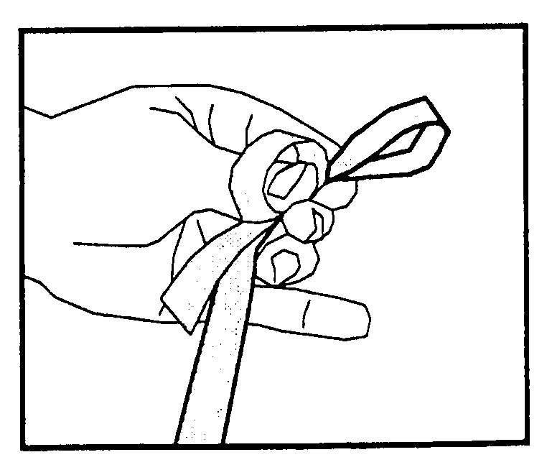  39. ______ | 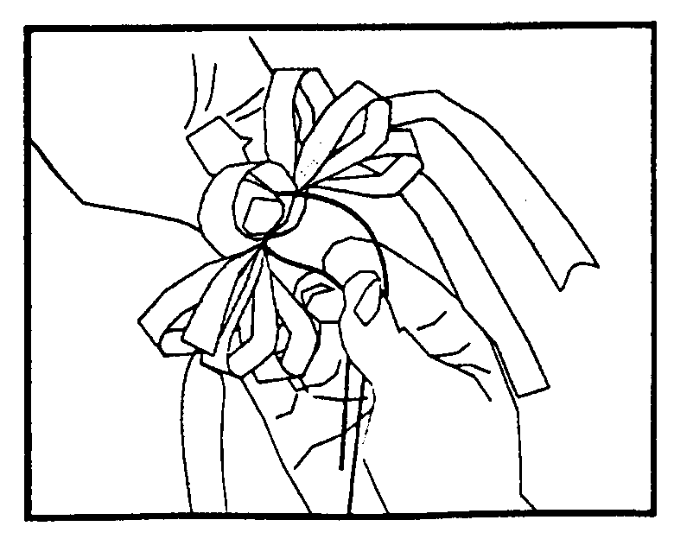  40. ______
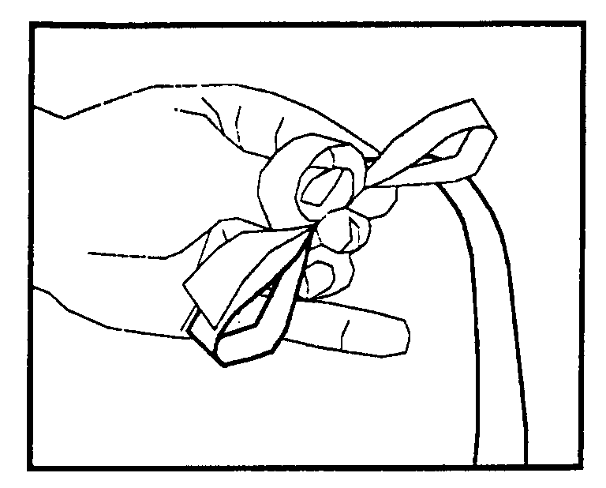  41. ______ | 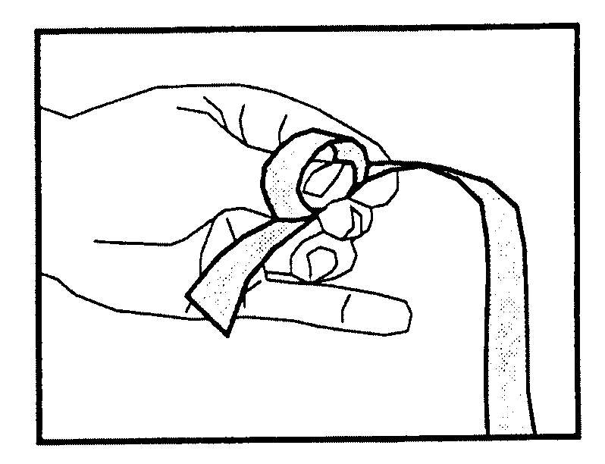  42. ______
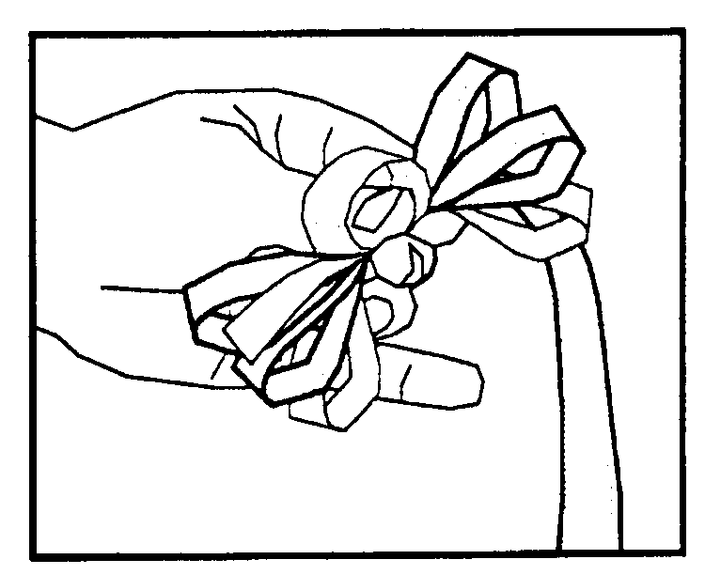
43. ______

