UNIT II - ISSUES IN BIOTECHNOLOGY

Lesson 3: Biotechnology Patents

Competency/Objective: Identify procedures involved in obtaining a patent for a biotechnology product.

Study Questions

1. What is a patent?

2. What are the requirements for obtaining a utility patent for a product of biotechnology?

3. What are the issues surrounding the patenting of biotechnology products?

4. What is DNA fingerprinting?

5. What are the problems associated with the handling of genetic material?

References

1. Biotechnology: Applications in Agriculture (Student Reference). University of Missouri-Columbia: Instructional Materials Laboratory, 1998, Unit II.

2. Transparency Master

a) TM 3.1: Section of a DNA Fingerprint

3. Activity Sheet

a) AS 3.1: Patent Debate

UNIT II - ISSUES IN BIOTECHNOLOGY

Lesson 3: Biotechnology Patents

TEACHING PROCEDURES

- Review

Lesson 2 discussed various regulatory agencies that affect the development of products using biotechnology. Before marketing or even field testing such a product, the developer usually secures a patent to protect the research investment. Patents for biotechnology products have played a major role in shaping the biotechnology industry. Companies have purchased other companies just to obtain certain patents. However, strong opposition to patenting genetically modified life forms has developed. This lesson will discuss patents and the issues surrounding patenting products of biotechnology.

- Motivation

  - In 1996, biotechnology generated nearly $13 billion in annual revenues in the United States. The value of biotechnology patents ranges from millions of dollars to less than the patent application fee itself. Many people refer to this search for profitable patents as a high-tech gold rush. Few prospectors will strike it rich, but many will dig for gold.

  - Using an ink pad and small Post-ItTM notes, have each student make a copy of his or her fingerprint. Display them to the class to show the differences. Discuss the process of genetic fingerprinting.

- Assignment

- Supervised Study

- Discussion

  - Ask students what a patent is. Discuss examples of products that have been patented (including plants and animals).

What is a patent?

    - A patent grants property rights that exclude others from making, using, or selling the patented invention throughout the United States for a stated period of time, normally 17 years.
    - The U.S. Patent and Trademark Office grants three types of patents.
      - Utility patent - granted for “new and useful” inventions that meet certain statutory requirements; the most common type of patent
      - Plant patent - issued to anyone who invents or discovers and asexually reproduces any new variety of plant, including cultivated spores, mutants, hybrids, and newly found seedlings
      - Design patent - granted for any new, original, and ornamental design for a manufactured article

  - Ask students what is required to obtain a patent. Discuss the requirements for obtaining a utility patent.

What are the requirements for obtaining a utility patent for a product of biotechnology?

    - Statutory requirements
      - The invention must be a new and useful process, machine, manufactured item, or composition of matter; most biotechnology products fall into the “composition of matter” category since they are essentially rearrangements of DNA.
      - The invention must be novel and nonobvious. An invention is obvious if it can be readily deduced from information available to the public by a person knowledgeable in the relevant technological field.
      - The invention must be fully described and clearly claimed in a patent application.
    - Additional qualifications
      - The invention must be patentable. The laws of nature, physical phenomena, and abstract ideas are not patentable.
      - A patent cannot remove anything from the public domain. This means that something already commonly used cannot be patented.
      - The granting of the patent must add adequate information about the invention to the public domain.

  - Discuss with students whether they think it is acceptable to patent life-forms. Have students complete the debate outlined in AS 3.1.

What are the issues surrounding the patenting of biotechnology products?

    - The question of ownership of genetically modified organisms
    - The patenting of the genetic material of plants and animals native to countries other than the United States

  - Ask students what makes fingerprints different. Just as the different line patterns make each fingerprint unique, the different locations of bands on an electrophoresis gel make each DNA fingerprint unique.

What is DNA fingerprinting?

    - DNA fingerprinting is the process of using laboratory analysis of DNA to generate a pattern that is unique to an individual organism.
    - DNA fingerprinting involves several steps.
      - Isolating the DNA
      - Cutting, sizing, and sorting the DNA
      - “Tagging” the DNA with a probe dye

  - Discuss some of the problems associated with handling genetic material.

What are the problems associated with the handling of genetic material?

    - Preventing the theft of genetic material
    - Flawed results from testing
    - Preserving the privacy of genetic information

- Other Activities

Have students further research the controversy surrounding patents on biotechnology by focusing on the issue of whether the government should have the right to grant itself patents. Have the students research cases in which the U.S. government issued a patent to itself for a product of biotechnology. Encourage students to use the Internet in their research.

- Conclusion

Patents play an important role in the biotechnology industry. Biotechnology companies view patents as vital because they protect their research investments. However, patents on genetic material and products of biotechnology have sparked new debate as to exactly what should be eligible for a patent. Ultimately, U.S. courts will have to decide the answer to this difficult question as lawsuits are filed to challenge certain patent rights.

- Answers to Activity Sheet

AS 3.1

Answers will vary.

- Answers to Evaluation

  - b
  - a
  - c

  - DNA fingerprinting is the process of using the laboratory analysis of DNA to generate a pattern that is unique to an individual organism.

  - The question of ownership of genetically modified organisms and the patenting of the genetic material of plants and animals native to countries other than the United States

  - Preventing the theft of genetic material, flawed results from testing, and preserving the privacy of genetic information

UNIT II - ISSUES IN BIOTECHNOLOGY Name

Lesson 3: Biotechnology Patents Date

EVALUATION

Circle the letter that corresponds to the best answer.

- A patent is the:

  - Permanent right to the profits received from the marketing of the patented invention.
  - Right to exclude others from making, using, or selling the patented invention.
  - Right to keep confidential the details of an invention.
  - Temporary right to use an invention in the United States.

- The most common type of patent obtained for an invention using biotechnology is the:

  - Utility patent.
  - Design patent.
  - Plant patent.
  - Genetic patent.

- Which of the following is not a statutory requirement for a utility patent?

  - The invention must be a new and useful process, machine, manufactured item, or composition of matter.
  - The invention must be novel and nonobvious.
  - The invention must be an abstract idea.
  - The invention must be fully described and clearly identified in the patent application.

Complete the following short answer questions.

- What is DNA fingerprinting?

- What are the issues surrounding the patenting of biotechnology products?

- What problems exist with the handling of genetic material?
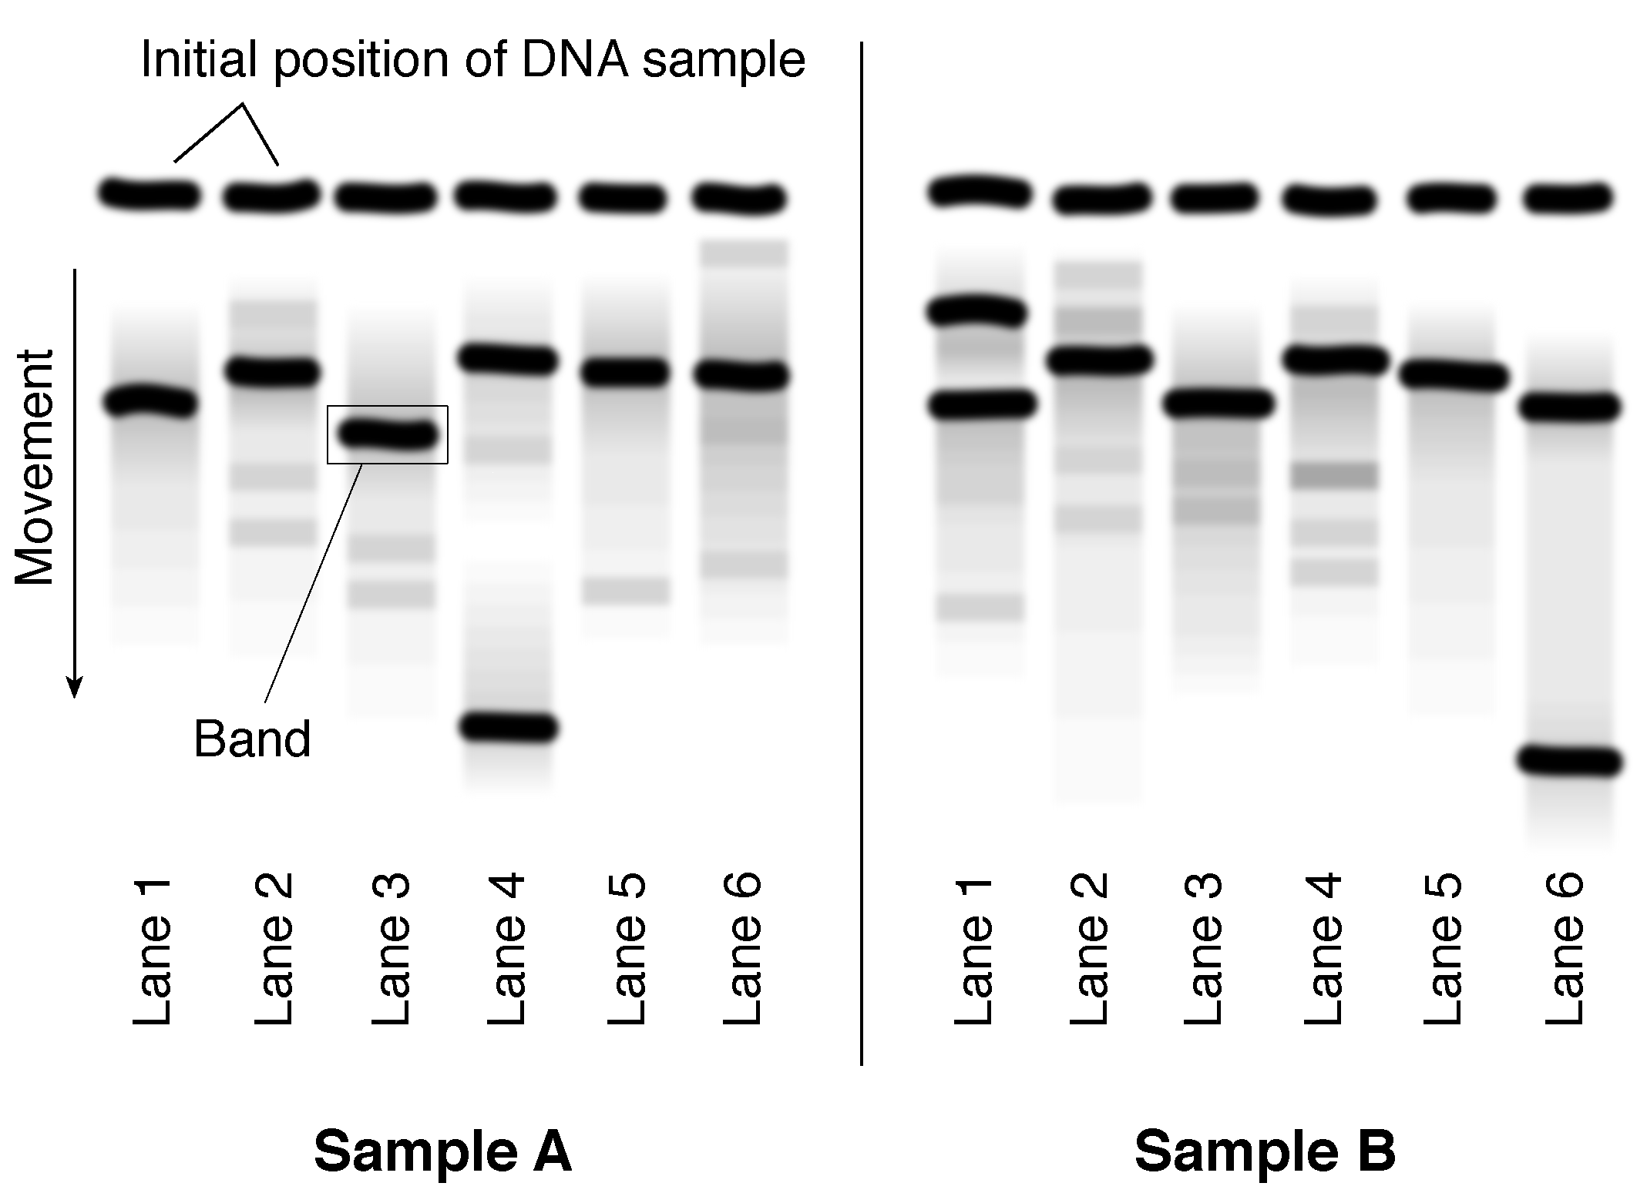
TM 3.1
Section of a DNA Fingerprint

Do the bands in Sample A match the bands in Sample B?

UNIT II - ISSUES IN BIOTECHNOLOGY AS 3.1

Lesson 3: Biotechnology Patents Name

Patent Debate

Objective: Examine issues surrounding the patenting of products of biotechnology.

Your instructor will divide the class into two groups. The first group represents the scientists and the corporations who want to strengthen their right to patent biotechnology products. The second group represents the groups opposed to patenting life-forms. Each group should search the Internet and other sources for information that will support their argument. The questions below should be used to help guide the research. A group must have four major arguments to support its case and be ready to answer the other group’s objections. Select one person in each group to record the arguments and answers to possible objections.

• Are patents necessary to protect the monetary investment made by researchers in developing useful products?

• Should plant, animal, or human DNA be patented, since it is not an invention?

• Who owns or controls the genes of plants and animals?

• What international trade problems have arisen or could arise due to patents on genetically modified plants and animals?

Your teacher will moderate the debate. Each side will take turns making a point and then giving the other group the opportunity to raise an objection to the point. This process will continue until both groups have raised their four points. Each group will then be given a short time for closing arguments.

