Lesson 3:
Biotechnology Patents

The biotechnology industry would not be as advanced as it is today if it were not for the ability to patent biotechnology products. While the decision to allow patents for genetically modified plants and animals is controversial, it has stimulated research in genetic engineering in the private sector. Patent applications are made as soon as a discovery or development that promises to have a useful application is verified. The research is kept secret until the patent is granted. This lesson will examine patents for products of biotechnology and the issues surrounding the patent process.

U.S. Patents

In the United States, patents are issued by the U.S. Patent and Trademark Office (USPTO). A patent issued by the USPTO grants the holder property rights that exclude others from making, using, or selling the patented invention throughout the United States for a stated period. Normally, this period is 17 years. In exchange for this exclusive right, the public receives the details of the “invention.” The purpose of this disclosure is to allow others the ability to develop and market the product after the patent expires. It also stimulates further research by competitors to develop new inventions that are related to, but not covered by, the patent.

The USPTO grants three types of patents. The most common type of patent is the utility patent. The utility patent is granted for inventions that are “new and useful” and that meet certain statutory requirements. The second type of patent is the plant patent. The Plant Patent Act of 1930 permits patent protection for particular types of plants. This patent is issued to anyone who invents or discovers and asexually reproduces any new variety of plant. The new plant variety may consist of cultivated spores, mutants, hybrids, and newly found seedlings. The applicant must be able to prove that the plant is different from other plants to receive the patent. The third type of patent is the design patent, which is issued for a new, original, and ornamental design for a manufactured article. Biotechnology products are not eligible to receive a design patent.

Patent Requirements

Many biotechnology products have obtained U.S. patents. For example, the first animal patent was issued in 1988 for a transgenic mouse developed from a fertilized mouse egg cell that had been genetically modified, establishing that modified animals can be patented in the United States under the current patent laws. Other biotechnology products that have been patented include genetically altered microorganisms, seeds, tissue cultures, and altered or nonnatural forms of a molecule, such as a modified protein molecule.

Since most biotechnology products receive a utility patent, an understanding of the requirements of this patent is important. A utility patent has three basic statutory requirements. The first is that the invention must be a new and useful process, machine, manufactured item, or composition of matter. Most biotechnology products fall into the “composition of matter” category since they are essentially rearrangements of DNA. The second statutory requirement is that the invention must be novel and nonobvious. An invention is obvious if it can be readily deduced from information available to the public by a person knowledgeable in the relevant technological field. The final statutory requirement is that the invention must be fully described and clearly claimed in the patent application.

Products must meet the definition of a patentable invention. Laws of nature, physical phenomena, and abstract ideas are not patentable; no one can patent gravity or centrifugal force, for example. For a patent to be granted, other qualifications must be met. A patent cannot remove anything from the public domain. This requirement means that something already commonly used cannot be patented. Not only must the patent not remove anything from the public domain, but it must add adequate information about the invention to the public domain. This information is disclosed as a part of the patent application.

Issues Surrounding the Patenting of Biotechnology Products

One of the issues surrounding biotechnology patents is the question of ownership of the genetically modified organism. Should genetically modified plants and animals be deemed the property of the individual or corporation responsible for modifying them? The answer to this question is controversial. Some people view genetic material as being owned by everyone and therefore nonpatentable. Those people who believe in the universal ownership of genetic material contend that genetic modifications are not patentable as inventions. However, others disagree, pointing out that genetic modifications constitute a rearrangement of matter. So far the USPTO and the U.S. Supreme Court have confirmed the patentability of genetically modified organisms. Much debate still exists on how broad the patents may be.

Other controversies surround the patenting of the genetic material of plants and animals native to countries other than the United States. Does a country own the DNA of native plants and animals? Should the United States grant patents on plants that have been used for centuries in Third World countries? A patent of this type was granted to a U.S. corporation for the genes producing the insecticidal properties of the seeds of neem trees. Farmers in India have used neem tree seeds as an insecticide for centuries. Even though the patent only covers the use of the insecticidal properties of neem seed in the United States, India would have to honor the patent due to international trade treaties. This patent has sparked an international lawsuit and much international debate.

DNA Fingerprinting

DNA fingerprinting is a complicated process involving several steps. The first step is to isolate DNA from an organism. The DNA is cut into many specifically sized pieces using an enzyme in a process called restriction digestion. After a probe dye is added to the DNA, it is sorted by the length of the pieces through a procedure known as gel electrophoresis, in which the pieces are placed in a gel and move through it along paths called lanes when an electric current is applied. Some of the pieces are “tagged” by the dye, which is a marker that attaches to a specific location on the DNA. The result is a pattern that looks like a set of bands (Figure 3.1) that identify the organism from which the DNA was extracted.make a copy of the plant or animal. The owners are therefore vulnerable to the theft of the genetic material by those handling it. For example, ranchers who want to maximize the productivity of a certain animal may choose to use embryo transfer. If a dishonest veterinarian or technician Problems with Handling Genetic Material
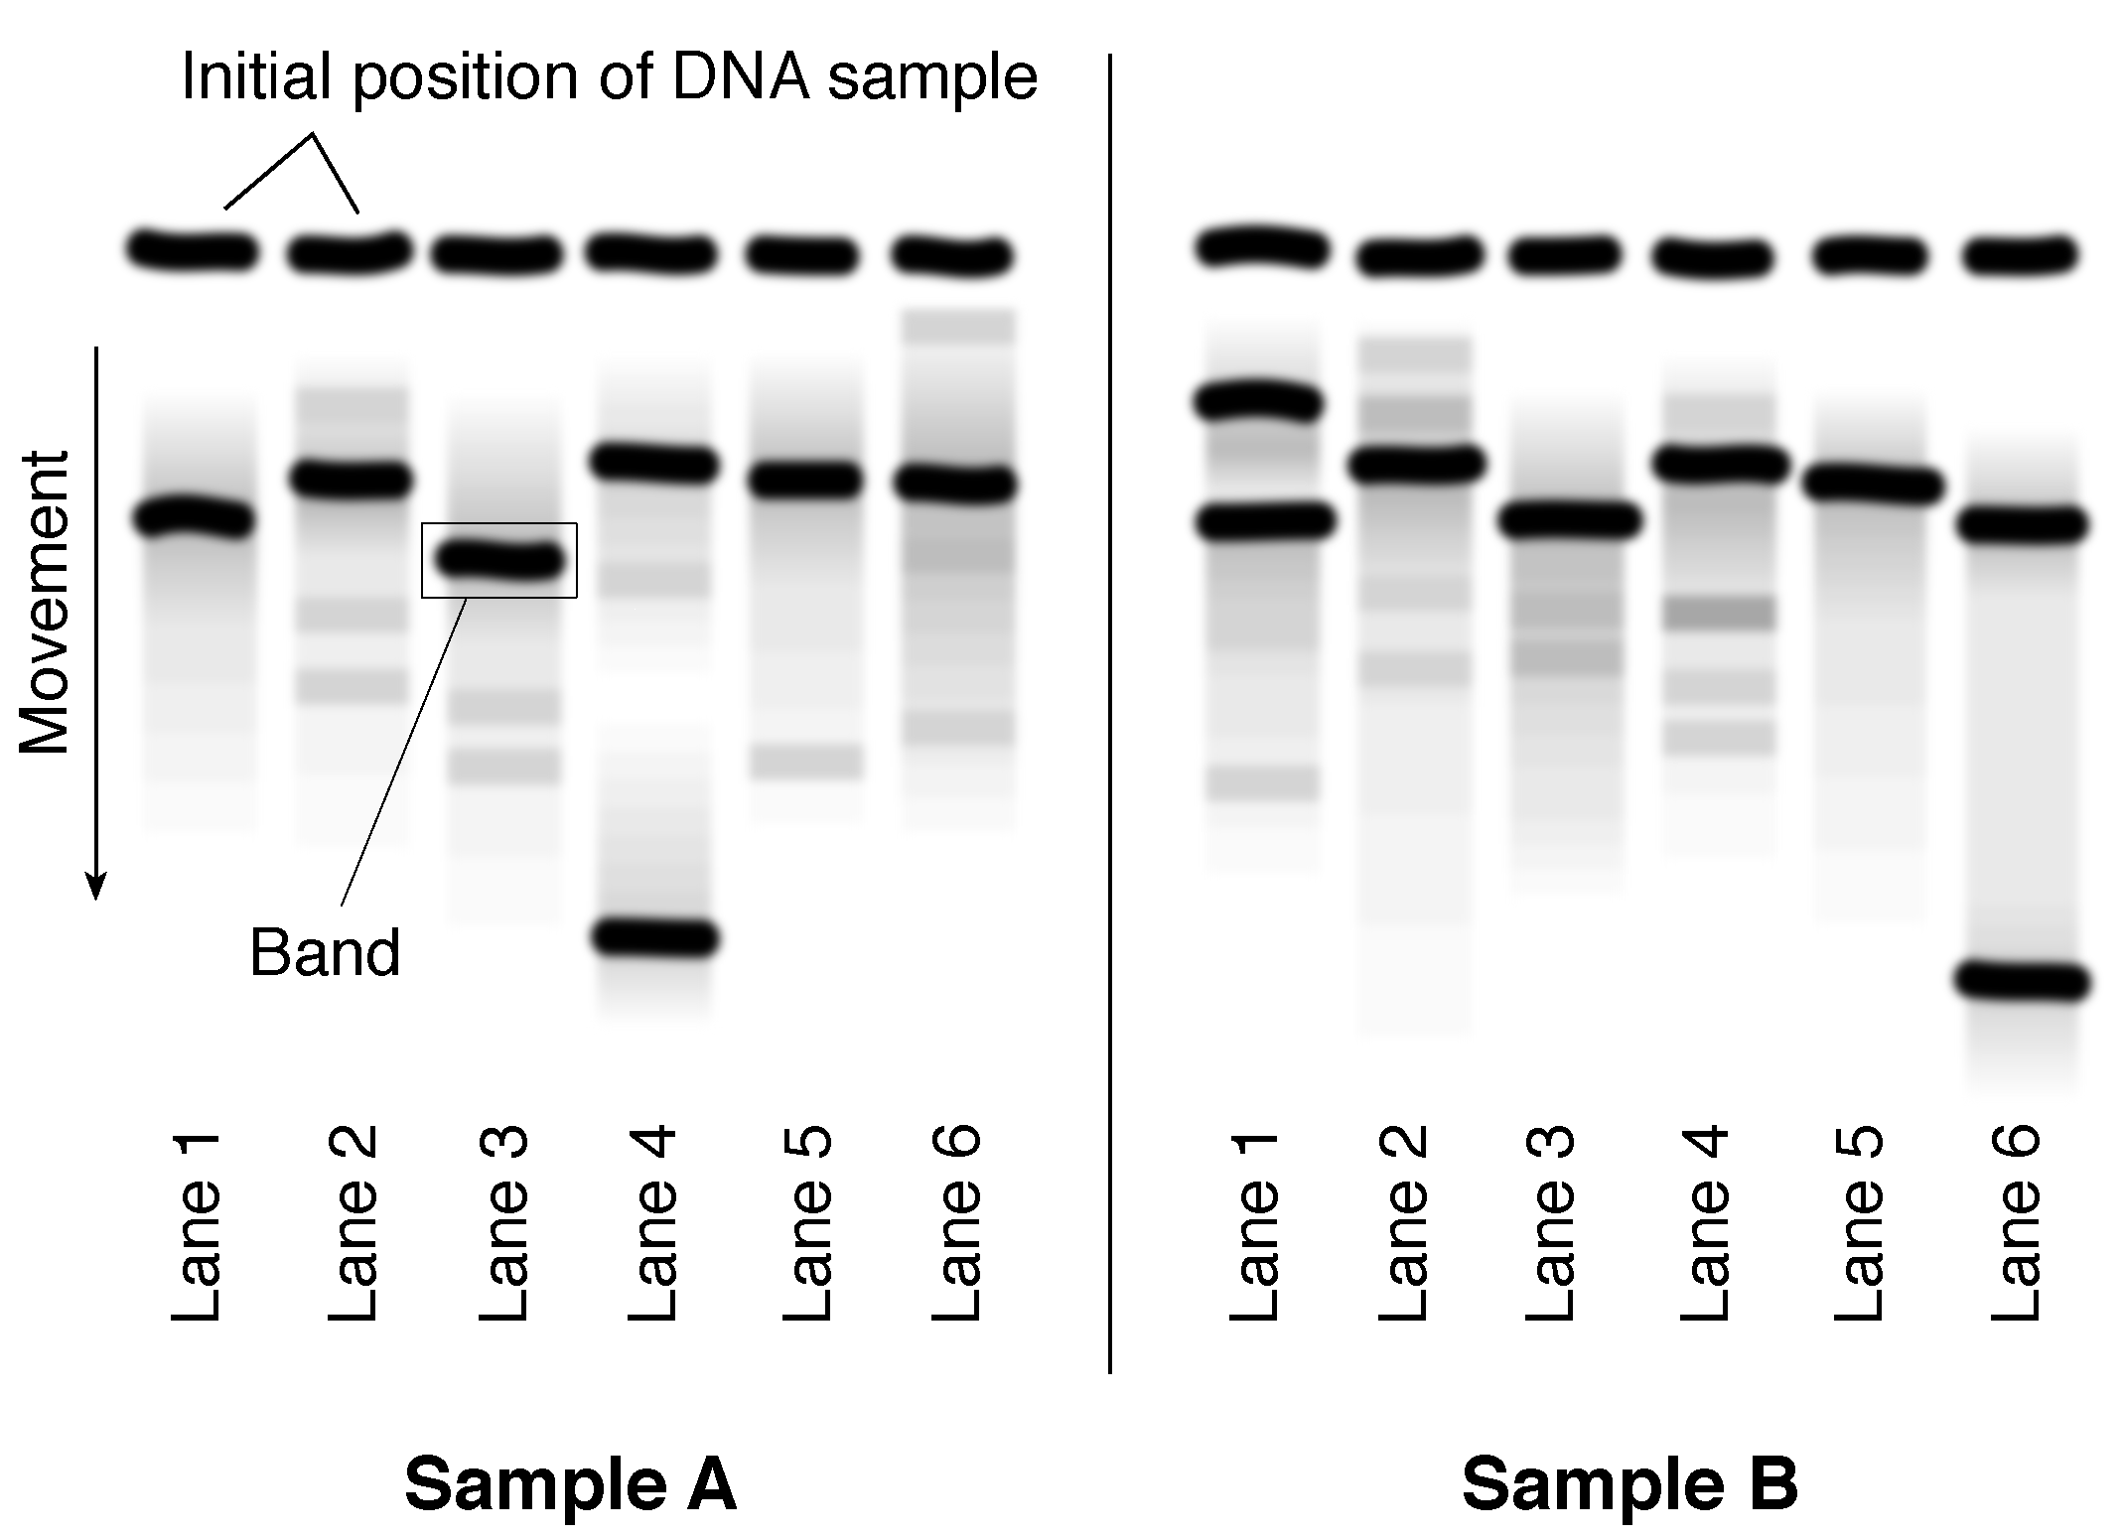

been used for decades by the criminal justice system to link individuals to evidence and to identify persons involved in crimes. More recently, DNA fingerprints have been used in the same way. DNA fingerprinting is the process of using laboratory analysis of DNA to generate a pattern that is unique to an individual organism. DNA fingerprinting is useful any time the exact identity of an organism must be confirmed. For example, the patent process requires that genetically modified organisms be conclusively identified, and DNA fingerprinting can provide this information. It is also used for insurance applications that require proof of the exact identity of a plant or animal and for breed associations that need to record the exact identity of an animal.

A major problem associated with the ownership of any genetic material through a patent is that in theory only a small amount of tissue, blood, or even hair is needed from a plant or animal to make a copy of the plant of animal. The owners are therefore vulnerable to the theft of the genetic material by those handling it. For example, ranchers who want to maximize the productivity of a certain animal may choose to use embryo transfer. If a dishonest veterinarian or technician is hired to perform the procedure, he or she could keep and sell some of the embryos collected.

Other problems associated with handling genetic material are the consequences of flawed test results and the ability to preserve the privacy of genetic information. Flawed results in genetic testing caused by mislabeled samples or experimental error could lead to disastrous decisions about ownership. Breed registrations may be denied or insurance policies made invalid due to flawed DNA fingerprinting results. The privacy of genetic information is also an issue. Controlling access to the genetic information of people, and to a lesser extent animals and plants, is a challenge facing the biotechnology industry.

Summary

Products of genetic modification can be patented in the United States if they meet certain requirements. Issues surrounding the patenting of biotechnology products will probably to be debated for many years. However, genetically modified plants, animals, and microorganisms will likely continue to be patented.

Credits

Bereano, Phillip L. “Patent Pending: The Race to Own DNA.” http://userwww.sfsu.edu/~rone/GE%20
Essays/DNA%20Race.htm (9 March 1997).

Betsch, David F. “DNA Fingerprinting in Human Health and Society.” http://www.gene.com/ae/AB/
TWT/DNA.Fingerprinting.Basics.html (28 August 1997).

Betsch, David F., and Glenda D. Webber. DNA Fingerprinting in Agricultural Genetics Programs (RP0554). North Central Region extension agricultural publications, 1994.

Feldman, Carl B. “Introduction” to “1996-97 Students’ and Citizens’ Guide to Biotechnology” http://www.bio.org/whatis/guide1.dgw#a (28 August 1997).

Jones, Phillip B. C. “Overview of United States Patent Law.” http://biotechlaw.ari.net/patentov.html (9 March 1997).

US Patent and Trademark Office. “General Information.” http://www.uspto.gov/web/offices/pac/
doc/basic/genifo.html (14 May 1997).

“More than 200 Organizations from 35 Nations Challenge U.S. Patent on Neem.” http://www.
twnside.org.sg/souths/twn/title/neem-ch.htm (9 March 1997).

“Patenting Life: When Nature Is Called an ‘Invention.” http://weber.u.washington.edu/~radin/
patent.htm (19 February 1997).

Shiva, Vandana. “The Neem Tree--A Case of Biopiracy.” http://www.twnside.org.sg/souths/twn/
title/pir-ch.htm (9 March 1997).

Snell, Marilyn Berlin, ed. “Bioprospecting or Biopiracy: The Hunt for Genetic Riches in the Developing World.” http://userwww.sfsu.edu/~rone/
GE%20Essays/Biopiracy.htm (9 March 1997).

Thayer, Ann. “Transgenic Cotton Highlights Patent Issues.” Chemical & Engineering News (14 March 1994): 18.

Thompson, Paul B. “Conceptions of Property and the Biotechnology Debate.” Bioscience 45 (1995): 275-282.

