Lesson 2:
Laboratory Equipment and Techniques

The heart of biotechnology is the research laboratory. Biotechnology laboratories are equipped with many types of tools and instruments. Individuals involved in biotechnology should be familiar with the equipment used in these laboratories as well as special procedures for developing and maintaining suitable working conditions that are free of contaminants.

Laboratory Equipment

Laboratories where biotechnology research is conducted contain many different types of laboratory equipment. The specific equipment found in a given laboratory will vary based on the type of research being done. However, most laboratories have a basic set of equipment.

The pipettor (Figure 2.1), which is used to measure and transfer amounts of liquid smaller than one milliliter (ml), is a common tool in biotechnology laboratories. Pipettors are available in three main sizes: zero to 20 microliters (μl), 20 to 200 μl, and 200 to 1,000 μl.

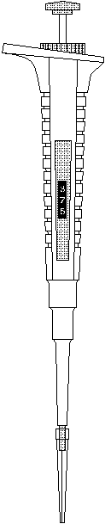

A variety of plastic ware and glassware is used in the biotechnology laboratory. Pipette tips, test tubes, and centrifuge tubes are examples of plastic ware used in a laboratory. Petri dishes made of plastic or glass are the containers most commonly used for growing bacteria or tissue cultures. Glassware used in laboratories includes beakers, flasks, graduated cylinders, and test tubes. Figure 2.2 shows some examples of plastic ware and glassware.

Researchers sterilize most of the plastic ware and glassware in an autoclave, which is illustrated in Figure 2.3. An autoclave uses steam under high pressure for sterilization.

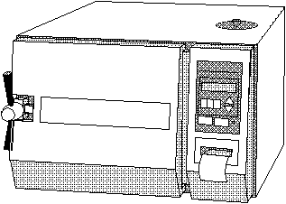

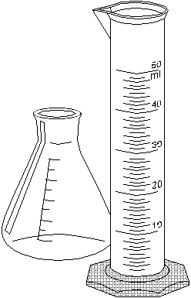
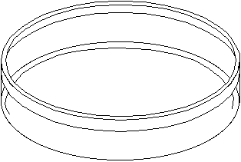

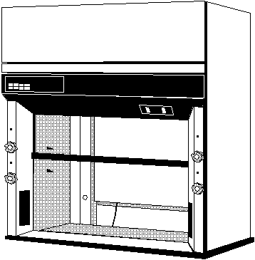
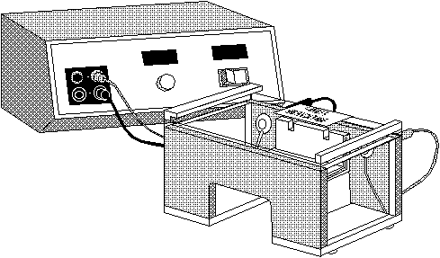
A fume hood (Figure 2.4) is an enclosure that vents air to the outside. Fume hoods allow researchers to use chemicals with dangerous or noxious fumes. They are commonly sterilized with ultraviolet light or a 70 percent alcohol solution when researchers do tissue culture and other sensitive procedures.

Another piece of equipment needed for tissue culture and the propagation of bacteria is an incubator, which is shown in Figure 2.5. An incubator maintains a preset temperature that provides an optimum climate for cell cultures to grow.

An electrophoresis unit (Figure 2.6) is a common piece of equipment. Electrophoresis separates DNA fragments by size using an electric current. The electrophoresis unit is like a sieve for separating these microscopic fragments. The fragments are shown on an electrophoresis gel.

A A transilluminator, shown in Figure 2.7, is used to view an electrophoresis gel. A transilluminator illuminates the gel by passing a shortwave ultraviolet light through it. Regular light will not show the dyes used to stain the gel.

Polymerase chain reaction (PCR) equipment is also found in biotechnology laboratories. PCR is a method of increasing the quantity of DNA in a sample by heating and cooling the DNA to break it down and force it to replicate. PCR equipment takes various forms, from a series of water baths to the newest automated form, the thermocycler (Figure 2.8).

DNA is separated from a liquid by using a microcentrifuge, which is illustrated in Figure 2.9. A microcentrifuge is essentially a high power spinner that uses centrifugal force to separate solids, such as DNA, from a liquid.

A vortex is a vibrating mixer used on test tubes. It mixes a solid or liquid with a liquid. A test tube is placed on a small rubber cap that vibrates in a circular motion, which causes the contents of the test tube to mix.
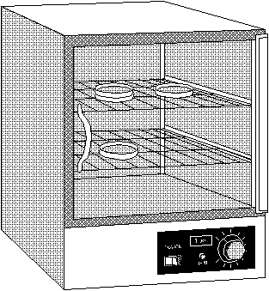
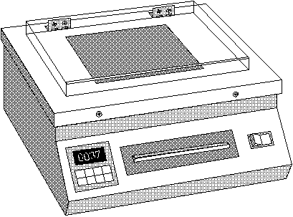
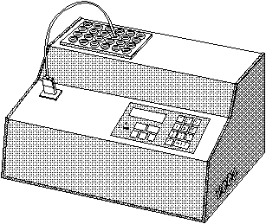

The microscope is an important device for enlarging and viewing organisms or specimens that are not visible to the naked eye. Two basic types of microscopes are used in biotechnology laboratories. The dissecting microscope is a low-power microscope that magnifies 10 to 100 times. This microscope is used in embryo transfer and tissue culture techniques. The second type of microscope is a general laboratory microscope that magnifies 100 to 1,000 times.

The Microscope

A microscope (Figure 2.10) has many parts. The ocular, or eyepiece, is the initial point for viewing a specimen and contains the first lens system, which normally magnifies the specimen 10 times (10X). The second lens system is called the objective. It projects the magnified image up through the ocular. Most microscopes have two or three objectives that vary in their degree of magnification. A rotating piece called the nosepiece holds the objectives.

The body tube of the microscope holds the ocular and the objectives the correct distance apart. The arm is the curved support that connects the body tube to the base. The base is the stand on which the microscope rests. Slides containing the specimens to be observed are placed on the stage, which has clips to hold the slide in place.
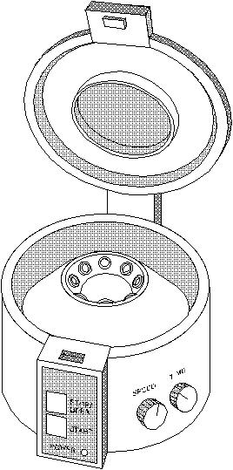

The disc diaphragm contains a series of different sized openings that control the amount of light shining on the specimen. The light comes from a light source like a mirror or small electric lamp. On microscopes with a lamp, a condenser focuses the light on the specimen.

The two main dials for adjusting a microscope are the coarse adjustment and the fine adjustment. The coarse adjustment is the larger of the two dials; it is always used first to focus on a specimen with the low power objective. The fine adjustment refines the focus. With the high-power objective, only the fine adjustment is used to focus the microscope.

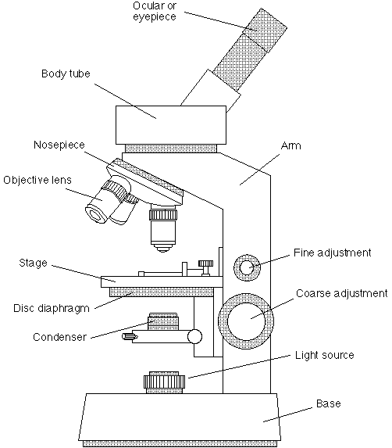
Procedures for Manipulating Microscopic Specimens

A specimen viewed under a microscope must be very thin since it is placed, or mounted, on a glass slide. If a wet mount is needed, a drop of water should be added to the specimen. Usually, a cover slip is placed on top of the specimen; gently pressing on the cover slip will remove air bubbles. To view some specimens correctly, they must be stained. The correct staining procedures vary greatly from specimen to specimen.

Once the slide is prepared, it is placed on the stage and secured by the clips. Next, the light source must be turned on and adjusted so that light passes through the specimen. The low-power objective is then selected, and the coarse adjustment is used to focus the specimen’s image. If more magnification is needed, the high-power objective is selected, and the fine adjustment is used to focus the image. The fine adjustment should only be used to move the objective up and away from the stage. If either the coarse adjustment is used or the fine adjustment is adjusted toward the specimen slide while using the high-power objective, damage to the objective can result.

Aseptic Techniques

Aseptic techniques are procedures used to create and maintain a work area free of bacteria and other microorganisms that might contaminate delicate experiments. A sterile environment is necessary for procedures such as tissue culture or the propagation of bacteria. Some aseptic techniques are described below.

• Controlled air movement - The researcher works in an enclosed chamber that allows the flow of air to be controlled.

• Disinfection - The work area is disinfected with a 10 percent bleach solution. Then the instruments and work area are sprayed with a 70 percent ethanol solution and allowed to air dry.

• Scrubbing up - The researcher scrubs his or her hands and arms thoroughly and allows them to air dry. He or she then sprays them with a 70 percent ethanol solution.

• Sterilization - Researchers use an autoclave to sterilize all materials and instruments. An ultraviolet light kills microorganisms in the work area.

A researcher may maintain an aseptic work area by using a shield to avoid breathing on an experiment. He or she should also avoid sneezing or coughing in the work area. When using a fume hood, researchers should use the rear portion of the enclosed area to reduce exposure to bacteria that might enter the area.

Importance of Aseptic Techniques

Experimental procedures like tissue culture and most DNA analysis techniques require proper aseptic techniques to be successful. Contaminants will destroy many biotechnology experiments, so the work environment must be free of them. Bacteria, viruses, and other microbes can interfere with many laboratory procedures.
Summary

Many different types of laboratory equipment are used in biotechnology research. A basic piece of equipment is the microscope, so understanding its parts and their functions is important. Researchers must also know the procedures for manipulating microscopic specimens. Researchers in biotechnology should practice aseptic techniques to prevent the contamination of their work.

Credits

Peterson, Dennis R., and Thomas Rehberger. Biotechnology in Agriculture. Stillwater, Okla.: Mid-America Vocational Curriculum Consortium, 1992.

Williams, O., E. Bonde, and N. Younggren. Laboratory Exercises for Biological Sciences. Philadelphia: Lea & Febiger, 1963.

Armitage, Kenneth B. Investigations in General Biology. New York: Academic Press, 1970.

