UNIT IV: FOUNDATIONS OF GENETIC ENGINEERING

Lesson 1: The Mechanics of Cells and DNA

Competency/Objective: Identify the parts of a cell, including DNA, and their functions.

Study Questions

1. What are the parts of a cell and their functions?

2. What is DNA?

3. What is the structure and function of DNA?

4. How does DNA replicate?

References

1. Biotechnology: Applications in Agriculture (Student Reference). University of Missouri-Columbia: Instructional Materials Laboratory, 1998, Unit IV.

2. Transparency Masters

a) TM 1.1: The Parts of a Cell
b) TM 1.2: The Cellular Chain of Command
c) TM 1.3: DNA Replication

3. Activity Sheet

a) AS 1.1: Comparing Plant and Animal Cells

UNIT IV: FOUNDATIONS OF GENETIC ENGINEERING

Lesson 1: The Mechanics of Cells and DNA

TEACHING PROCEDURES

- Introduction

Just as an automobile mechanic must understand the basics of how an engine works, so the biotechnology researcher must understand the cell, its parts, and how they work. This lesson will provide a review of concepts taught in biology and will lay the foundation for future lessons on the manipulation of genetic material.

- Motivation

  - Use a model of DNA to illustrate its structure. A model can be purchased, or a flat model of DNA can be put together using a series of cards with the base pairs written on them. Students could also hold these cards in the appropriate position to simulate the double helix structure.

  - To observe cell walls in a plant cell, slice a carrot very thinly, so that light can easily be seen through it. Freeze the carrot slices. Take a frozen slice and place it under a microscope. Quickly observe the cell walls as they deteriorate when the cells thaw.

- Assignment

- Supervised Study

- Discussion

  - Ask students to name as many parts of a cell as they can. Have a student write these on the board. Add any parts that they might have missed. Use TM 1.1 to illustrate the parts. Have students complete AS 1.1.

What are the parts of a cell and their functions?

    - Animal cell
      - Cell (plasma) membrane - controls movement of materials into and out of the cell
      - Cytoplasm - the contents of the cell, excluding the nucleus; contains fluid that helps control the movement of substances within the cell and includes the organelles
      - Mitochondria - powerhouses of the cell; break down nutrients to provide energy
      - Endoplasmic reticulum - network of membranes that transports materials within the cell; location of the ribosomes
      - Ribosomes - primary location for protein synthesis
      - Golgi apparatus - packages protein molecules for movement within and outside the cell
      - Vacuole - stores water, enzymes, pigments, and other substances
      - Nucleus - control center for the cell; contains chromosomes
      - Chromosomes - tightly wrapped pieces of DNA; location of genes
      - Genes - a segment of DNA on a chromosome that produces a polypeptide (protein) and is responsible for the expression of genetic traits
    - Plant cell - contains all of the structures found in animal cells with two additions
      - Chloroplasts - contain chlorophyll, which is used in photosynthesis
      - Cell wall - rigid outer layer that provides support for the plant cell and works collectively with other cells to support the plant

    - Bacteria cell
      - Cell wall
      - Cell membrane
      - Ribosomes
      - Nucleoid region - chromosomal material not contained within a nucleus
      - Plasmid - small circular piece of DNA that codes for specific traits and replicates independently of chromosomal DNA; normally contains only a few genes

  - Ask a student to look up the definition of DNA, or deoxyribonucleic acid, in a dictionary or a CD-ROM encyclopedia.

What is DNA?

    - DNA (deoxyribonucleic acid) is the genetic material of the cell composed of small chemical units called nucleotides, which consist of three parts.
      - A phosphate group
      - A sugar (called deoxyribose) unit
      - One of four nitrogen base units (adenine, guanine, thymine, and cytosine)
    - A single strand of DNA may contain more than 100 million base pairs.

  - Ask students to list as many words on the board as they can that describe what a DNA molecule looks like. Use TM 1.2 to illustrate the structure of DNA.

What is the structure and function of DNA?

    - Structure
      - Two strands of nucleic acid are intertwined in a double helix structure that looks like a twisted or spiraling ladder.
      - The phosphate and sugar units form the sides of the ladder, while the nitrogen base units form the rungs.
      - The base units are found in one of two bonding arrangements, adenine bonded to thymine or guanine bonded to cytosine; hydrogen bonds join the base units.
    - Function
      - DNA determines what types of proteins to build in protein synthesis.
        - DNA functions in sections called codons, which are sets of three nucleotides that code for one of the twenty amino acids.
        - These amino acids are then linked together to form polypeptides.
        - Two or more polypeptides are linked together to form a protein.
      - In DNA replication, DNA makes a copy of itself to pass on its code to new cells formed by cell division.

  - Using TM 1.3, ask students why DNA needs to replicate. Explain that DNA must replicate, or each time a cell divided, it would lose half its DNA. Next, have students explain how DNA replication takes place.

How does DNA replicate?

    - A protein made by the cell binds to a place on the DNA called the origin.
    - An enzyme begins to break the hydrogen bonds that hold the two strands of the helix together, causing the double helix to “unzip.”
    - A complex enzyme (DNA polymerase) binds to each DNA strand segment and begins to add a new base unit to the strand; the added base must be compatible with the base on the parent DNA strand.
    - Another enzyme then bonds the new nucleotides with the parent DNA strand.
    - Each DNA molecule now consists of one parent strand and one newly formed strand.

- Other Activities

  - Have students use cardboard puzzle pieces made to look like bases to show how DNA replicates.

  - Have students research and present a report about the discovery of the structure of DNA by Watson and Crick.

- Conclusion

Plant, animal, and bacteria cells are all different in some respects. However, they all contain at least one chromosome, and therefore they contain DNA. The DNA in a plant, animal, or bacteria cell is essentially the same except for the base pair sequence it contains. This similarity of DNA makes the manipulation and transfer of DNA between different life-forms possible. If the structure or function of plant DNA was different from animal DNA, then DNA from a plant could not be spliced into the DNA of an animal. A clear understanding of the makeup of cells and a working knowledge of the structure and function of DNA is necessary to understand genetic manipulation.

- Answers to the Activity Sheet

Student pictures will vary, but they should show that the students observed some parts of the cells.

- Answers to the Evaluation

  - j
  - k
  - g
  - e
  - c
  - f
  - l
  - a
  - b
  - h
  - i
  - d
  - a
  - d
  - b

  - The steps in the replication of DNA are as follows:

• A protein binds to a place on the DNA called the origin.
• An enzyme begins to break the hydrogen bonds that hold the two strands of DNA together, unzipping the double helix.
• As the DNA strands are being unzipped, a complex enzyme (DNA polymerase) binds to each DNA strand segment and begins to add a new base unit to the strand. The added base must be compatible with the base on the parent DNA strand.
• Another enzyme then bonds the new nucleotides with the parent DNA strand.

UNIT IV: FOUNDATIONS OF GENETIC ENGINEERING Name

Lesson 1: The Mechanics of Cells and DNA Date

EVALUATION

Match the correct function on the right to the cell part on the left by writing the letters in the blanks.

1. Cell wall

2. Cell membrane

3. Cytoplasm

4. Mitochondria

5. Endoplasmic reticulum

6. Ribosomes

7. Golgi apparatus

8. Vacuole

9. Plasmid

10. Nucleus

11. Chromosome

12. Gene

a. Stores water, enzymes, pigments and other substances

b. Small circular piece of DNA that contains a few genes

c. A membrane that transports molecules

d. Segment of DNA that is responsible for the expression of a trait

e. Powerhouse of the cell

f. Primary location for protein synthesis

g. Contents of the cell, excluding the nucleus

h. Control center for the cell

i. Location of genes

j. Provides support for plant cells

k. Controls the movement of materials into and out of the cell

l. Packages protein molecules for movement within and outside the cell

Circle the letter that corresponds to the best answer.

- The unit of a DNA molecule that contains the code for building proteins is the:

  - Nitrogen base unit.
  - Phosphate unit.
  - Sugar unit.
  - Potassium unit.

- When examining the structure of DNA, which of the following bonding arrangements is found in the DNA molecule?

  - Guanine bonded to thymine
  - Cytosine bonded to thymine
  - Adenine bonded to cytosine
  - Guanine bonded to cytosine

- A codon is a:

  - Segment of DNA that is responsible for the expression of a trait.
  - Segment of DNA that is three base pairs long and codes for a specific amino acid.
  - Segment of DNA that codes for one of twenty polypeptides.
  - Segment of DNA that contains no base units.

Complete the following short answer question.

- What are the steps in DNA replication?

TM 1.1

The Parts of a Cell
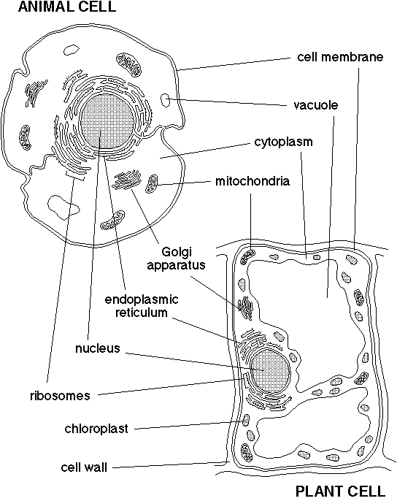

TM 1.2

The Cellular Chain of Command
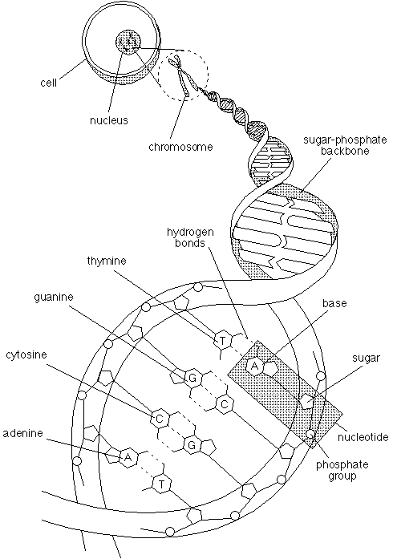

TM 1.3

DNA Replication

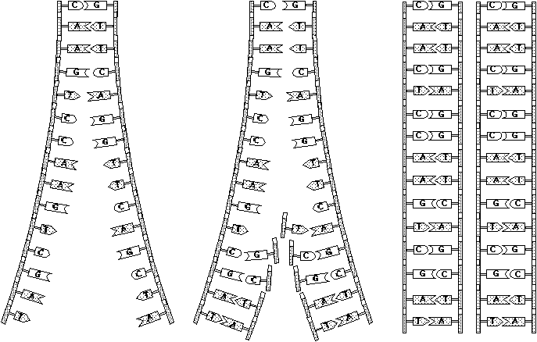

UNIT IV: FOUNDATIONS OF GENETIC ENGINEERING AS 1.1

Lesson 1: The Mechanics of Cells and DNA Name

Comparing Plant and Animal Cells

Objective: Identify the parts of plant and animal cells.

Materials and Equipment:

Microscope
2 glass slides
2 cover slips
Onion
Toothpicks
0.9 percent NaCl
Methylene blue

Procedure:

A. Red or Purple Onion Cells

1. Remove a paper thin section of an onion peel. Cut out a small piece about the size of a penny. Place this tissue sample on a clean glass slide. Add a drop of water and carefully place a cover slip over the specimen. Gently press out any air bubbles.

2. Examine the tissue using the low-power objective and then the high-power objective. Look for the nucleus, nuclear membrane, cytoplasm, and cell wall.

3. Draw a picture of one of the onion cells and label the cell parts that you observed.

B. Human Epithelial Cells

1. Carefully scrape the inside of your mouth with the flattened end of a toothpick. Place the scrapings in a drop of 0.9 percent NaCl on a clean glass slide. Repeat the scraping procedure four times and then place a cover slip over the specimens.

2. Add a drop of methylene blue to one edge of the cover slip. To pull the stain across the specimen, use a paper towel to begin absorbing liquid at the edge of the cover slip opposite the stain. Continue until the excess stain has been removed.

3. Examine the cells using the low- and high-power objectives. Draw and label the parts of the cells that you observe.

