Lesson 1:
The Mechanics of Cells and DNA

Cells are the fundamental units of life. Biotechnology research is usually done on the cellular or subcellular level. Knowing the cellular components and how the parts of a cell work is therefore necessary. Of particular importance is the core component of biotechnology research, DNA.

The Parts of Cells

All cells contain DNA. However, the structures found in the cells may vary. The cells found in plants and animals are similar, but they do have some differences. Bacteria cells are very different from plant and animal cells.

An animal cell (Figure 1.1) has a cell membrane, or plasma membrane, that forms the boundary of the cell. The cell membrane is primarily a lipid (fatty substance), carbohydrate, and protein structure. The membrane’s primary function is to control the movement of substances into and out of the cell.

Inside the cell membrane is the cytoplasm, which consists of the contents of the cell, excluding the nucleus. The fluid of the cytoplasm helps control the movement of many substances within the cell. The cytoplasm includes many structures, called organelles, that fill different specialized functions in the cell.

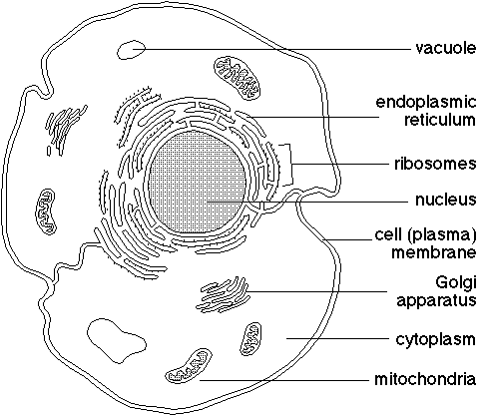
Mitochondria are the powerhouses of the cell. They break down nutrients to provide energy to the cell. Hundreds of mitochondria may be found in a single cell.

The endoplasmic reticulum is a large network of membranes that transports material within the cell. Ribosomes are found on the endoplasmic reticulum. They are the sites where protein molecules are assembled, or synthesized. These protein molecules are important to the cell and to the organism as a whole because they control the chemical activities of cells.

The Golgi apparatus works with the endoplasmic reticulum in transporting proteins. It packages protein molecules for transport within and outside the cell.

Vacuoles are the storage units of the cells. They store water, enzymes, pigments, and other substances.

The control center of a cell is called the nucleus, which is defined by a pair of nuclear membranes. Inside the nucleus, chromosomes consisting of DNA can be found. Chromosomes are essentially tightly wrapped pieces of DNA that function as a unit. Genes are segments of DNA on chromosomes that produce a polypeptide (protein). Genes are responsible for the expression of genetic traits because the proteins produced by genes control the appearance, growth, and functioning of the organism.
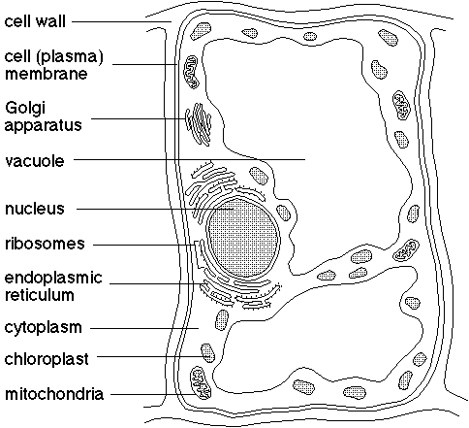

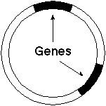

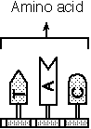

Plant cells (Figure 1.2) contain these structures, but they also have a few differences. They have more vacuoles, which can be very large in mature plant cells. Plant cells have chloroplasts; they contain the chlorophyll used in photosynthesis. The cells also have a rigid outside layer called a cell wall that is composed of cellulose. The cell wall provides support for the plant cell and works collectively with the walls of other cells to support the plant. The cell wall has openings that allow substances to pass through it. The cell membrane in plant cells is just inside the cell wall.

Bacteria have a cell wall and cell membrane. They also have ribosomes that carry out protein synthesis. Unlike animal and plant cells, the chromosomal material is not contained within a nuclear membrane but instead forms a nucleoid region. A unique structure found only in bacteria cells is the plasmid (Figure 1.3). One or more plasmids can be found in a cell. Plasmids are essentially small circular pieces of DNA that code for specific traits and replicate independently of the chromosomal DNA. They normally contain only a few genes. Plasmids play an important role in biotechnology because they can be easily modified to produce pharmaceuticals.

DNA

Genetic modification involves the manipulation of DNA, or deoxyribonucleic acid. DNA is the genetic material of the cell. It is composed of small chemical units called nucleotides. A nucleotide consists of three parts: a phosphate group, a sugar unit (deoxyribose), and a base unit that contains nitrogen. DNA has four different nitrogen bases, creating four different nucleotides. These nucleotides are named after the nitrogen base. The four nitrogen bases are adenine (A), guanine (G), thymine (T), and cytosine (C). The nitrogen base units contain the code used to build proteins. A single strand of DNA may contain more than 100 million base pairs. DNA is not a simple molecule.

The Structure and Function of DNA

James Watson, a biologist, and Francis Crick, a physicist, were the first to discover the structure of DNA. They won the Nobel Prize in 1962 for their work. Watson and Crick found that two strands of nucleic acid are intertwined in a double helix structure. It looks like a twisted or spiraling ladder. The phosphate and sugar units form the sides of the ladder, while the nitrogen base units form the rungs. The nitrogen base adenine will only bond to thymine, and guanine will only bond to cytosine. Hydrogen chemical bonds join the base units.

The DNA in a plant, animal, or bacteria cell is essentially the same except for the sequence of bases it contains. This similarity of DNA makes the manipulation and transfer of DNA between these different life-forms possible. If the structure or function of plant DNA was different from animal DNA, then DNA from a plant could not be spliced into the DNA of an animal.

DNA is the blueprint of a cell. A builder of a house uses a blueprint to see where and how to install the walls, windows, plumbing, electricity, and many other things. In the same way, the cell uses its DNA to determine what types of proteins to build, or synthesize. The proteins produced during protein synthesis by the cells in an organism function as the chemical basis for the development of the organism.

Codons are sections of DNA three nucleotides long (Figure 1.4). Codons code for one of the twenty amino acids that are the building blocks of proteins. The codons are lined up end to end to form the DNA strand. Using this code, amino acids are lined up and linked together to form polypeptides. Two or more polypeptides are then linked together to form proteins. The kind and sequence of amino acids makes the shape of one polypeptide different from another. The shape of a protein is strongly related to how the protein will function.
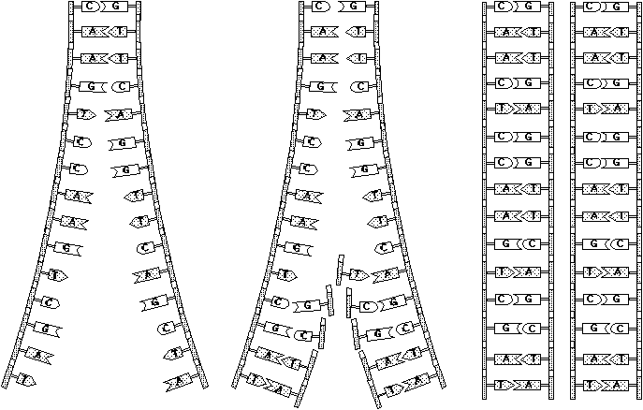

DNA not only codes for protein production in a cell but also passes this code on to new cells formed by cell division. Essentially, DNA copies itself before a cell divides. This process is called DNA replication.

DNA Replication

Cell division occurs when a cell grows and begins to get too large. When a nonsex cell in a plant or animal divides, the DNA in that cell must first replicate itself so that the two new cells have the same genetic material. Otherwise, each time a cell divided, it would lose half of its DNA. In DNA replication (Figure 1.5), the genetic material copies itself using a strand of DNA as a template. Replication begins when a protein made by a cell undergoing division binds to a section of the DNA called the origin. This event signals an enzyme to begin breaking the hydrogen bonds that hold the two strands of the helix together, causing the double helix structure of the DNA to “unzip.” As the DNA strands come apart, a complex enzyme called DNA polymerase that is found in the nucleus of cells binds to each DNA strand segment and begins to add a new base unit to the strand. The added base must be compatible with the base on the parent DNA strand. Another enzyme then bonds the new nucleotides together with the parent DNA strand. Each DNA molecule now consists of one parent strand and one newly formed strand. With replication complete, the cell can then divide.

Summary

Cells have many organelles that must function together in order for the cell to survive. Each organelle has one or more functions that help the cell live, grow, and divide. DNA is very important to the cell since the code for building proteins is contained in the cell’s DNA. The process of DNA replication allows the genetic code to be passed on to daughter cells.

Credits

Herren, Ray V. The Science of Agriculture: A Biological Approach. Albany: Delmar, 1997.

Johnson, G. B. Biology: Visualizing Life. New York: Holt, Rhinehart, and Wilson, 1994.

Miller, Kenneth R., and Levine, Joseph. Biology. Englewood Cliffs, N.J.: Prentice Hall, 1993.

Oram, Raymond F. Biology of Living Systems. Waterville, Ohio: Glencoe, 1994.

