UNIT IV - FOUNDATIONS OF GENETIC ENGINEERING

Lesson 2: Cell Reproduction and Genetics

Competency/Objective: Explain how cells reproduce.

Study Questions

1. What is mitosis?

2. What is meiosis?

3. How do mitosis and meiosis differ?

4. What are dominant and recessive genes?

5. What are homozygous and heterozygous gene pairs?

6. What are genotypes and phenotypes?

7. What are mutations?

References

1. Biotechnology: Applications in Agriculture (Student Reference). University of Missouri-Columbia: Instructional Materials Laboratory, 1998, Unit IV.

2. Transparency Masters

a) TM 2.1: Mitosis
b) TM 2.2: Meiosis

3. Activity Sheet

a) AS 2.1: Mitosis and Meiosis

UNIT IV - FOUNDATIONS OF GENETIC ENGINEERING

Lesson 2: Cell Reproduction and Genetics

TEACHING PROCEDURES

- Review

In the last lesson, the cell and its components were examined in some detail. This lesson focuses on the two ways in which cells reproduce and how this reproduction can pass on genetic information and the traits seen in the organism’s offspring.

- Motivation

When discussing cell reproduction, the obvious question to ask is why body cells need to reproduce at all. If a body cell can grow and get bigger, why does it need to reproduce itself? Think for a moment about a large car factory. Why do manufacturers like General Motors or Ford have different factories in the Midwest? Why not one big factory?

Several reasons exist for having many factories or many cells. First, the managers of the factory (the nucleus of the cell) can only control a limited workload. The operations of the factory (the making of proteins in the cell) cannot increase above the capacity that the management (cell nucleus) can handle. Another reason for having more than one is so that the supply and export of products is not slowed. The larger a factory gets the more raw materials it demands (just as the larger a cell gets the more nutrients, oxygen, and other raw materials it demands). At the same time, the export of products also increases, and these two factors slow the movement of raw materials and products into and out of the factory (cell).

- Assignment

- Supervised Study

- Discussion

  - Ask students if they know how hair, fingernails, skin, or muscles grow. Use TM 2.1 to show the stages of mitosis and how tissues grow.

What is mitosis?

    - Mitosis is a type of cell division in which somatic cells divide and form two new cells; each new cell contains the same number of paired chromosomes as the parent cell, or two complete sets of chromosomes (a diploid number of chromosomes).
    - Stages of mitosis (Hint: Remember PMAT.)
      - Prophase
        - Chromosomes coil and condense to form a double-stranded structure consisting of two paired chromatids connected at a body called a centromere.
        - The nuclear membrane dissolves gradually.
        - A network of microtubules begins forming around centrioles, which start to move to opposite ends of the cell; the network of microtubules is called a spindle.
        - Spindle fibers extend out from the centrioles toward the center of the cell.
      - Metaphase
        - Chromosomal units move to the center of the cell and form a line between the two poles.
        - Each spindle fiber attaches to a centromere.

      - Anaphase
        - The centromeres break, allowing the spindle fibers to pull apart the chromatids.
        - The chromosomes move toward opposite poles of the cell.
        - The poles move farther apart, elongating the cell.
        - At the end of anaphase, the two poles each have a complete set of chromosomes.
      - Telophase
        - In animal cells, the cell membrane pinches together, dividing the cell into two cells.
        - In plant cells, a cell plate forms in the middle of the cell and begins to divide it into two cells; a cell membrane forms on both sides of the cell plate, and the cell plate changes to a cell wall.
        - Nuclear membranes develop in the daughter cells.
        - The chromosomes uncoil and lose their distinct outlines.

  - Ask students how sex cells divide. Use TM 2.2 to show the stages of meiosis. Have students complete AS 2.1. When doing the activity, make sure to observe each phase before allowing students to move on to the next one. The instructor may want to make up a poster showing the different phases so that students can use it as a model.

What is meiosis?

    - Meiosis is a type of cell division that produces gametes (sex cells). It has two phases of cell division, producing four gametes. The gametes contain half the number of chromosomes found in the parent cell, or a single set of chromosomes, and are referred to as haploid cells.
    - Meiosis I
      - Prophase I
        - Homologous chromosomes pair together and form a tetrad, a grouping of four chromatids side by side.
        - Nonpaired chromatids may exchange segments in a process called “crossing over.”
        - The centrioles move apart and the spindle forms.
        - The nuclear membrane dissolves.
      - Metaphase I
        - Homologous chromosomes line up in the center of the cell.
        - The spindle fiber ends attach to centromeres.
      - Anaphase I - Homologous chromosomes separate and are pulled to different poles.
      - Telophase I
        - The cell plate and/or cell membrane forms, creating two haploid daughter cells.
        - Nuclear membranes form.
    - Meiosis II
      - Prophase II
        - The spindle fibers develop.
        - Paired chromatids move to the center of the cell.
      - Metaphase II
        - The chromosomal units line up in a row between the two poles.
        - They become attached to the spindle fibers.
      - Anaphase II - Chromatids separate and move toward opposite poles.
      - Telophase II
        - The center of each cell closes off with the formation of a cell membrane or cell plate.
        - Nuclei form.
        - Chromosomes uncoil.

  - Have students compare mitosis and meiosis and list the differences.

How do mitosis and meiosis differ?

    - Mitosis produces two cells from one parent cell, while meiosis produces four cells from one parent cell.
    - Mitosis produces diploid somatic cells, while meiosis produces haploid gametes.
    - Mitosis produces two identical cells, and meiosis produces four nonidentical cells.
      - During mitosis, chromosomes contribute an identical chromosome to each daughter cell.
      - In meiosis, homologous chromosomes split and contribute nonidentical chromosomes to each daughter cell.
    - Meiosis allows genes to cross over, while mitosis does not.

  - Ask students to define the word dominant. Relate this definition to dominant and recessive genes.

What are dominant and recessive genes?

    - Chromosomes work in pairs.
    - Each chromosome has a homologous chromosome that has genes that code for the same information but somewhat differently.
    - Each gene in a gene pair is either dominant or recessive.
    - Dominant genes are expressed; they mask the expression of a recessive gene.
    - Recessive genes are genes that are not expressed, or apparent in the traits of the animal.

  - Ask students to define the terms homozygous and heterozygous.

What are homozygous and heterozygous gene pairs?

    - Either of the two possible expressions of a gene or multiple genes that code for a specific trait is called an allele.
    - An organism with two dominant alleles or two recessive alleles is homozygous for that specific trait; they are either homozygous dominant or homozygous recessive.
    - An organism with one dominant allele and one recessive allele is heterozygous for that trait.

  - Have students explain and give examples of a genotype and a phenotype.

What are genotypes and phenotypes?

    - Genotype - The specific combination of alleles for a trait.
    - Phenotype - The appearance or expression of a trait as determined by the genotype.

  - Ask student if they believe that all mutations are bad. Point out that mutations such as seedless grapes and oranges are not harmful.

What are mutations?

    - Mutations are alterations in the nucleotide sequence found in a DNA molecule; they may be from the insertion, deletion, or miscoding of a base unit during replication.
    - Mutations can occur during replication in mitosis or meiosis.
      - Mutations during mitosis are not inheritable; they affect the daughter cell and any cells descending from it.
      - Mutations prior to meiosis are passed on to an organism’s offspring if the mutant gamete is fertilized.

- Other Activities

Review the use of Punnet squares to further discuss genotype and phenotype.

- Conclusion

An understanding of cell reproduction and the basic genetic concepts discussed in this lesson suggests how genetic manipulation must be done. To add a gene to an entire plant or animal, genetic manipulation must be done before or during meiosis. Gene interaction is quite complex, and genetic manipulation is even more complex.

- Answers to Activity Sheet

AS 2.1

  - a. Mitosis produces two cells from one parent cell, while meiosis produces four cells from one parent cell.
b. Mitosis produces diploid somatic cells, while meiosis produces haploid gametes.
c. Mitosis produces two identical cells, and meiosis produces four nonidentical cells.
d. Meiosis allows genes to cross over, while mitosis does not.

2. In meiosis I, homologous chromosomes are separated, and a double-stranded chromosomal unit is passed on to the new cells. In meiosis II, the chromatids split apart, with each new cell receiving one chromosome.

- Answers to the Evaluation

  - a
  - d
  - b
  - a
  - c

  - Mutations are alterations in the nucleotide sequence found in a DNA molecule; they may be from the insertion, deletion, or miscoding of a base unit during replication.

  - a) Prophase
b) Metaphase
c) Anaphase
d) Telophase

8. Students may list any two of the following:

• Mitosis produces two cells from one parent cell, while meiosis produces four cells from one parent cell.
• Mitosis produces diploid somatic cells, while meiosis produces haploid gametes.
• Mitosis produces two identical cells, and meiosis produces four nonidentical cells.
• Meiosis allows genes to cross over, while mitosis does not.

UNIT IV - FOUNDATIONS OF GENETIC ENGINEERING Name

Lesson 2: Cell Reproduction and Genetics Date

EVALUATION

Circle the letter that corresponds with the best answer.

- Meiosis can be defined as a type of cell division in which:

  - Gametes are produced.
  - Somatic cells are produced.
  - Two identical cells are produced.
  - Diploid cells are produced.

- One difference between animal and plant cells during the last phase of mitosis is that in animal cells the cell membrane pinches in to divide the cell, while in plant cells:

  - Cell membranes do not exist.
  - The cell membrane grows out of the center of the cell, dividing it.
  - The nuclear wall grows to divide the cell.
  - The cell plate grows to divide the cell.

- What is the term used to describe when chromosomes exchange segments during meiosis?

  - Haploid exchange
  - Crossing over
  - Centromere replication
  - Mutation

- If a plant has a recessive allele for a dwarf plant and a dominant allele for a tall plant, how tall would the plant be?

  - Tall
  - Short
  - Medium height
  - It is impossible to tell how tall it will be.

- What is the appearance or expression of a trait in an organism called?

  - Chromotype
  - Genotype
  - Phenotype
  - Heterozygous

Complete the following short answer questions.

- What are mutations?

- What are the four stages of mitosis, in the order in which they occur?

- What are two ways in which mitosis and meiosis differ?

TM 2.1

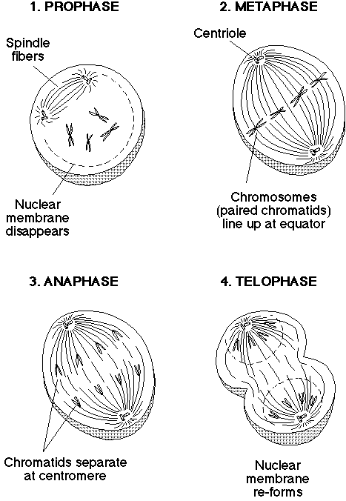 Mitosis

TM 2.2
Meiosis
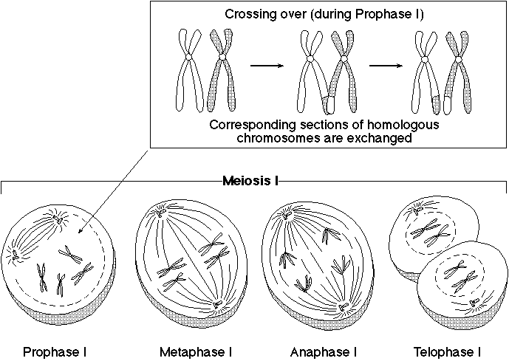

TM 2.2 (Cont.)

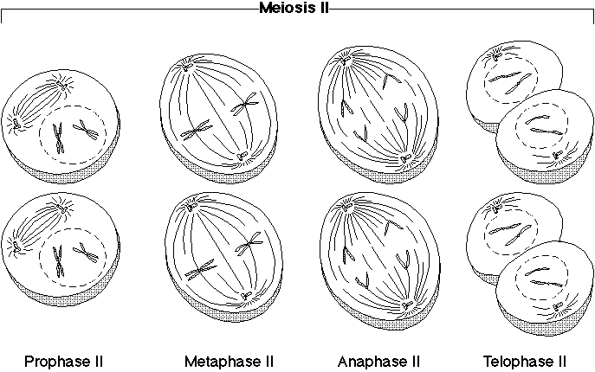

UNIT IV - FOUNDATIONS OF GENETIC ENGINEERING AS 2.1

Lesson 2: Cell Reproduction and Genetics Name

Mitosis and Meiosis

Objective: Simulate the stages of mitosis and meiosis.

Materials and Equipment:

Pipe cleaners
Beads
Pieces of yarn

Procedure:

1. Using pipe cleaners, beads, and pieces of yarn, illustrate the four stages of mitosis. The pipe cleaners and beads should represent the chromosomes. The pieces of yarn can illustrate the nucleus, centrioles, and spindle fibers. Be ready to explain what happens in each of these four stages.

2. Use the pipe cleaners, beads, and yarn to illustrate the four stages of meiosis I. Be sure to show the differences that distinguish meiosis I from mitosis. Be ready to explain each stage of meiosis I.

3. Use the pipe cleaners, beads, and yarn to illustrate the four stages of meiosis II. Be sure to illustrate the crossing over of genes. Be ready to explain each stage of meiosis II.

Key Questions:

1. What are four differences that exist between mitosis and meiosis?

a.

b.

c.

d.

2. How does meiosis I differ from meiosis II in terms of the genetic material passed on to the new cells?

