Lesson 2:
Cell Reproduction and Genetics

After organisms begin life, they grow and eventually reach maturity and reproduce. Their offspring then begin to grow and develop. A similar life cycle goes on at the cellular level. Young cells grow and mature until they are stimulated to reproduce. Cell reproduction takes place by cell division, in which the material in a cell is divided to produce two new cells. Cell division produces both body tissue cells and sex cells needed to produce offspring.

Mitosis

Mitosis is a type of cell division that takes place in somatic cells. Somatic cells include all the cells in an organism except the sex cells, or gametes (ova or sperm). Before mitosis begins, a cell replicates its genetic material. Each of the two new cells created by mitosis will therefore contain the same number of paired chromosomes as the parent cell. They will have two complete sets of chromosomes, or a diploid number of chromosomes. The process of mitosis involves four stages, which are illustrated in Figure 2.1.

The first stage of mitosis is prophase. The chromosomal material coils and condenses, and a double-stranded chromosomal structure becomes visible. This structure consists of two paired chromatids created by the duplication of DNA. Each double-stranded chromosomal unit has a point where the two chromatids connect. This point of connection, which is a body called the centromere, can occur at any point along the chromatids. The nuclear membrane then gradually dissolves. A network made up of complex protein units like hollow tubes, which are known as microtubules, begins forming around structures called centrioles, which start to move to opposite ends of the cell. The centrioles serve as anchors for the network of microtubules. This entire network is called the spindle. Spindle fibers extend from the centrioles toward the center of the cell. At this point, prophase ends.
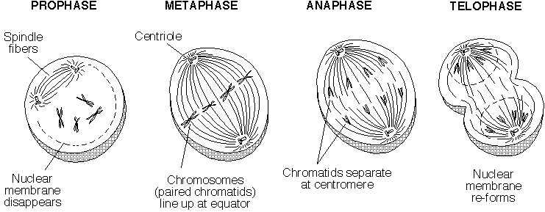

Metaphase is the next stage of the process. The chromosomal units move to the center of the cell and form a line between the two poles formed by the centrioles. Each spindle fiber attaches to the centromere of one of the chromosomal units.

The third stage is called anaphase. The centromeres break and allow the spindle fibers to pull the two chromatids of the chromosomal unit apart. The chromosomes move toward opposite poles of the cell. The poles move even farther apart, elongating the cell. At the end of anaphase, the two poles of the cell each have a complete set of chromosomes.

The last phase, telophase, begins differently in animal and plant cells. In animal cells, the cell membrane pinches in at the center of the cell until the cell is completely divided into two cells. In plant cells, a structure called a cell plate forms and begins to divide the cell into two cells. A cell membrane forms on both sides of the cell plate, and eventually the cell plate changes into a cell wall. After the cell membrane or cell plate begins to form, a nuclear membrane develops around the two sets of chromosomes. The chromosomes themselves begin to uncoil and lose their distinct outlines. Mitosis ends when this process is complete.
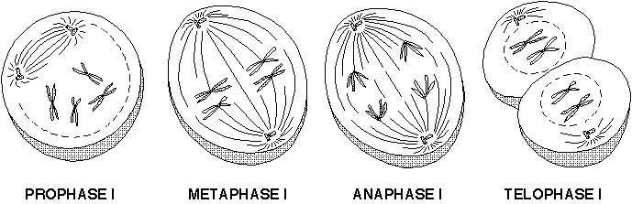

Meiosis

Meiosis is also a type of cell division, but it produces gametes rather than somatic cells. Meiosis produces four gametes, since it consists of two phases of cell division. The gametes produced contain only half the number of chromosomes of the original parent cell, or a single set of chromosomes. It is for this reason that these gametes are referred to as haploid cells.
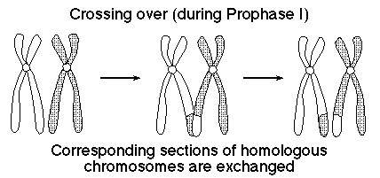

The first cell division process, or meiosis I (Figure 2.2), is somewhat similar to mitosis. The chromosomes replicate before the beginning of meiosis, just as they do before mitosis. During prophase I of meiosis, homologous chromosomes pair together. Homologous chromosomes are paired chromosomes that contain the same set of genes. One of the homologous chromosomes came from one of the organism’s parents, and the other came from the other parent. They form a tetrad, a grouping of four chromatids side by side. The nonpaired chromatids may exchange segments through a process called “crossing over,” in which a segment from one chromatid breaks off and reattaches to another. The process results in a change in the makeup of the chromosomes (see Figure 2.3). This exchange happens randomly. As in mitosis, the centrioles move apart and the spindle forms. The nuclear membrane dissolves.

Metaphase I is marked by homologous chromosomes lining up in the center of the cell. The spindle fiber ends attach to the centromeres of paired chromatids.

During anaphase I, homologous chromosomes separate and are pulled to different poles of the cell. The two cells formed after telophase will therefore not be genetically identical.

Telophase I can be identified by two distinct events. The first event is the formation of the cell membrane in animal cells or development of the cell plate and cell membrane in plant cells. The second event is the formation of nuclear membranes around the two new nuclei. The result is two haploid daughter cells.

After meiosis I, the two cells go through a short period of rest and then begin meiosis II, shown in Figure 2.4. Unlike mitosis or meiosis I, the two cells do not undergo DNA replication. Meiosis II begins with the development of the spindle fibers and the movement of paired chromatids to the center of the cell during prophase II. During metaphase II, the chromosomal units line up in a row between the two poles and become attached to the spindle fibers. In anaphase II, the chromatids separate and move toward the opposite poles. In telophase II, the center of each of the two cells closes off with the formation of a cell membrane or cell plate, nuclei form, and the chromosomes uncoil. Meiosis yields four haploid daughter cells that are not identical to the parent cell.
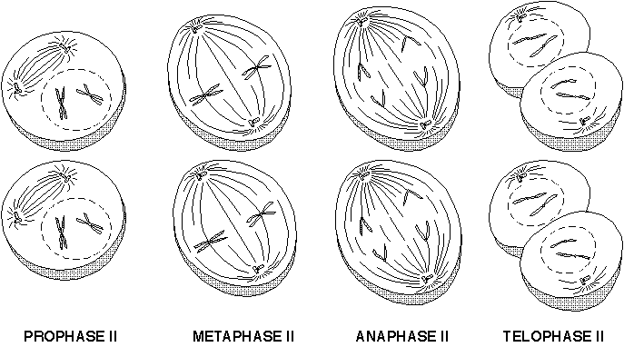

Differences Between Mitosis and Meiosis

Mitosis and meiosis have four major differences. One of the more obvious differences is that mitosis produces two cells from one parent cell, while meiosis produces four cells from one parent cell. Another obvious difference is that mitosis produces diploid somatic cells, while meiosis produces haploid gametes. However, a more subtle difference is that while mitosis produces two identical cells, meiosis produces four nonidentical cells. During mitosis, chromosomes double and contribute an identical chromosome to each daughter cell, while in meiosis homologous chromosomes split and contribute nonidentical chromosomes to each daughter cell. The last major difference between mitosis and meiosis is that in meiosis a tetrad forms and allows “crossing over” of genes to occur between homologous chromosomes.

Dominant and Recessive Genes

Most chromosomes in all species of plants and animals work in pairs. For example, cattle have 60 chromosomes in the nucleus of every somatic cell. These chromosomes function as 30 pairs of chromosomes. Each chromosome has a homologous chromosome that has genes that code for the same information but in a somewhat different way. Each gene in a gene pair is either dominant or recessive.

The interaction between dominant and recessive genes can be seen by looking at coat color in cattle. One section of one of the chromosomes codes for coat color. The gene for coat color is found at the same location on both chromosomes. If one of these genes codes for black and the other codes for white, what will the coat color of the animal be? Since the black gene is a dominant gene in cattle, the animal in question would have a black coat. The dominant gene is expressed, or seen in the animal. A dominant gene masks or covers up the expression of a recessive gene, which will not be apparent as a physical trait of the animal. In this example, the recessive gene is the gene that codes for white.

Homozygous and Heterozygous Gene Pairs

The term allele is used to describe either of the two possible expressions of a gene or multiple genes that code for a specific trait. An allele is usually represented by a letter of the alphabet. If the gene acts as a dominant gene, a capital letter is used to represent it; a lowercase letter is used to represent a recessive gene. If a plant or animal has two dominant alleles or two recessive alleles for a specific trait, it is homozygous for that specific trait. The terms homozygous dominant and homozygous recessive are used to differentiate between the two types of homozygous traits. If, however, a plant or animal has one dominant allele and one recessive allele, it is heterozygous for that trait.

Genotypes and Phenotypes

The genotype of an animal or plant refers to the specific combination of the alleles it possesses for each genetic trait. It is the actual genetic make up of the organism; for the example given above, the genotype would be either BB, Bb, or bb. The phenotype is the expression or appearance of a trait as determined by the genotype.

Mutations

What happens when a base unit is mistakenly inserted, deleted, or miscoded during the replication of DNA? Such a mistake is called a mutation. A mutation is an alteration of the nucleotide sequence found in a DNA molecule. This alteration can happen during replication prior to the beginning of mitosis or meiosis; it affects the organism differently depending on when the mistake occurs. If the mutation occurs just prior to mitosis, the change in the genetic code will be passed on to the daughter cell and any cell descending from the parent cell. Cancer is an example of a somatic cell mutation in which the mutated cell rapidly reproduces. Mutations can also occur just prior to meiosis. In this case, the mutation is passed on to an organism’s offspring if the gametes are fertilized. The offspring would have the altered DNA in every one of its cells.

Some mutations can be very beneficial, some can have a negative effect, and others may have no visible effect on an organism. An example of a positive mutation is the mutation that led to the development of the Polled Hereford breed of cattle. This breed was developed in the early 1900s by a rancher who noticed that calves from his Hereford cattle occasionally did not develop horns.

Summary

Cell reproduction is carried out through the processes of mitosis and meiosis. The genetic material passed on through these processes includes dominant and recessive genes and heterozygous and homozygous gene pairs. The genes an organism possesses determine its genotype and phenotype. Sometimes mutations also have an effect on the organism.

Credits

Baker, Andy. Animal Science. University of Missouri-Columbia: Instructional Materials Laboratory, 1996.

Fleck, Earl. Meiotic Cell Division. http://www.
whitman.edu/Departments/Biology/classes/B111/B111Outlines MaiMei.html (4 Sept. 1997)

Fleck, Earl. The Cell Cycle and Mitosis. http://www.
whitman.edu/Departments/Biology/classes/B111/B111OutlinesCDCellCyc.html (4 Sept. 1997)

Herren, Ray V. The Science of Agriculture: A Biological Approach. Albany: Delmar, 1997.

Johnson, G. B. Biology: Visualizing Life. New York: Holt, Rhinehart, and Wilson, 1994.

Miller, Kenneth R., and Levine, Joseph. Biology. Englewood Cliffs, N.J.: Prentice Hall, 1993.

Oram, Raymond F. Biology of Living Systems. Waterville, Ohio: Glencoe, 1994.

