Lesson 3:
Genetic Modification

Genetic modification is a very complicated process performed by highly trained researchers. This lesson will cover the basic procedures used in genetic engineering.

Gene Mapping and Gene Sequencing

Before the driver of a car makes a change in the planned route, he or she should check a road map to find out which roads to add to the route and which roads to avoid. Making changes in the genetic code of a cell is much the same, except that in this case the driver or researcher is driving blind because DNA cannot be seen except under extremely powerful microscopes. The researcher needs a map of the chromosomes of an organism to be able to select specific genes for modification. Gene mapping is the process of finding the location of genes for specific traits on the chromosomes of an organism. An example is a genome map of a corn plant, which shows the parts of the chromosomes that are responsible for plant height.

Gene sequencing is a related process that shows the order of all the base units (A, T, C, G) as they line up on a particular gene. A gene sequence is really a map of a single gene, which may be comprised of 100,000 or more base pairs. Gene sequencing is important to scientists because it allows them to recognize how to cut out a particular gene or gene fragment so that it can be placed into the DNA of the cell being modified.

DNA Extraction

Once a desired gene has been identified, it must be removed from the cell. DNA extraction is a three-step process. The cell membrane or cell wall must first be broken down to release the cytoplasm. The nuclear membrane must also be broken to release the chromosomes. Researchers accomplish this with the use of a surfactant, a fatty acid compound much like a household detergent. These compounds consist of lipids, just like the cell membrane. The surfactant breaks down the cellular membranes at a rate determined by temperature. Heat accelerates this process.

The second step involves the use of a protease, such as the enzyme papain. DNA strands in the chromosome wrap around protein molecules called histones. The protease will split this protein and the other protein contents of the cytoplasm.

The last step involves separating the DNA from the other cell components. Cold alcohol is added to the cellular solution. The DNA strands will clump together and rise to the top of the alcohol, since DNA is insoluble in alcohols. The DNA is then collected for later use.

Restriction Digestion

Restriction digestion is the process of cutting DNA into smaller fragments. The DNA is cut by restriction enzymes, which are essentially biochemical scissors. Each restriction enzyme cuts DNA at a specific sequence of nucleotide base pairs, as illustrated in Figure 3.1. The sequence is called a restriction site. All DNA contains natural restriction sites. Researchers use restriction enzymes to cut genes or DNA fragments out of extracted DNA strands. Restriction digestion is useful to researchers in several ways. For example, researchers can identify whether a strand of DNA has a particular gene on it. They can also cut a gene from a strand for gene splicing.

Gel Electrophoresis

Gel electrophoresis is a process in which researchers apply an electric current to a gel to separate different lengths of DNA fragments into groups. The researchers can then recover a desired gene or gene fragment. Performing gel electrophoresis requires an electrophoresis box, a buffer solution, a special power supply, and a gel made from agarose or another agent. One end of the electrophoresis box has a positive pole and the other has a negative pole. The gel rests between them. The researcher places DNA fragments that have been stained with a dye in small wells or pockets at the end of the gel nearest the negative pole and applies an electric current to the gel. The buffer solution keeps the gel moist and facilitates the flow of the electrical current. The current causes the DNA fragments, which are negatively charged, to be repelled away from the negative pole and attracted to the positive pole (Figure 3.2). Short lengths of DNA will move through the gel faster than long lengths. The electric current is removed just before the short fragments reach the end of the gel. Fragments of DNA of the same size will be grouped at one spot on the gel. The markings caused by fragments of different sizes are called bands.
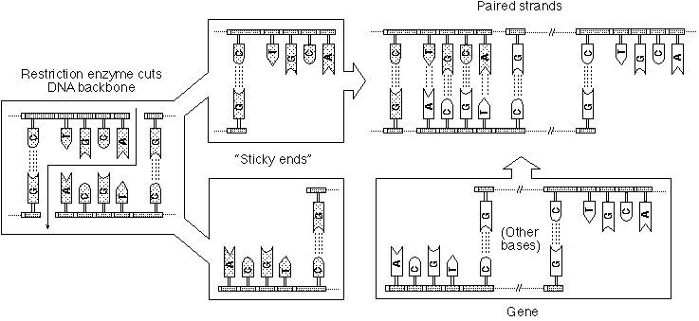

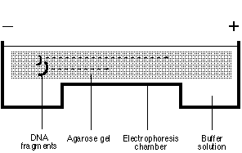

Gene-Splicing

Gene-splicing is the process of inserting a piece of DNA into a chromosome of a cell. It is also called ligation because the enzyme ligase is the biochemical glue that joins the pieces of DNA. Gene-splicing involves several steps. The process begins with the researcher cutting out a piece of DNA with a restriction enzyme. The correct restriction enzyme must be used so that the ends of the DNA will be “sticky,” meaning that they contain bases that are complementary to the bases of the fragment to be incorporated. Gel electrophoresis must be performed to separate the DNA fragments by size and isolate the appropriate fragment. The researcher then joins the ends of the selected fragment to the DNA being transformed through a chemical reaction called a ligase reaction. Ligase chemically joins two DNA fragments by causing a bond to form between the phosphate portion of each fragment. The reaction is often done in a test tube. The result is a cell containing DNA from two different sources that forms a new genetic code, which is therefore called recombinant DNA.

This cell is then grown into an organism. In transgenic animals, the gene is spliced into the chromosomes of a fertilized egg, which is then implanted in the female reproductive tract. In plants, the plant cell with the transferred genetic material (often referred to as a transgene) is stimulated to grow into a plant. In each case, the organism has a copy of the new genetic information in every cell.

Summary

Genetic engineering is accomplished through the use of several processes. Gene mapping is used to locate the desired trait. DNA extraction isolates the DNA containing the desired gene. Restriction digestion then cuts the extracted DNA into specific pieces. Electrophoresis separates the DNA fragments into groups of like size. Gene-splicing joins the isolated piece of DNA to the DNA being modified. These basic genetic engineering technologies are used in research laboratories across the country.

Credits

The Biotechnology Education Project, in conjunction with the Mathematics and Science Education Center. An Introduction to Biotechnology: A Unit for High School Students. Dubuque: Kendall/Hunt Publishing Company, 1996.
Bjork, Warren B., et al. Biology: The Study of Life. 4th ed. Needham, Mass.: Prentice Hall, 1991.

“DNA Extraction from Onion.” http://www.biotech.
iastate.edu/lab_protocols/DNA_Extraction_Onion.html (29 October 1997).

“DNA Extraction with Kitchen Chemistry.” http://raven.umnh.utah.edu/secondlevel/core/
dnaextraction/index/dnaindex.html (29 October 1997).

Glick, Bernard R., and Jack J. Pasternak. Molecular Biotechnology: Principles and Applications of Recombinant DNA. Washington, D. C.: ASM Press, 1994.

Herren, Ray V. The Science of Agriculture: A Biological Approach. Albany: Delmar, 1997.

Lee, Jasper S., and Diana L. Turner. Introduction to World Agriscience and Technology. Danville, Ill.: Interstate Publishers, Inc., 1997.

Molecular Biology Cyberlab. Experiment 1: Restriction Digestion. http//www.life.uiuc.edu/
molbio/geldigest/digest.htm.l (30 May 1997).

