Lesson 1:
Artificial Insemination

Animal biotechnology began when humans began selecting and pairing more desirable animals during breeding to produce offspring of higher quality. Artificial insemination (AI) is an extension of selective breeding that gives livestock managers more options for improving offspring. The advantages and disadvantages of AI must be examined if it is to be used effectively.

Artificial Insemination

In 1780, an Italian researcher first developed a procedure for impregnating female animals without the presence of a male animal at breeding time. However, artificial insemination was not used by breeders until the late nineteenth and early twentieth centuries. Artificial insemination (AI) is the process of collecting semen from a male animal and placing it in the reproductive tract of a female animal. It is a form of biotechnology that is commonly used by livestock producers across the United States.

The Benefits of Artificial Insemination

Both artificial insemination and natural breeding have certain benefits. A major benefit of AI is that it allows producers to select and use male animals in their breeding programs that are proven performers, regardless of where the animals are physically located. Another benefit of AI is that reproductive or venereal diseases are not spread between breeding animals. A third benefit of AI is that it can reduce or eliminate the cost of owning and maintaining male animals for breeding purposes. The cost of the semen, the insemination process, and the hormones needed to manipulate the estrous cycle of female animals offset some of the economic benefits, but an AI system can still be more cost effective than a natural breeding system. One of the broader benefits of AI for the livestock industry as a whole is that the genetic improvement of livestock populations through the use of superior animals occurs much more quickly with AI, because of a dramatic increase in the number of offspring a male animal can produce (sire) per year. A single bull can only breed about 60 cows naturally in a year, but that same bull can be used to inseminate nearly 20,000 cows a year with AI.

Equipment for Artificial Insemination
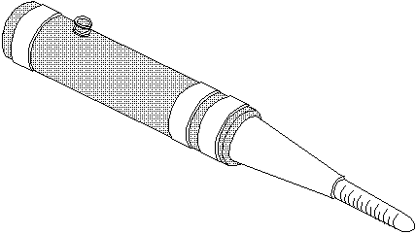

Several different pieces of equipment are used for artificial insemination. Semen collection is most commonly done through the use of a dummy, which is a female replica. Male animals are trained to mount the dummy, and the penis is guided into an artificial vagina. The artificial vagina (see Figure 1.1) is a water-filled plastic sheath and has a collection tube in one end that holds the semen after ejaculation. A microscope is used when analyzing the collected semen. The semen is put into long, thin plastic tubes called semen straws. Each straw holds the amount of semen needed to breed one female. These straws are frozen and stored in an aluminum semen tank (Figure 1.2) containing liquid nitrogen. The straws are placed in an insemination instrument at the time of breeding. The insemination instrument is a long syringe-like tool that holds the straw and deposits the semen into the female reproductive tract.
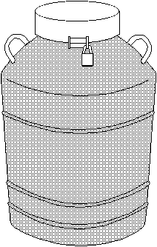

The Process of Artificial Insemination

Artificial insemination begins with the collection, inspection, and preparation of the semen. The collection of semen is important, since poor collection techniques will yield poor quality semen. After semen is collected using an artificial vagina, it is analyzed to examine the motility (active movement), shape, and quantity of the sperm. When the semen has been inspected, an extender is added to the semen to increase the volume. Several different types of extenders are used, but the most common are citrate, egg-yolk phosphate, and homogenized milk. These extenders protect and provide nourishment to the sperm when they are frozen. After the extenders have been added to the semen, it is placed in straws and frozen in liquid nitrogen at -320 degrees Fahrenheit.

The next part of the AI process begins when a producer decides to breed his or her animals. Producers must carefully manage the timing of insemination. Good semen and correct insemination procedures will not result in successful fertilization without proper timing. Each animal species has a different estrous cycle, which dictates the timing of insemination. Generally, insemination should occur shortly before ovulation.

When the time is right, the semen is thawed using proper thawing procedures to ensure that the sperm are not damaged. Once the semen is thawed, the straw is placed in the inseminating instrument, which is then inserted into the vagina of the animal being bred. The instrument is guided through the cervix, and the semen is placed just at the end of the cervix or the beginning of the uterus. A trained technician should perform this part of the process.

Manipulation of the Estrous Cycle

Female animals naturally produce the hormones that control the estrous cycle. However, through the injection of certain hormones, a producer can cause females to begin estrous as a group. This process, which is called estrous synchronization, simplifies the management of an artificial insemination program, because the animals in the group can all be bred within one or two days of each other.

Summary

Artificial insemination is an animal biotechnology that has a significant impact on the livestock industry. Artificial insemination is the process of collecting sperm from a male animal and placing it in the reproductive tract of a female animal. AI requires special equipment and close monitoring. The timing of insemination is critical to its success.

Credits

Baker, Andy. Animal Science (Student Reference). University of Missouri-Columbia, Instructional Materials Laboratory, 1996.

Herman, H. A., Jere R. Mitchell, and Gordon A. Doak. The Artificial Insemination and Embryo Transfer of Dairy and Beef Cattle. 8th ed. Danville, Ill.: Interstate Publishers, Inc., 1994.

Herren, Ray V. The Science of Agriculture: A Biological Approach. Albany: Delmar Publishers, 1997.

Lee, Jasper S., and Diana L. Turner. Introduction to World Agriscience and Technology. Danville, Ill.: Interstate Publishers, Inc., 1997.

Peiter, Andrea. Introduction to Animal Reproduction (Student Reference). University of Missouri-Columbia: Instructional Materials Laboratory, 1996.

Peterson, Dennis R., and Thomas Rehberger. Biotechnology in Agriculture. Stillwater, Okla.: Mid-America Vocational Curriculum Consortium, Inc., 1992.

