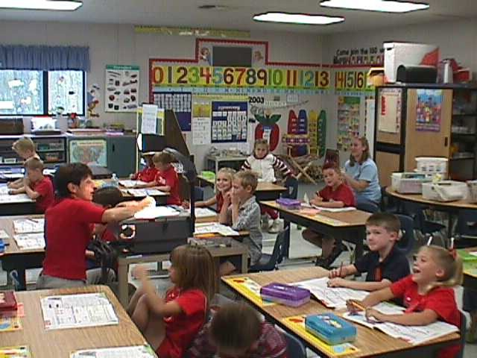
Pre-Professional Education Cadet
Quotes from Cadets:
“Cadet teaching is the best part of my day! I get to spend 2 hours a day with adorable kindergarteners and I get to leave the high school after 5th hour.
Before I started cadet teaching, I honestly wasn’t sure if education was for me; but now after this experience, I cannot wait to be an elementary teacher.” — Jessica, Senior ‘09

“Cadet teaching is the best class I have ever taken!” — Katy , Senior ‘09

Mary Ann Lanoue, Coordinator
Lee’s Summit High School
maryann.lanoue@leesummit.k12.mo.us
Kathy Nash, Coordinator
Lee’s Summit North High School
Kathyj.nash@leesummit.k12.mo.us

Pick up application in
Guidance Office or outside A152

Price List

Center of Excellence
Tel: 555 555 0125

The mission of this class is to teach the important skills, knowledge, and values necessary to be a successful teacher in the future. Cadet Teaching provides the means for exploring the opportunities in education before entering a teaching program at the university level.
Receive two weighted credits at the high school level.
Cadets are assigned to an elementary or middle school within their high school attendance boundary.
Cadet teachers may enroll in EDFL 2100
Foundations of Education and
FLDX 2150 Field Experience
through the University of Central Missouri for 3 hours of college credit.

Cadet Teaching:
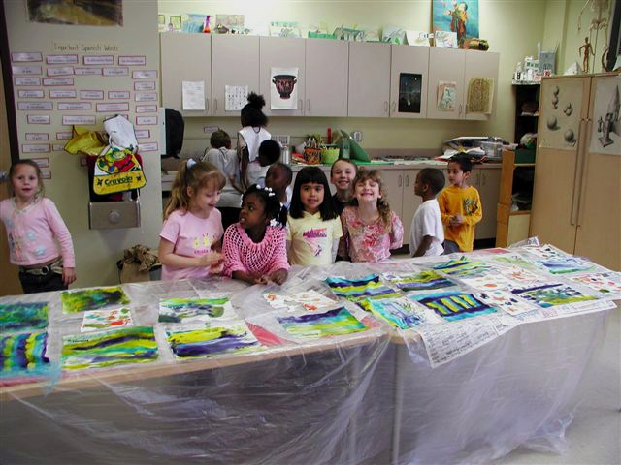


What are my responsibilities as a

Cadet Teacher?

The cadet teacher works under the direct supervision of a certified teacher as they gain knowledge and experience related to the field of teaching. Cadets will spend a minimum of two-thirds of their time in teaching activities and one-third in non-teaching activities. You must furnish your own transportation. Cadets spend four days per week with their supervising teacher and one day per week at UCM Summit Center.

What are teaching activities?
Working with individual or small groups of students on drill and practice activities, reading aloud to the class.
Helping with the lesson(s)
Presenting a
lesson
Attending
field trip(s)
What are non-teaching activities?
Organizing materials for the class, making copies
Creating bulletin boards and room displays
Grading papers
Researching topics for the teacher

Fun Assignments
Reading children’s books
Creating bulletin boards
Developing lesson plans
Attending a full day at the assigned school
Going on field trips

