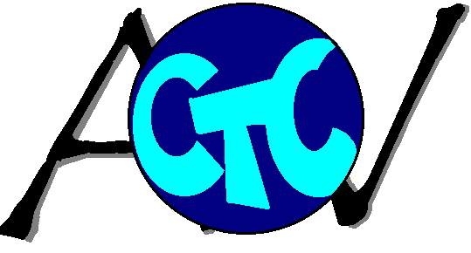
Arcadia Valley CTC
Name: _______________________________ Program:____________________________

WRITING RUBRIC

CATEGORY | 4 | 3 | 2 | 1
Topic Sentence | Each paragraph starts with a well-constructed and focused topic sentence. | Almost all paragraphs start with a well-constructed topic sentence. | The topic sentences are not well constructed and they don’t focus on one topic. | Paragraphs do not start with a sentence with a focused topic.
Supporting Details | Each paragraph contains 2 or 3 details that support the topic. | Each paragraph contains at least 2 details that support the topic. | Each paragraph contains at least 1 detail that supports the topic. | Paragraphs do not contain details that support the topic.
Vocabulary | Vivid words and phrases are used that bring the topic alive and are used accurately. | Vivid words and phrases are used that bring the topic alive and they may not always be used accurately. | The vocabulary words used clearly communicate ideas but there is a lack of variety. | The vocabulary used is limited and does not adequately communicate ideas.
Grammar & Spelling | There are no errors in grammar or spelling. | There are 1 or 2 errors in grammar or spelling but they don’t affect meaning. | There are 3 or 4 errors in grammar or spelling that distract the reader from the content. | There are more than 4 errors in grammar or spelling that make the paper difficult to understand.
Capitalization & Punctuation | There are no errors in capitalization or punctuation. | There are 1 or 2 errors in capitalization and/or punctuation but the paper is still easy to understand. | There are a few errors in capitalization and/or punctuation that distracts from the content. | There are more than four errors in capitalization and/or punctuation that make the paper difficult to understand.
Conclusion | The conclusion is well constructed and draws together all the details to form an ending. | There is a conclusion and it draws together most of the details. | There is a conclusion but it doesn’t draw together most of the details. | There is no clear conclusion or ending to the paper.

