UNIT I - INTRODUCTION TO AGRICULTURE

Lesson 1: Agriculture: What Is It?

Competency/Objective: Define agriculture and identify career opportunities in agriculture.

Study Questions

- What is agriculture?

- How does agriculture affect your daily life?

- What are the major sectors of the agricultural industry?

- What are examples of agricultural careers in each sector?

References

1. Exploring Agriculture in America (Student Reference). University of Missouri-Columbia: Instructional Materials Laboratory, 2000, Unit I.

2. Think About It (Brochure). National FFA Center, P.O. Box 68960, 6060 FFA Drive, Indianapolis, IN 46268-0960, 1996.

3. Agriculture’s New Professionals (Ag Video 105). Missouri Resource Center for Career & Technical Education, University of Missouri-Columbia, 1990.

4. Transparency Masters

TM 1.1 Agriculture Is . . . . .
TM 1.2 Agriculture Is . . . . . (cont.)
TM 1.3 World Population Growth
TM 1.4 Average Annual Expenditures for Typical U.S. Family
TM 1.5 Disposable Income Spent for Food
TM 1.6 Life Expectancy

5. Activity Sheets

AS 1.1 Planting Seeds
AS 1.2 Change in World Population (Instructor)
AS 1.3 Current World Population
AS 1.4 Agricultural Career Collage
AS 1.5 A to Z Agricultural Careers
AS 1.6 Cheeseburger, Fries, and Shake
AS 1.7 Name That Career (Instructor)
AS 1.8 Agriculture in My Community (Instructor)
UNIT I - INTRODUCTION TO AGRICULTURE

Lesson 1: Agriculture: What Is It?

TEACHING PROCEDURES

A. Introduction

This lesson begins with the evolution of the term agriculture. By completing the activities and assignments, students will develop a more personal view of how agriculture affects them and will identify career opportunities available in the major sectors of agriculture.

B. Motivation

1. Conduct a word association activity where students list the first thought that comes to mind when the teacher mentions the following words: DNA, food, tractor, baseball, denim, agriculture, greenhouse, newspaper, genetic engineering, zoo, and farming. Have students share their answers.

Next, ask students to analyze the word list presented by the teacher and identify possible relationships. What words have something in common? For example, food, denim, and baseball represent processed agricultural products produced on a farm. This activity could also be accomplished in groups through a concept (web) map or by brainstorming.

Very few students will associate agriculture with many of the words. Conclude the activity by explaining that all the words are related to agriculture and this will become evident during this course.

- To obtain a baseline on student knowledge and perceptions on agriculture, place one of the following items on a table where groups of three to four students can gather: baseball, newspaper or agricultural magazine, golf tee (traditional wood), soybean processed material used in construction, golf tee (made from biodegradable corn starch), house plant, candy made from agricultural products (such as Super Soynuts).

Each group should discuss several questions: (a) What is your item made of? (b) Is there a connection between your item and agriculture?

- To prepare for the next unit, conduct AS 1.1. Ask students what is going to happen with the seeds they have planted. The students should check on their seeds each day to watch for growth and to care for them. Select fast-growing vegetables, such as radishes, that can be raised and consumed by students. Also plant corn and soybeans so that parts might be used in Unit II, Lesson 2.

C. Assignment

D. Supervised Study

E. Discussion

Q1. What is agriculture?

A1. All aspects of the global food, fiber, and natural resources systems, including the development, production, processing, marketing, and distribution of food and fiber products; the health and nutrition of food consumption; the use, conservation, and maintenance of environmental, and recreational resources; and the related scientific, economic, sociological, political, and cultural characteristics of the food, fiber, and natural resources systems.

Using TMs 1.1 and 1.2, ask students to define agriculture. Next, ask students to identify key words in the definition. Conduct AS 1.2 to have students graph how world population has increased, then show TM 1.3 to provide the answer. Have students complete AS 1.3 to get an idea of how much the population increases minute-by-minute.

Q2. How does agriculture affect your daily life?

A2.
a) Agriculture is the largest industry in the United States, providing
approximately 20% of the jobs. The agricultural industry employs over 22 million people.
b) Americans enjoy low food costs compared to all the items they buy.
c) Americans spend approximately 11% of their disposable income on food, which is less than people in other countries.
d) Agricultural research and a healthy food supply have contributed to a much longer life expectancy.
e) Millions of dollars of taxes generated by agriculture support the local, state, and national governments. Many rural school districts receive a major portion of their funding from agricultural property taxes.

Engage students in discussion by asking them to guess the cost of food for an average family of 2.5 people and the life expectancy for various countries in the world. Use TMs 1.4, 1.5, and 1.6 to summarize this area.

Q3. What are the major sectors of the agricultural industry?

A3. There are many different ways to categorize the major sectors of agriculture; however, a common and accepted classification system is as follows:

a) Agricultural systems technology
b) Agricultural processing and marketing
c) Agricultural supplies and services
d) Forestry
e) Horticulture
f) Production agriculture
g) Natural resources

Show the video Agriculture’s New Professionals as an overview of the major sectors of the agricultural careers in the United States. Student groups or individual students can complete AS 1.4 to create an agricultural career collage. Old agricultural magazines with photos could help the students.

Q4. What are examples of agricultural careers in each sector?

A4. There are many answers for this question from the brochure Think About It. Several careers for each of the major sectors are listed below:

- Agricultural systems technology
1) Engine technician
2) Agricultural electrician
3) Agricultural engineer
- Agricultural processing and marketing
1) Meat department manager
2) Food scientist
3) Grain elevator manager
4) Citrus processor
- Agricultural supplies and services
1) Agricultural journalist
2) Genetic engineer
3) Agricultural loan officer (banker)
4) Veterinarian
- Forestry
1) Park ranger
2) Forester
3) Timber manager
- Horticulture
1) Floral designer
2) Turf grass specialist
3) Landscape architect
- Production agriculture
- Beekeeper
- Livestock herdsman
- Grain producer
- Natural resources
1) Soil conservationist
2) Fish and wildlife specialist
3) Water quality specialist

Assign students AS 1.5 to complete and bring to the next class period. Most students will name production careers such as A - Apple grower, B - Berry grower, etc. Provide students with the brochure Think About It and conduct AS 1.4 again but this time challenge students to identify agricultural careers that may interest them but are not in the production agriculture sector. Students should identify in which sector of agriculture each career would be found. Finally, have students complete AS 1.6, AS 1.7, and AS 1.8 to expand their knowledge of careers and agriculture-related businesses.

F. Other Activities

1. Access the Agricultural Career Center web site to research agricultural careers. <http://www.ffa.org/careers/index.html>

2. Order agricultural career posters ("Living Science" Poster Set, available for $4 from Office of the Dean, Purdue University, School of Agriculture, Administration Building, West Lafayette, IN 47907-1140)

G. Conclusion

Agriculture is more than farming. The definition of agriculture has evolved to include career areas in seven major sectors of the agricultural industry. The global aspect of agriculture is concerned with the increasing world population. The country’s largest employer is agriculture. Several major benefits are provided by agriculture including a low food cost compared to other countries and helping to increase the life expectancy of humans. Agriculture benefits everyone each and every day.

H. Answers to Activity Sheets

Answers to all activity sheets will vary.

I. Evaluation

A unit test is provided at the end of this unit. If a lesson quiz is needed, use questions pertaining to this lesson from the unit test.

TM 1.1

Agriculture is . . . . .

All aspects of the global food, fiber, and natural resources systems, including

- the development, production,

processing, marketing, and

distribution of food and fiber products;

- the health and nutrition of food

consumption;

TM 1.2

Agriculture is . . . . . (cont.)

- the use, conservation, and

maintenance of environmental and

recreational resources;

- and the related scientific, economic,

sociological, political, and cultural

characteristics of the food, fiber, and

natural resources systems.

TM 1.3

World Population Growth

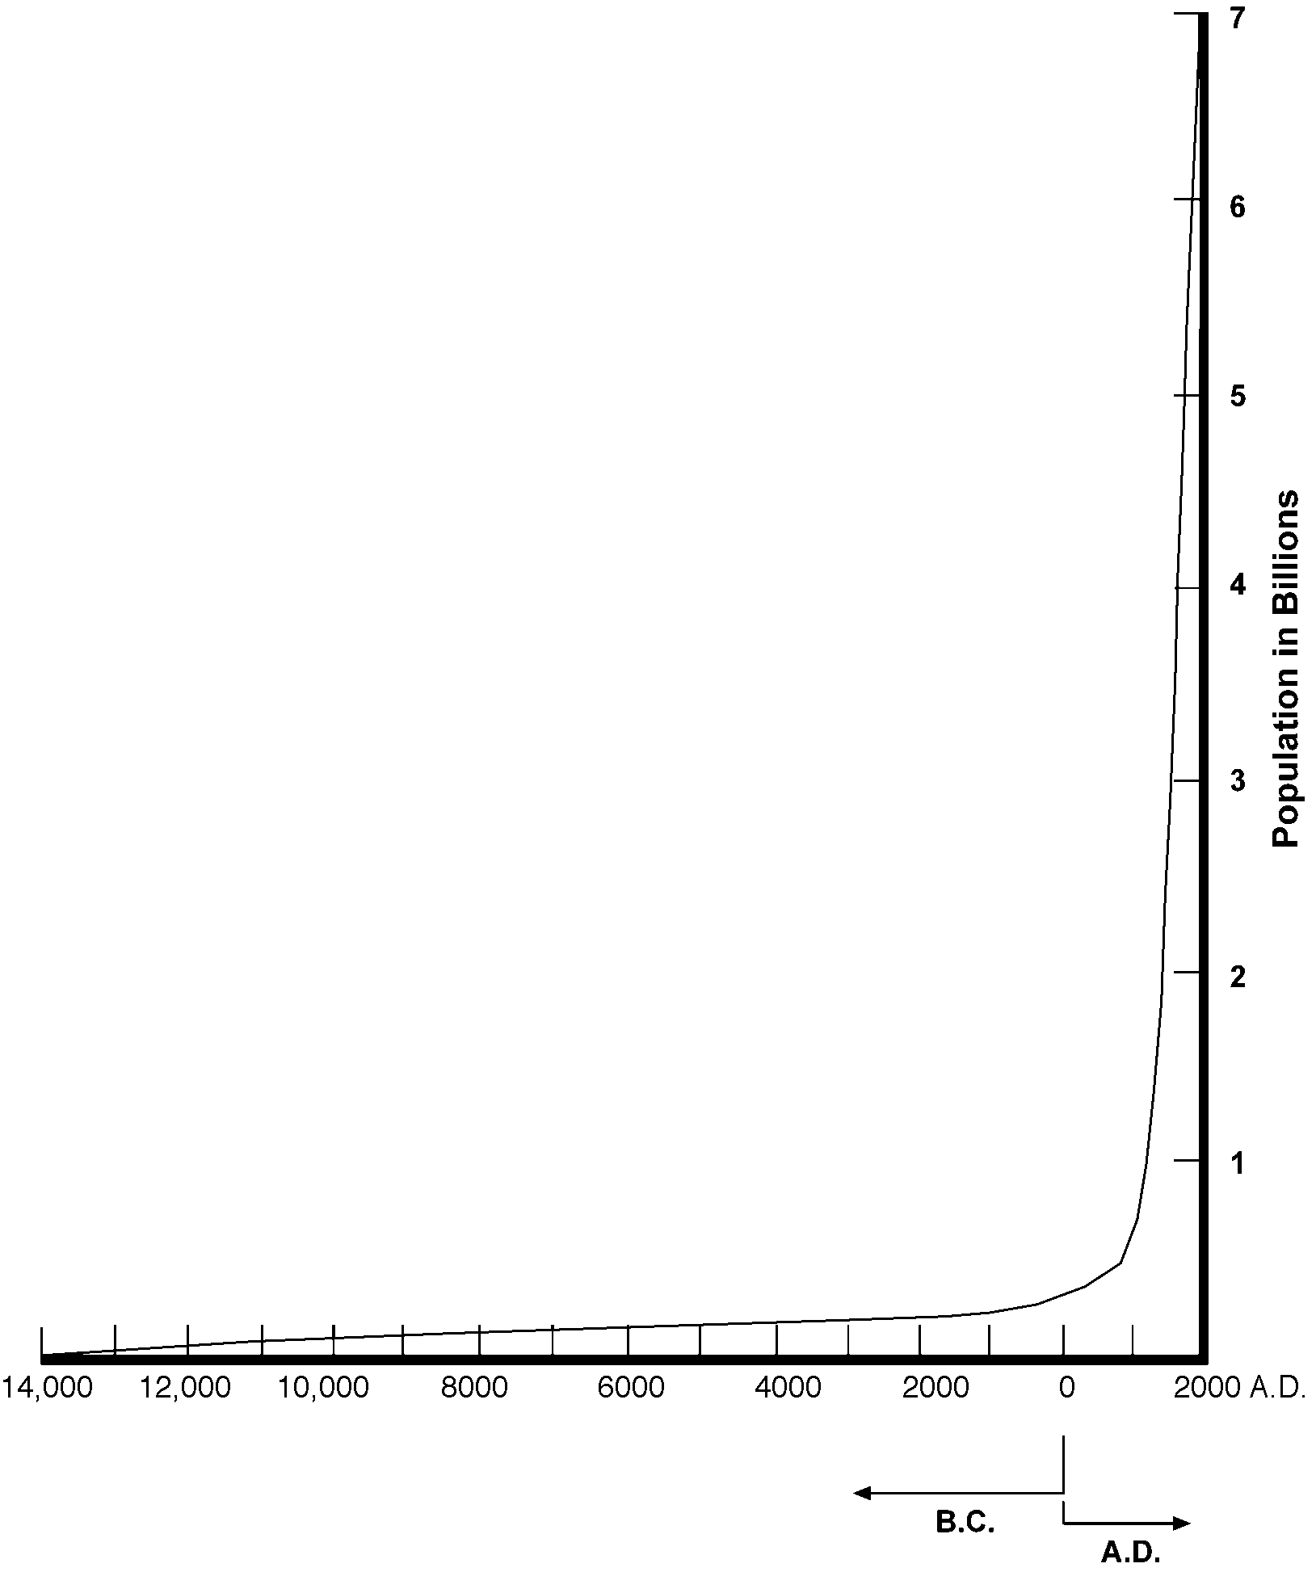

TM 1.4

Average Annual Expenditures for Typical U.S. Family

Source: U.S. Department of Labor - Bureau of Labor Statistics (1998)
Average Number in Family: 2.5
Average Number of Earners: 1.3

TM 1.5

Disposable Income Spent for Food

Source: U.S. Department of Agriculture (1996)

TM 1.6

Life Expectancy

Source: Central Intelligence Agency - The World Fact Book (1999)

UNIT I - INTRODUCTION TO AGRICULTURE AS 1.1

Lesson 1: Agriculture: What Is It? Name__________________________

Planting Seeds

Objective: Students will be able to demonstrate how to plant seeds.

Materials and Equipment:

1 container – flowerpot, cup, etc.
Potting soil
Seeds - to be provided by instructor
Water

Procedure:

1. First watch the instructor demonstrate how to plant seeds. You will follow these directions.

2. If you are using a cup instead of a flowerpot, place a hole in the bottom so the water can drain out.

3. Fill the pot with soil up to 1/2 inch from the top.

4. Use your finger to make a small hole in the soil.

5. Place the seed in the hole and cover lightly with the soil.

6. Water thoroughly.

7. Place the pot in a well-lighted area, such as by a window.

- Examine your plant every day and water it when it is dry.

UNIT I - INTRODUCTION TO AGRICULTURE AS 1.2

Lesson 1: Agriculture: What Is It? Instructor

Change in World Population

Objective: Students will develop an understanding of the increasing world population.

Directions: Use the chalkboard or white board to construct a graph of world population. The vertical axis represents billions of people in the world and the horizontal axis represents years, starting from the beginning of recorded time to the present. To show the concept of increasing world population, it is important to use an accurate scale to represent time. In addition, the starting point of recorded history will challenge students to remember social studies issues and they may want to talk to a social studies teacher about this concept.

Provide students with the data below or have students do research. An excellent source to use is the U.S. Census Bureau, which can be accessed on the Internet at <http://www.census.gov/ipc/www/world.html>. Ask for student volunteers to draw what they think has been the change in population over time. After students have drawn the graph, show TM 1.3 to summarize the concept of increasing world population.

Teacher-Provided World Population Data
Following are the approximate world populations for the indicated years.

Year | Population in Billions
1825 | 1.0
1925 | 2.0
1960 | 3.0
1975 | 4.0
1987 | 5.0
1999 | 6.0

The following graph shows typical student responses.

As an additional assignment, students could predict the future world population by using a math skill called extrapolation. Students can research this topic as well on the U.S. Census Bureau web site.

UNIT I - INTRODUCTION TO AGRICULTURE AS 1.3

Lesson 1: Agriculture: What Is It? Name

Current World Population

Objective: Students will develop an understanding of how the increasing world population relates to agriculture.

Directions: Use the U.S. Census Bureau World Population Information on the Internet <http://www.census.gov/ipc/www/world.html> to answer the following questions.

After going to the above address, click on the World POPClock link, find the dynamic World POPCLOCK, and gather up-to-the-minute world population data. You will record the population every minute for 10 minutes. In the table below, record the time, population, and change in population during the last minute. Record the data, wait 1 minute, and then press the reload button to get the new data. Continue to press the reload button every minute.

Minutes | Actual Time Listed at the Web Site | World Population |  | Population Change During the Last Minute
Start |  |  |  | N/A
1
2
3
4
5
6
7
8
9
10
Total Increase in World Population During Previous
10 Minutes
(Add values in the 4th column)

Key Questions:

1. Does the population change the same amount during each of the 10 minutes?

2. Assuming a constant rate, how much would you expect the world population to increase in 1 day (total increase in world population during previous 10 minutes x 6 x 24)?

3. How much would you expect the population to increase in 1 year (365 days), assuming a constant rate?

4. If you assume that the population of the world increases at the same rate, what will the population be in 20 years?

5. List some variables that could cause your 20-year prediction to be inaccurate.

6. Why do you think the ability to predict the world’s population is important?

UNIT I - INTRODUCTION TO AGRICULTURE AS 1.4

Lesson 1: Agriculture: What Is It? Name

Agricultural Career Collage

Objective: Students will develop an understanding for the various career sectors in agriculture.

Directions: Select one of the following sectors of the agricultural industry and develop a collage that represents that sector.

The agricultural industry consists of seven sectors:

1. Agricultural systems technology
2. Agricultural processing and marketing
3. Agricultural supplies and services
4. Forestry
5. Horticulture
6. Production agriculture
7. Natural resources

You will be evaluated according to the following scoring guide.

Item | Points Possible | Your Score
Representative: Collage represents the sector. | 5
Diversity: Various careers, businesses, and geographic areas are represented. | 5
Colorful: Color pictures are more appealing than black and white. | 5
Creativity: Special effects such as poster shape, words, 3-D, etc., are used rather than a basic rectangular design. | 5
Total | 20

Comments:

UNIT I - INTRODUCTION TO AGRICULTURE AS 1.5

Lesson 1: Agriculture: What Is It? Name

A to Z Agricultural Careers

Objective: Students will identify career opportunities available in agriculture.

Directions: Identify agricultural careers by each letter of the alphabet.

A

B

C

D

E

F

G

H

I

J

K

L

M

N

O

P

Q

R

S

T

U

V

W

X

Y

Z

UNIT I - INTRODUCTION TO AGRICULTURE AS 1.6

Lesson 1: Agriculture: What Is It? Name

Cheeseburger, Fries, and Shake

Objective: Students will identify how careers in agriculture affect their everyday life.

Directions: Identify all of the careers associated with cheeseburger, fries, and shake. Place each of the agricultural careers into one of the seven sectors of agriculture. How many are agricultural or related to agriculture?

1. Agricultural systems technology

2. Agricultural processing and marketing

3. Agricultural supplies and services

4. Forestry

5. Horticulture

6. Production agriculture

7. Natural resources

UNIT I - INTRODUCTION TO AGRICULTURE AS 1.7

Lesson 1: Agriculture: What Is It? Instructor

Name That Career

Objective: Students will identify careers based on descriptions.

Directions: This is an activity that can be conducted during this unit or at other times.

1. Each student first researches an agricultural career of his/her choice and writes information about the following key points:

a. Job description
b. Skills needed
c. Work environment
d. Work alone or with others
e. Equipment, tools, or machinery used

2. Collect the career reports.

3. Form teams of three to five students, depending on the class size.

4. Randomly hand out one career report to each team and instruct each team not to tell the other team(s) what career they have.

5. Instruct students in each team to briefly study their career so they can answer questions about it.

6. One member of the first team selects a person on the second team and asks a "yes" or "no" question about the career. The objective is to identify the career with the least number of questions.

7. Set the number of questions each team member can ask. Usually two or three works well.

8. Give each team a point for each question asked. The lowest score wins.

UNIT I - INTRODUCTION TO AGRICULTURE AS 1.8

Lesson 1: Agriculture: What Is It? Instructor

Agriculture in My Community

Objective: Students will identify businesses in their community that are agriculture-related.

Materials:

Local phone directories (one for each student)
Poster paper

Directions:

1. Divide students into groups of three and assign each group a portion of the alphabet. For example, five groups would receive the following assignments: A-E, F-J, K-O, P-T, U-Z.

2. Using the phone books, have students list on poster paper the businesses that are related to agriculture. Challenge groups to see how many businesses they can list and justify as related to agriculture.

3. Have students categorize each business as one of the seven major sectors of agriculture.

4. Finally, students should identify one business in each of the seven major sectors that best represents that career area of agriculture.

