UNIT I - INTRODUCTION TO AGRICULTURE

Lesson 2: Agriculture in the World

Competency/Objective: Describe the role of agriculture in the world.

Study Questions

- Why is agriculture important in the world?

- How and why does agriculture vary throughout the world?

- What commodities are produced in the major world regions?

4. What is the role of U.S. agriculture in the world market?

References

1. Exploring Agriculture in America (Student Reference). University of Missouri-Columbia: Instructional Materials Laboratory, 2000, Unit I.

2. Global Vision instructional material and video. National FFA Organization, P.O. Box 68960, Indianapolis, IN 46268-0960, free.

3. Transparency Masters

TM 2.1 Food Deficit Countries
TM 2.2 World Map
TM 2.3 Agricultural Commodities in Major World Regions
TM 2.4 World Statistics for Food, Population, and Life Expectancy
TM 2.5 United States Exports Purchased

4. Activity Sheets

AS 2.1 International Auction (Instructor)
AS 2.1 International Auction (Student)
AS 2.2 Travel to a Foreign Country on the Internet
AS 2.3 World Food Activity (Instructor)
UNIT I - INTRODUCTION TO AGRICULTURE

Lesson 2: Agriculture in the World

TEACHING PROCEDURES

A. Review

In the previous lesson we discussed how the definition of agriculture has evolved to encompass all aspects of the global food, fiber, and natural resources systems. This lesson examines the role of agriculture in the world – its importance, why it varies, and where agricultural commodities are produced.

B. Motivation

1. Put agricultural items that are imported to the United States on tables and have students sample them for taste. Some product examples and the major countries where they are grown are as follows: bananas (Costa Rica, Ecuador), cashews (Brazil, India), coffee (Columbia, Brazil, Mexico), olives (Spain, Morocco, Greece), and peppers (Mexico). Have students guess where the items are grown. Summarize that all of the items have a connection in that they are examples of agricultural products grown in the world that are imported to the United States.

2. Talk about a world issue, make announcements, etc., for one minute and then ask students to estimate how many people were born in the world during that time span. In 1999, the number was 250. What does this mean for agriculture? Can we produce enough food for these people? Put this number in terms of students in a class, school, city, etc., so the issue becomes relevant. For example, in the past minute, a school our size was born in the world.

World figures for 1999 available through the U.S. Census Bureau are as follows (figures may not add to totals due to rounding).

Time Unit | Births | Deaths | Natural Increase
Second | 4.2 | 1.7 | 2.5
Minute | 250 | 103 | 147
Hour | 15,008 | 6,181 | 8,827
Day | 360,187 | 148,348 | 211,839
Month | 10,955,686 | 4,512,252 | 6,443,434
Year | 131,468,233 | 54,147,021 | 77,321,212

3. Conduct AS 2.1. The Instructor version explains how to conduct the international auction.

C. Assignment

D. Supervised Study

E. Discussion

Q1. Why is agriculture important in the world?

A1.
a) Provides food, clothing, and shelter
b) Provides income for other purchases
c) Provides medicines and pharmaceuticals

The survival of many countries is dependent upon the products of other countries. Agricultural producers play an important role in the world economy. Use TM 2.1 to identify the countries that do not produce enough food to feed themselves. Engage the class in a discussion of what they observe on this map emphasizing that the countries shaded in black have much less food available to them. Ask students what they think it would be like to live in one of those countries. Some countries export agricultural products to get money needed to buy products they are not able to produce. Show the Global Vision video. It has two 12-minute segments.

Q2. How and why does agriculture vary throughout the world?

A2.
a) Climate
b) Soil fertility, drainage, and topography
c) Economic development
d) Technology
e) Marketing and distribution system

Conduct AS 2.2 by assigning each student a country to research. Select countries from each of the continents so there is representation throughout the world. This will also be helpful during AS 2.3. Go to the computer lab and access the Internet. When students report on their country, it will be very evident how and why agriculture varies in the world.

Q3. What commodities are produced in the major world regions?

A3.
a) Africa - cotton, metals, and petroleum products
b) Asia - rice and tea
c) Australia - wheat, sheep, and wool
d) Europe - floriculture, potatoes, cereal grains, and textiles
e) North America - corn, soybeans, beef, pork, and wood products
f) South America - coffee, soybeans, metals, and wood products

Show TM 2.2 and ask students where and what commodities are produced in the world. Show TM 2.3 to summarize the answers.

Q4. What is the role of U.S. agriculture in the world market?

A4.
a) Supplies the food needed to feed its citizens
b) Exports food and other products needed by other countries
c) Provides technical and educational assistance
d) Administers foreign food assistance programs

The United States has sufficient resources to produce nearly all of the food needed to feed its population. Agriculture in the United States also provides support for many developing nations. Other countries are less fortunate and buy food produced in the United States to feed their people. Agricultural exports are vitally important to the United States’ economy and totaled $61.8 billion in 1998. Discuss TMs 2.4 and TM 2.5 as an introduction to conducting AS 2.3.

F. Other Activities

G. Conclusion

Agricultural products play an important role in the world economy. Agriculture varies from country to country primarily due to climate and technology. Imports supply countries with agricultural products that cannot be produced in that country. The United States continues to play a key role in providing assistance to countries that cannot produce the food and other products needed for their citizens. Such programs involve providing technical and educational assistance to developing countries.

H. Answers to Activity Sheets

Answers to all activity sheets will vary.

I. Evaluation

A unit test is provided at the end of this unit. If a lesson quiz is needed, use questions pertaining to this lesson from the unit test.
TM 2.1

Food Deficit Regions

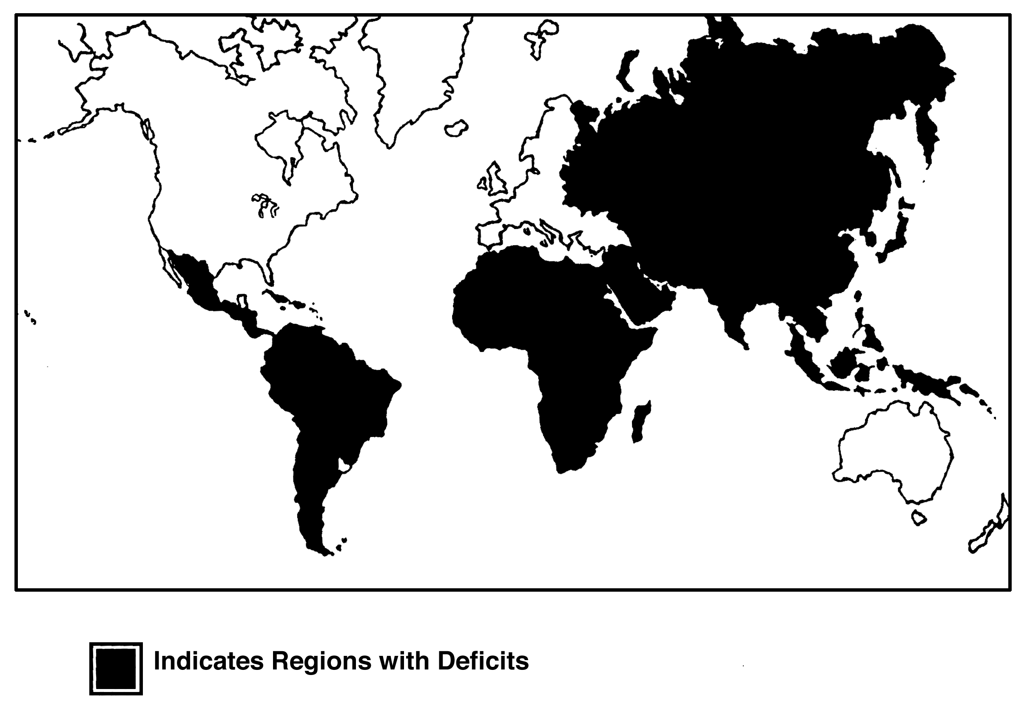

TM 2.2

World Map

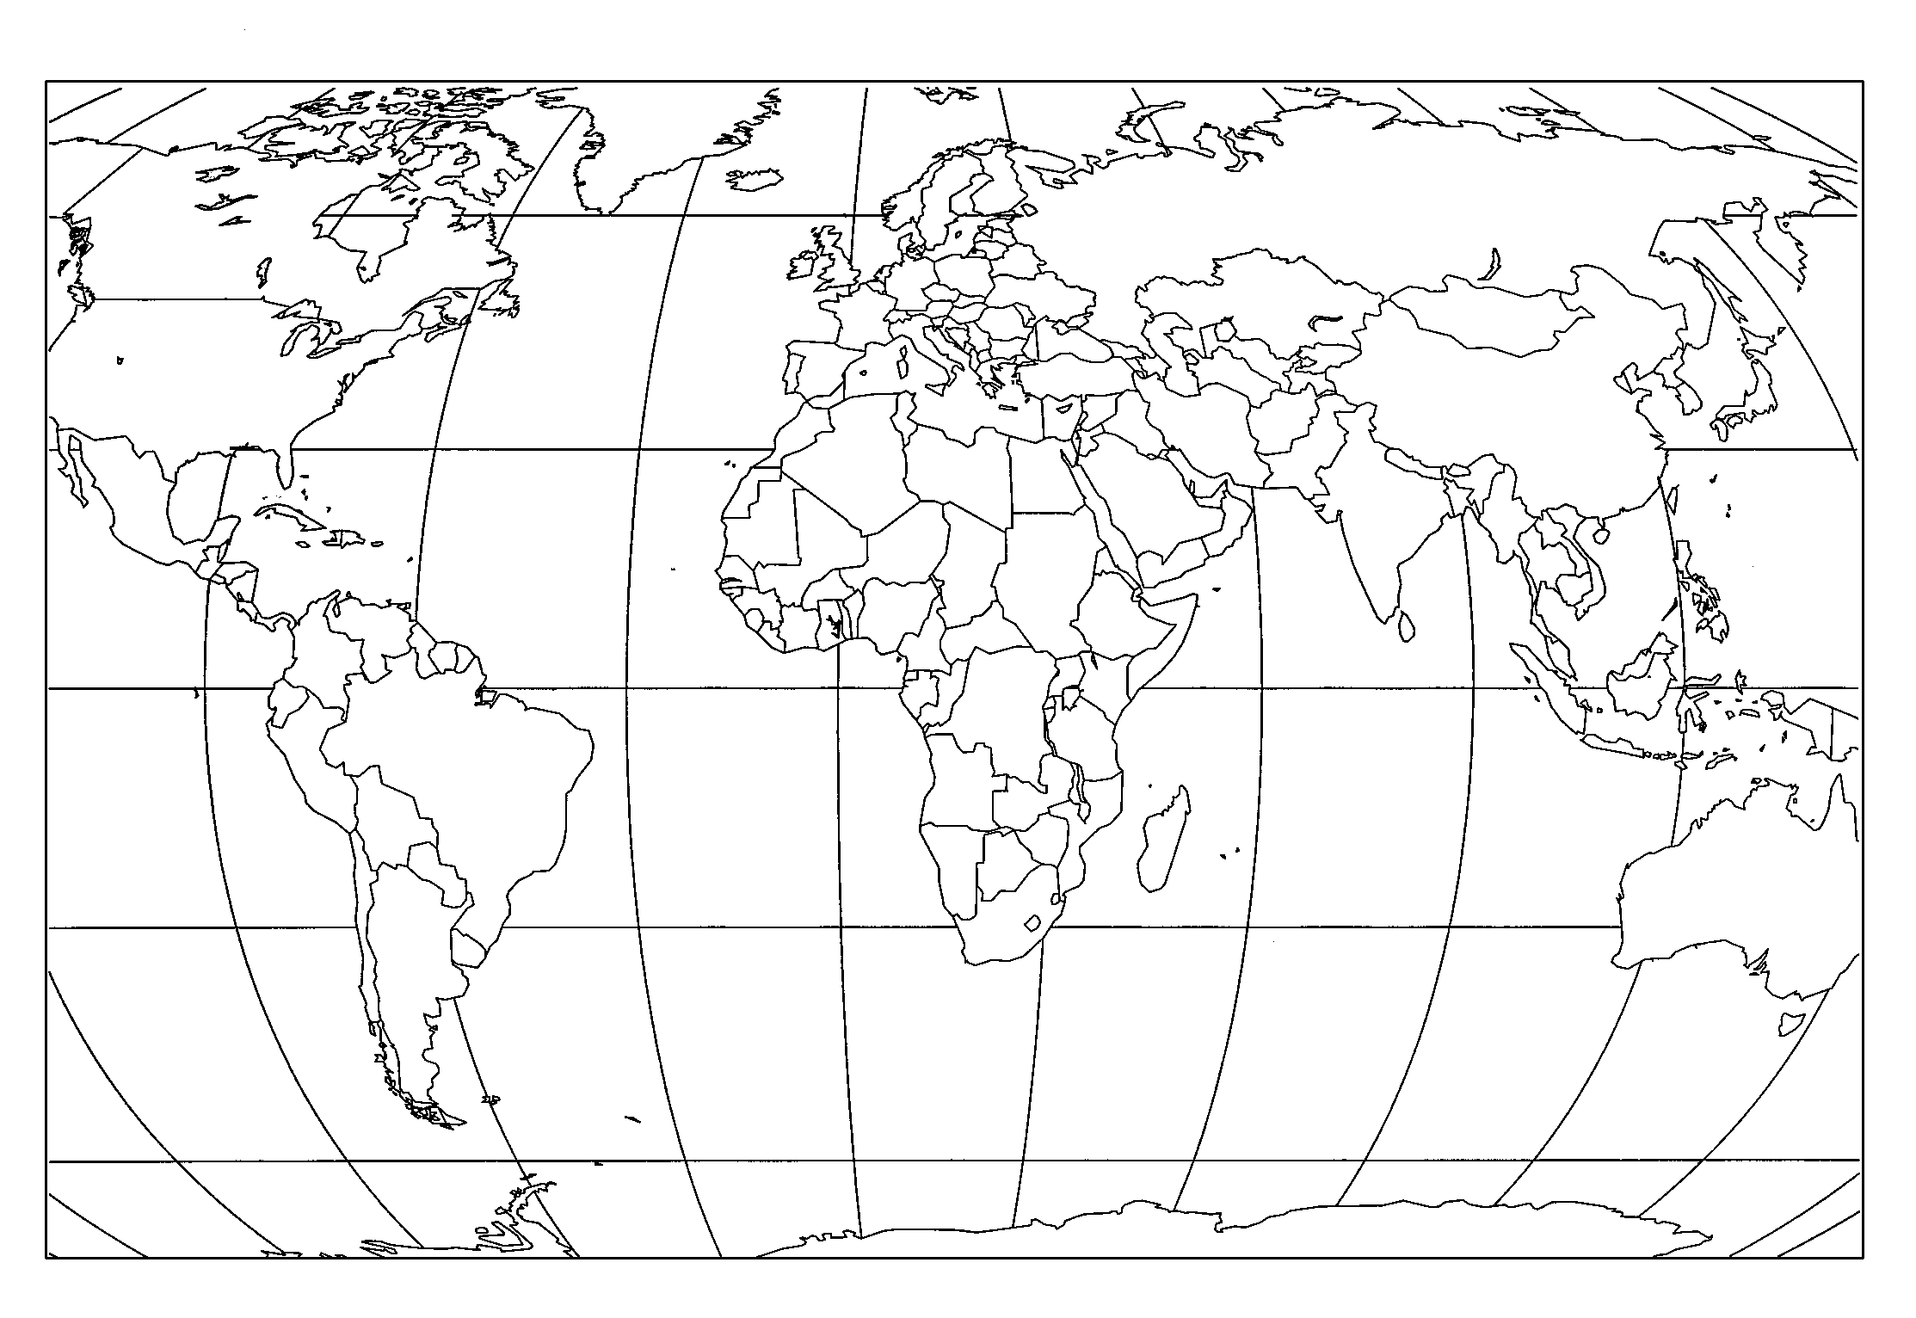

TM 2.3

Agricultural Commodities
in Major World Regions
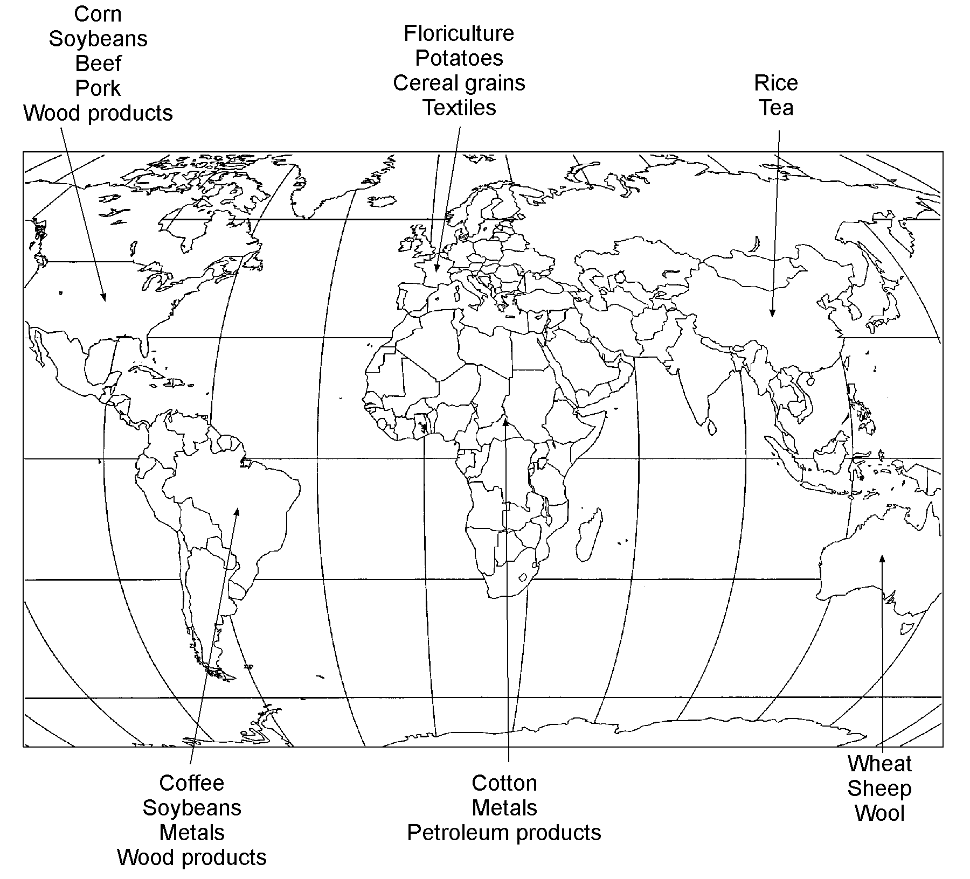

TM 2.4

World Statistics for Food, Population, and Life Expectancy

Continent | World  Food Consumed (%) | World Population (%) | Life Expectancy
Africa | 8 | 13 | 54
Asia | 23 | 61 | 64
Europe | 36 | 12 | 74
North America | 22 | 8 | 74
South America | 11 | 6 | 67

Source: World Population Prospects, United Nations Population Division (1999)

TM 2.5

U.S. Exports Purchased

Country | Amount of U.S. Agricultural Exports Purchased (in Billions of Dollars) | Percent of U.S. Agricultural Exports
Japan | $12.1 | 19.6%
European Union  (15 countries) | $10.0 | 16.3%
Canada | $9.0 | 14.6%
Mexico | $6.3 | 10.2%
South Korea | $2.4 | 3.9%

UNIT I - INTRODUCTION TO AGRICULTURE AS 2.1

Lesson 2: Agriculture in the World Instructor

International Auction

Objective: Students will gain a better understanding of how funds available to purchase agricultural products on the world market affect food distribution.

Directions: Before class begins, copy five pages of "food product" coupons and five pages of "other product" coupons (provided on the next two pages). Cut out the coupons.

Divide the class into groups of three or four students. Assign each group to represent a country from the list provided below. Provide each group with the amount of money indicated, which is the amount of money available to buy agricultural products on the world market. Tell each group how much money it has available and how many food coupons it needs to purchase to feed the country's population. Distribute a copy of AS 2.1 (Student) to each group (country) to record its purchases.

Each group should purchase the food first; additional products may be purchased if the amount of food is adequate. Have each group report its position after all trading has been completed.

Country

USA
England
France
Australia
USSR
China
India
Japan
Ethiopia
Saudi Arabia
Units of Food Needed

1
1
1
1
5
10
15
5
10
5
Funds Available

$50 billion
$10 billion
$10 billion
$10 billion
$20 billion
$10 billion
$10 billion
$30 billion
$5 billion
$40 billion

Conduct an auction, beginning with the food product coupons until each group (country) has spent all of its money or does not wish to make any more purchases. At the end of the auction, have each group explain what was purchased and how much money is left over.

Students should be guided to the conclusion that some countries lack sufficient resources to raise or purchase the food needed to feed their people. Other countries are wealthy enough to supply the food and also to purchase other products to improve the quality of life for their citizens. Also, note that countries with a large amount of funds available usually get those funds by exporting other products. Countries with limited funds usually have fewer products that they can sell as exports.

FOOD PRODUCT COUPONS

Food Products  $1 Billion | Food Products  $1 Billion
Food Products  $1 Billion | Food Products  $1 Billion
Food Products  $1 Billion | Food Products  $1 Billion
Food Products  $1 Billion | Food Products  $1 Billion
Food Products  $1 Billion | Food Products  $1 Billion
Food Products  $1 Billion | Food Products  $1 Billion

OTHER PRODUCT COUPONS

Automobiles  $2 Billion | Crude Oil  $2 Billion
Electronic Equipment  $3 Billion | Military Aircraft  $3 Billion
Medicine  $1 Billion | Tractors  $1 Billion
Lumber  $1 Billion | Steel  $1 Billion
Airplanes  $3 Billion | Agricultural Equipment  $1 Billion
Shoes  $1 Billion | Clothing  $1 Billion

UNIT I - INTRODUCTION TO AGRICULTURE AS 2.1

Lesson 2: Agriculture in the World Name__________________________

International Auction

Objective: Students will gain a better understanding of how funds available to purchase agricultural products on the world market affect food distribution.

Directions: Fill in the blanks as indicated. As purchases are made, record what was purchased and how much was spent on each purchase.

Country

Food Units Needed

Funds Available $

Units Purchased | Funds Spent
Ending Balance: $

Were you able to purchase enough food to feed your country? Why or why not?

UNIT I - INTRODUCTION TO AGRICULTURE AS 2.2

Lesson 2: Agriculture in the World Name__________________________

Travel to a Foreign Country on the Internet

Objective: Students will identify key information about foreign countries.

Directions: Use the 1999 World Fact Book (<http://www.odci.gov/cia/publications/factbook/index.html> and then click on the Country Listing link to find the following key information about your country.

Country

Location
Area
(comparative)
Land Use
Environment
(current issues)

Age Structure
0-14 years
15-64 years
65 years and over

Literacy
definition
total population
Population Growth Rate

Life Expectancy At Birth
total population
male
female
Languages
(official)

Population Below Poverty Line

Unemployment Rate

Agriculture
(products)

UNIT I - INTRODUCTION TO AGRICULTURE AS 2.3

Lesson 2: Agriculture in the World Instructor

World Food Activity

Objective: Students will be able to understand the relationship between people and food in the global setting.

Materials and Equipment:

Food items such as donuts, bread sticks, candy, etc., work the best for this activity. The quantity and the exact food item will depend on the size of the class and the time of day the class meets.
Cutting utensils, plates, and napkins may also be needed, depending on the food items selected.

Procedure:

Note: An example is provided on the next page to help understand these procedures.

1. Put food item on a table at the front of the room and explain that the food represents all the food that will be consumed in the world today.

2. Write each continent name on a piece of cardboard, and then fold into a tent shape. Place these names at tables so students know which continent each group of students represents.

3. Based on the percent of world population in each continent (found in the example), and the number of students in the class, make slips of paper to represent this distribution. For example, Africa has 13% of the world population. In a class of 20 students, 13% or approximately 3 students (.13 x 20) would represent Africa.

4. In addition, indicate poor country, rich country, or country with political power on the slips of paper (see example). Not all counties located on their respective continents are equal, so this aspect adds some realism. This information will help students role-play the financial and political status of the country they represent.

5. Have each student randomly draw the continent/country that he/she will represent. After this random selection, students will gather by continent around a table(s) or section of the room.

6. Before each continent is given its amount of food (see example), each group must develop a plan for distribution to each country. Students must discuss and form a consensus as to how their food will be consumed. If the students can't come to a consensus, the instructor will make the decision.

7. Ask each continent to explain its food distribution plan. Finally, have a representative come forward to obtain that continent’s food supply. How do students who did not get as much food to eat feel? Continents may offer to trade items for another continent’s excess food. Do students think there is a connection between life expectancy and food?

8. Will students give the same portion to everyone? Or will they give larger portions to the ones who have more monetary or political power? Will the poor countries receive any food at all?

9. Continents with a low food supply or those with excess food may wish to discuss importing or exporting. Encourage this discussion and after each continent receives its food, discussion will become more serious. Will an “international conflict” take place?

Example: Using 10 donuts for a class of 20 would result in the following donut distribution:

Continent | Donut | % Food | % Population | Life Expectancy
Africa | 1 | 8 | 13 | 54
Asia | 2 ¼ | 23 | 61 | 64
Europe | 3 ½ | 36 | 12 | 74
North America | 2 ¼ | 22 | 8 | 74
South America | 1 | 11 | 6 | 67

These continent/country indicator names are in the correct proportion based on world population and a class of 20 (use these for the slips of paper for the drawing):

Africa (rich country) Asia (poor country)

Africa (poor country) Asia (poor country)

Africa (poor country) Asia (poor country)

Asia (country with political power) Asia (poor country)

Asia (rich country) Asia (poor country)

Asia (rich country) Europe (rich country)

Asia (rich country) Europe (poor country)

Asia (poor country) North America (rich country)

Asia (poor country) North America (poor country)

Asia (poor country) South America

