UNIT I - INTRODUCTION TO AGRICULTURE

Lesson 3: Agriculture in the United States

Competency/Objective: Describe the role of agriculture in the United States.

Study Questions

1. Where are major products produced in the United States?

2. What enables agriculture to be successful in the United States?

3. What are the goals of agriculture in the United States?

4. How has the U.S. agricultural industry evolved?

5. How have changes in agriculture impacted U.S. history?

References

1. Exploring Agriculture in America (Student Reference). University of Missouri-Columbia: Instructional Materials Laboratory, 2000, Unit I.

2. Transparency Master

TM 3.1 Map of United States

3. Activity Sheets

AS 3.1 Census of Agriculture (Instructor)
AS 3.1 Census of Agriculture (Student)
AS 3.1 Census of Agriculture (Supplement)
AS 3.2 Time Line of Agriculture and History (Instructor)
UNIT I - INTRODUCTION TO AGRICULTURE

Lesson 3: Agriculture in the United States

TEACHING PROCEDURES

A. Review

Previously we learned the importance of agriculture in the world. This lesson examines the role of the agricultural industry in the United States. Discussion about our country’s largest employer will focus on the evolution of agriculture, how it has impacted U.S. history, and important characteristics of agriculture.

B. Motivation

1. Ask students to guess how much of the following food items each person (per capita) consumes each year. These 1996 figures are available from the USDA web site at <http://www.nass.usda.gov/pa/annsum98/page88.htm>.

Food Item | Per Capita Consumption
Beef | 64 lb.
Pork | 46 lb.
Chicken | 50 lb.
Fish | 15 lb.
Potatoes | 145 lb.
Fruit | 228 lb.
Vegetables | 253 lb.
Ice cream | 16 lb.
Milk | 24 gal.
Coffee | 22 gal.
Carbonated soft drinks | 52 gal.
Bottled water | 14 gal.

2. Conduct a word association activity where students list the first thought that comes to mind regarding agriculture when the teacher announces the following states: Texas, Idaho, California, Iowa, Georgia, Kansas, Minnesota, Washington, Florida, Wisconsin, North Carolina. This motivational activity will help the teacher assess the basic knowledge level students have about agriculture in the United States.

C. Assignment

D. Supervised Study

E. Discussion

Q1. Where are major products produced in the United States?

A1. Based on the 1997 Census of Agriculture:

Agricultural Product | Leading States
Beef cows | Texas, Missouri, Nebraska, Oklahoma, South Dakota
Market beef | Texas, Kansas, Nebraska, Colorado, Iowa
Dairy cows/products | California, Wisconsin, New York, Pennsylvania, Minnesota
Market pigs | Iowa, North Carolina, Minnesota, Illinois, Indiana
Sheep and lambs | Colorado, Texas, Wyoming, California, South Dakota
Egg production (layers) | California, Ohio, Pennsylvania, Iowa, Indiana
Chickens (broilers) | Georgia, Arkansas, Alabama, North Carolina, Mississippi
Turkeys sold | North Carolina, Minnesota, Virginia, Arkansas, California
Corn | Iowa, Illinois, Nebraska, Minnesota, Indiana
Wheat | Kansas, North Dakota, Montana, Washington, Oklahoma
Soybeans | Iowa, Illinois, Minnesota, Indiana, Ohio
Cotton | Texas, California, Georgia, Mississippi, Arkansas
Peanuts | Georgia, Texas, Alabama, North Carolina, Florida
Potatoes | Idaho, Washington, Wisconsin, Oregon, Colorado
Alfalfa hay | California, Wisconsin, South Dakota, Nebraska, Idaho
Green peas | Minnesota, Wisconsin, Washington, Oregon, New York
Lettuce | California, Arizona, Florida, New Jersey, Colorado
Sweet corn | Minnesota, Wisconsin, Washington, New York, Oregon
Tomatoes | California, Florida, Ohio, Michigan, Indiana
Apples | Washington, Michigan, New York, California, Pennsylvania
Oranges | Florida, California, Texas, Arizona, Hawaii
Grapefruit | Florida, California, Texas, Arizona, Hawaii
Pears | Washington, California, Oregon, New York, Michigan
Peaches | California, Georgia, South Carolina, New Jersey, Michigan
Pecans | Georgia, Texas, New Mexico, Arizona, Oklahoma
Strawberries | California, Florida, Oregon, Washington, Michigan

Have students complete AS 3.1 to answer this study question. Use more current data if available. Using the answers for AS 3.1 and the U.S. map on TM 3.1, locate the states that grow the major commodities.

Q2. What enables agriculture to be successful in the United States?

A2.
a) Fertile soil - some of the finest in the world
b) Growing conditions - very favorable for producing a variety of crops
c) New technology and many discoveries by leaders, inventors, researchers, and scientists
d) Technology adopted by entrepreneurs to improve production and efficiency
e) Advanced and extensive transportation and marketing system

Discuss with students the successful characteristics of a business. Relate those factors to agriculture.

Q3. What are the goals of agriculture in the United States?

A3.
a) Provide food, clothing, and shelter
b) Protect the environment
c) Ensure food safety
d) Use technology to benefit consumers

Have students provide examples of how agriculture fulfills each of the four goals. Identify how the goals of agriculture have changed over time.

Q4. How has the U.S. agricultural industry evolved?

A4.
a) The United States has shifted from a nation of farmers at the time of the Revolutionary War (90% of the colonists were farmers) to an agribusiness economy.
b) Technology has made it possible for less than 2% of the U.S. population to be farmers and approximately 20% to be employed in agribusiness.
c) Many advances have taken place in production agriculture due to management, technology, and agricultural research. In general, crop yields have increased and meat animals have become leaner and more cost efficient.

Refer to Table 3.1 in the Student Reference and discuss why the production of corn has increased over the years while hours of labor have decreased. Discuss how more people can be fed through fewer hours of labor and fewer farm workers.

Q5. How have changes in agriculture impacted U.S. history?

A5. Significant events in U.S. agricultural history:
a) 1793 - Eli Whitney invented the cotton gin.
b) 1836 - The grain combine was patented.
c) 1837 - John Deere plows were first manufactured.
d) 1862 - Morrill Land-Grant College Act was passed.
e) 1867 - Barbed wire was invented.
f) 1892 - John Froelich built the first gasoline tractor.
g) 1914 - Smith-Lever Act established the Extension Service.
h) 1917 - Smith-Hughes Act was passed.
i) 1922 - Hybrid seed corn was developed.
j) 1950s - Mechanization increased and commercial fertilizer was adopted.
- 1960s - Herbicides and insecticides gained popularity.
- 1970s - Use of confinement structures began and artificial insemination of livestock increased.
m) 1980s - Use of conservation tillage and computers increased.
n) 1990s - Global positioning systems technology emerged.
o) Mid 1990s - First crops improved through biotechnology were commercialized.
p) 1997 - A sheep was genetically cloned from adult cells.

Discuss the evolution of agriculture in America. Conduct AS 3.2 to have students research and create a time line of other events that have impacted U.S. agricultural history.

F. Other Activities

1. Bring in a variety of food items for students to sample. Identify the state where the item or major ingredient(s) or processed product was raised and produced.

2. Have students research and report on the role of agriculture in the westward expansion of the United States.

3. Have students select a significant event in agricultural history and present a report either oral or written.

4. Students may develop pen pals in different states as a means to explore agriculture across the United States. One possibility is the discussion group on National FFA Online <http://www.ffa.org/ffatalk.html>.

5. Have each student write to a department of agriculture in a different state. Each student should request information about agriculture in that state such as pictures, maps, product samples, etc.

G. Conclusion

The United States is fortunate to have ideal growing conditions for the production of a variety of crops and livestock. Many inventors, legislators, researchers, scientists, and entrepreneurs were instrumental in the development of agriculture in the United States. They have contributed to the efficiency and productiveness of American agriculture. At the same time, agriculture has remained true to its goal of providing food, clothing, and shelter as well as fulfilling the recent goals of protecting the environment, ensuring a safe food supply, and using technology to benefit consumers.

H. Answers to Activity Sheets

AS 3.1 Census of Agriculture

See the answer to study question 1 for data from 1997.

AS 3.2 Time Line of Agriculture and History

Answers will vary.

I. Evaluation

A unit test is provided at the end of this unit. If a lesson quiz is needed, use questions pertaining to this lesson from the unit test.

TM 3.1

Map of United States

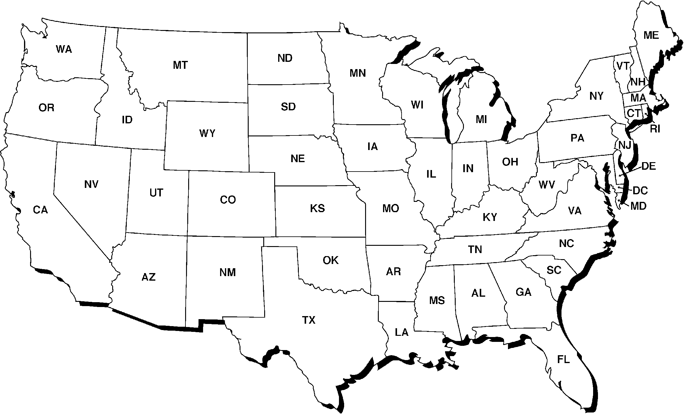

UNIT I - INTRODUCTION TO AGRICULTURE AS 3.1

Lesson 3: Agriculture in the United States Instructor

Census of Agriculture

Objective: Students will investigate where agricultural products are grown in the United States.

Directions:

1. There are 26 agricultural commodities listed on AS 3.1.

2. This assignment can be completed several ways.
a. It may be a take-home assignment where each student completes the entire sheet.
b. It may be a take-home assignment where each student finds rankings for one or two products.
c. Teams of students could find a certain number of items.
d. A computer lab at school can be used for research.

3 After the information on AS 3.1 is found, each student could identify where the major production areas are in the United States using AS 3.1 Supplement or TM 3.1.

4. Have students or teams orally present where their agriculture products are primarily produced in the United States.

5. Finally, students will help develop a bulletin board with their research.

a. Obtain or make a large map of the United States.

b. Post it on a bulletin board or another area of the classroom.

c. Have students or teams make a symbol for the agricultural product(s) they researched. Place the symbol on the leading state(s) on the bulletin board display.

UNIT I - INTRODUCTION TO AGRICULTURE AS 3.1

Lesson 3: Agriculture in the United States Name ________________

Census of Agriculture

Objective: Students will investigate where agricultural products are grown in the United States.

Directions: Using the 1997 Census of Agriculture, locate the following information. Tables with this information can be found at <http://www.hass.usda.gov/census/census97/rankings/tablist.htm>. Ask your instructor if information for a more recent year is available.

Agricultural Product | Leading States
Beef cows
Market beef
Dairy cows/products
Market pigs
Sheep and lambs
Egg production (layers)
Chickens (broilers)
Turkeys
Corn
Wheat
Soybeans
Cotton
Peanuts
Potatoes
Alfalfa hay
Green peas
Lettuce
Sweet corn
Tomatoes
Apples
Oranges
Grapefruit
Pears
Peaches
Pecans
Strawberries

UNIT I - INTRODUCTION TO AGRICULTURE AS 3.1

Lesson 3: Agriculture in the United States Supplement

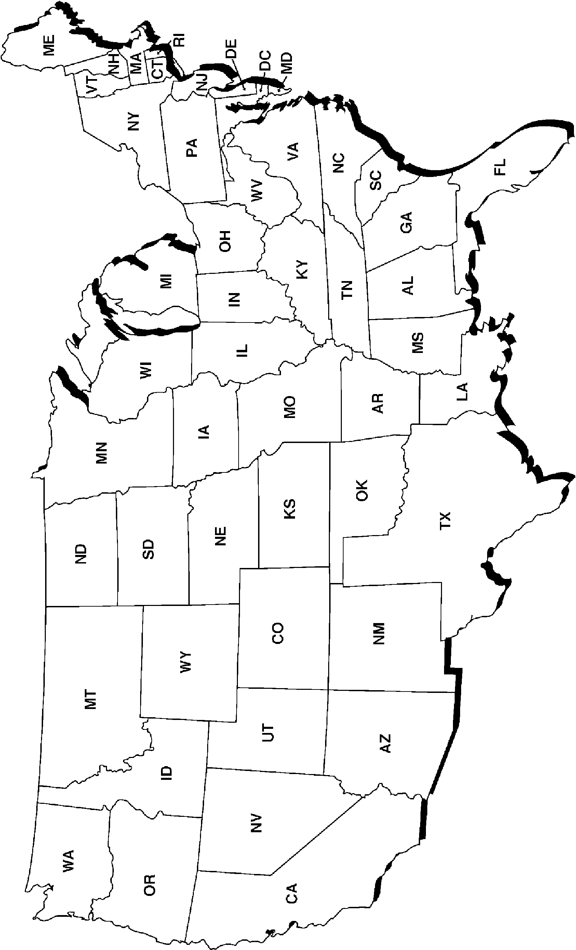
Map of the United States

UNIT I - INTRODUCTION TO AGRICULTURE AS 3.2

Lesson 3: Agriculture in the United States Instructor

Time Line of Agriculture and History

Objective: Students will discover historical events that impacted agriculture in the United States.

Materials and Equipment:

Poster paper that can be cut into a long time line
Markers

Procedure:

1. Divide the students into groups of three to five, depending on the size of the class. Assign the groups a span of years, for example, 1750-1800, 1801-1850, 1851-1900, 1901-1950, and 1951-2000. Have them use the "Historical Impact of Changes in Agriculture" section in the Student Reference as a starting point.

2. Students will need to research other important historical events. These dates will help to integrate social studies and agriculture. Events that might be added could include dates of major wars, important inventions, formation of organizations, sporting events, legislation, etc.

3. Each group will put its time line on the poster paper.

4. Tape the time lines together and post them around the room.

