UNIT I - INTRODUCTION TO AGRICULTURE

Lesson 4: Agriculture in Missouri

Competency/Objective: Describe agriculture in Missouri.

Study Questions

1. What commodities are produced in Missouri?

2. Why is agriculture important in Missouri?

3. Why and how has Missouri agriculture changed?

References

1. Exploring Agriculture in America (Student Reference). University of Missouri-Columbia: Instructional Materials Laboratory, 2000, Unit I.

2. Missouri Farm Facts 1999. Missouri Department of Agriculture and U.S. Department of Agriculture. Missouri Agricultural Statistics Service, August, 1999. (Updated versions are available yearly from Missouri Agricultural Statistics Service <http://agebb.missouri.edu/mass>.)

3. Transparency Masters

TM 4.1 Missouri's 1998 Ranking in the United States
TM 4.2 How Has Missouri Agriculture Changed?

4. Handout

HO 4.1 1997 Cash Receipts

5. Activity Sheets

AS 4.1 Name That Drawing (Instructor)
AS 4.2 Agricultural Commodities Produced in Missouri
AS 4.3 Hat Day
UNIT I - INTRODUCTION TO AGRICULTURE

Lesson 4: Agriculture in Missouri

TEACHING PROCEDURES

A. Review

Agriculture is a major industry in the United States. Agricultural products provide food for U.S. consumers and are exported to several foreign countries. Agriculture is also an important industry in the state of Missouri.

B. Motivation

Conduct AS 4.1 so that students will appreciate the diverse components of Missouri agriculture.

C. Assignment

D. Supervised Study

E. Discussion

Q1. What commodities are produced in Missouri?

A1.
a) The following commodities and their rank among the other 49 states per 1998 data are as follows:
1) Number of farms - 2nd
2) Beef cows - 2nd
3) Grain sorghum - 4th
4) Hay (all types)- 4th
5) Turkeys raised - 5th
6) Concord grapes - 6th
7) Rice - 6th
8) Soybeans - 6th
9) Hogs and pigs - 7th
10) Cheese - 9th
11) Watermelons - 9th
12) Broilers - 10th
13) Corn - 10th
14) Winter wheat - 11th
15) Cotton - 12th
16) Ice cream - 12th
17) Tobacco - 12th
18) Eggs - 14th
19) Milk - 15th
b) Logging and wood products manufacturing contribute $3 billion each year to Missouri's economy.
c) Horticultural businesses produced almost $68 million in sales in 1998.
d) Missouri is a large supplier of Golden and Red Delicious, and Jonathan apples. More than 40 million pounds of apples are produced annually.

Divide students into groups and have them list agricultural commodities produced in Missouri. Write their answers on the board and discuss them. Next, show the left half of TM 4.1. Ask students to guess Missouri's ranking in the United States.

Have students complete AS 4.2 using copies of Missouri Farm Facts or the Internet <http://agebb.missouri.edu/mass/farmfact/index.htm>.

Q2. Why is agriculture important in Missouri?

A2.
a) A diversity of environmental factors enables agriculture to be produced in Missouri.
1) Geography
2) Vegetation
3) Climate
4) Soil fertility
b) The value of agricultural products produced in Missouri each year is approximately $4.5 billion.
c) In addition to production agriculture, many people are employed in other areas of the agricultural industry.
2) Agribusiness employs more than 15% of Missouri's labor force, which is one in every six workers in the state, or more than 400,000 people.
3) The agricultural processing and marketing sector employs approximately 92,000 people.

Missouri produces a variety of crops and other agricultural products. Use HO 4.1 to identify Missouri counties where crop and livestock production is concentrated. (The instructor should update the handout using the most current Missouri Farm Facts.) Conduct AS 4.3 to familiarize students with various agricultural careers.

Q3. How has Missouri agriculture changed?

A3.
a) Medium-size farms have declined the most.
b) The average size of farms has increased.
c) The average age of producers has increased.
d) There are lower numbers of producers under the age of 35.
e) Agricultural businesses are hiring more employees, especially females.
f) Producers are continuing to adopt new technology.
g) More attention is paid to soil conservation and water quality.
h) The trend has been toward larger farming operations, the formation of farmer cooperatives, and the consolidation of agricultural businesses.
i) The number of businesses involved in biotechnology and life sciences are increasing in Missouri.

Use TM 4.2 to discuss changes in Missouri agriculture.

F. Other Activities

1. Use the Missouri Agricultural Statistics service <http://agebb.missouri.edu/mass/index.htm> and county Agri-Facts to identify key information about your county.

2. Ask a representative from the Missouri Department of Agriculture or the Cooperative Extension Service to talk to the class.

3. Have students write for their own copy of Missouri Farm Facts for home. They can request a copy from Missouri Agricultural Statistics Service, P.O. Box L, Columbia, MO 65205, (573) 876-0950, <http://agebb.missouri.edu/mass>.

G. Conclusion

Agriculture is very diverse in Missouri and is the most important industry. Agricultural production provides raw products, agricultural business, and career opportunities that directly contribute to the state's economy. More than 15% of Missouri's labor force is employed in agribusiness. Missouri products are used by consumers in the state, across the United States, and throughout the world. Missouri has changed and will continue to change agriculturally. However, the importance of the industry to the economy of the state will continue.

H. Answers to Activity Sheets

AS 4.1 Name That Drawing

There are no answers for this activity.

AS 4.2 Agricultural Commodities Produced in Missouri

Answers should be checked to the most current Missouri Farm Facts. The answers given below are for 1998 production.

Commodity | Area of Production
Corn | Northern half and Bootheel
Cotton | Bootheel
Wheat | North central and Bootheel
Soybeans | Northwest, north central, and Bootheel
Hay | Southwest
Dairy cattle | Southwest
Hogs and pigs | North and north central
Beef cows | Southwest
Sheep and lambs | Northern third
Grain sorghum | West central, central and Bootheel
Rice | Bootheel
Tobacco | Missouri River bottom

AS 4.3 Hat Day

The instructor should determine if the answers are appropriate.

I. Evaluation

A unit test is provided at the end of this unit. If a lesson quiz is needed, use questions pertaining to this lesson from the unit test.

TM 4.1

Missouri's 1998 Ranking in the
United States

Category/Commodity | Rank
Number of farms | 2nd
Beef cows | 2nd
Grain sorghum | 4th
Hay (all types) | 4th
Turkeys raised | 5th
Concord grapes | 6th
Rice | 6th
Soybeans | 6th
Hogs and pigs | 7th
Cheese | 9th
Watermelons | 9th
Broilers | 10th
Corn | 10th
Winter wheat | 11th
Cotton | 12th
Ice cream | 12th
Tobacco | 12th
Eggs | 14th
Milk | 15th

Source: Missouri Farm Facts 1999

TM 4.2

How Has Missouri Agriculture Changed?

Variable | Year
Variable | 1982 | 1997
Land in farms (acres) | 29,266,609 | 28,826,182
Percent of land in farms | 66.3 | 65.3
Number of farms | 112,447 | 98,860
Average size of farm (acres) | 260 | 292
Number of farm operators by age  - under 25  - 25-34  - 35-44  - 45-54  - 55-64  - 65 years or older | 3,606  14,231  21,546  24,517  25,924  22,623 | 1,257  7,133  18,523  22,285  22,192  27,470
Average age of producers | 51 | 55
Operator's principal occupation (percent)  - Farming  - Other | 52  48 | 45  55
Farms by value of sales (number)  - Less than $9,999  - $10,000-$49,999  - $50,000-$99,999  - $100,000 or more | 61,236  32,053  10,004  9,126 | 54,982  26,664  6,529  10,685

Source: Missouri Farm Facts 1999

HO 4.1

1997 Cash Receipts
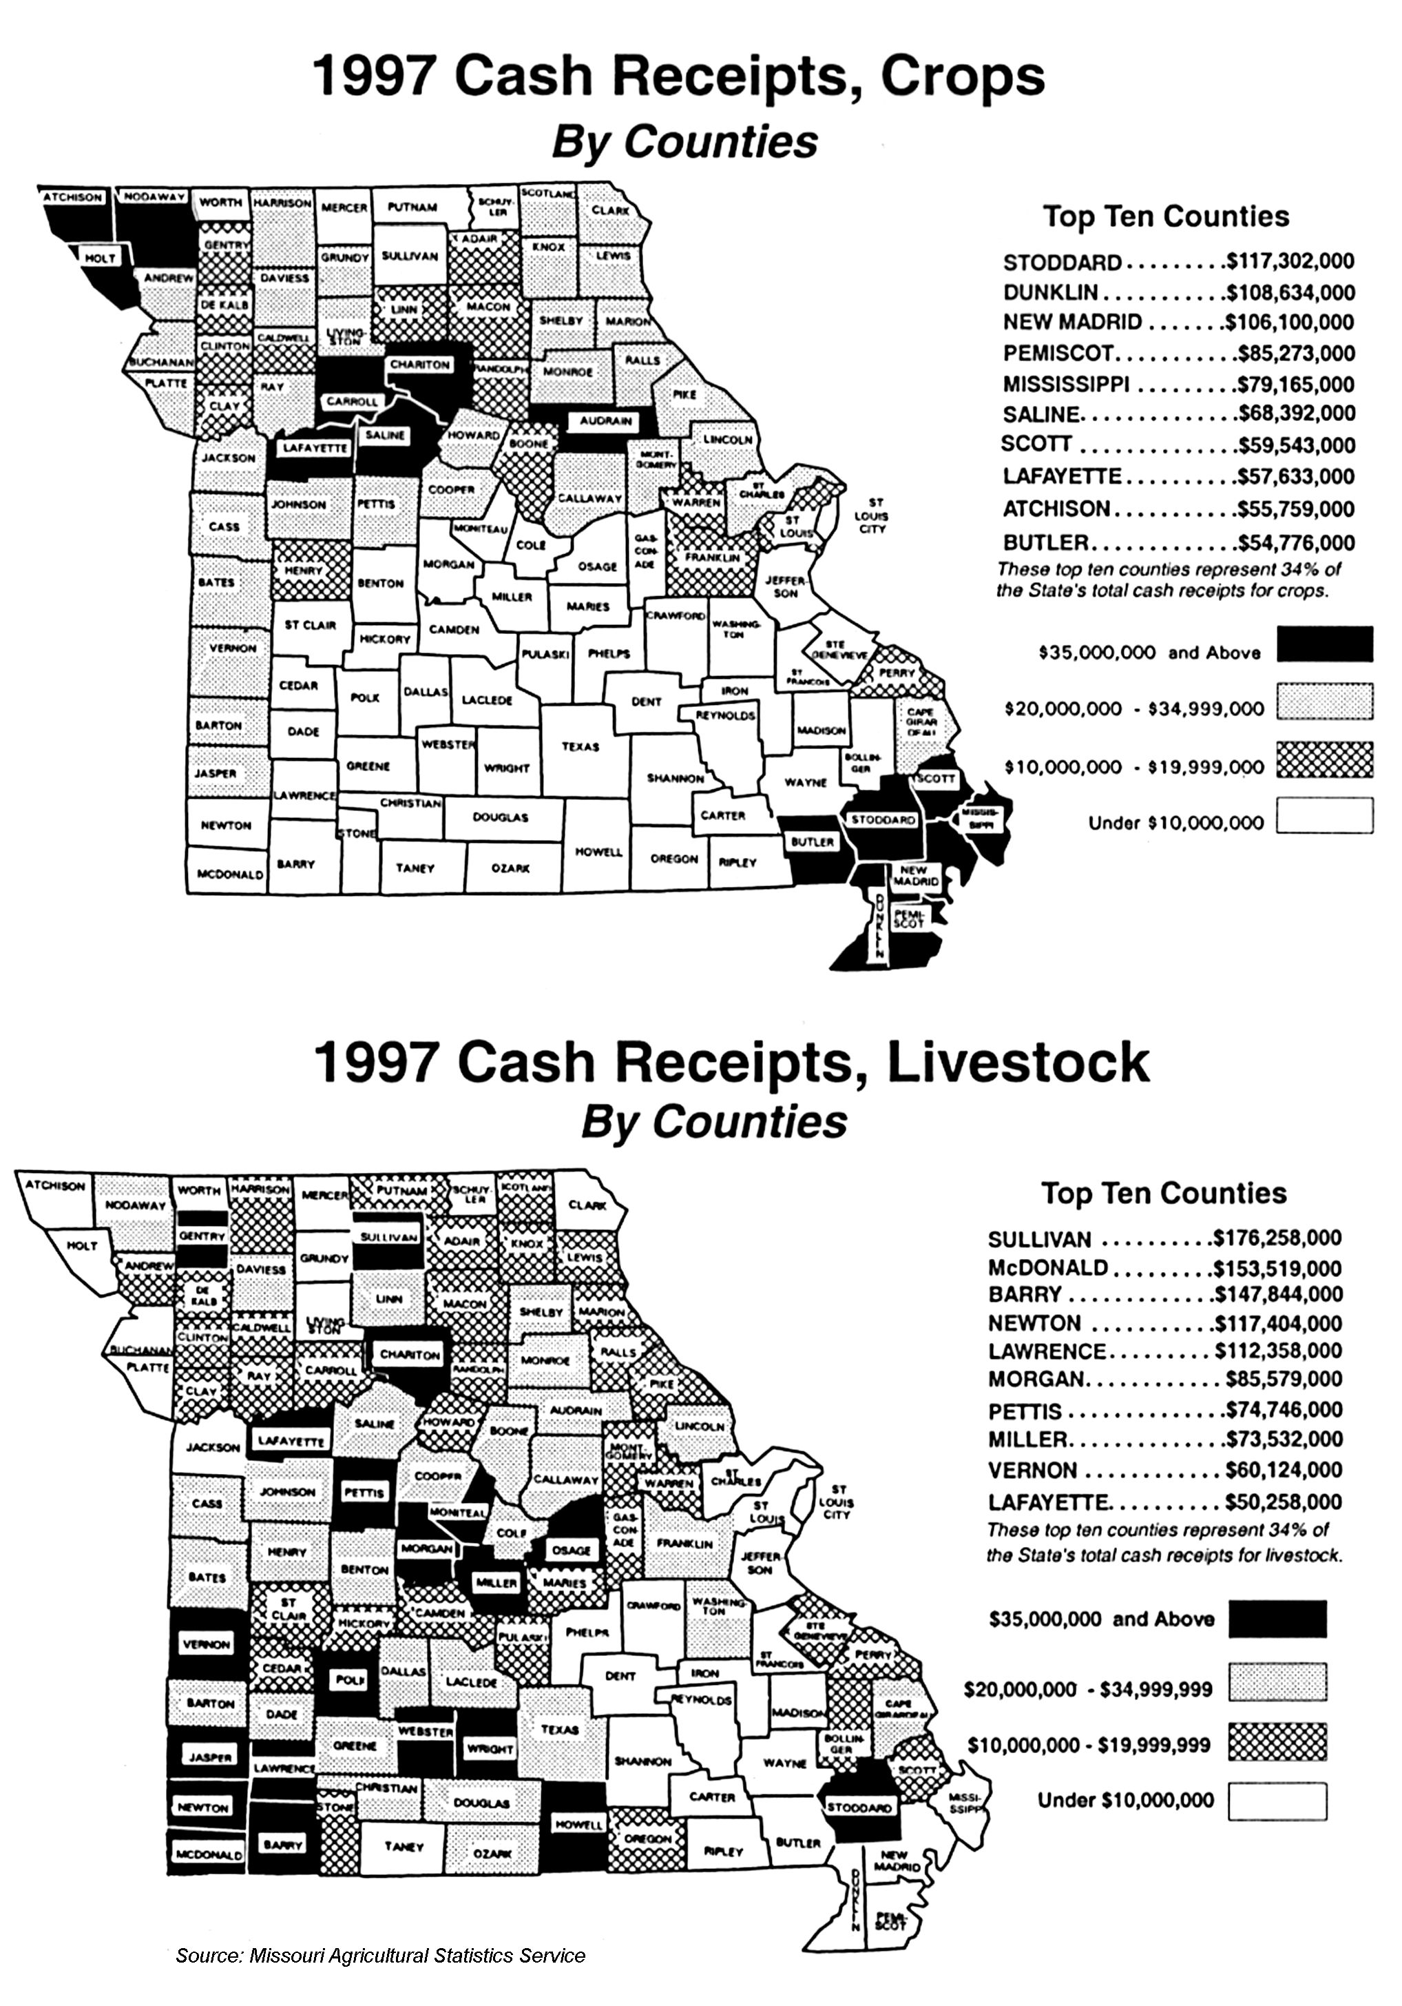

UNIT I - INTRODUCTION TO AGRICULTURE AS 4.1

Lesson 4: Agriculture in Missouri Instructor

Name That Drawing

Objective: Students will understand different components of Missouri agriculture.

Materials and Equipment:

Poster paper, white board, or blackboard
Markers or colored chalk
Note cards

Procedure:

1. Write each of the words listed below for the four concepts on separate note cards.

2. Divide the class into four teams of four to six students. Each team will be given a set of cards for a specific concept. (If there are more students in the class, additional concepts should be developed.)

3. Explain the rules below:

a. Each team will select a person to draw an image to represent the word on the card.
b. All the words lead to a concept and each of the concepts has a commonality.
c. Each word is worth 5 points, the concept is worth 10 points, and the commonality is worth 15 points.
d. There is no talking between the team members and the person drawing.
e. Each team will have 2 minutes to guess all of its words and solve the concept puzzle.
f. The person drawing may pass on one word.
g. If a team does not correctly state its concept, each of the other teams can write the
answer on a note card and gain the 10 points.
h. At the end of the game, each team will write its answer (commonality) on a note card.

4. The following are examples of words that can be used.

Words | Words | Words | Words
Corn | Pig | Lawn | DNA
Tractor | Cow | Flower | Cloning
Planter | Lamb | Greenhouse | Laboratory
Soil | Steak | Tree | Scientist
Weeds | Feed | Vegetable
Concept | Concept | Concept | Concept
Agronomy | Livestock or Animals | Horticulture | Biotechnology
Commonality
The concepts should build to the commonality that all describe agriculture in Missouri.

UNIT I - INTRODUCTION TO AGRICULTURE AS 4.2

Lesson 4: Agriculture in Missouri Name__________________________

Agricultural Commodities Produced in Missouri

Objective: Students will identify where major commodities are produced in Missouri.

Directions: Twelve agricultural commodities produced in Missouri are listed below. Using Missouri Farm Facts, identify areas of the state that have high concentrations of the commodity listed. Some information may be found on the Internet at <http://agebb.missouri.edu/mass/farmfact/index.htm>. One commodity has been done for you.

Commodity | Area of Production
Corn | Northern half and Bootheel
Cotton
Wheat
Soybeans
Hay
Dairy cattle
Hogs and pigs
Beef cows
Sheep and lambs
Grain sorghum
Rice
Tobacco

UNIT I - INTRODUCTION TO AGRICULTURE AS 4.3

Lesson 4: Agriculture in Missouri Name__________________________

Hat Day

Objective: Students will identify various jobs or careers in agriculture.

Directions: Interview a person who has a job in agriculture and answer the questions below. Role-play the person's job by wearing the hat to class and explaining what the person does.

1. Name of person you interviewed

2. Job title

3. Name of the business the person works for

4. Major sector of agriculture (one of seven identified in Unit I, Lesson 1)

5. What did you find out about the person's job?

a. Responsibilities

b. Favorable aspects

c. Least favorable aspects

d. Advice

