UNIT I - INTRODUCTION TO AGRICULTURE

Lesson 5: Advances in Agricultural Technology

Competency/Objective: Identify advances in agricultural technology and their implications.

Study Questions

1. What are recent changes in agriculture?

2. How will agriculture change in the future?

3. What are the implications of changes in agriculture?

References

1. Exploring Agriculture in America (Student Reference). University of Missouri-Columbia:
Instructional Materials Laboratory, 2000, Unit I.

2. Activity Sheets

AS 5.1 The Future and Change (Instructor)
AS 5.2 Future Headlines (Instructor)
AS 5.3 Invent a New Product for 2020
UNIT I - INTRODUCTION TO AGRICULTURE

Lesson 5: Advances in Agricultural Technology

TEACHING PROCEDURES

A. Review

Agriculture is a diverse industry. Many discoveries have been made in recent years that keep American agriculture on the leading edge of technology. There is a bright future for agriculture in America and for the people of this nation and the world. In this lesson, breakthroughs in agricultural technology and their effects on food and fiber production will be discussed.

B. Motivation

1. Pass out small, individual boxes of raisins to each student. While they eat the raisins, ask them to guess how much time it takes to process grapes into raisins. They should estimate the time needed to dump the product into the hopper, de-stem, sort by size and quality, wash, dry, package, and stack the containers. Write the students' answers on the board. The correct answer is 8 minutes. Show the video Green Cows, Quags, and Mummies available from the Missouri Resource Center for Career & Technical Education. Many of the concepts in the video have taken place. Discuss how technology will affect the production and marketing of food products in the future.

2. Using a microwave, cook two kinds of hot dogs, cut them into pieces, and have the students sample each. One package should be "all-beef" hot dogs. The other package should be made of turkey, chicken, or soybean products. Conduct a taste test to see which hot dogs students prefer. Explain the differences in the cost of the two products.

C. Assignment

D. Supervised Study

E. Discussion

Q1. What are recent changes in agriculture?

A1.
a) Computers
1) Maintenance of management records
2) Communication by e-mail
3) Information through the Internet
4) Environmental monitoring of facilities
5) Computer chips for animal identification
b) Mechanical
1) Electronic monitoring
2) Laser-guided equipment
3) Surveying instruments
4) Robotics
c) Livestock management
1) Automated systems of feeding, watering, and waste disposal
2) Totally controlled environments
3) Increased building size and more located in areas favorable for production
d) Embryo transfer
1) Eggs from superior female animals implanted into recipient females
2) Multiple offspring from one animal in a year
e) Cloning
1) Fertilized egg reproduced to create identical individual
2) Individuals with superior genetics produced
f) Genetically-modified crops or genetically-modified organisms (GMOs)
1) Corn resistant to corn borer
2) Soybeans resistant to herbicides
g) Precision agriculture
1) More efficiency through use of global positioning systems (GPSs)
2) "Farming by the inch" made possible

Present AS 5.1 to students and discuss how advancements in agricultural research continue to change America.

Q2. How will agriculture change in the future?

A2.
a) Biotechnology and precision agriculture will increase production.
b) Crop yields will increase.
c) Machinery and animals will become more cost efficient.
d) Value added to products will create new uses for by-products.
e) Combining science, agriculture, food, and health research will result in new products.

Technology has increased the production efficiency of American producers. New methods, equipment, and techniques have been developed to improve the quantity and quality of agricultural production. Some of the technology is very expensive and must be modified before it can be adopted in agriculture. Conduct AS 5.2 to get students thinking about future events.

Q3. What are the implications of changes in agriculture?

A3.
a) The challenge is to continue to increase agricultural productivity with about the same amount of land.
b) Global trade has increased and its importance must be recognized.
c) New career opportunities will be created.

Have students complete AS 5.3 to stimulate their thinking about agricultural inventions that would be useful in the future.

F. Other Activities

1. Invite a veterinarian, agronomist, or biotechnologist to class to discuss advances in technology.

2. Conduct a class experiment on hydroponics, growing plants in nutrient solutions without soil.

3. Have students do research papers on biotechnology.

4. Have students write an essay on what their town will be like in 50 years.

5. Invite a retired farmer to class to explain how technology has changed in agriculture.

G. Conclusion

Agriculture has and will continue to change. The fundamental goal will be to continue to produce quality food and fiber for the increasing population. New technology and research will help to increase productivity without compromising resources. Preserving natural resources is a top concern for everyone in agriculture. There will be many career opportunities in agriculture as the demand for food and fiber continues to increase.

H. Answers to Activity Sheets

AS 5.1 The Future and Change

There are no answers for this activity.

AS 5.2 Future Headlines

There are no answers for this activity.

AS 5.3 Invent a New Product for 2020

The instructor should determine if the answers are appropriate.

I. Answers to Evaluation

1. c
2. a
3. d
4. a
5. b
6. b
7. c
8. d
9. a
10. c
11. b
12. d
13. b
14. c
15. d
16. c
17. d
18. a
- c

20.
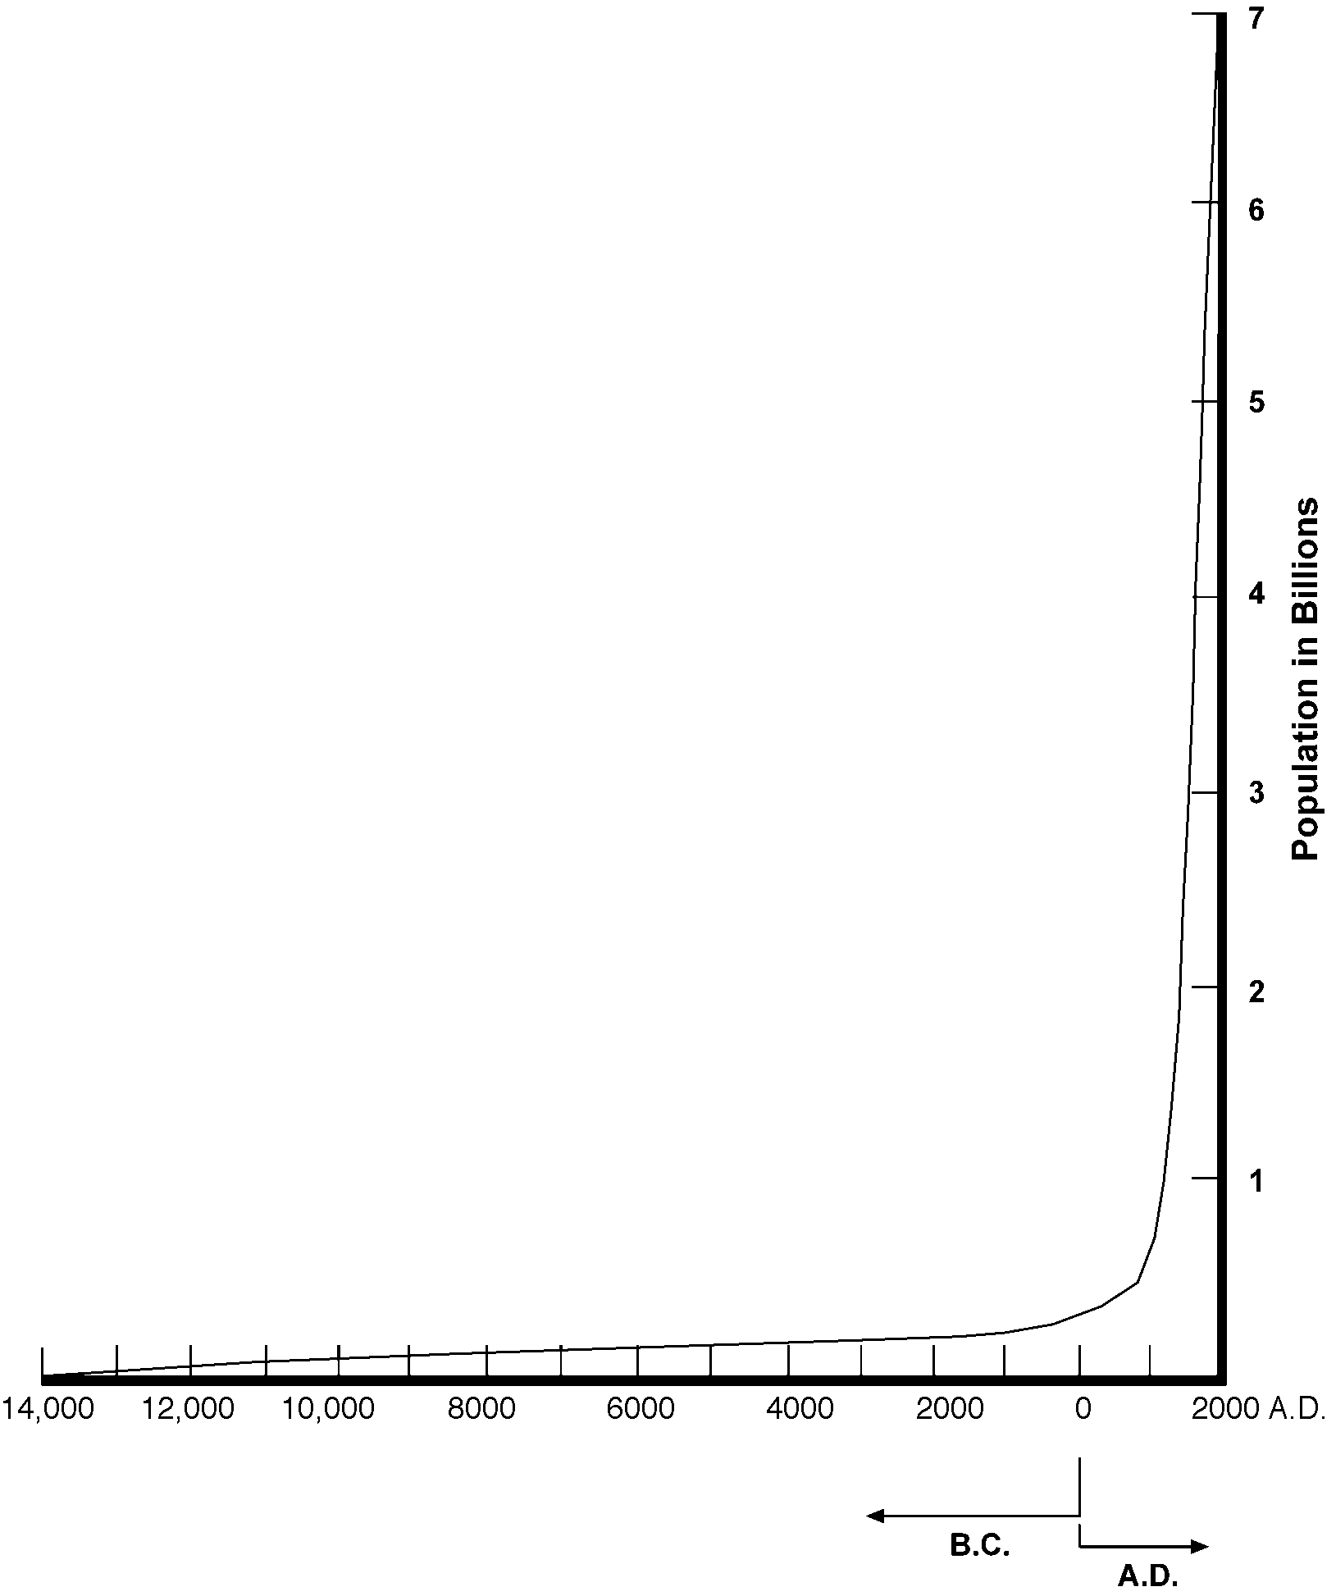

21. Any two of the following are correct: agriculture is more than farming, agriculture is the country's largest employer, variety of careers and opportunities, or bright future.
22. The instructor will need to determine if the answer is appropriate. Any one of the following is a suggested answer: hybrid seed corn developed, tractors replaced horses on farms, commercial fertilizers adopted, or crops improved through biotechnology.
23. a
24. c
25. c
26. f or g
27. c
28. c or b
29. e
30. e
31. e
32. b
33. d or g
34. c
35. f or e
36. g
37. c
38. f or e
39. c
- c
- g or c

UNIT I - INTRODUCTION TO AGRICULTURE AS 5.1

Lesson 5: Advances in Agricultural Technology Instructor

The Future and Change

Objective: Students will gain perspective of the time humans have existed and will make predictions about the future.

Directions: Have students discuss the following questions.

1. Ask students how long people have been around. Many answers will be given. Lead the group into agreeing on the following scenario that can be put on the blackboard.

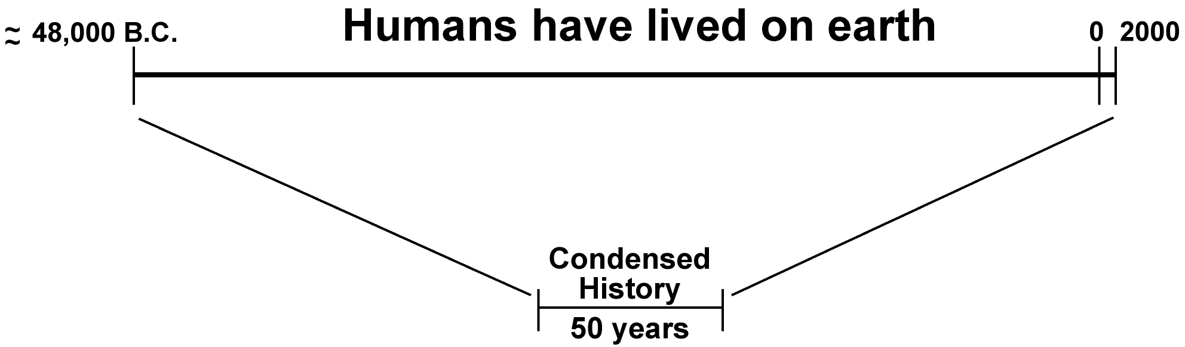

2. Read the following information to students. Fill in the correct dates or have students create a time line.

There are many ideas about how long humans have been on the earth. According to some scientists, humans have lived on this planet about 50,000 years. Due to our limited time on earth, it is practically impossible for anyone to accurately conceive 50,000 years. However, to provide a reference, imagine that everything that has happened to humans has occurred in a reduced period of time, namely, 50 years. With the scale so reduced, here is a scenario of what has happened:

- 11 years ago, or in ______, humans stopped living in caves.
- 5 years ago, or in ______, picture writing was invented.
- 2 years ago, or in ______, Christianity began.
- Approximately 8 months ago, ______, the printing press was invented.
- 10 days ago, electricity was discovered.
- Yesterday, the Wright brothers flew their first airplane at Kitty Hawk.
- Television was invented this morning.
- Jets came into being since we began talking about the future and change.
- The last 60 seconds brought about all our operations in space.
- The computer was invented in the last 20 seconds.

Just about every convenience that makes up our material world, from cars to jets, has been invented within the last 24 hours.

3. What will education and the world be like in the new millennium? Technological advances change our lives on a daily basis.

UNIT I - INTRODUCTION TO AGRICULTURE AS 5.2

Lesson 5: Advances in Agricultural Technology Instructor

Future Headlines

Objective: Students will consider possibilities for future society.

Materials and Equipment:

Overhead transparencies
Markers

Procedure:

1. Have students individually respond to the following question at the beginning of class, or assign this question as homework for the next day.

What do you predict will be the newspaper headlines in the year 2020?

Instruct them that agriculture has to be one of the areas for their predictions.

2. Review with students the basic rules of brainstorming.

a. Write down every idea.
b. Every idea or suggestion is a good one.
c. The objective is to generate as long a list of ideas as possible.
d. The procedure is to go around the circle with each person offering one idea at a time.

3. Divide students into groups of three to five, depending on the size of the class.

4. After brainstorming, distribute the transparencies and markers to each group. Instruct the students to identify at least five of their favorite headlines, of which at least one must pertain to agriculture. (Sports, movies, music, cars, etc. are other possibilities.)

5. Have the groups share their headlines and discuss what the effects would be if their predictions were to happen.

UNIT I - INTRODUCTION TO AGRICULTURE AS 5.3

Lesson 5: Advances in Agricultural Technology Name___________________________

Invent a New Product for 2020

Objective: Students will develop an idea for an invention that will be useful in the future of agriculture.

Directions:

1. Use magazines, books, agribusiness material, the Internet, etc., to research the latest in agricultural technology.

2. Use this research to invent a new agricultural product to be marketed in 2020.

3. Write a report that briefly explains the new product, its intended use, and its biggest advantage over the competition. Attach the magazine article, agribusiness material, or Internet information you used for research on the topic.

4. Prepare a brief oral report about your new invention.

UNIT I - INTRODUCTION TO AGRICULTURE Name ____________________

Date _____________________

UNIT EVALUATION

Circle the letter that corresponds to the best answer.

1. What is the meaning of the word agriculture in Latin?

a. Culture of growers
b. Merger of humankind and the environment
c. Science and art of cultivating the soil
d. Art of plants and animals

2. The largest industry in the United States is _____________________________________.

a. Agriculture
b. Automotive manufacturing
c. Computer technology
d. Transportation

3. Approximately _______________ % of the jobs in the United States are related to agriculture.

a. 2
b. 5
c. 10
d. 20

4. Less than ___________ % of the U.S. population are farmers.

a. 2
b. 5
c. 10
d. 20

5. The average American family spends approximately _______ % of its income for food.

a. 5
b. 11
c. 25
d. 32

6. Compared to other countries in the world, people in the United States enjoy _____________ food prices and have ______________________life expectancies.

a. Low, average
b. Low, long
c. Average, long
d. High, average

7. All of the following are top U.S. agricultural exports except _______________________________.

a. Soybeans
b. Consumer food (e.g., beef, pork, lamb)
c. Petroleum products
d. Grains (e.g., corn, oats, barley, sorghum, rye)

8. Agricultural differences throughout the world do not include _______________________________.

a. Climate
b. Soil fertility
c. Topography
d. Population

9. The United States imports _________________ from Columbia, Brazil, and Mexico.

a. Coffee
b. Automobiles
c. Petroleum products
d. Olives

10. In general, livestock production in the United States is located _____________________________.

a. In warmer regions
b. By research facilities
c. Where crops used for livestock food is readily available
d. On wheat farms

11. Which of the following choices is not a factor in why agriculture is successful in the United States?

a. Favorable growing conditions
b. Good air quality
c. Fertile soil
d. Many leaders, inventors, researchers, and scientists

12. One of the goals of U.S. agriculture is to ______________________________________________.

a. Learn how to grow bananas
b. Maintain traditions
c. Devote more land to farming
d. Protect the environment

13. Most of the first settlers who came to the United States were ______________________________.

a. Ship builders
b. Farmers
c. Blacksmiths
d. Carpenters

14. Based on statistics from 1998, Missouri is second in _____________________________________.

a. Winter wheat and rice
b. Hay and cheese
c. Number of farms and number of beef cows
d. Turkeys and number of farmers

15. Missouri's hilly and wooded areas in the ___________________ provide timber, pasture, and favorable weather for growing fruits and vegetables.

a. Central region
b. Northwest region
c. Northeast region
d. Ozarks

16. One of the ways Missouri agriculture has changed is that the ______________________________.

a. Medium-size farms have increased
b. Average age of producers has decreased
c. Number of producers under the age of 35 has decreased
d. Hiring in agribusinesses has declined

17. Which of the following choices is not a recent change in agriculture?

a. Computer technology
b. Embryo transfer
c. Genetically-modified crops
d. Commercial fertilizer

18. One of the predicted changes for agriculture is ________________________________________.

a. Increased crop yields
b. Machinery and animals will become obsolete
c. Biotechnology will decrease production
d. Precision farming will be phased out

19. Which of the following statements is not one of the implications of agricultural change?

a. Crop yields will increase using the same amount of land.
b. Global trade will become increasingly important.
c. The United States will isolate itself from the world market.
d. New career opportunities will be created.

Complete the following short-answer questions.

20. Identify how world population has changed through history. Explain this by drawing a graph and properly labeling the horizontal axis (years) and vertical axis (population).

21. A fellow student asks you about the career opportunities in agriculture. What are two important points to tell the student?

a.

b.

22. There are many important events in U.S. agricultural history. Identify one that you personally consider significant and justify your selection.

Match the career area of agriculture (a-g) with the job title. All are used at least once. Some job titles could have several answers, however select the one that describes its major job responsibility.

23. _____ Agricultural Electrician

24. _____ Agricultural Journalist

25. _____ Agricultural Loan Officer (Banker)

26. _____ Beekeeper

27. _____ Farm Broadcaster

28. _____ Federal Meat Inspector

29. _____ Floral Designer

30. _____ Greenhouse Manager

31. _____ Landscape Architect

32. _____ Meat Department Manager

33. _____ Park Ranger

34. _____ Pet Shop Operator

35. _____ Raspberry Grower

36. _____ Soil Conservationist

37. _____ University Professor

38. _____ Vegetable Producer

39. _____ Veterinarian

40. _____ Youth Leader (4-H)

41. _____ Zoo Manager

a. Agricultural systems technology

b. Agricultural processing and marketing

c. Agricultural supplies and services

d. Forestry

e. Horticulture

f. Production agriculture

g. Natural Resources

