UNIT II - PLANT SCIENCE

Lesson 2: Plant Parts and Processes

Competency/Objective: Describe the parts of a plant and major processes.

Study Questions

1. What are the functions of the parts of a plant?

2. How do plants reproduce?

3. What are the parts of a flower?

4. What is germination?

5. What is photosynthesis?

6. What is the difference between annuals, biennials, and perennials?

7. What is the difference between monocots and dicots?

References

1. Exploring Agriculture in America (Student Reference). University of Missouri-Columbia: Instructional Materials Laboratory, 2000. Unit II.

2. Transparency Masters

TM 2.1 Main Parts of a Plant
TM 2.2 Plant Propagation
TM 2.3 Asexual Propagation Methods
TM 2.4 Methods of Taking Cuttings
TM 2.5 Parts of a Complete Flower
TM 2.6 Can You Name an Annual, Biennial, or Perennial?
TM 2.7 Monocot or Dicot?
TM 2.8 Stages in Germination and Emergence of a Monocot
TM 2.9 Stages in Germination and Emergence of a Dicot

3. Activity Sheets

AS 2.1 Starting Plants from Stem Cuttings (Asexual Propagation)
AS 2.2 Parts and Functions of a Complete Flower
AS 2.3 Effect of Light on Photosynthesis

UNIT II - PLANT SCIENCE

Lesson 2: Plant Parts and Processes

TEACHING PROCEDURES

A. Review

Plants provide people with oxygen to breathe, food to eat, clothing, shelter, and landscaping beauty. Many plant science careers are available in agronomy, horticulture, and forestry.

B. Motivation

- Show examples of seeds that are small (bentgrass) and large (lima bean). Ask students if they are living or dead. What causes them to sprout (germinate)?

- Bring in examples of plants showing different stress problems such as excessive light, too little light, excessive water, compacted soil, lack of fertilizer, or pollution damage. Discuss the plant problems and what caused them. Discuss how proper conditions would allow for better growth.

- Is a room with plants healthier than one without? If this were true, why would plants make a difference? Discuss photosynthesis with students.

- Demonstrate several methods of plant propagation. Examples may include air layering a rubber plant, grafting a fruit tree, planting a bulb or tuber, or dividing a perennial flower.

C. Assignment

D. Supervised Study

E. Discussion

Q1. What are the functions of the parts of a plant?

A1.

a) Roots
- 1) Absorb water and minerals from the soil
- 2) Anchor the plant
- 3) Food storage area
- Stem
- Supports the plant's leaves and flowers
- Transports water, minerals, and manufactured food to all parts of the plant
- Site of some photosynthesis
- Food storage area
- Leaves
- Major producer of food for the plant (through photosynthesis)
- Food storage area
- Site of respiration and transpiration

d) Flower
- 1) Site of sexual propagation
- 2) Source of fruit and seed
- 3) Attracts pollinators

Bring into class a flowering plant and have the class discuss the main parts. Ask students to tell the function of the main parts. Use TM 2.1 to display the main parts of a plant.

Q2. How do plants reproduce?

A2.

a) Sexually
1) Sexual propagation occurs within the flower as a result of pollination.
2) This produces fruit and seeds.

b) Asexually
1) Asexual propagation uses vegetative parts.
2) Asexual techniques can produce new plants from leaves, stems, and roots, depending on the plant.
3) There are several common asexual propagation methods.
(a) Cuttings
(b) Grafting
(c) Division
(d) Layering
(e) Budding
(f) Tissue culture
4) There are four main reasons for using asexual propagation.
(a) Some plants do not produce seed or seeds are difficult to germinate.
(b) It is usually a faster process than seeding.
(c) It is more economical.

Bring in some garden flower seeds to show the product of sexual propagation and how easily they may be handled. Also, bring in a banana and a naval orange to illustrate the need for asexual propagation due to their lack of viable seeds. Remind students about the seeds that they planted in Unit I, Lesson 1. Point out that starting plants from seed is sexual propagation. Use TMs 2.2, 2.3, and 2.4 to illustrate plant reproduction.

Bring in samples of several plants or pictures of plants propagated by the various asexual propagation methods. Discuss how they were propagated. Pass out AS 2.1 and demonstrate how to take stem cuttings, then allow students to take some cuttings. Students should be allowed to take cuttings from several different plants.

Q3. What are the parts of a flower?

A3.

a) Petals - attract insects for pollination

b) Pistil
- Female structure of the flower
- Site of fruit and seed formation
- Contains the stigma, style, and ovary

c) Sepal - protects flower in the early stages

d) Stamen
- Male structure of the flower
- Produces pollen
- Contains the anther and filament

Bring in a flower, such as a tulip, lily, or petunia, or a model of a flower to illustrate the different parts and explain their importance. Use TM 2.5 to review the process of pollination after discussing the parts of a flower. Have students complete AS 2.2 to test their knowledge on plant parts and functions.

Q4. What is germination?

A4.
- Germination is the beginning of plant growth as seen by the sprouting of the seed.
- The seed is in a dormant, or resting, stage with a supply of food and a protective seed coat until the requirements for germination are met.
- The following are needed for a seed to germinate:
- Favorable temperature that varies by species
- Sufficient moisture
- Air
- Presence or absence of light (depends on plant species)

Ask students for their definition of germination. Bring in some soybeans and cover them with water. Ask students what they think will happen to the soybeans overnight. The soybeans will swell to rupture the seed coat, the first stage of germination.

Q5. What is photosynthesis?

A5. Photosynthesis is the process that occurs in green parts of plants. The chlorophyll in the plant reacts with water, carbon dioxide, and sunlight to produce oxygen and simple sugars.

Bring in examples of plants with different leaf sizes and colors and have the students discuss how plants may differ in their ability to photosynthesize. Have students complete AS 2.3 to illustrate how light and lack of light affects plant growth.

Q6. What is the difference between annuals, biennials, and perennials?

A6.
- Annuals are plants that complete their life cycle (grows, flowers, produces seed, and dies) in one year.
- Biennials are plants that grow during one year and flower, produce seed, and die during the next year. They live for two years.
- Perennials are plants that live for more than two years. They can grow year after year without replanting.

Ask students to identify common plant examples that are annuals, biennials, and perennials. Use TM 2.6 to show examples of each life cycle.

Q7. What is the difference between monocots and dicots?

A7.

a) Monocots (e.g., corn, wheat)
- One cotyledon (seed leaf)
- Leaves with parallel veins
- Fibrous root system

b) Dicots (e.g., soybeans, alfalfa)
- Two cotyledons
- Leaves with netted veins
- Taproot system

Summarize using TMs 2.7, 2.8, and 2.9 to illustrate the differences in physical makeup and germination stages.

F. Other Activities

1. Do an in-depth study of one of the propagation techniques and demonstrate it to the class.

2. Ask someone from a nursery to demonstrate advanced propagation techniques, such as grafting, budding, or tissue culture.

3. Get a tissue culture kit from a science supply company (e.g., Carolina Biological Supply Co.). Do the tissue culture experiment with the help of the class.

4. Bring in potatoes and have the students cut them into pieces and plant them in pots. Have the students discuss why they will grow.

5. Show the videos Plant Propagation Vol. I and II (Ag Video 46 & 47) available from the Missouri Resource Center for Career & Technical Education, University of Missouri-Columbia.

G. Conclusion

Plants have major parts that serve important functions and are important for plant survival or reproduction. Plants can be reproduced sexually by germinating seeds or asexually using vegetative plant parts. The main parts of a flower are the petals, pistil, sepal, and stamen. Germination is the sprouting of a seed when conditions are favorable. Photosynthesis occurs when the chlorophyll in the plant reacts with water, carbon dioxide, and sunlight to produce oxygen and simple sugars (food for the plant). The plant’s life cycle may be completed in one year (annual), two years (biennial), or more than two years (perennial). Plants may be classified as monocots (single-seed leaf) or dicots (two-seed leaves).

H. Answers to Activity Sheets

AS 2.1 Starting Plants from Stem Cuttings (Asexual Propagation)

The instructor should determine if the student completes the activity in an appropriate manner.

AS 2.2 Parts and Functions of a Complete Flower

- Petals
- Anther
- Filament
- Stamen
- Sepal
- Ovary
- Style
- Stigma
- Pistil

A. Attracts insects for pollination
D. Male part of flower, produces pollen
E. Protects the flower in the bud stage
I. Female part of flower, site of fruit and seed formation

AS 2.3 Effect of Light on Photosynthesis

The instructor should determine if answers are appropriate.

I. Evaluation

A unit test is provided at the end of this unit. If a lesson quiz is needed, use questions pertaining to this lesson from the unit test.
TM 2.1

Main Parts of a Plant
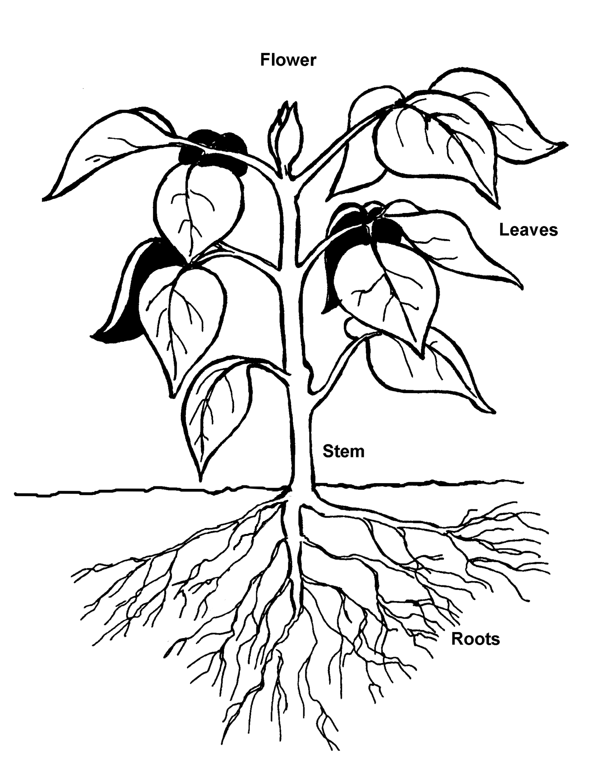

TM 2.2

Plant Propagation

Propagation – To increase in number, to reproduce

Two Methods

- Sexual – by seed
- Asexual – vegetative method

Examples of Asexual Propagation

- Cuttings
- Grafting
- Division
- Layering
- Budding
- Tissue culture

TM 2.3

Asexual Propagation Methods

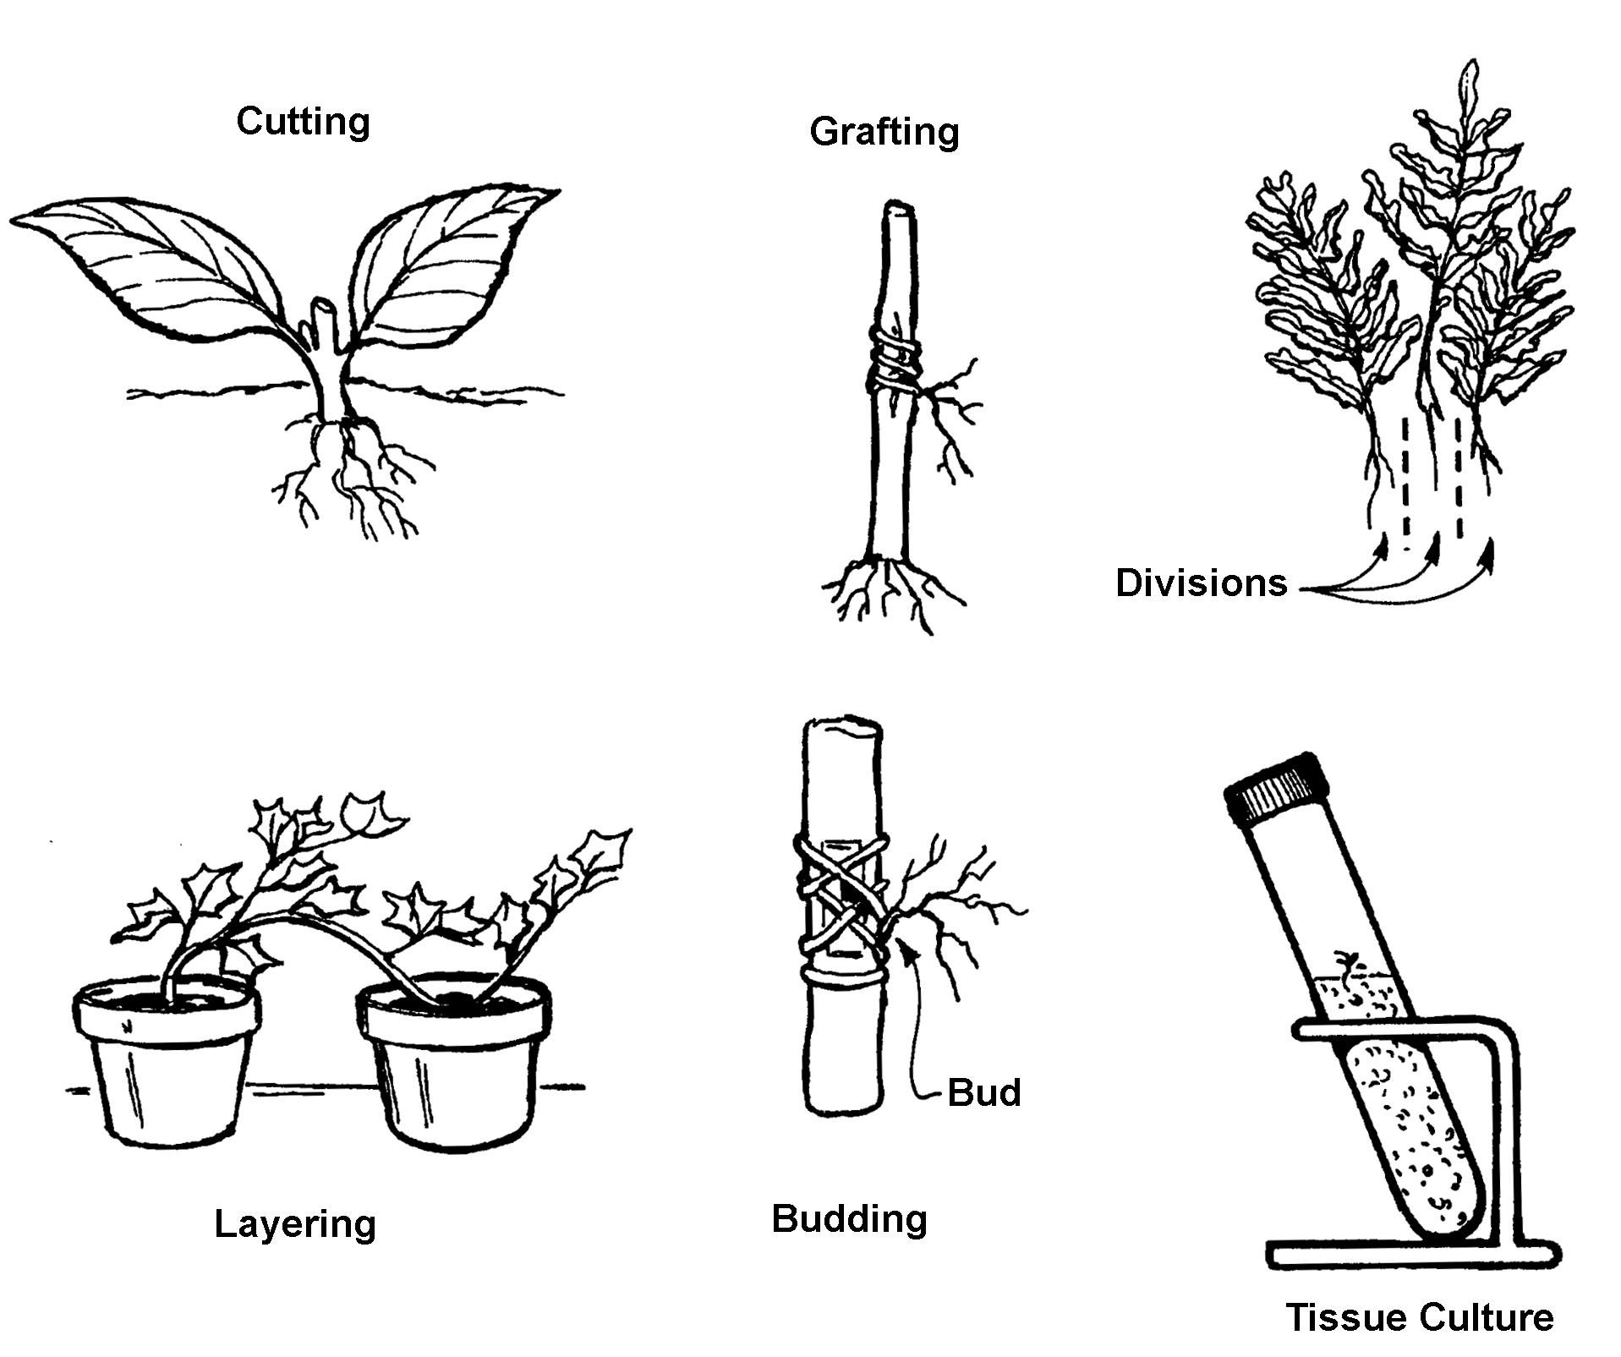

TM 2.4

Methods of Taking Cuttings
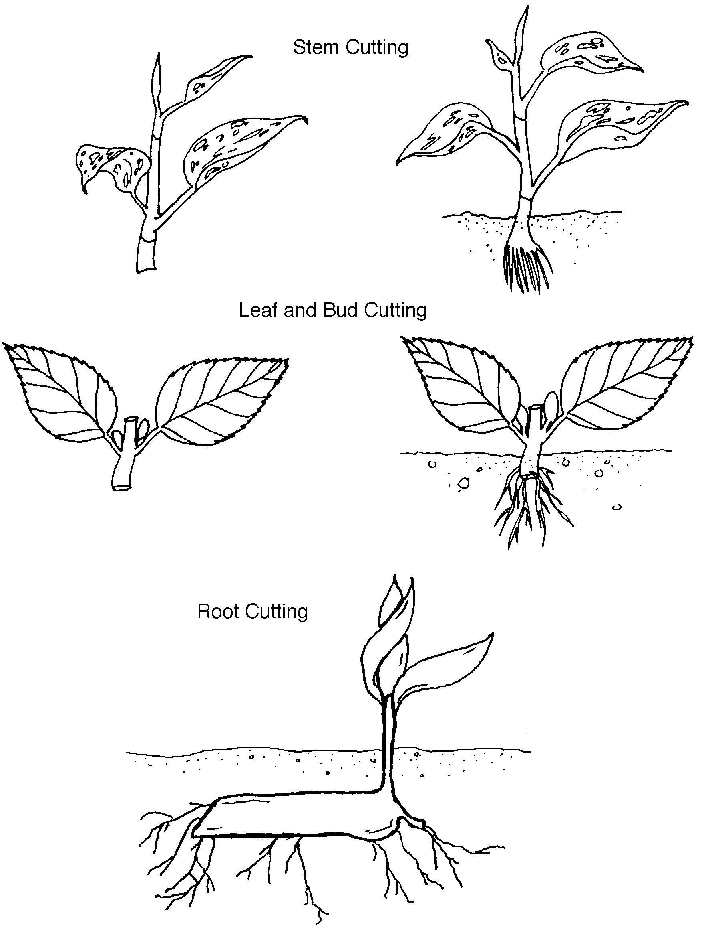

TM 2.5

Parts of a Complete Flower

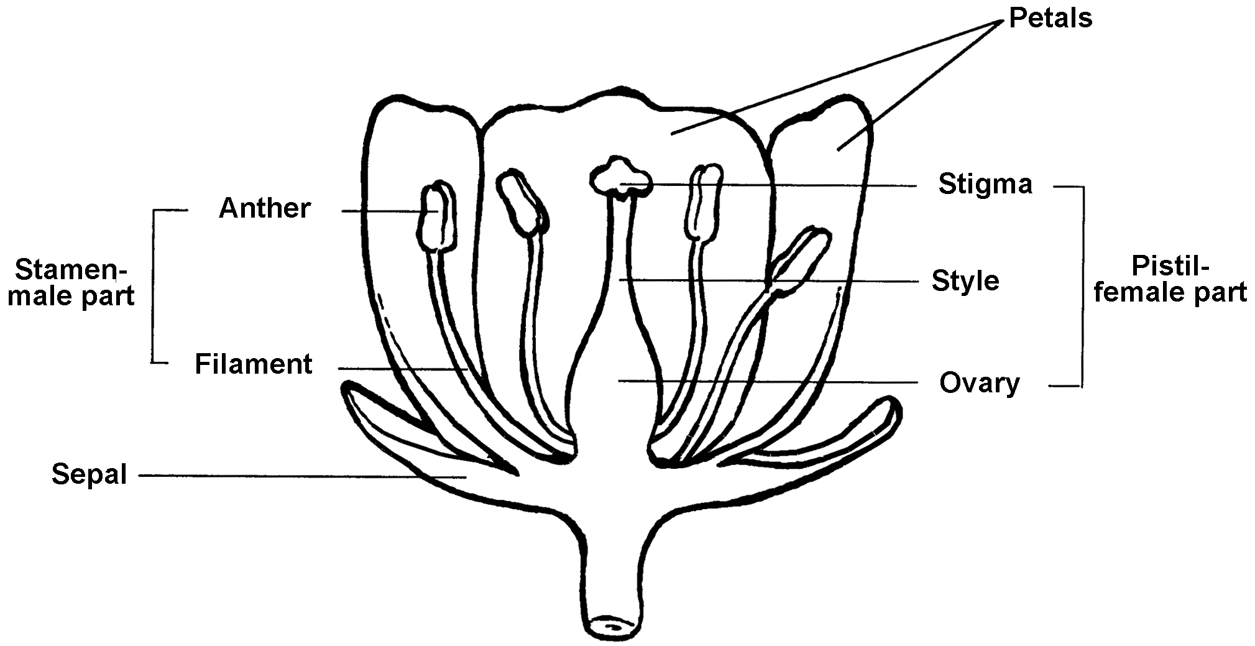

TM 2.6

Can You Name an Annual or Perennial?

Annual |  | Perennial
Vegetables: | Cucumber | Vegetable: | Asparagus
 | Lettuce Lettuce
 | Peas Peas
 | Radish | Fruit: | Strawberry
 | Snap bean
 | Sweet corn | Flowers: | Chrysanthemum
 |  |  | Hibiscus
Flowers: | Petunia |  | Peony
 | Geranium
 | Impatiens | All trees
 | Marigold

Source: Introduction to Horticulture: Science and Technology (1995)

TM 2.7

Monocot or Dicot?

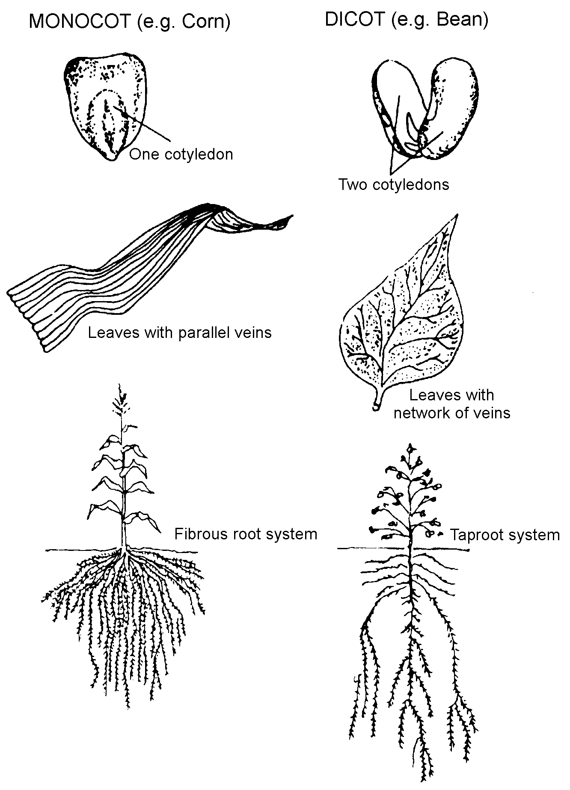

TM 2.8

Stages in Germination and Emergence of a Monocot

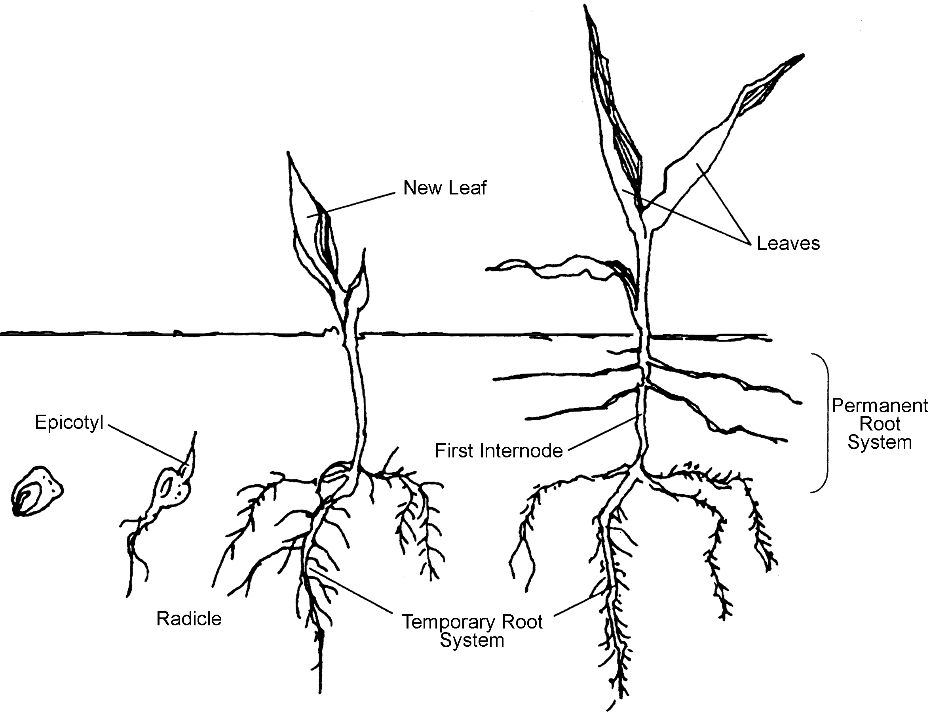

TM 2.9

Stages in Germination
and Emergence of a Dicot

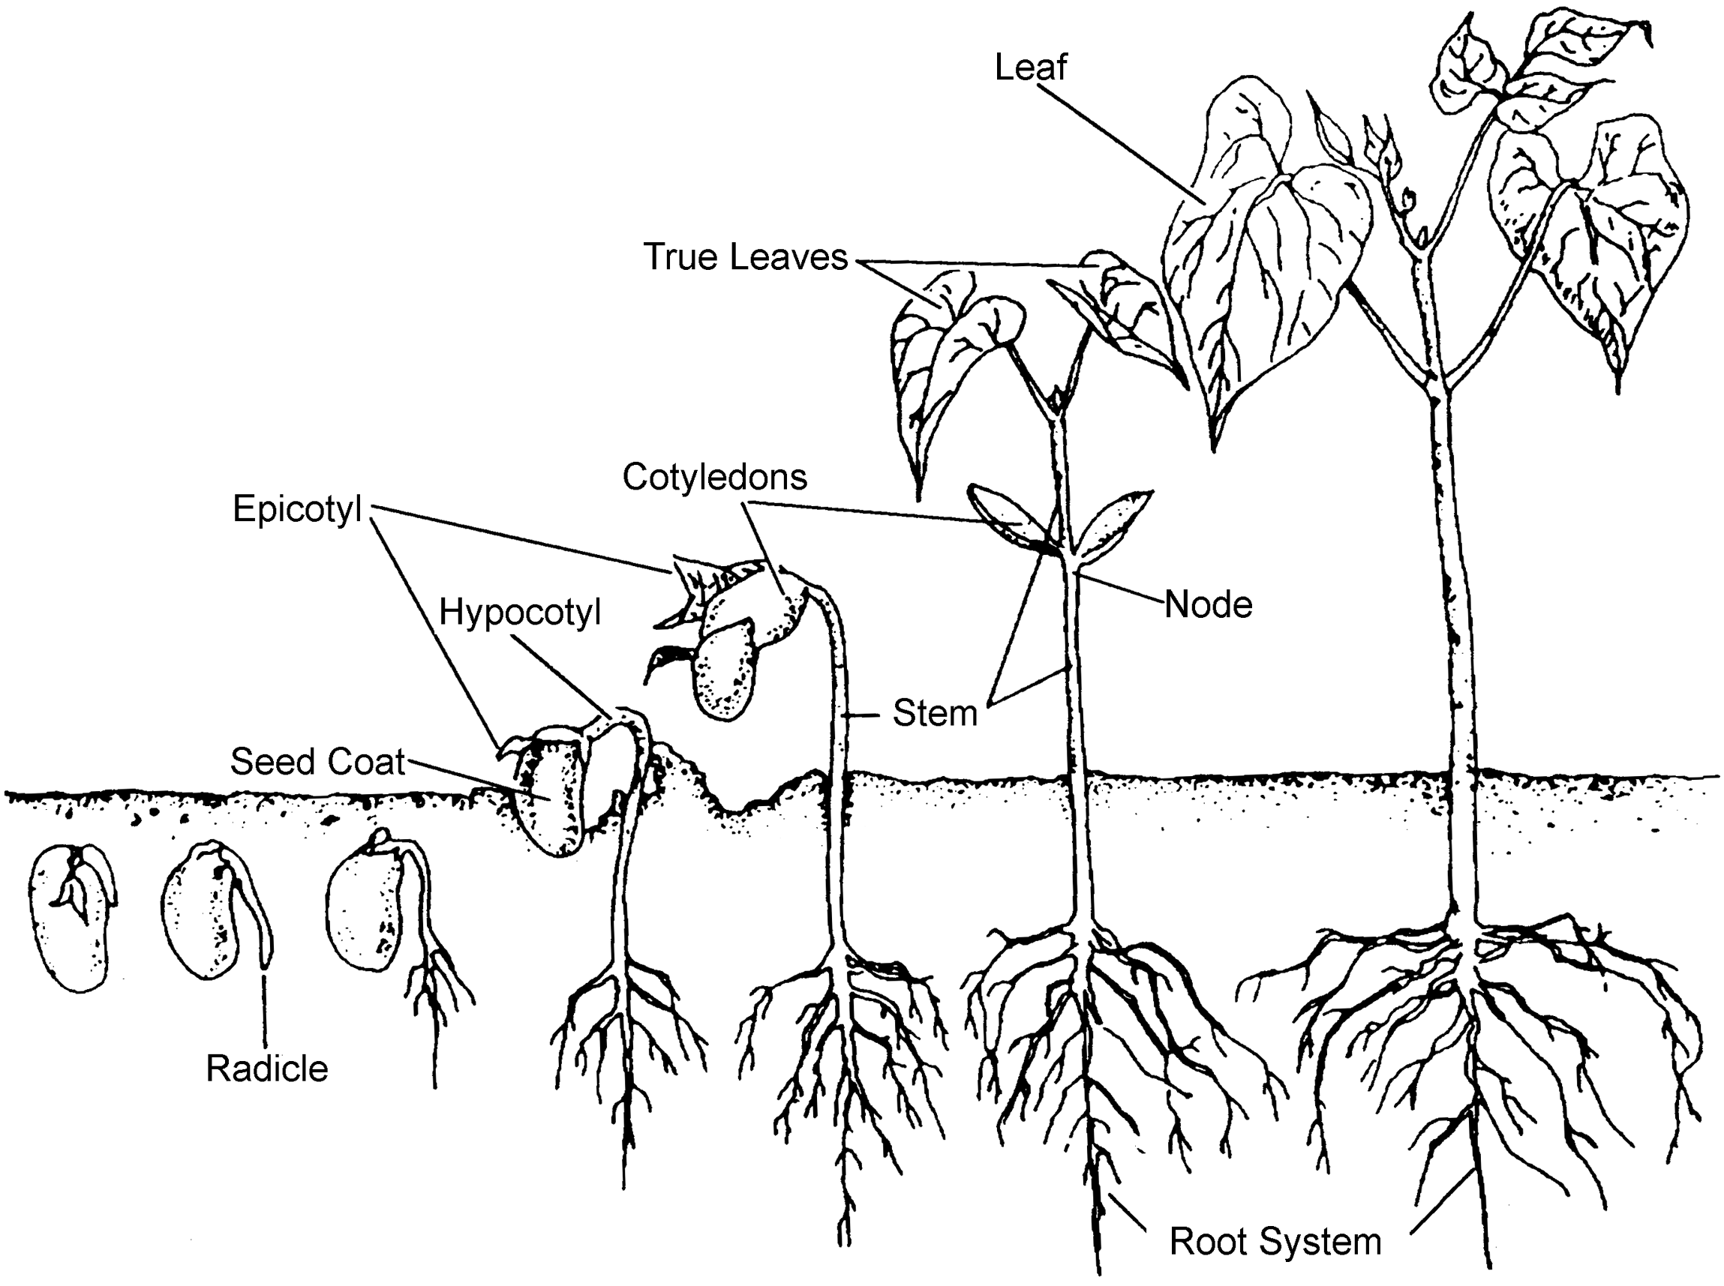

UNIT II - PLANT SCIENCE AS 2.1

Lesson 2: Plant Parts and Processes Name _______________________

Starting Plants from Stem Cuttings
(Asexual Propagation)

Objective: Students will be able to start a plant from a stem cutting.

Materials and Equipment:

Potting soil
Pot, flowerpot, cup, etc.
Plant for stem cutting such as Swedish ivy
Rooting hormone
Knife
Water
Small clear plastic bag with tie

Procedure:

1. Watch the instructor demonstrate how to start plants from stem cuttings.

2. If you are using a cup instead of a pot, place a small hole in the bottom so the water can drain out.

3. Fill the pot with the soil up to 1/2 inch from the top.

4. Use your finger to make a hole 1 inch deep in the soil.

5. Take the stem cutting from a plant determined by the instructor.

6. The cutting should have three to seven leaves or nodes.

7. Remove the bottom two leaves from the stem.

8. Place rooting hormone on the bottom 1/2 inch of the stem.

9. Insert the cutting into the soil and firm the soil around it.

10. Water thoroughly.

11. Place the pot in a small clear plastic bag and tie it closed to hold in the moisture.

- Place the pot in a well-lighted area.

- Check the pot every day. Open the plastic bag and water the soil when it is dry to the touch.

UNIT II - PLANT SCIENCE AS 2.2

Lesson 2: Plant Parts and Processes Name _______________________

Parts and Functions of a Complete Flower

Objective: Students will be able to identify the parts of a complete flower and give their functions.

Directions: Label the parts of a complete flower and give their functions below.

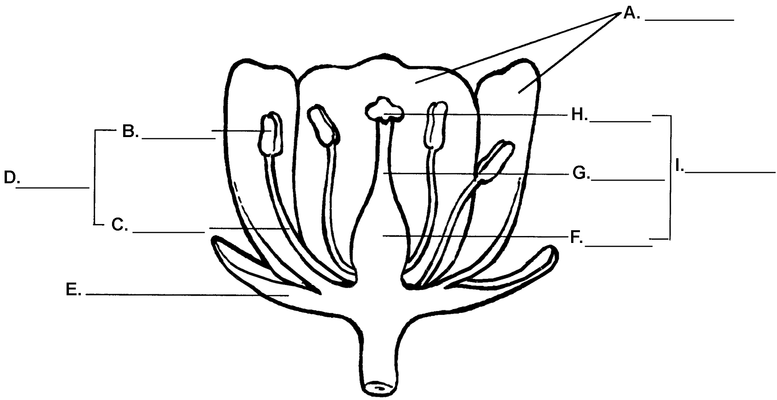

Functions:

A.

D.

E.

I.

UNIT II - PLANT SCIENCE AS 2.3

Lesson 2: Plant Parts and Processes Name _______________________

Effect of Light on Photosynthesis

Objective: Students will be able to describe the effect of light on photosynthesis.

Materials and Equipment:

Two 2-liter empty soda bottles
Knife or scissors
Potting soil
Two plants of equal size (tomatoes, cabbage, etc.)
Water
Black plastic bag with tie

Procedure:

1. Rinse out the soda bottles and allow them to dry.

2. Use the knife or scissors to cut off the top one-third of the bottle.

3. Put 2 inches of soil in the bottom of each soda bottle.

4. Carefully transplant one plant into each container.

5. Moisten the soil and replace the tops of the soda bottles.

6. Place one container in a window to receive good light.

7. Place the other container in a black plastic bag. Tie it securely so that it will not receive light.

8. Allow plants to grow for 2 weeks, being sure to water the plant when the soil is dry to the touch.

9. Examine the plants.

Key Questions:

1. Did the plants grow the same amount?

2. How did light or the lack of light affect photosynthesis?

