UNIT IV - PRODUCTS FROM AGRICULTURE

Lesson 1: Agriculture in the Food Chain

Competency/Objective: Describe the role of agriculture in the food chain.

Study Questions

1. What is the food chain?

2. Why do people manipulate the food chain?

3. What is the role of agriculture in the food chain?

References

1. Exploring Agriculture in America (Student Reference). University of Missouri-Columbia: Instructional Materials Laboratory, 2000, Unit IV.

2. Transparency Masters

TM 1.1 Simple Food Chain in the Natural Environment
TM 1.2 Simple Food Chain in the Aquatic Environment
TM 1.3 Agricultural Food Chain

3. Activity Sheets

AS 1.1 Student Chain (Instructor)
AS 1.2 Food Web (Instructor)
UNIT IV - PRODUCTS FROM AGRICULTURE

Lesson 1: Agriculture in the Food Chain

TEACHING PROCEDURES

A. Introduction

This lesson is about the food chain and how agricultural activities affect the process.

B. Motivation

Explain to students that during this lesson we will look at the food chain. Discuss what comes to mind when we say “chain.” Answers such as “connected,” “links,” “chain letter,” etc., will be given. Explain that we are going to make a student chain. Then conduct AS 1.1 as a motivational interest approach.

C. Assignment

D. Supervised Study

To be prepared for AS 6.2 in lesson 6 of this unit, order the following materials now.

Obtain biodegradable golf tees from the following address: |  | Obtain cornstarch superabsorbent polymer from the following address:
ECO GOLF  Box 17872  Indianapolis, IN 46217  <http://www.ecogolf.com>  888-326-3003  fax (317) 889-9921 | Grain Processing Corporation  1600 Oregon Street  Muscatine, IA 52761-1494  <http://www.grainprocessing.com>  (319) 264-4265  sales@grainprocessing.com

To be prepared for AS 6.3, order the following materials now.

Minnesota Forest Industries
902 Medical Arts Building
324 West Superior Street
Duluth, MN 55802
(218) 722-5013
<http://www.minnesotaforests.com>

E. Discussion

Q1. What is the food chain?

A1. The food chain is a sequence in which living organisms obtain food. There are four main parts to a food chain: sun, producer, consumer, and decomposer.

Ask students to give an example of a food chain. Use TM 1.1 to illustrate the simple food chain in the natural environment. Use TM 1.2 to illustrate the food energy flow in the aquatic environment. In nature, lower animal forms are consumed by higher animal forms. Ultimately, consumption by humans, the highest animal form, is the end of the food chain. Garbage and waste products are then consumed by bacteria, etc., and the food chain process begins again. Conduct AS 1.2 to have students create a food chain with a more complex web of interconnections.

Q2. Why do people manipulate the food chain?

A2. Humans cannot survive by only using food produced by the natural food chain.

Ask students why people alter the food chain. Discuss why natural food chains can no longer provide the food that people need. Management of the food chains allows producers to raise more food in a shorter amount of time than would be possible naturally.

Q3. What is the role of agriculture in the food chain?

A3.
a) Controlled, large-scale production of food crops
b) Domestication of animals and plants for food
c) Protection of the environment and natural food chain for wildlife

Discuss the role of agriculture in the food chain. As the human population increases, the need for food increases as well. Agricultural practices enable people to produce larger amounts of food than would be produced naturally in the food chain. Use TM 1.3 to illustrate the various food sources and their path to human consumption. Agriculture strives to maximize positive environmental factors (e.g., fertilizers, confinement housing, and vaccinations) while minimizing adverse factors (e.g., competition from weeds, weather conditions, and diseases).

F. Other Activity

Have students list as many food products as they can, categorizing them into plant or animal products. Also, list as many producers and consumers of these products as possible.

G. Conclusion

Natural food chains occur throughout the world in every environment. Agriculture and agricultural practices have enabled people to produce larger amounts of food than would be produced naturally in the food chain. Domestication of animals and plants has helped to produce food and clothing for humankind. Agricultural practices must protect the environment and the natural food chain for wildlife.

H. Answers to Activity Sheets

Answers will vary.

I. Evaluation

A unit test is provided at the end of this unit. If a lesson quiz is needed, use questions pertaining to this lesson from the unit test.

TM 1.1

Simple Food Chain

in the Natural Environment

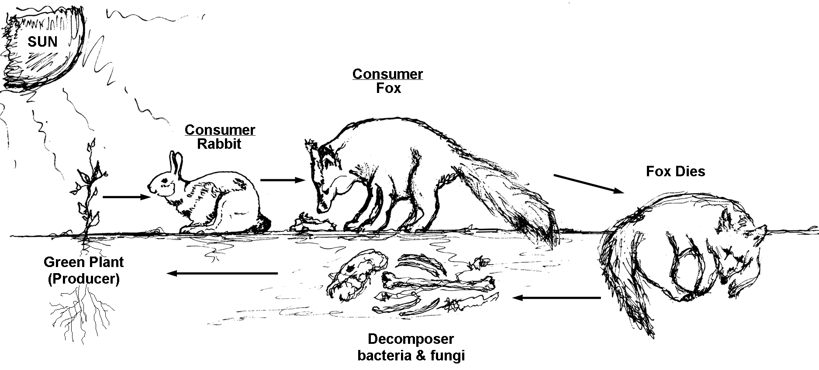

TM 1.2

Simple Food Chain

in the Aquatic Environment

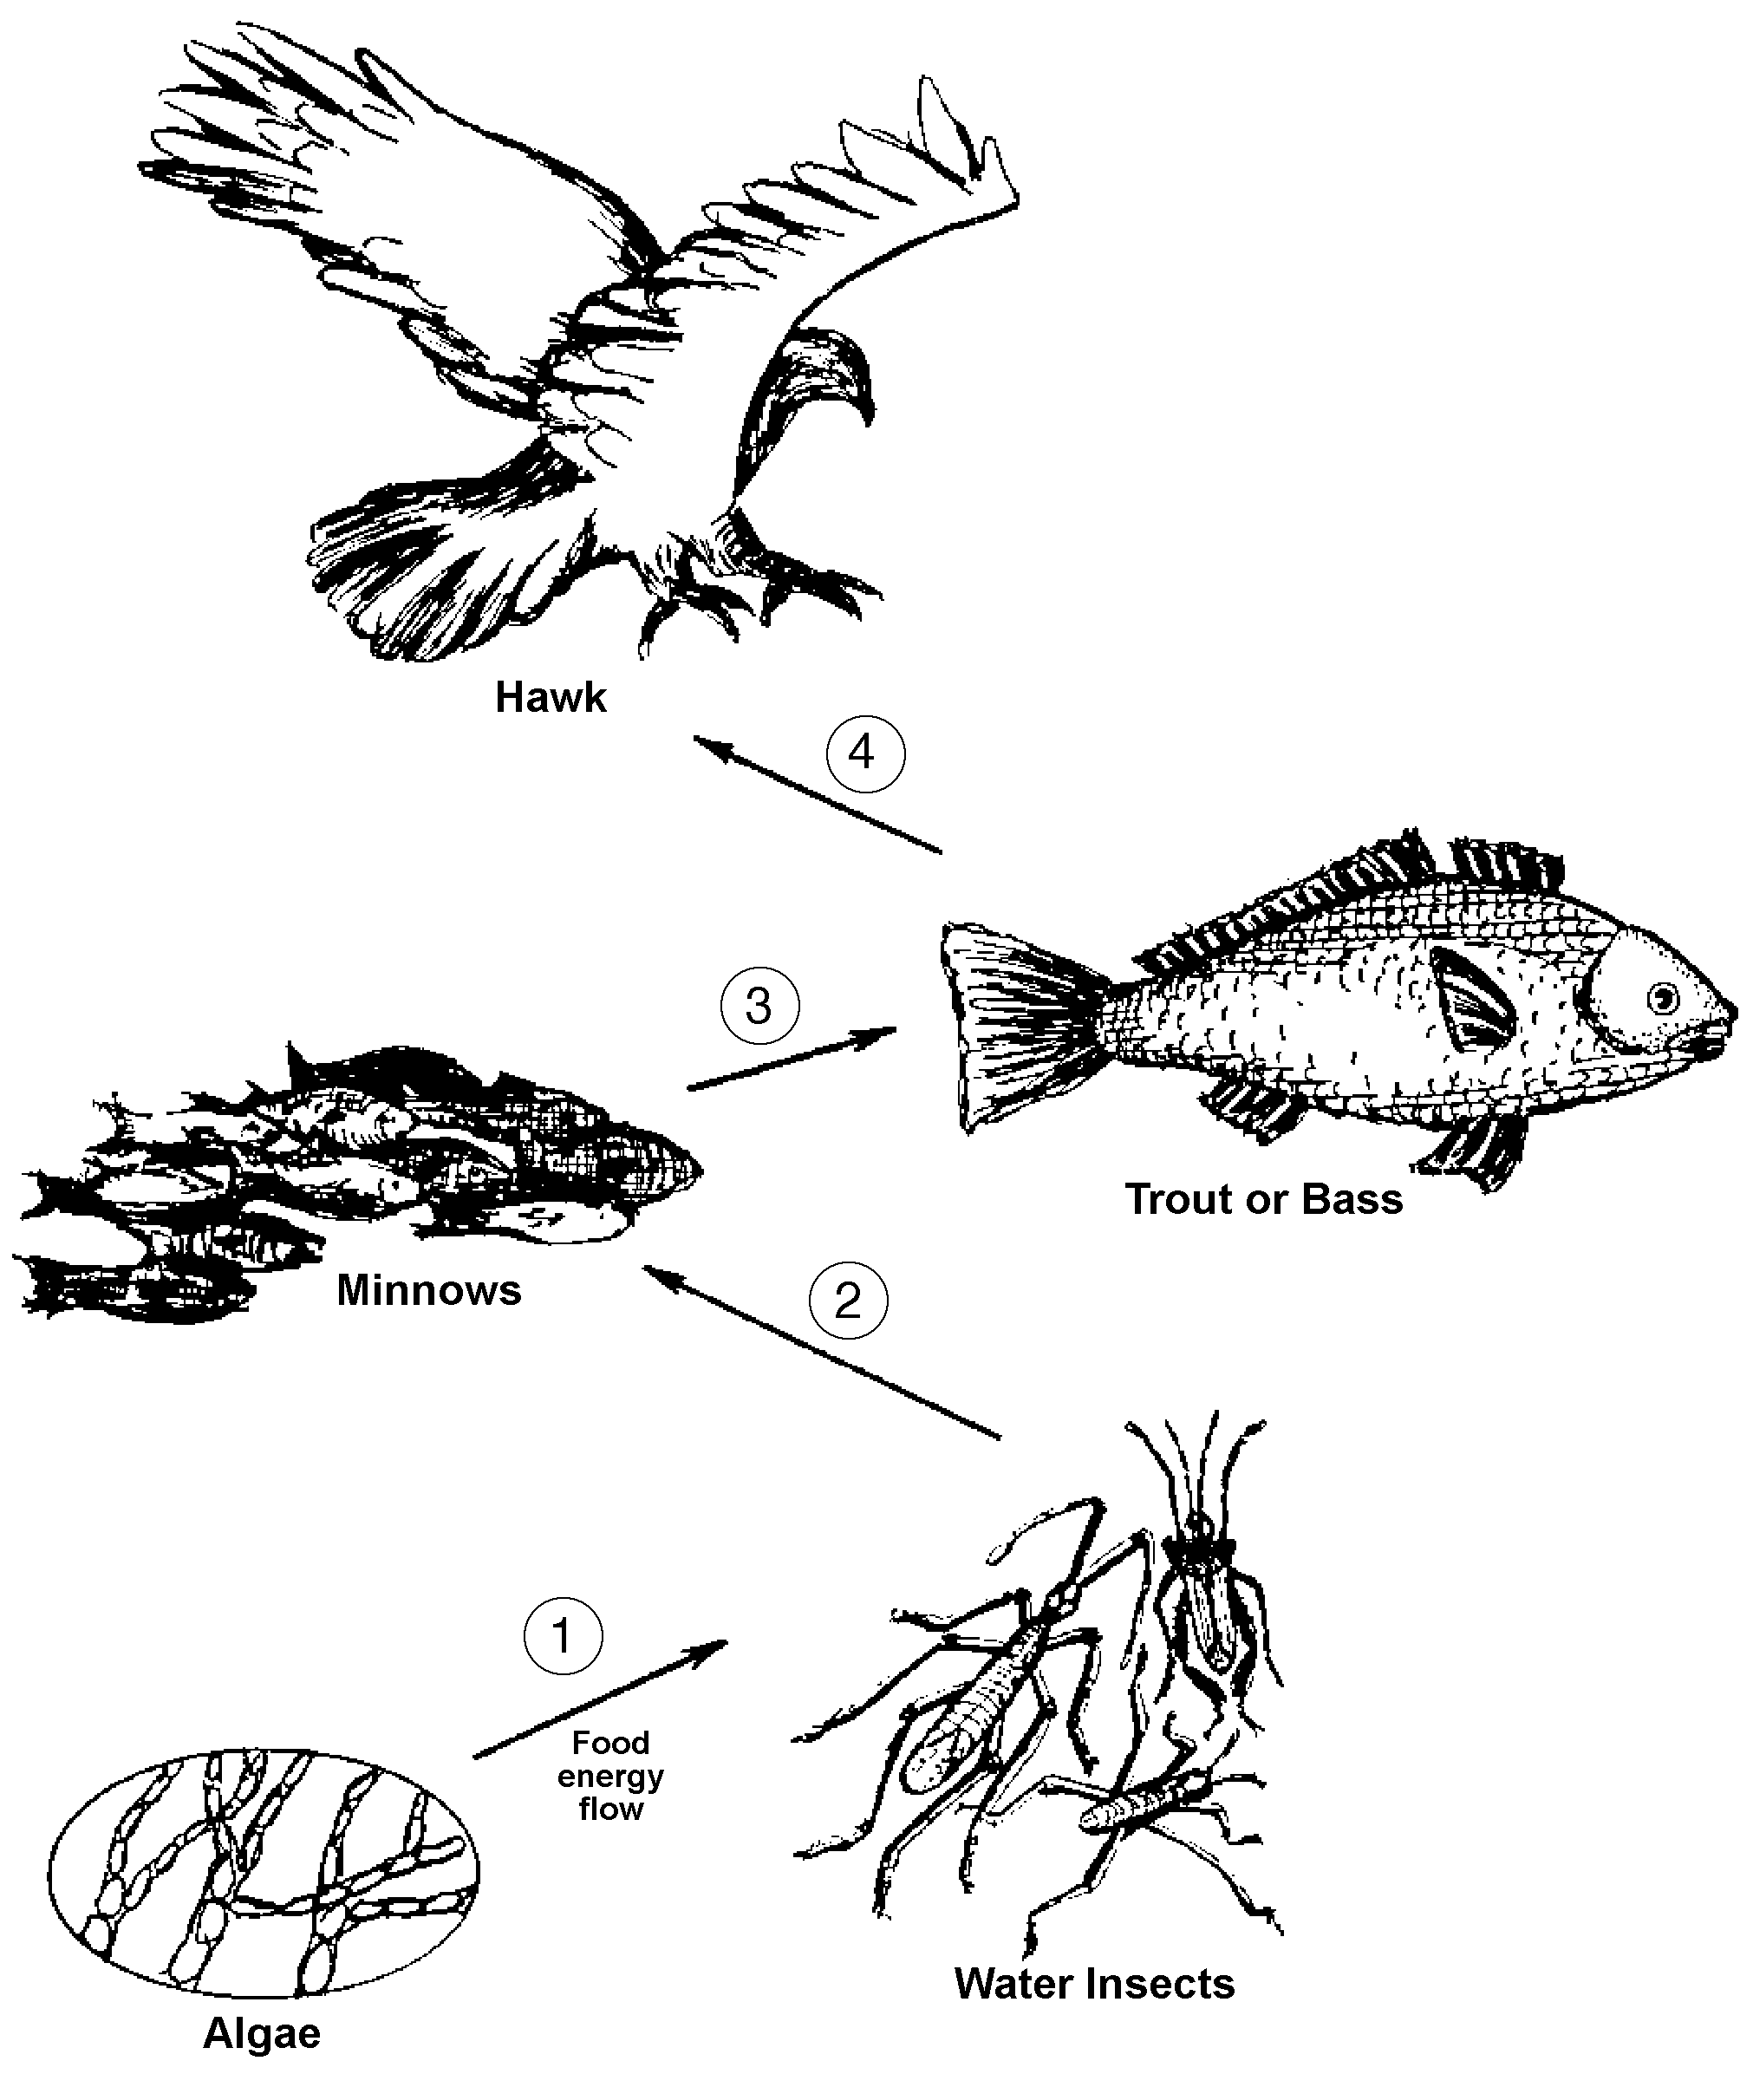

TM 1.3

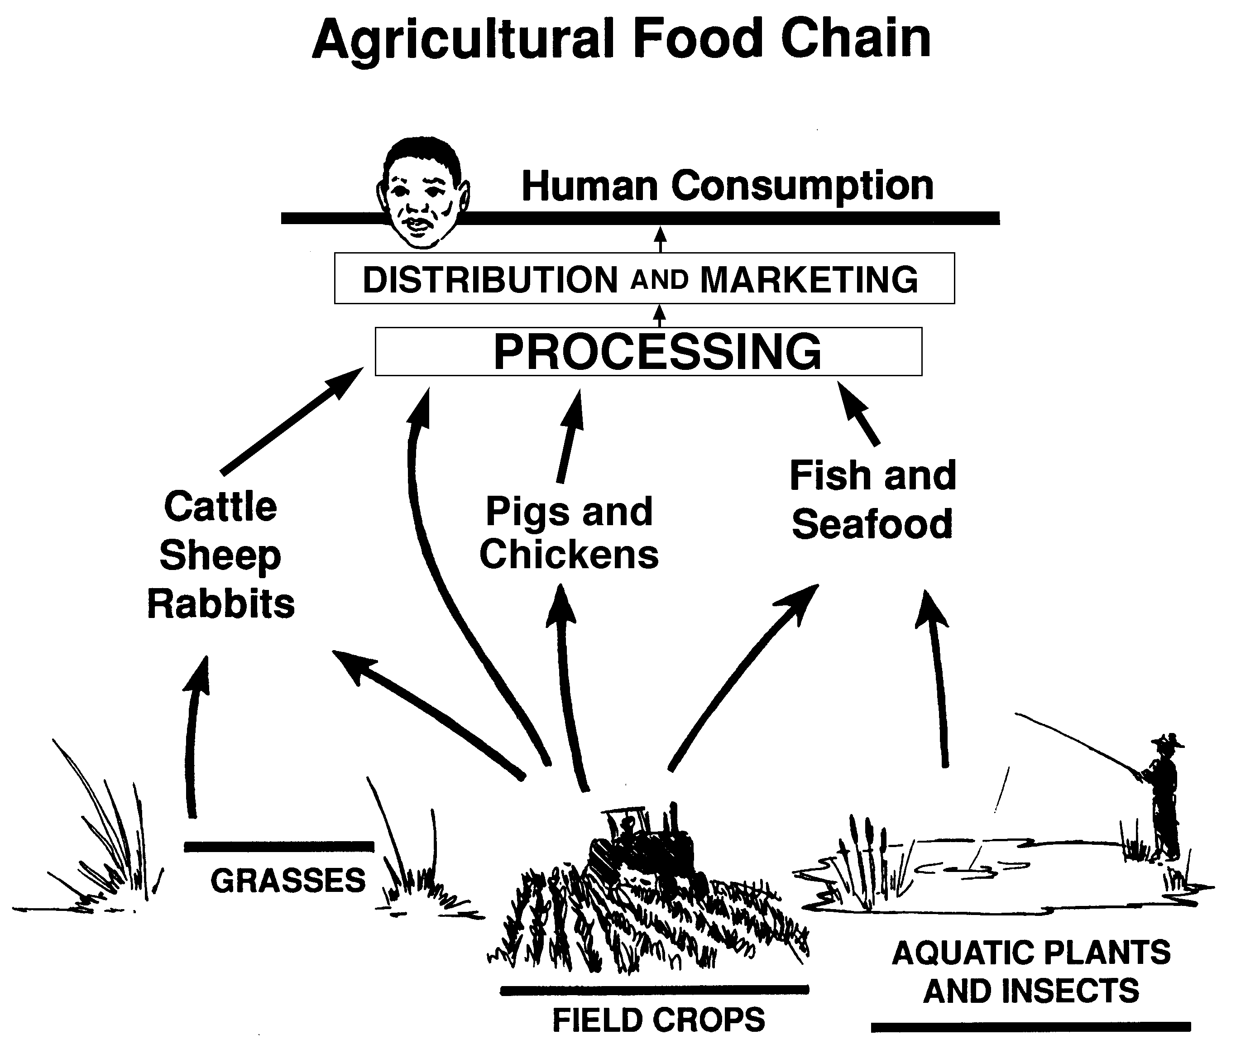

UNIT IV - PRODUCTS FROM AGRICULTURE AS 1.1

Lesson 1: Agriculture in the Food Chain Instructor

Student Chain

Objective: Students will understand the concept of a "chain" to be used in developing knowledge about food chains.

Directions: This motivational activity compares the interconnections in a food chain with the various word associations students make with a word like "tree." As students see how various words all link back to the same source (tree), they will be able to appreciate the concept of links in the food chain. There is not a right or wrong answer to this activity.

Procedure:

1. Give the first person in a row or table a piece of paper with tree printed in the upper corner. Other words selected by the instructor may be used in place of "tree."

Tree

2. Tell the first student to write a connection with tree and then pass the paper to the next student.

Tree
Leaves

3. The second student writes a connection to the first person’s word. In turn, the third, fourth, fifth, etc., person follows the same process.

Tree
Leaves
Raking
Part-time job

4. Finally, the last student writes down his/her connection on the paper and brings it to the instructor.

5. Share the series of connections with the class. Be sure to ask each student to share how each connection relates back to the previous connection.

6. In closing, tell the students that there are many food chains, just like there were many different connections made by students in this activity.

UNIT IV - PRODUCTS FROM AGRICULTURE AS 1.2

Lesson 1: Agriculture in the Food Chain Instructor

Food Web

Objective: Students will develop an understanding of how food webs work.

Materials and Equipment:

Poster paper
Markers

Procedure:

1. Discuss TM 1.1 and 1.2 so students have a basic understanding of a food chain.

2. Next, expand this concept to a food web by asking students what else might eat the rabbit, what might eat the fox, etc.

3. Using poster paper and markers, have students brainstorm and create graphs listing a large food web using at least 30 organisms (see example below). Remind students to show the correct food energy flow with the arrows.
Water Insects
Ducks
Frogs
Tadpoles
Turtles
Minnows
Trout or Bass
Humans
Hawk
Worm
Bacteria
Algae

4. Note which group has the longest food chain with the most numbers of organisms involved.

5. Post them and have students explain the interconnections.

