UNIT IV - PRODUCTS FROM AGRICULTURE

Lesson 2: Food Products from Plants

Competency/Objective: Identify food products from plants.

Study Questions

1. What food products come from grain?

2. What food products come from vegetables?

3. What food products come from fruits?

4. What food products come from other plants?

5. What information is contained in the food label?

References

1. Exploring Agriculture in America (Student Reference). University of Missouri-Columbia: Instructional Materials Laboratory, 2000. Unit IV.

2. Transparency Masters

TM 2.1 Cereal Food Label Ingredients

TM 2.2 Key Parts of a Food Label

3. Activity Sheets

AS 2.1 Food Inventory
AS 2.2 Do You Know Your Food Label?
AS 2.3 Compare Food Labels

UNIT IV - PRODUCTS FROM AGRICULTURE

Lesson 2: Food Products from Plants

TEACHING PROCEDURES

A. Review

In the last lesson, we discussed the many food chains in the natural environment (ecosystem). People in agriculture have learned to manage the food chains to produce larger amounts of food than would be produced naturally. We will now focus on the variety of food products provided by plants.

B. Motivation

1. Bring in a name brand, grocery store brand, and generic brand of potato chips. Have students sample some of each. Ask students which one was the healthiest, cost the least or most, tasted the best, etc.

2. Bring in several items produced from plants such as fresh fruits or vegetables, canned fruits or vegetables, or other processed foods from plants. Ask students to identify the products and where they are produced.

3. Bring in five to seven fresh vegetables (e.g., green bean, broccoli, cauliflower, and spinach). Encourage students to taste the raw vegetables. The next day have the vegetables cooked for students to taste. Discuss the students' reactions.

C. Assignment

D. Supervised Study

E. Discussion

Q1. What food products come from grains?

A1.
a) Flour
b) Cereals
c) Cooking oils
d) Pasta
e) Protein and soybean meal
f) Starch
- Dextrose for sweeteners
- Snack chips and crackers
- Popcorn

Bring in and discuss samples of grains grown in the area and some products produced from those grains. Ask students to think of other products made from locally produced grains. Show TM 2.1 and identify the ingredients that came from plants.

Q2. What food products come from vegetables?

A2.
a) Fresh vegetables
b) Canned vegetables
c) Frozen vegetables
d) Vegetable juices
e) Soups

Bring in various food items that contain vegetables and have the students identify the vegetables on the list of ingredients. Discuss the vegetables in those products and other products.

Q3. What food products come from fruits?

A3.
a) Fresh fruit
b) Canned fruit
c) Frozen fruit
d) Dried fruit
e) Fruit juices
f) Jams and jellies

Ask students to discuss what products are processed from fruits. Bring in various dried fruits and have students try to identify them. Students can then eat the dried fruit.

Q4. What food products come from other plants?

A4.
a) Maple syrup
b) Herbs
c) Chocolate
d) Nuts
e) Mustard
f) Tea
g) Coffee
h) Spices

Divide the class into groups of three or four students. Have them brainstorm other food products that come from plants. Students may think of products that are not listed above. Assign AS 2.1 to have students identify various food products from plants that they have at home or can find in a grocery store.

Q5. What information is contained in the food label?

A5. The following items can be found in the Nutrition Facts food label:
a) Serving size
b) Total calories and calories from fat
c) Percentage (%) daily value
d) Total fat
e) Cholesterol
f) Sodium
g) Potassium
h) Carbohydrates
i) Protein
j) Vitamins and minerals
k) Daily values footnote
l) Calories per gram footnote
m) Ingredients

Show TM 2.2 to illustrate the key parts of a food label. The numbers on the graphic correspond to the listing of key parts in the Student Reference. Assign AS 2.2 to have students find information on a food label. For more practice in reading food labels, have students complete AS 2.3.

F. Other Activities

1. For a week, have students inventory foods served in school lunches to determine which foods came from plants or have plant products in them.

2. Visit a farmers' market to see which fruits and vegetables are grown locally.

3. Invite a 4-H representative to class to discuss food products from plants.

G. Conclusion

Foods from plants make up a large portion of the human diet. Foods from grains, vegetables, fruits, and other plants may be eaten fresh or in a variety of processed forms. Food labels provide nutritional information to help consumers make informed buying decisions.

H. Answers to Activity Sheets

AS 2.1 Food Inventory

Answers will vary.

AS 2.2 Do You Know Your Food Label?

1. 10
2. 450
3. 12
4. Cholesterol
5. a. corn
b. vegetable oil
c. soybean

d. cottonseed

AS 2.3 Compare Food Labels

Answers will vary.

I. Evaluation

A unit test is provided at the end of this unit. If a lesson quiz is needed, use questions pertaining to this lesson from the unit test.

TM 2.1

Cereal Food Label Ingredients
INGREDIENTS: OAT FLOUR, SUGAR, WHEAT STARCH, DRIED APPLE PIECES, BROWN SUGAR, CORN SYRUP, MALT, SALT, PARTIALLY HYDROGENATED VEGETABLE OIL (CONTAINS ONE OR MORE OF THE FOLLOWING OILS: CANOLA, SOYBEAN), CINNAMON, CALCIUM CARBONATE, TRISODIUM PHOSPHATE, SODIUM ASCORBATE (VITAMIN C), ZINC OXIDE, NIACINAMIDE, REDUCED IRON, CALCIUM PANTOTHENATE, BHT (A PRESERVATIVE), VITAMIN A PALMITATE, THIAMIN MONO-NITRATE (VITAMIN B1), PYRIDOXINE HYDROCHLORIDE (VITAMIN B6), RIBOFLAVIN (VITAMIN B2), FOLIC ACID, VITAMIN B12, AND VITAMIN D.

TM 2.2

Key Parts of a Food Label

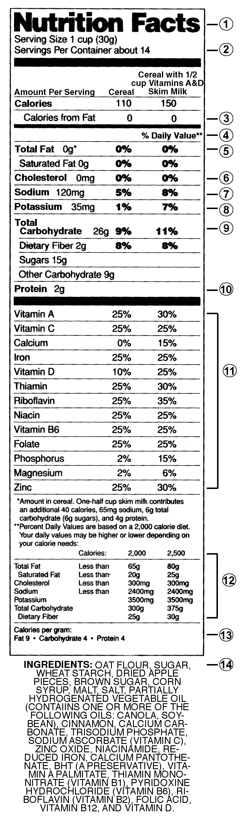

UNIT IV - PRODUCTS FROM AGRICULTURE AS 2.1

Lesson 2: Food Products from Plants Name

Food Inventory

Objective: Students will be able to identify food products made from grains, vegetables, fruits, and other plants.

Directions: Look on the kitchen shelves at home or at the grocery store. Identify 10 food products in each of the following categories.

Grains |  | Vegetables |  | Fruits |  | Other Plants

UNIT IV - PRODUCTS FROM AGRICULTURE AS 2.2

Lesson 2: Food Products from Plants Name

Do You Know Your Food Label?

Objective: Students will read information found on a food label.
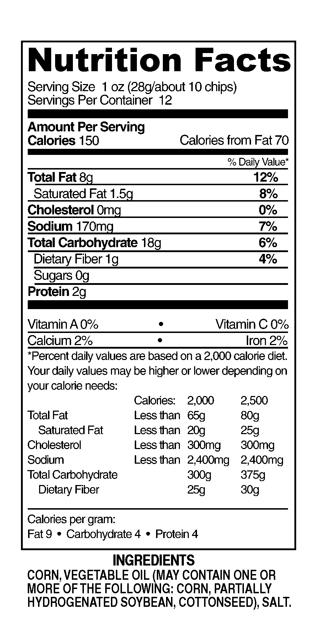

Directions: Answer the following questions about

the food label at the right.

1. There are chips in one serving.

2. It’s Friday Video Night and you eat 1/4 of the bag (30 chips) during the evening.
This is calories.

3. One serving of the chips supplies % of the daily requirement for fat.

4. The chips do not contain .
(Hint: High levels of this substance contribute to heart problems.)

5. List the ingredients that came from plants:

a.

b.

c.

d.

UNIT IV - PRODUCTS FROM AGRICULTURE AS 2.3

Lesson 2: Food Products from Plants Name

Compare Food Labels

Objective: Students will compare food labels of two brands of a favorite food.

Directions: Obtain the following information from the Nutrition Facts food label found on the package of two brands of your favorite crackers, chips, cereals, pop, popcorn, etc. Make sure the serving size is the same, record what you paid for each item at the grocery store, and attach both labels to this assignment. Answer the questions on the next page.

Name of Product
Serving Size
Servings per Container
Calories per Serving
Calories from Fat
Total Fat (g)
Saturated Fat (g)
Cholesterol (mg)
Sodium (mg)
Potassium (mg)
Total Carbohydrate (g)
Dietary Fiber (g)
Sugars (g)
Protein (g)
Vitamin A (%)
Vitamin C (%)
Iron (%)
Calcium (%)
Wt. of Total Package
Price
Price/Serving (priceservings per container)

Key Questions:

1. Based on a comparison of the two labels, which product is more nutritious to eat? Explain why.

2. Based on the nutritional information, price, and taste, which product do you recommend? Explain your answer.

