UNIT IV - PRODUCTS FROM AGRICULTURE

Lesson 3: Food Products from Animals

Competency/Objective: Identify food products from animals.

Study Questions

1. What food products come from beef cattle?

2. What food products come from hogs?

3. What food products come from sheep?

4. What food products come from poultry?

5. What food products come from dairy animals?

6. What are some examples of fish and seafood?

7. What are some examples of processed meats?

8. What information is contained in the meat label?

References

1. Exploring Agriculture in America (Student Reference). University of Missouri-Columbia: Instructional Materials Laboratory, 2000, Unit IV.

2. Transparency Masters

TM 3.1 Wholesale and Retail Cuts of Beef
TM 3.2 Meat Consumption Trends in the United States
TM 3.3 Know Your Meat Label

3. Handouts

HO 3.1 Per Capita Consumption of Meat Products in the United States
HO 3.2 Beef Chart
HO 3.3 Pork Chart
HO 3.4 Lamb Chart
HO 3.5 Meat Labels

4. Activity Sheets

AS 3.1 Identify the Most Popular Meat Product
AS 3.2 Animal Food Products
AS 3.3 Identifying per Capita Consumption Trends of Meat Products
AS 3.4 Processing Whipped Cream and Butter
AS 3.5 Reading a Meat Label
UNIT IV - PRODUCTS FROM AGRICULTURE

Lesson 3: Food Products from Animals

TEACHING PROCEDURES

A. Review

Americans eat many foods produced from plants. They are essential for a balanced diet. However, a number of food products are also produced from animals.

B. Motivation

1. Ask students what category of meat is most popular in the United States. This will lead to listing and explaining the major categories: beef, chicken, fish, lamb, pork, turkey, and veal. Explain the concept of per capita consumption and then distribute AS 3.1. Use HO 3.1 to provide the actual figures. Discuss and compare answers.

- Ask students what is in a hamburger. Obviously, it is ground beef. Then ask them why it is called hamburger, a pork name, when it is actually beef. Offer extra credit to the student(s) with the answer the following day. (It originated in Hamburg, Germany.)

- Bring in samples of a variety of meats and have students try to distinguish between different types of meat.

C. Assignment

D. Supervised Study

E. Discussion

Q1. What food products come from beef cattle?

A1.
a) Hamburger
b) Steak
c) Roast
d) Veal - young cattle

Show TM 3.1, distribute copies of HO 3.2, and discuss the common cuts of beef.

Q2. What food products come from hogs?

A2.
a) Pork chops
b) Ham
c) Bacon

Distribute HO 3.3 and discuss the common cuts of pork.

Q3. What food products come from sheep?

A3.
a) Lamb chops
b) Leg of lamb

Distribute HO 3.4 and discuss the common cuts of lamb. Have student complete AS 3.2 to test their knowledge of beef, pork, and lamb cuts.

Q4. What food products come from poultry?

A4.
a) Eggs
b) Meat

Ask students to discuss what foods come from poultry. Assign AS 3.3 to have students graph the U.S. meat consumption trends. Show TM 3.2 to better illustrate meat consumption trends.

Q5. What food products come from dairy animals?

A5.
a) Milk
b) Cheese
c) Ice cream
d) Yogurt
e) Sour cream
f) Cottage cheese
g) Butter

Bring in samples of butter and margarine. Conduct a taste test to see if students can tell the difference between the two products. The taste difference in butter comes primarily from the fat content. Have students do AS 3.4 to create whipped cream and butter from cream. This can be a group activity or an individual student activity.

Q6. What are some examples of fish and seafood?

A6.
a) Fish
1) Catfish
2) Trout
3) Bass
4) Tuna
5) Salmon
6) Halibut
7) Cod
8) Shark
b) Seafood
1) Lobster
2) Crabs
3) Oysters
4) Scallops
5) Shrimp
6) Clams

Ask students to identify fish and seafood they have eaten. List suggestions on the board. Ask students to describe their experiences in catching some of the fish and/or seafood they identified.

Q7. What are some examples of processed meats?

A7.
a) Processed beef and pork
1) Luncheon meats
2) Hot dogs
3) Pepperoni
b) Processed chicken patties and nuggets

Discuss the various types of processed meats and have students tell their favorites.

Q8. What information is contained in the meat label?

A8.
a) Species
b) Wholesale cut
c) Retail cut
d) Total price
e) Price/lb.
f) Net weight
g) "Sell by" date

Show TM 3.3 and discuss the key information on a meat label. Distribute copies of HO 3.5 and assign AS 3.5 to have students answer questions about sample meat labels.

F. Other Activities

1. Conduct a cooking/tasting day with a variety of meats and fish.

2. Visit a farm to observe how livestock are raised.

3. Write to livestock breed associations and ask for additional information on the meat characteristics of each breed.

4. Tour a grocery store meat department or packing plant to observe meat processing activities.

G. Conclusion

There is a wide variety of food products produced from animals. Some foods are served fresh while others are processed. Meat contains protein needed to maintain good health. Protein can also be acquired from dairy and fish products. Information is provided on meat labels to help consumers make informed decisions.

H. Answers to Activity Sheets

AS 3.1 Identify the Most Popular Meat Product

Answers will vary.

AS 3.2 Animal Food Products

CUT OF MEAT |  | TYPE OF MEAT ANIMAL
 |  | BEEF |  | PORK |  | SHEEP
 | 1. Bacon |  |  |  | X
 | 2. Sirloin steak |  | X
 | 3. T-bone steak |  | X
 | 4. Lamb chops |  |  |  |  |  | X
 | 5. Filet mignon |  | X
 | 6. Loin chop |  |  |  | X |  | X
 | 7. Kabobs |  | X |  |  |  | X
 | 8. Flank steak |  | X
 | 9. Rump roast |  | X
 | 10. Sausage |  |  |  | X
 | 11. Rib steak |  | X
 | 12. Fresh arm picnic |  |  |  | X
 | 13. Tenderloin |  | X |  | X
 | 14. Round steak |  | X
 | 15. Ham slice |  |  |  | X
 | 16. Loin roast |  |  |  | X
 | 17. Shoulder steak |  | X
 | 18. Leg of lamb |  |  |  |  |  | X
 | 19. Short ribs |  | X
 | 20. Blade steak |  | X |  | X

AS 3.3 Identifying per Capita Consumption Trends of Meat Products

Answers will vary.

AS 3.4 Processing Whipped Cream and Butter

There are no answers for this activity.

AS 3.5 Reading a Meat Label

1. Species
2. Wholesale cut
3. Retail cut
4. Total price
5. Price/lb.
6. Net wt.
7. “Sell by” date
8. $4.22
9. Ground beef - 70% lean
10. Loin
11. Dec. 14
12. T-bone pot roast
13. 8, $ 0.30

I. Evaluation

A unit test is provided at the end of this unit. If a lesson quiz is needed, use questions pertaining to this lesson from the unit test.
TM 3.1

Wholesale and Retail Cuts of Beef

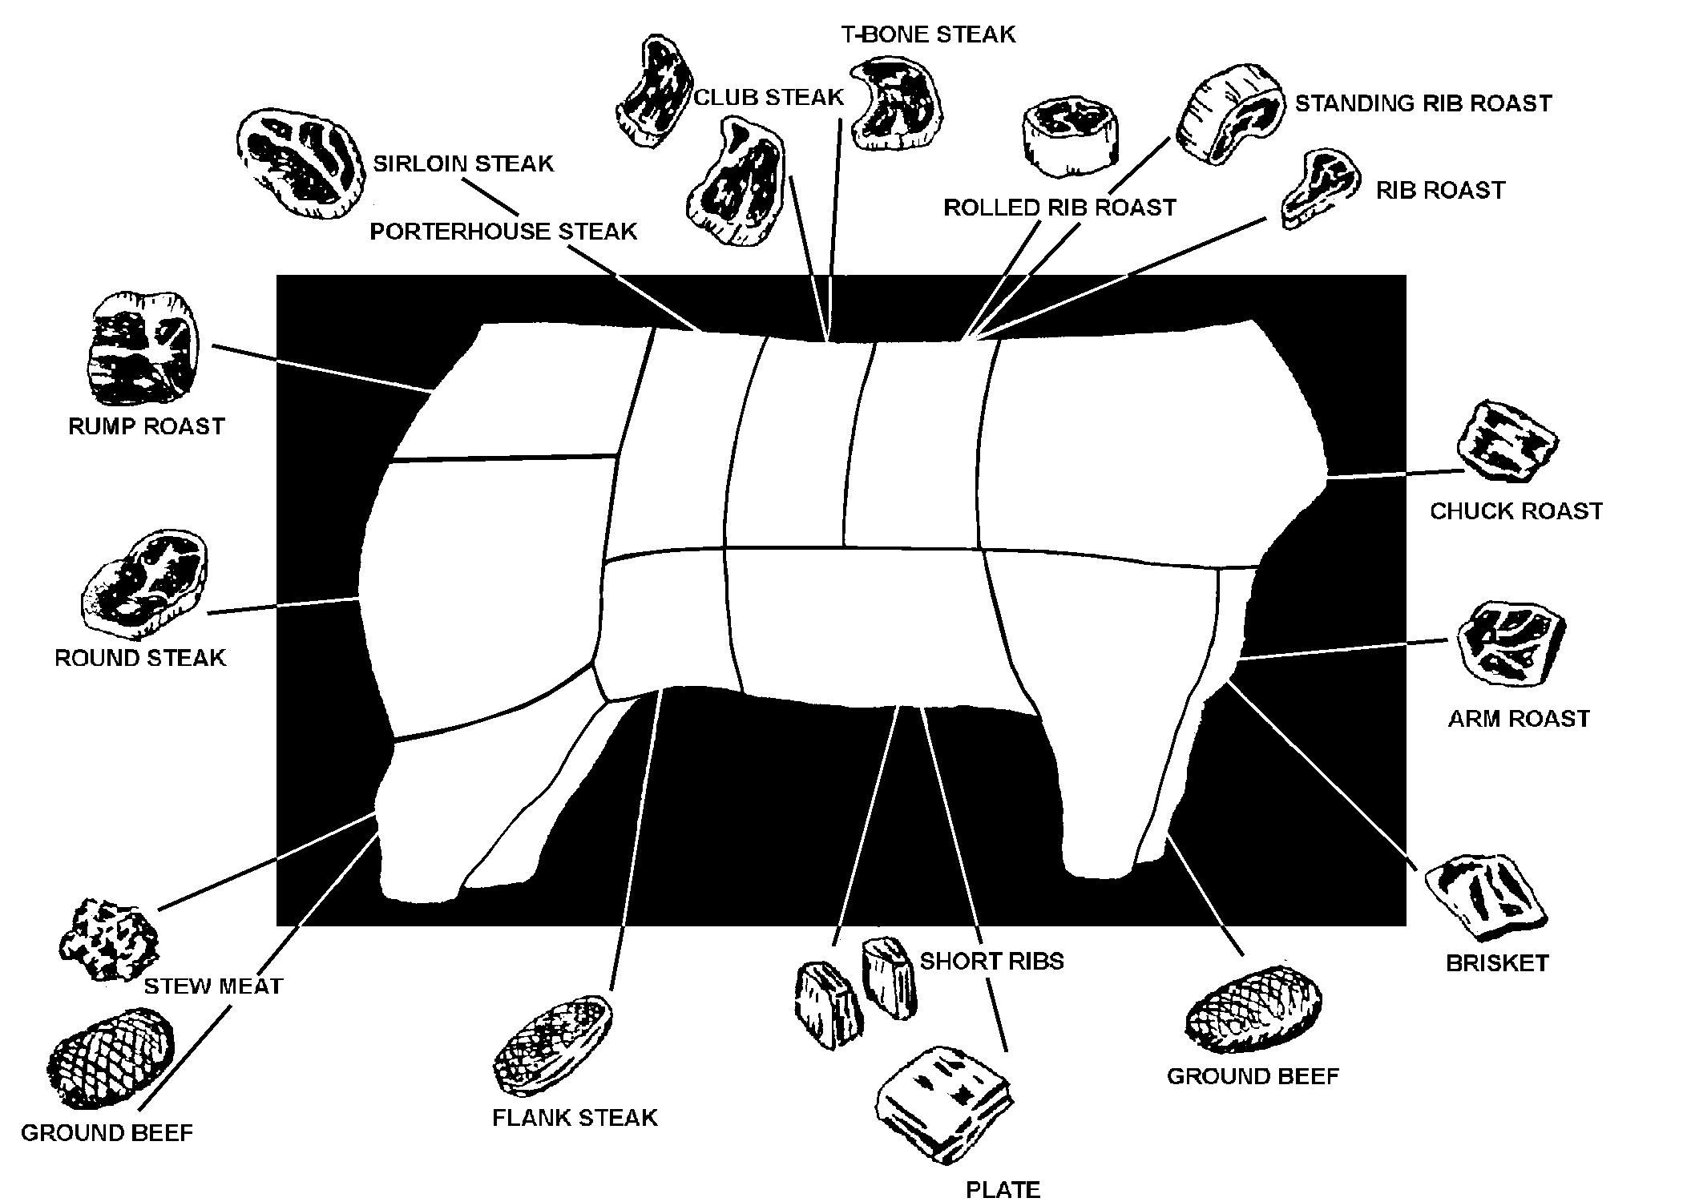

TM 3.2

Meat Consumption Trends

in the United States

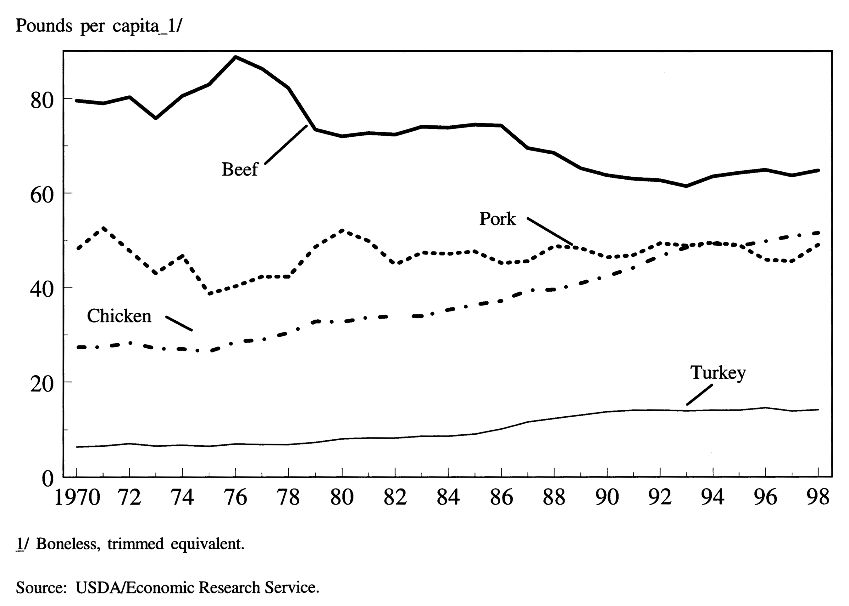

TM 3.3

Know Your Meat Label

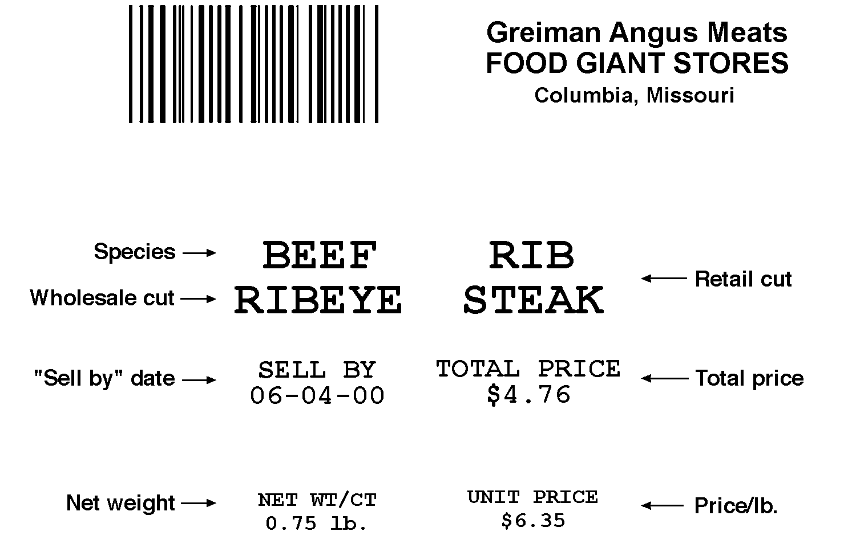

HO 3.1

Per Capita Consumption of Meat Products in the United States 1/
Year | U.S. Total PopulationJuly 1  2/ | Beef |  | Veal |  | Pork |  | Lamb |  | Total  3/ | Chicken  4/ & 5/ |  | Turkey |  | Total  3/ | Fish and Shellfish | Total  3/
Millions ---------------------------------------------------------Pounds------------------------------------------------------------
1970 | 205.052 | 79.6 | 2.0 |  | 48.0 |  | 2.1 |  | 131.7 |  |  | 27.4 | 6.4 | 33.8 |  | 11.7 | 177.3
1971 | 207.661 | 79.0 | 1.9 |  | 52.6 |  | 2.1 |  | 135.5 |  |  | 27.4 | 6.6 | 34.0 |  | 11.5 | 181.0
1972 | 209.896 | 80.3 | 1.6 |  | 47.8 |  | 2.2 |  | 131.8 |  |  | 28.3 | 7.1 | 35.4 |  | 12.5 | 179.7
1973 | 211.909 | 75.8 | 1.2 |  | 43.0 |  | 1.7 |  | 121.8 |  |  | 27.1 | 6.6 | 33.7 |  | 12.7 | 168.2
1974 | 213.854 | 80.6 | 1.6 |  | 46.7 |  | 1.5 |  | 130.4 |  |  | 27.0 | 6.8 | 33.8 |  | 12.1 | 176.3
1975 | 215.973 | 83.0 | 2.8 |  | 38.7 |  | 1.3 |  | 125.8 |  |  | 26.4 | 6.5 | 32.9 |  | 12.1 | 170.9
1976 | 218.035 | 88.8 | 2.7 |  | 40.3 |  | 1.2 |  | 133.0 |  |  | 28.5 | 7.0 | 35.5 |  | 12.9 | 181.4
1977 | 220.239 | 86.3 | 2.6 |  | 42.3 |  | 1.1 |  | 132.3 |  |  | 29.0 | 6.9 | 35.9 |  | 12.6 | 180.9
1978 | 222.585 | 82.2 | 2.0 |  | 42.3 |  | 1.0 |  | 127.5 |  |  | 30.4 | 6.9 | 37.3 |  | 13.4 | 178.2
1979 | 225.055 | 73.5 | 1.4 |  | 48.6 |  | 1.0 |  | 124.4 |  |  | 32.8 | 7.3 | 40.1 |  | 13.0 | 177.6
1980 | 227.726 | 72.1 | 1.3 |  | 52.1 |  | 1.0 |  | 126.4 |  |  | 32.7 | 8.1 | 40.8 |  | 12.4 | 179.6
1981 | 229.966 | 72.8 | 1.3 |  | 49.9 |  | 1.0 |  | 125.1 |  |  | 33.7 | 8.3 | 42.1 |  | 12.6 | 179.7
1982 | 232.188 | 72.5 | 1.4 |  | 44.9 |  | 1.1 |  | 119.8 |  |  | 33.9 | 8.3 | 42.2 |  | 12.4 | 174.4
1983 | 234.307 | 74.1 | 1.4 |  | 47.4 |  | 1.1 |  | 123.9 |  |  | 34.0 | 8.7 | 42.7 |  | 13.3 | 180.0
1984 | 236.348 | 73.9 | 1.5 |  | 47.2 |  | 1.1 |  | 123.7 |  |  | 35.3 | 8.7 | 44.0 |  | 14.1 | 181.7
1985 | 238.466 | 74.6 | 1.5 |  | 47.7 |  | 1.1 |  | 124.9 |  |  | 36.4 | 9.1 | 45.5 |  | 15.0 | 185.4
1986 | 240.651 | 74.4 | 1.6 |  | 45.2 |  | 1.0 |  | 122.2 |  |  | 37.2 | 10.2 | 47.4 |  | 15.4 | 184.9
1987 | 242.804 | 69.6 | 1.3 |  | 45.6 |  | 1.0 |  | 117.4 |  |  | 39.4 | 11.6 | 51.0 |  | 16.1 | 184.5
1988 | 245.021 | 68.6 | 1.1 |  | 48.8 |  | 1.0 |  | 119.5 |  |  | 39.6 | 12.4 | 51.9 |  | 15.1 | 186.6
1989 | 247.342 | 65.4 | 1.0 |  | 48.4 |  | 1.0 |  | 115.9 |  |  | 40.9 | 13.1 | 53.9 |  | 15.6 | 185.4
1990 | 249.949 | 63.9 | 0.9 |  | 46.4 |  | 1.0 |  | 112.3 |  |  | 42.4 | 13.8 | 56.3 |  | 15.0 | 183.5
1991 | 252.636 | 63.1 | 0.8 |  | 46.9 |  | 1.0 |  | 111.9 |  |  | 44.2 | 14.1 | 58.3 |  | 14.8 | 185.1
1992 | 255.382 | 62.8 | 0.8 |  | 49.4 |  | 1.0 |  | 114.1 |  |  | 46.7 | 14.1 | 60.8 |  | 14.7 | 189.5
1993 | 258.089 | 61.5 | 0.8 |  | 48.9 |  | 1.0 |  | 112.1 |  |  | 48.5 | 14.0 | 62.5 |  | 14.9 | 189.5
1994 | 260.602 | 63.6 | 0.8 |  | 49.5 |  | 0.9 |  | 114.7 |  |  | 49.3 | 14.1 | 63.3 |  | 15.1 | 193.2
1995 | 263.039 | 64.4 | 0.8 |  | 49.0 |  | 0.9 |  | 115.1 |  |  | 48.8 | 14.1 | 62.9 |  | 14.9 | 193.0
1996 | 265.453 | 65.0 | 1.0 |  | 45.9 |  | 0.8 |  | 112.8 |  |  | 49.8 | 14.6 | 64.4 |  | 14.7 | 191.8
1997 | 267.901 | 63.8 | 0.9 |  | 45.6 |  | 0.8 |  | 111.0 |  |  | 50.9 | 13.9 | 64.8 |  | 14.5 | 190.3
1998 P | 270.290 | 64.9 | 0.7 |  | 49.1 |  | 0.9 |  | 115.6 |  |  | 51.6 | 14.2 | 65.8 |  | 14.5 | 195.9

P = Preliminary
1/ Excludes shipments to territories. Boneless equivalent for red meat derived from carcass weight, using conversion factors shown in supply and utilization tables. Boneless equivalent for chicken and turkey derived from ready-to-cook weight, using conversion factors shown in supply and utilization tables. Boneless equivalent or edible weight for fish is calculated by the U.S. Department of Commerce (see fishery products per capita table). 2/ Excludes U.S. territories. 3/ Computed from unrounded data. 4/ Includes skin, neck meat, and giblets. 5/ Excludes the amount of ready-to-cook chicken going to pet food as well as some water leakage that occurs when chicken is cut up before packaging.

Source: USDA/Economic Research Service and U.S. Department of Commerce/National Marine Fisheries.

HO 3.2

Beef Chart
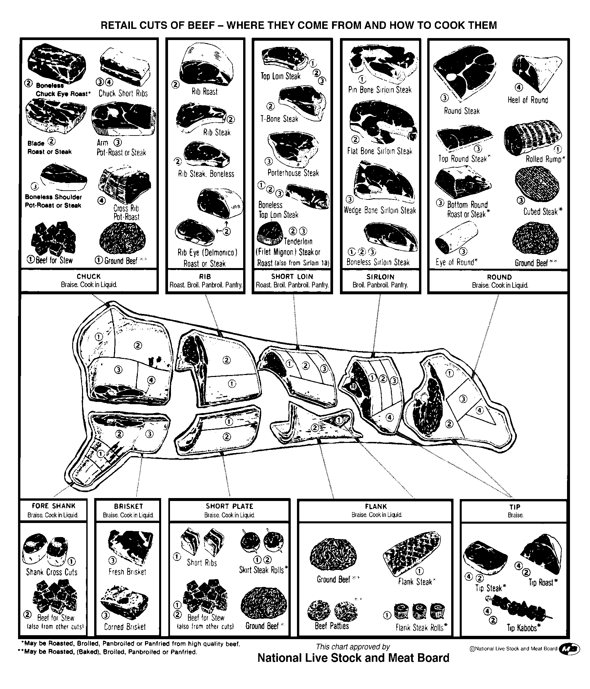

HO 3.3

Pork Chart
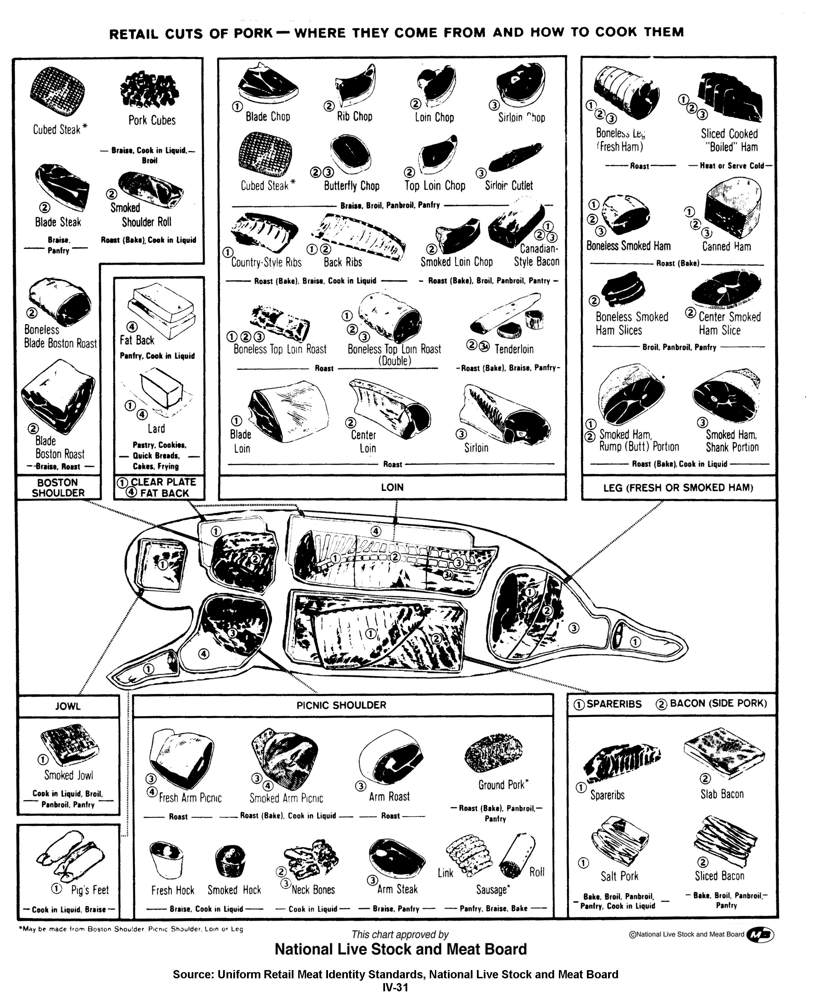

HO 3.4

Lamb Chart
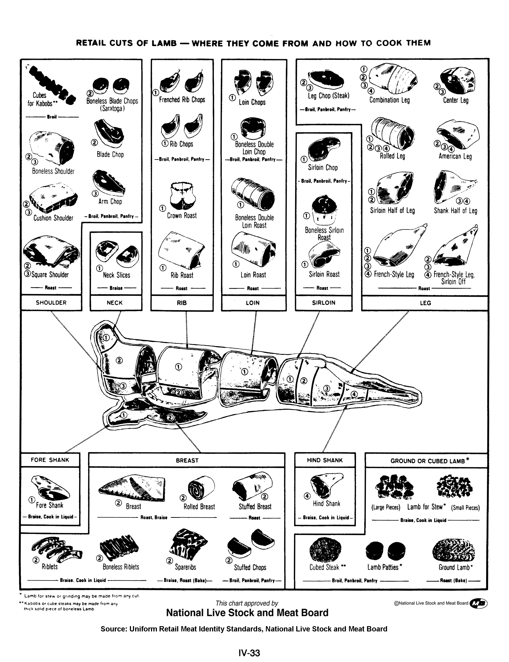

HO 3.5

Meat Labels

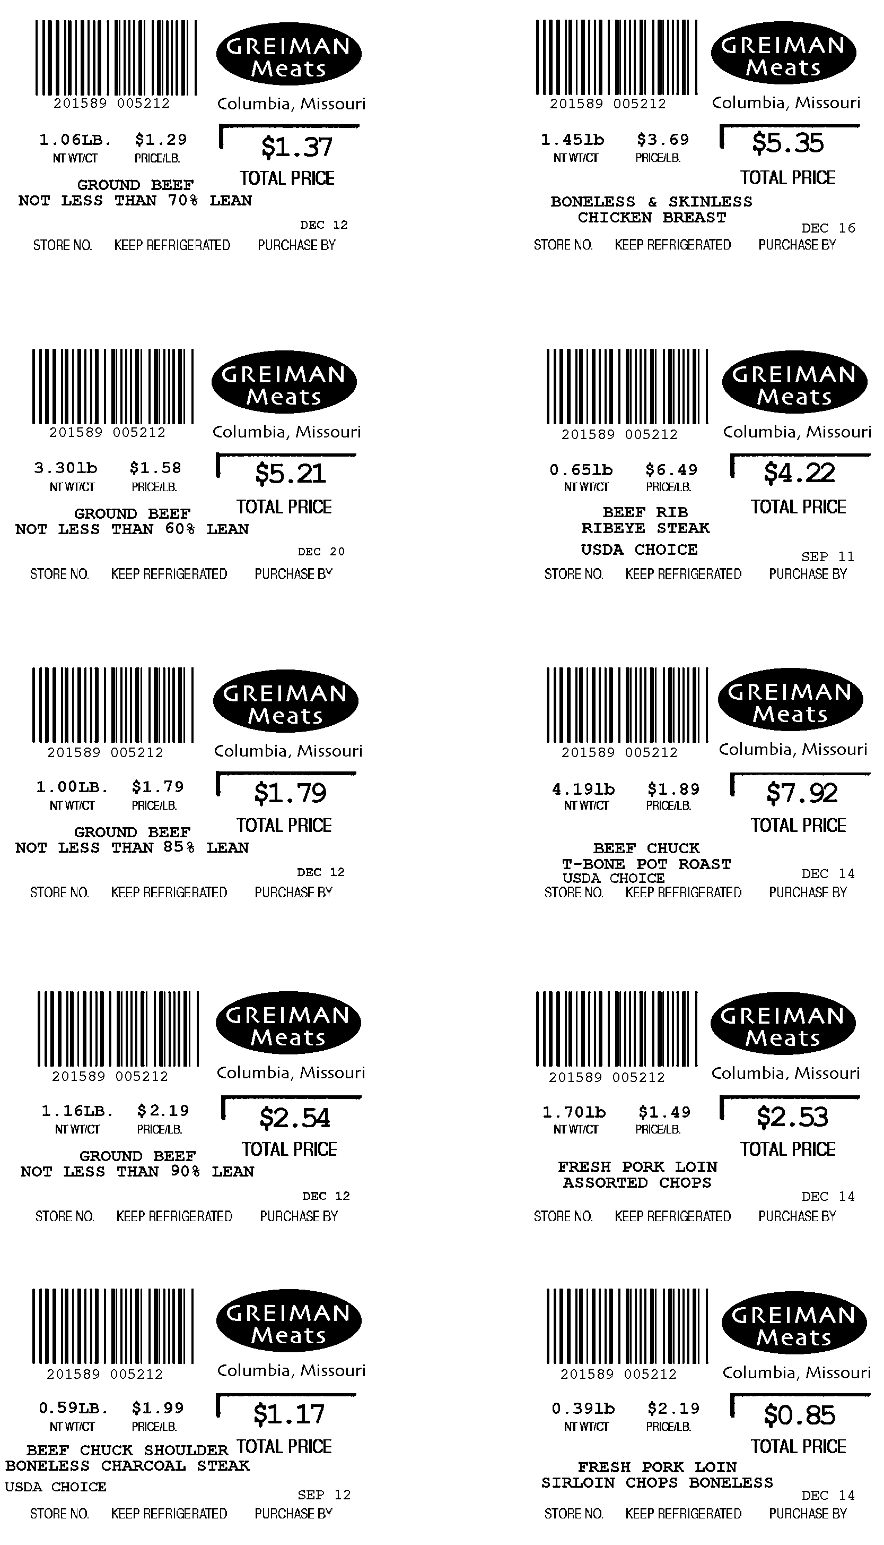

UNIT IV - PRODUCTS FROM AGRICULTURE AS 3.1

Lesson 3: Food Products from Animals Name

Identify the Most Popular Meat Product

Objective: Students will estimate the average amount of meat they consume per year.

Directions: How much of these items did you eat during the past year? Estimate your consumption. Your instructor will provide the latest actual figures.

CATEGORY | POUNDS PER YEAR
CATEGORY | MY ESTIMATE | ACTUAL
Beef
Chicken
Fish
Lamb
Pork
Turkey
Veal

UNIT IV - PRODUCTS FROM AGRICULTURE AS 3.2

Lesson 3: Food Products from Animals Name

Animal Food Products

Objective: Students will be able to identify the type of meat animal that produces various cuts of meat.

Directions: Using HO 3.2, HO 3.3, and HO 3.4, place a check in the box to identify the type of meat animal that produces the cut of meat. Certain cuts of meat can come from more than one animal.

CUT OF MEAT | TYPE OF MEAT ANIMAL
CUT OF MEAT | BEEF | PORK | SHEEP
1. Bacon
2. Sirloin steak
3. T-bone steak
4. Lamb chops
5. Filet mignon
6. Loin chop
7. Kabobs
8. Flank steak
9. Rump roast
10. Sausage
11. Rib steak
12. Fresh arm picnic
13. Tenderloin
14. Round steak
15. Ham slice
16. Loin roast
17. Shoulder steak
18. Leg of lamb
19. Short ribs
20. Blade steak

UNIT IV - PRODUCTS FROM AGRICULTURE AS 3.3

Lesson 3: Food Products from Animals Name

Identifying per Capita Consumption Trends of Meat Products

Objective: Students will be able to graph current trends of consumption and predict future trends.

Directions: Use HO 3.1 to develop a graph that will show the trends of consumption in the United States.

1. Plot per capita consumption (pounds per person) of beef, pork, lamb, chicken, and turkey on the vertical (Y) axis and time (years) on the horizontal (X) axis.

2. Next, extend your graph to the year 2030 and predict what you think the trends will be.

UNIT IV - PRODUCTS FROM AGRICULTURE AS 3.4

Lesson 3: Food Products from Animals Name

Processing Whipped Cream and Butter

Objective: Students will be able to make whipped cream and butter from cream.

Materials and Equipment:

1/2 pint of cream (in store container)
Salt
Crackers

Procedure:

1. Shake container for 10 minutes.

2. Open the container to see if the cream has become whipped cream. Shake slightly longer if whipped cream has not formed.

3. Close the container tightly.

4. Continue shaking until butter forms, approximately 10 minutes.

5. Pour off the liquid, "buttermilk."

6. Add salt to taste.

7. Spread butter on crackers. Enjoy!

UNIT IV - PRODUCTS FROM AGRICULTURE AS 3.5

Lesson 3: Food Products from Animals Name

Reading a Meat Label

Objective: Students will be able to recognize and use information found on meat labels.

Directions: Answer each of the following questions in the space provided.

Typically, seven items of information are found on a meat label in a grocery store. They are:

1.
2.
3.
4.
5.
6.
7.

Use HO 3.5 to answer questions 8 to 12.

8. What is the total price you will pay when buying the ribeye steak?
9. Which retail item costs the least per pound?
10. Which wholesale cut do pork chops (assorted) come from?
- On what date should the pork sirloin chops be removed from the meat counter?
- Which retail cut weighs the most?
13. Hamburger costs $1.20 per pound. You purchase 2 pounds and plan to make quarter pound hamburgers. How many hamburgers can you make? How much does each hamburger cost?

