UNIT IV - PRODUCTS FROM AGRICULTURE

Lesson 6: Nonfood Products from Agriculture

Competency/Objective: Describe nonfood products from agriculture.

Study Questions

1. What nonfood products are made from grains?

2. What nonfood products are made from trees?

3. What nonfood products are made from other plants?

4. What nonfood products are made from livestock?

References

1. Exploring Agriculture in America (Student Reference). University of Missouri-Columbia: Instructional Materials Laboratory, 2000, Unit IV.

2. Transparency Master

TM 6.1 Corn Has Many Uses

3. Activity Sheets

AS 6.1 Biodegradable Plastic
AS 6.2 Cornstarch Activities (Instructor)
AS 6.3 The Papermaking Kit (Instructor)
AS 6.4 Nonfood Products from Cattle and Hogs
UNIT IV - PRODUCTS FROM AGRICULTURE

Lesson 6: Nonfood Products from Agriculture

TEACHING PROCEDURES

A. Review

Many of the fibers in clothing come from agriculture. Cotton has remained one of the most common fabrics used for clothing. Wool is also popular for suits and sweaters. This lesson will discuss many of the other nonfood products from agriculture.

B. Motivation

1. Obtain packing peanuts made from cornstarch. Put one in a jar of water. Screw the lid on and shake it. Open the lid and have students verify that the packing peanut has "disappeared." Ask students why this occurred. The answer is the packing peanut is 95% cornstarch and naturally degrades when it comes into contact with water. This process is similar to leaving a slice of bread outside.

2. Hold up a magazine or newspaper. Ask students what the newspaper has to do with agriculture. Many answers can be justified. In this unit, however, the answer to emphasize is as follows: Soy ink was used to print the newspaper. Ask students how they can tell soy ink was used. The answer is the logo "PRINTED WITH SOY INK" can be found in the publication.

3. Bring to class a leather basketball, baseball glove, shoe (or boot), and jacket. Ask students to identify what the articles have in common. Have students identify other products that could be made from leather.

C. Assignment

D. Supervised Study

E. Discussion

Q1. What nonfood products are made from grains?

A1.
a) Ethanol (grain alcohol)
b) Packing peanuts
c) Noncorrosive road deicer
d) Superabsorbent polymers
e) Biodegradable plastics
f) Animal feed
g) Industrial products
h) Soy printing ink
i) Construction materials
j) Soy diesel

Ask students to discuss nonfood products processed from grains such as ethanol and biodegradable plastics. Describe how the use of these products helps reduce Americans' dependence on petroleum-based products. Show TM 6.1 to illustrate uses of corn. Conduct AS 6.1 in which students create biodegradable plastic and AS 6.2 in which students can experiment with materials that contain cornstarch. Students can work in groups of three or four or on their own.

Q2. What nonfood products are made from trees?

A2.
a) Lumber
b) Paper
c) Cardboard
d) Christmas trees
e) Charcoal
f) Bark chips and mulch
g) Turpentine
h) Varnish
i) Paints

Ask students to name products from trees. List the answers on the chalkboard as they are discussed. Conduct the papermaking activity in AS 6.3.

Q3. What nonfood products are made from other plants?

A3.
a) Ornamentation, landscaping, erosion control, and shade - trees, shrubs, ground covers, and grasses
b) Flower arrangements - flowers
c) Insecticides
d) Medicines - aloe vera
e) Perfume

Pass around a bottle of shampoo or hand lotion containing aloe vera. Have students discuss the aloe and other plants that provide ingredients for nonfood products.

Q4. What nonfood products are made from livestock?

A4.
a) Detergents, soaps, glues, and candles - animal fats
b) Insulin and replacement heart valves for humans - hogs
c) Feathers - chickens and ducks
d) Leather - cattle and hogs
1) Clothing
2) Upholstery
3) Book covers
4) Luggage
e) Lanolin - wool
f) Meal products, fertilizers, animal feeds - bones, feathers, blood, and fish

Ask students why the agricultural industry wants to find new uses for animal parts. Why is it beneficial to be able to use feathers and leather? Describe the economic benefits of using the by-products of production or processing systems. Note that many of the nonfood products are made from materials that would be wasted or thrown away if alternative uses were not discovered. Assign AS 6.4 to have students research nonfood products from cattle and hogs.

F. Other Activities

1. Divide the class into transportation groups, which represent the following sources of fuel or energy:
- Fossil (gasoline, diesel)
- Inexhaustible (ethanol, soy diesel)
- Electric
- Solar
- Nuclear
Using the Internet, allow one class period for students to research their group. Have students identify advantages and disadvantages and then report to the class.

2. Have students write a paper about nonfood products from animals or plants.

3. Have students develop a chart with a cow, pig, chicken, soybeans, or corn in the center. Around the outside, provide examples of nonfood products that are derived from the raw material.

4. Show videos about wood products available from the Missouri Department of Conservation <http://www.conservation.state.mo.us/>.

G. Conclusion

Many nonfood products are processed from animals and plants. Some plants and animals are raised specifically for the special products they provide. Other products are by-products of plant or animal production.

H. Answers to Activity Sheets

AS 6.1 Biodegradable Plastic

The instructor should determine if the results are satisfactory.

AS 6.2 Cornstarch Activities

The instructor should determine if the results are satisfactory.

AS 6.3 The Papermaking Kit

The instructor should determine if the results are satisfactory.

AS 6.4 Nonfood Products from Cattle and Hogs

Category | Nonfood Products from Cattle |  | Nonfood Products from Hogs
Pharmaceuticals/Health Care | Blood factor  Collagen  Heparin  Insulin  Thrombin |  | Heart valves  Insulin  Skin
Household Products | Candles  Ceramics  Deodorants  Detergents  Floor wax  Insulation | Linoleum  Mouthwash  Paints  Plastic  Soups  Toothpaste | Cement  Floor wax  Glue  Insulation  Matches  Plastics
Textiles/Clothing | Shoes  Boots  Belts  Wallets  Gloves  Luggage |  | Buttons  Fabric dye
Travel | Antifreeze  Asphalt  Lubricants  Tires |  | Antifreeze  Tires

I. Answers to Evaluation

1. a
2. d
3. c
4. a
5. c
6. b
7. a
8. c
9. a
10. b
11. d
12. c
13. b
14. a
15. b
16. d
17. a
18. c
19. c
20. a
21. b
22. a
23. d
24. d
25. a
26. e
27. f
28. c
29. b
30. d
31. Whole milk has 5% cream or milkfat. Two % milk has 2% cream or milkfat. Skim milk has all cream removed.
32. a. Clean – Wash hands for 20 seconds in hot, soapy water before preparing food.
b. Separate – Reduce cross-contamination by keeping raw meat products separate from ready-to-eat foods.
c. Cook – Select appropriate cooking temperatures and length of time to properly cook food.
d. Chill – Refrigerate or freeze leftovers within 2 hours or less.

TM 6.1
Corn Has Many Uses

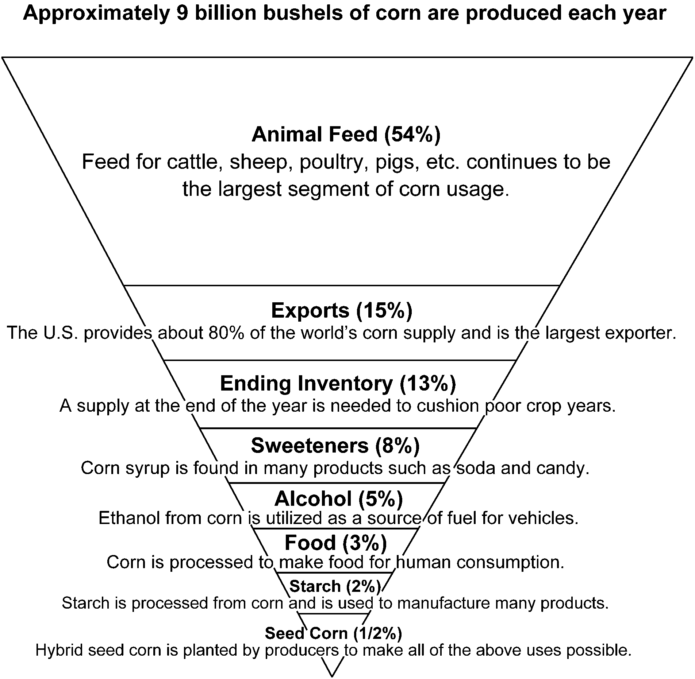

UNIT IV - PRODUCTS FROM AGRICULTURE AS 6.1

Lesson 6: Nonfood Products from Agriculture Name__________________________

Biodegradable Plastic

Objective: Students will create biodegradable plastic.

Materials and Equipment:

Cornstarch
Water
Tablespoon
Microwave oven
Corn oil
Paper cup
Stir stick
Food coloring
Eye dropper

Procedure:

1. Place 1 tablespoon of cornstarch in a paper cup.

2. Add 2 drops of corn oil to the cornstarch.

3. Add 1 tablespoon of water to the corn oil and cornstarch.

4. Stir the mixture.

5. Add 2 drops of your favorite food coloring to the mixture and stir well.

6. Microwave for 25 seconds on high.

7. When it is cool enough to handle, carefully remove the material from the cup.

8. Roll the material into a ball.

UNIT IV - PRODUCTS FROM AGRICULTURE AS 6.2

Lesson 6: Nonfood Products from Agriculture Instructor

Cornstarch Activities

Objective: Students will recognize some different uses of various materials that contain cornstarch.

Materials and Equipment:

Normal golf tee
Biodegradable golf tee (one for each student or group)
Jar
Water
Toothpick/straw
6-oz. plastic cup (one for each student or group)
Superabsorbent polymer
Teaspoon

Note: Ordering information for the biodegradable golf tees and superabsorbent polymer is in the Supervised Study section of Lesson 1 of this unit.

Activity 1 - Golf Tee

Procedure:

Put a normal golf tee and a biodegradable golf tee in a jar of water. Observe it each week until the biodegradable golf tee begins to degrade.

Activity 2 - Superabsorbent Polymer

Procedure:

1. Give each student or group a 6-oz. plastic cup half full of water.

2. Add 2 teaspoons of superabsorbent polymer to the cup and mix with a toothpick or straw. In less than 1 minute, the mixture in the cup should turn to a gelatin or applesauce consistency. If this does not happen, experiment by adding more of the superabsorbent polymer or reducing the amount of water.

UNIT IV - PRODUCTS FROM AGRICULTURE AS 6.3

Lesson 6: Nonfood Products from Agriculture Instructor

The Papermaking Kit

Objective: Students will learn how to make paper.

This kit is an innovative, hands-on classroom project that involves students in the art of making paper. Each kit is capable of meeting the needs of a classroom of approximately 30 students. Instructions are provided with each kit.

Cost: $8.00/kit

Order from the following address:

Minnesota Forest Industries
902 Medical Arts Building
324 West Superior Street
Duluth, MN 55802
(218) 722-5013
<minntrees@aol.com>
<http://www.minnesotaforests.com>

Note: Instructions for making paper can also be found in Boy Scout/Girl Scout publications.

UNIT IV - PRODUCTS FROM AGRICULTURE AS 6.4

Lesson 6: Nonfood Products from Agriculture Name__________________________

Nonfood Products from Cattle and Hogs

Objective: Students will be able to identify nonfood products from cattle and hogs.

Directions: List at least two nonfood products in each of the categories that comes from cattle and hogs. Access the following Internet sites for research:

<http://www.nppc.org/ForKids/byproducts.html>
<http://www.beef.org/library/publications/wow_that_cow/index.htm>

Category | Nonfood Products from Cattle | Nonfood Products from Hogs
Pharmaceuticals/Health Care
Household Products
Textiles/Clothing
Transportation

UNIT IV - PRODUCTS FROM AGRICULTURE Name ____________________

Date _____________________

UNIT EVALUATION

Circle the letter of the best answer.

1. The four main parts of a food chain are _____________________________________________.

a. Sun, producer, consumer, decomposer
b. Animals, plants, humans, grain
c. Sun, humans, recycler, bacteria
d. Sun, plants, herbivores, humans

2. In the agricultural food chain, the primary producers are ________________________________.

a. Livestock
b. Sheep
c. Soybeans
d. Plants

3. __________________ is an example of people manipulating the food chain.

a. Spider eating an insect
b. Fish in a river
c. Domestication of animals
d. Recycling paper

4. Which of the following products are processed from grain?

a. Flour, cereal, sweeteners
b. Soups, cereal, sweeteners
c. Pasta, snack chips, juices
d. Spices, jelly, tea

5. How are fruits and vegetables processed?

a. Fresh and packed in oils
b. Canned and cereals
c. Frozen and fresh
d. Dried and hermetically sealed

6. White bread is usually made from _______________________.

a. Rice
b. Wheat
c. Barley
d. Oats

7. Which of the following is an important product of plants grown in Missouri?

a. Pecans
b. Chocolate
c. Maple syrup
d. Coffee

8. What is the term used for the meat from young cattle?

a. Hamburger
b. Beef
c. Veal
d. Porterhouse

9. Which of the following products are from dairy animals?

a. Milk, ice cream, yogurt
b. Veal, processed patties, lard
c. Butter, milk, eggs
d. Cheese, luncheon meat, dextrose

10. All of the following products are obtained from hogs except ______________________________.

a. Pork chops
b. Hamburger
c. Ham
d. Bacon

11. Which of the following is a freshwater fish?

a. Shrimp
b. Scallops
c. Lobster
d. Catfish

12. Who cleans, separates, handles, and prepares food for the distributor?

a. Harvester
b. Wholesaler
c. Processor
d. Producer

13. Which of the following is not a reason for processing foods?

a. To improve taste
b. To decrease additives
c. To prevent spoilage
d. For the convenience of consumers

14. Which of the following describes the pasteurization process?

a. Heating a dairy product to kill bacteria
b. Cooling a dairy product to kill bacteria
c. Removing the moisture content to kill bacteria
d. Removing fat from a dairy product to kill bacteria

15. Reducing the size of fat particles is a food process called ___________________________.

a. Fermentation
b. Homogenization
c. Emulsification
d. Extrusion

16. Forcing a food component through an opening under high pressure is a food process called _______________________________.

a. Fermentation
b. Homogenization
c. Emulsification
d. Extrusion

17. Where can consumers purchase food products directly from producers?

a. Farmers' market
b. Grocery store
c. Wholesaler
d. Food warehouse

18. To safely store food in a refrigerator, the temperature should be maintained at _____°F or lower.

a. 5
b. 20
c. 40
d. 47

19. Which of the following fibers is manufactured from cellulose from tree fibers?

a. Cotton
b. Flax
c. Rayon
d. Mohair

20. Which of the following fibers can be used to make rope?

a. Hemp
b. Acetate
c. Flax
d. Angora

21. Which of the following fibers is produced by a worm?

a. Wool
b. Silk
c. Angora
d. Mohair

22. Which of the following is made from petroleum chemicals?

a. Polyester
b. Angora
c. Rayon
d. Burlap

23. Which of the following is a synthetic fiber?

a. Wool
b. Flax
c. Silk
d. Nylon

24. Gasohol is produced by blending gasoline with _______________________________.

a. 5% soy oil
b. 10% dextrose from corn
c. 10% STP
d. 10% ethanol from corn

Identify what plant, animal, or by-product from the right column can produce the by-products in the left column.

25. _____ Packing peanuts

26. _____ Printing ink

27. _____ Charcoal

28. _____ Insulin

29. _____ Down comforters

30. _____ Lanolin in hand lotion
a. Cornstarch

b. Ducks

c. Pigs

d. Sheep wool

e. Soybeans

f. Trees

Complete the following short answer questions.

31. Explain the difference between whole milk, 2% milk, and skim milk.

32. Identify and briefly explain the four steps to keep our food safe from harmful bacteria.

a.

b.

c.

d.

