UNIT V - NATURAL RESOURCES AND CONSERVATION

Lesson 2: Soil Conservation

Competency/Objective: Describe the importance of soil conservation.

Study Questions

- What factors contribute to soil erosion?

- How does soil erosion affect food production?

- What is soil conservation?

- What are soil conservation practices?

References

1. Exploring Agriculture in America (Student Reference). University of Missouri-Columbia: Instructional Materials Laboratory, 2000, Unit V.

2. Transparency Master

TM 2.1 U.S. Land Affected by Soil Erosion

3. Activity Sheet

AS 2.1 How Does Mulch Prevent Soil Loss? (Instructor)
UNIT V - NATURAL RESOURCES AND CONSERVATION

Lesson 2: Soil Conservation

TEACHING PROCEDURES

A. Review

Lesson 1 discussed how natural resources are a precious commodity in the environment. Soil is a vital resource for the continued production of food and fiber crops. Each growing season, crops are planted and then harvested. Conservation practices to reduce soil erosion are important.

B. Motivation

1. Using different samples of soil, explain how plants get what they need from the soil. Pass around different types of soil samples for students to see and feel.

2. Ask students how many of them cross a creek to get to school. When a heavy rain comes, what color is the creek? Point out that the muddy color is actually soil in the water. Discuss how long it takes to replace 1 inch of topsoil. (It takes between 200 and 1,000 years.)

3. Take students on a walk on the school grounds. Identify erosion problem areas or potential areas. Discuss what could be done to control erosion in these areas.

C. Assignment

D. Supervised Study

E. Discussion

Q1. What factors contribute to soil erosion?

A1.
a) Human activity such as plowing or construction

b) Water erosion
1) Excess rainfall cannot be absorbed into the earth, so it runs off the surface and carries large amounts of soil with it.
2) Raindrop splash causes soil particles to become separated and thrown about.
c) Wind erosion - small particles of soil carried away by gusts of wind
d) Natural events
- Earthquakes
- Floods
- Tornadoes
- Land slippage on wet, sloping land

Discuss acreage that is affected by soil erosion and its impact on plant and animal life. Have students complete AS 2.1 to help them identify factors that affect soil erosion.

Q2. How does soil erosion affect food production?

A2.
- Soils that have been eroded lose their nutrients and ability to hold water, making plant life unable to thrive and grow.
- Plant nutrients are reduced and animals do not receive proper nutrients to grow and thrive.

Explain to students how soil erosion impacts the food chain and how it affects overall food production.

Q3. What is soil conservation?

A3. Soil conservation involves the protection, conservation, and improvement of the soil.

Explain to students the concept of soil conservation. Remind them of the work done by the Natural Resources Conservation Service that was discussed in the previous lesson.

Q4. What are soil conservation practices?

A4.
- Contour planting
- Crop rotation
- Terracing
- Grassed strips
- Diversion ditches
- Strip cropping
- Vegetative covers

Show TM 2.1 to illustrate how land is affected by soil erosion. Refer to Figure 1 in the Student Reference for examples of soil conservation practices. Explain to students that this is just a sampling of the conservation practices being used in agriculture. Have the students research other ways in which conservation practices are being used in their local area.

F. Other Activities

1. Gather pictures of areas that have been affected by soil erosion. Discuss the adverse effects.

2. On the board, list measures or techniques that can be used to prevent soil erosion.

3. View the video Stream Sense (Ag Video 123) available through the Missouri Resource Center for Career & Technical Education, University of Missouri-Columbia.

4. Invite a representative of the Natural Resources Conservation Service to discuss soil conservation.

- Invite a representative from the highway department to class to discuss the various requirements during construction.

G. Conclusion

Soil is a precious resource needed to sustain life. The movement of wind or water causes most soil erosion across the soil surface. Soil erosion removes fertile topsoil, leaving less fertile subsoil behind. Soil erosion is a problem that affects everyone. Farmers and others are using soil management practices to conserve soil resources.

- Answers to Activity Sheet
There are no answers for this activity.

I. Evaluation

A unit test is provided at the end of this unit. If a lesson quiz is needed, use questions pertaining to this lesson from the unit test.

TM 2.1

U.S. Land Affected by Soil Erosion

UNIT V - NATURAL RESOURCES AND CONSERVATION AS 2.1

Lesson 2: Soil Conservation Instructor

How Does Mulch Prevent Soil Loss?

Objective: Students will discover how mulch will prevent loss of soil through erosion.

Materials and Equipment:

Two small boxes about 16 inches long, 12 inches wide, and 4 inches deep
Two quart-size flower sprinklers
Two half-gallon wide-mouth jars
Two sticks of wood about 1 inch thick

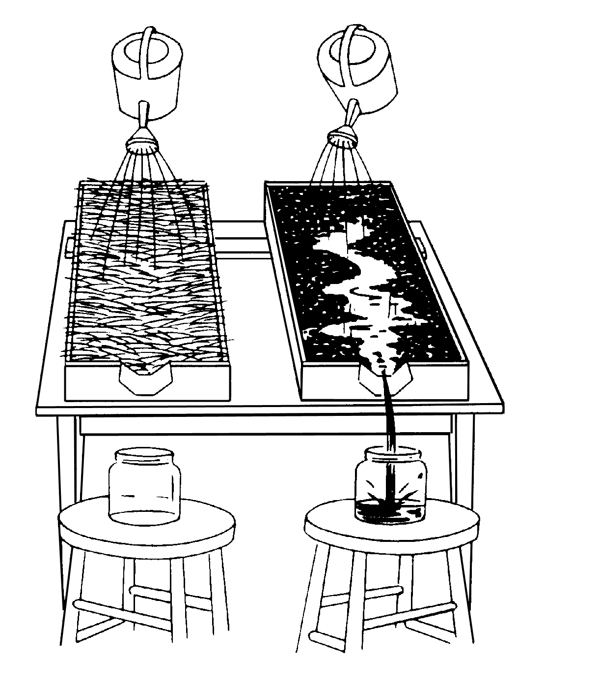
Procedure:

- At one end of the box, cut a V-notch 1 to 1 ½ inches deep and fit with a tin spout to draw runoff water into a container (see drawing).

- Fill the boxes with the same type of soil. Cover one box of soil with a thin layer of straw, grass, wood shavings, or sawdust. Leave the other box of soil bare.

- Set the boxes on the table, placing sticks under one end to make a slope.

- Put the empty jars on stools placed beneath the spouts.

- Fill the two sprinklers with water and pour the water on both boxes at the same time. Pour steadily at the same rate for both boxes. Hold the sprinklers about the same height from the boxes. About a foot is satisfactory, although you can get various results with different heights.

- Note how much and how fast the water runs off into each jar.

- The water on the bare soil will rush off into the jars. The jar will contain muddy water. The water that flows over the mulch will take longer for the flow to start and it will continue longer. Also, not as much water will reach the jar. The water flowing into the jar should be fairly clean.

- This demonstration illustrates how soil covered with mulch, or other protective coverings, reduces water runoff as opposed to soil that is bare.

