UNIT VII - BASIC HOME AND FARMSTEAD SAFETY AND MAINTENANCE

Lesson 1: Electricity

Competency/Objective: Understand electricity and explain precautions for the safe use of electricity.

Study Questions

What is electricity?

How is electricity generated and transported?

How is electricity measured?

What is the difference between a fuse and a circuit breaker?
5. What are hot, neutral, and ground wires?

6. What are the different types of lightbulbs?

7. What hazards are associated with the use of electricity in the farm and home?

References

- Exploring Agriculture in America (Student Reference). University of Missouri-Columbia: Instructional Materials Laboratory, 2000, Unit VII.

- Bergwall Productions, Inc. Working Safely With Electricity, (T&I Video Kit I). Chadds Ford, PA, 1997. Available from Missouri Resource Center for Career & Technical Education, University of Missouri-Columbia.

- Transparency Masters

TM 1.1 Reading an Electric Meter
TM 1.2 Fuses and Circuit Breakers

- Activity Sheets

AS 1.1 Daily Use of Electricity in My Home
AS 1.2 Electrical Safety Checklist

UNIT VII - BASIC HOME AND FARMSTEAD SAFETY AND MAINTENANCE

Lesson 1: Electricity

TEACHING PROCEDURES

Introduction

Electricity has so many uses, it is difficult to imagine life without it. Electrical energy improves the quality of life in our homes, on the farm, in agricultural industry, and nearly everywhere else. It is important for all people to gain an understanding of electricity and safety precautions associated with its use around the house as well as the farm.

Motivation

1. Begin the lesson by asking students to write all of the ways in which they use electricity in a typical day. Challenge them to think of an instance in their daily lives in which they don’t use electricity either directly or indirectly. Have students describe how their daily lives would change if they did not have electricity. Discuss and stress the importance of electricity in improving quality of life.

2. Begin the lesson by asking students to define electricity in their own words. Ask leading questions and generate thoughts on subjects such as:

What is electricity?
Is lightning a form of electricity?
Is static electricity really electricity?
Why can someone “shock” you after dragging his/her feet across the carpet?

Assignment

Supervised Study

Discussion

Q1. What is electricity?

A1. Electricity is a form of energy created by the flow of negatively charged particles in a circuit through a conductor.

Explain an electric conductor and circuit and the flow of electrons. Compare it to water flowing in a river or stream.

Q2. How is electricity generated and transported?

A2.
a) Electricity is generated by mechanically passing coils of wire through a magnetic field.
1) Water power is created by flowing water from a higher level to a lower level to turn the generator.
2) Steam power is created by heated water, which causes steam that turns the generator. Ways to heat water include the following.
- Burning fossil fuels - burning coal, oil, and natural gas
- Nuclear fission - splitting atoms
- Geothermal - steam rising from cracks in the earth
- Burning waste - burning solid waste products
3) Wind power uses air currents to turn the generator.
4) Solar power uses solar cells to convert sunlight to electricity.
b) Electricity is transported from the power plant where it was generated through power lines to the local electric company. It then travels through distribution lines to the customer.

Discuss the positive and negative aspects of each energy form used to generate electricity.

- Water power requires a water source so it would not be effective in a desert.
- Steam power creates a great deal of energy. The burning process may create air pollution. Burning solid wastes may be an effective way to create energy from waste products as well as dispose of wastes.
- Wind and solar power are effective ways of using natural sources of energy; however, both require a steady supply of wind and/or sunlight.

Q3. How is electricity measured?

A3. Electricity is measured in units of watt-hours called kilowatt-hours.

If possible, locate a meter within walking distance of the classroom to show what it looks like. Discuss how the kilowatt-hours are read from the meter. Electrical use is computed by multiplying the pressure times the flow (i.e., volts times amps), which yields watts. Kilowatt-hours are the amount of kilowatts of electricity used over time. One kilowatt-hour represents the use of 1,000 watts of electricity over a 1-hour time period. Use TM 1.1 to illustrate how to read an electric meter. Distribute AS 1.1 and direct students to do a daily meter reading over a 1-week or a 2-week time period. Discuss home usage of electricity at the conclusion of the activity.

Q4. What is the difference between a fuse and a circuit breaker?

A4.
- A fuse is a short piece of metal that will melt at a predetermined number of amps. It is a disposable device designed to be replaced when blown.
- A circuit breaker is a switch that trips when excess current passes through it. When a circuit breaker is tripped, it only needs to be reset.
- Both devices are designed to limit the amount of current passing through them.

Provide examples or pictures of fuses and circuit breakers. Show TM 1.2 to show students the difference between fuses and circuit breakers. Explain to the class that the purpose of a fuse and a circuit breaker is to protect a wiring system. If there is an overload or short in a circuit, the fuse or circuit breaker will keep the wiring system from overheating.

Q5. What are hot, neutral, and ground wires?

A5. Electricity travels from its source to electrical tools and appliances through a series of wires.

a) Hot wires - These are the positive wires that conduct the electrical power to the appliance or tool. They are usually coated with red or black plastic.
b) Neutral wires - These wires help to complete the electrical circuit by carrying the electrical current from the appliance or tool back to its source. Neutral wires are usually coated with gray or white plastic.
c) Ground wires - These wires, usually coated in green plastic, serve as a connection from the electrical appliance or tool to the earth. If that electricity travels outside its normal path, ground wires help provide an alternate path for the electricity back to its source.

Provide examples or pictures of hot wires, neutral wires, and ground wires. Explain their purpose and color coding.

Q6. What are the different types of lightbulbs?

A6.
a) Incandescent - a filament wire heated inside the bulb
b) Fluorescent - light radiated from a gas contained in the bulb after electricity has passed through it
c) Halogen - gases inside the bulb forming a very bright hot light
d) Mercury vapor - an inner bulb with a tube containing sodium with a mixture of argon and neon gas
e) Metal halide - compounds of metal and halogen with a basic two-bulb design
f) Sodium - an arc tube made of aluminum oxide containing a solid mixture of sodium and mercury

Have each type of lightbulb available for the class and discuss uses of each. Discuss which bulbs are the safest and most energy efficient. Emphasize the importance of choosing the appropriate bulb for a task while considering safety hazards and energy costs of each bulb.

Q7. What hazards are associated with the use of electricity in the farm and home?

A7. The main source of injuries associated with electricity occurs from fire or electrical shock. The following situations can create some of these electrical hazards.

a) Installation hazards - Always turn off the main power source and follow all instructions and codes when working with electricity.
b) Overuse of extension cords - Extension cords should be used only for short periods when cords on equipment will not reach an outlet. They should never be used permanently due to a lack of wall outlets.
c) Misuse of fuses and circuit breakers - A blown fuse or a tripped circuit breaker indicates a problem in an electrical circuit. Always attempt to find the source of the problem before replacing a fuse or resetting the breaker.
d) Using electricity in wet areas - Water is an excellent conductor of electricity and can cause electrical shock. Never work with electrical items near wet or damp areas.

Discuss safe practices for electricity usage. Distribute AS 1.2 for students to complete to emphasize safety in handling electricity. View T&I videos 1 and 4 in Working Safely With Electricity (available from Missouri Resource Center for Career & Technical Education, University of Missouri-Columbia) and discuss the dangers involved with electricity.

F. Other Activities

- Refer to the Alliance to Save Energy web site for educators at <www.ase.org/educators> for an activity titled “Making Choices.” This activity will expand on the first motivation listed at the beginning of this lesson where students are challenged to evaluate the impact that electricity has on their daily lives.

- Visit a local power plant to show students the generation and transport of electricity in their areas.

- Invite various guest speakers including electricians and utility company employees to discuss how to handle minor electrical emergencies at home and on the farm.

- Ask a local Rural Electric Cooperative representative to visit and speak with the class.

G. Conclusion

Conclude the lesson by having students provide answers to the questions they generated from the first motivation. Electricity is created by a flow of electrons. There are many sources of electrical power. It is measured in kilowatt-hours. Safe use of electric power requires precautions to avoid shock and fire hazards.

H. Answers to Activity Sheets

AS 1.1 Daily Use of Electricity in My Home

The instructor should determine if the answers are appropriate.

AS 1.2 Electrical Safety Checklist

The instructor should determine if the answers are appropriate.

I. Answers to Evaluation

A unit test is provided at the end of this unit. If a lesson quiz is needed, use questions pertaining to this lesson from the unit test.

TM 1.1

Reading an Electric Meter

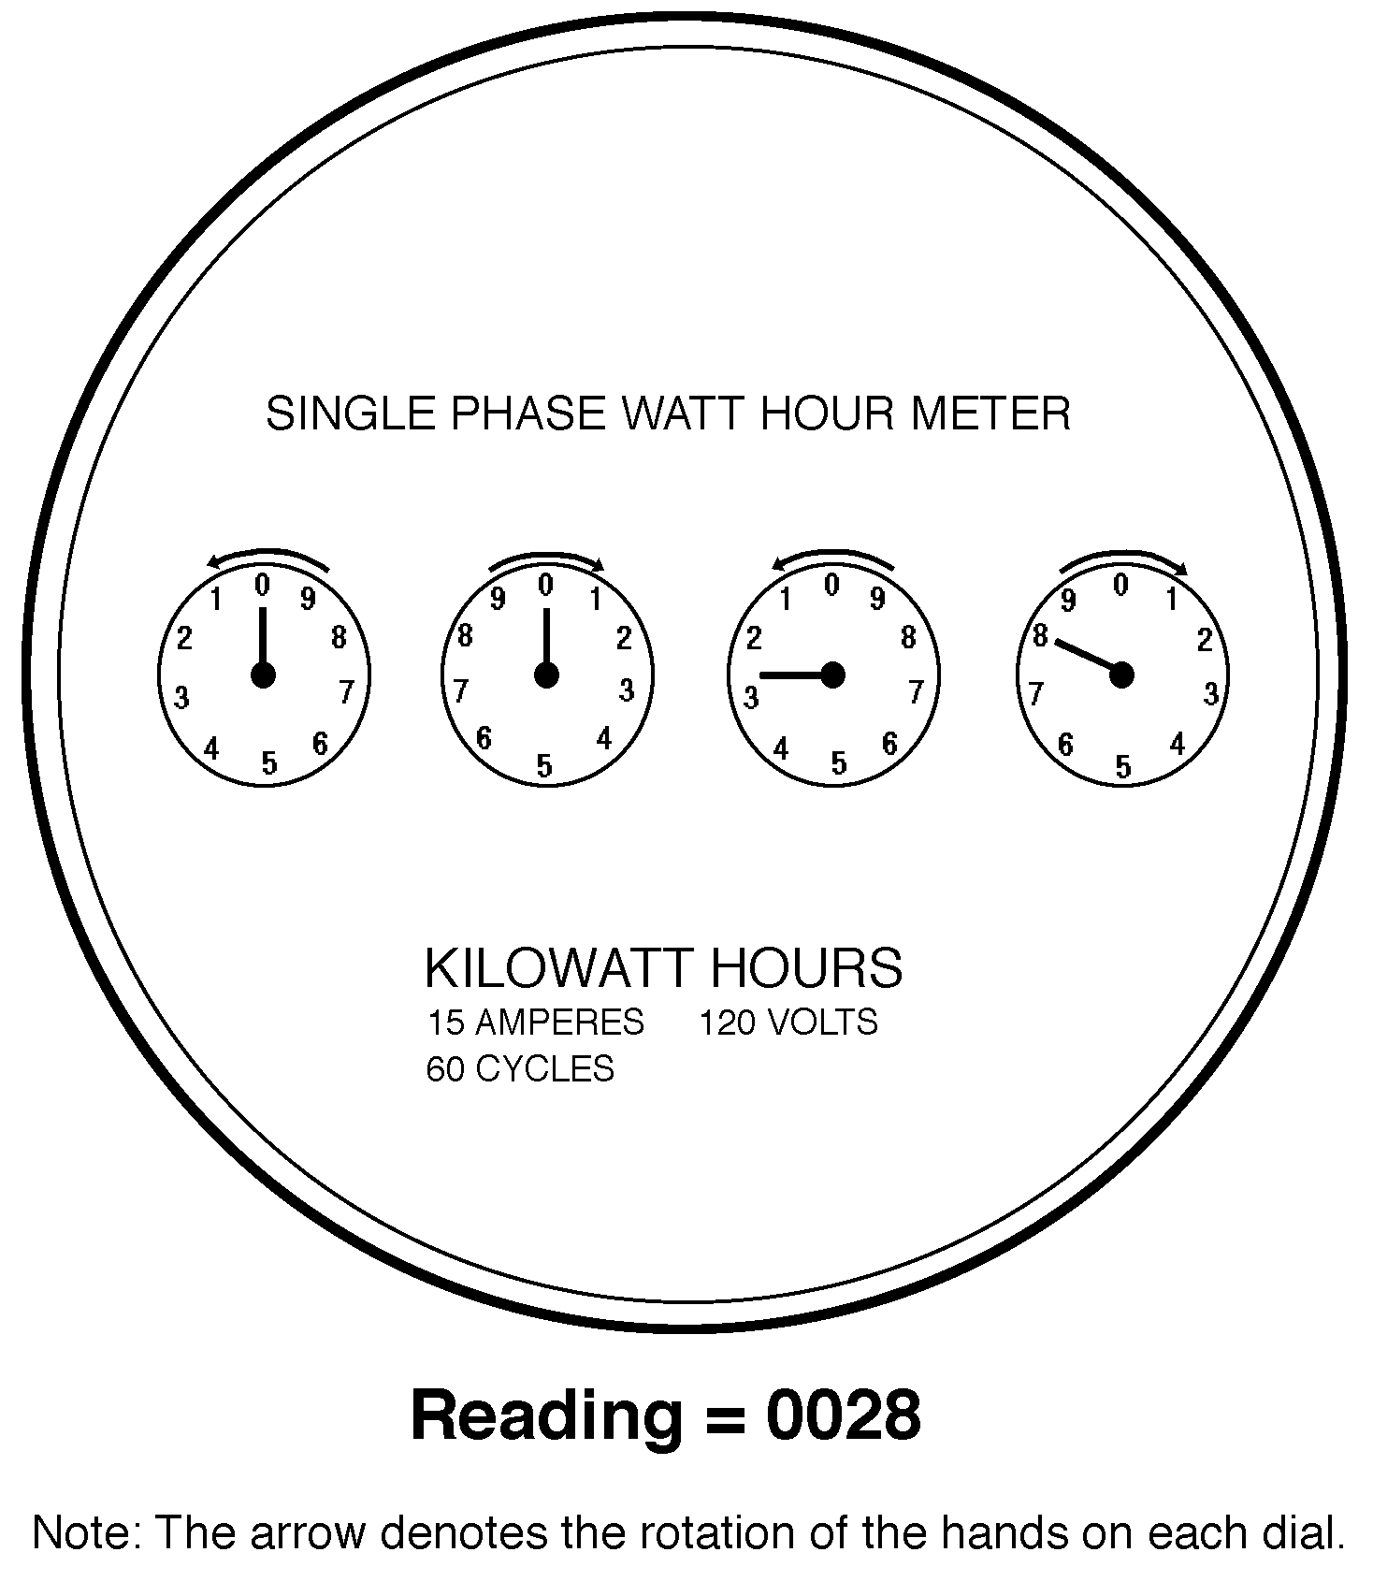

TM 1.2

Fuses and Circuit Breakers

UNIT VII - BASIC HOME AND FARMSTEAD SAFETY AND MAINTENANCE AS 1.1

Lesson 1: Electricity Name_____________________

Daily Use of Electricity in My Home

Objective: Students will determine daily and weekly usage of electricity in their homes.

Directions: To analyze your family’s electricity use, read your meter daily for 2 weeks at approximately the same time each day. Record the readings on the following table. By subtracting the previous day’s reading from the current reading each day, you get the number of kilowatt-hours used during that 24-hour period. By adding the daily figures into a weekly total, you can see how much and when your family used electric power. If there are large variances during a day or week, consider what additional electricity may have been used that contributed to the differences.

DATE | TIME | READING | kWh USED DAILY
Day 1
Day 2
Day 3
Day 4
Day 5
Day 6
Day 7
WEEKLY TOTAL
Day 8
Day 9
Day 10
Day 11
Day 12
Day 13
Day 14
WEEKLY TOTAL

UNIT VII - BASIC HOME AND FARMSTEAD SAFETY AND MAINTENANCE AS 1.2

Lesson 1: Electricity Name__________________________

Electrical Safety Checklist

Objective: Students will identify potential electrical hazards in the home.

Directions: Survey your home using the following list of safety precautions to identify potential electrical hazards. Place a check mark in the blank before each statement properly observed in the home.

___ 1. Do not tamper with or bypass safety features on electrical tools and/or appliances.

___ 2. Do not touch electrical tools or appliances with wet hands or feet.

___ 3. Do not remove the third prong (ground prong) on a three-prong plug.

___ 4. Do not use extension cords that are worn, frayed, or get warm during use.

___ 5. Do not place extension cords under a rug or carpet.

___ 6. Use only double-insulated or three-prong (grounded) cord power tools and appliances.

___ 7. Correct problem before resetting circuit breaker or replacing fuse.

___ 8. Use the appropriate size fuse or circuit breaker for each circuit.

___ 9. Do not leave heat-producing appliances unattended while operating (e.g., toaster, iron, hair dryer).

___ 10. Keep heaters and lamps away from combustible materials.

___ 11. Keep electric motors well lubricated and free of dirt and grease buildup.

___ 12. Keep electric appliances and tools dry to avoid shock hazards.

___ 13. Replace switches, outlets, fixtures, or extension cords that are cracked or damaged.

___ 14. Do not operate electrical equipment in wet conditions.

___ 15. Use caution when handling long objects (e.g., ladders, pipe, lumber) to avoid overhead power lines.

___ 16. Use caution when digging in areas where power lines may be buried.

___ 17. Avoid the use of multiple plug adapters in electrical outlets.

What electrical hazards did you identify? How were they corrected?

