UNIT VII - BASIC HOME AND FARMSTEAD SAFETY AND MAINTENANCE

Lesson 2: Common Measurements and Their Uses

Competency/Objective: Identify common measurements and give examples of their uses.

Study Questions

1. What are common linear measurements and their uses?

2. What are common area measurements and their uses?

3. What are common volume measurements and their uses?

4. What are common weight measurements and their uses?

References

1. Exploring Agriculture in America (Student Reference). University of Missouri-Columbia: Instructional Materials Laboratory, 2000, Unit VII.

2. Transparency Masters

TM 2.1 Reading a Ruler
TM 2.2 Measures of Length, Area, Volume, and Weight

3. Activity Sheets

AS 2.1 Reading a Ruler
AS 2.2 Area Calculations
AS 2.3 Volume Calculations
AS 2.4 Calculating Board Feet
AS 2.5 Weight Calculations

UNIT VII - BASIC HOME AND FARMSTEAD SAFETY AND MAINTENANCE

Lesson 2: Common Measurements and Their Uses

TEACHING PROCEDURES

A. Review

Performing accurate measurements and converting from one unit of measure to another are important in the study of agricultural mechanics. There are two common systems used today. The English system of measurement is the most commonly used in the United States. However, the metric system is used widely around the world and its practices are becoming more prevalent in the United States, namely, in the automotive industry.

B. Motivation

- Begin the lesson with the following problem. “This weekend, the maintenance department will be putting new commercial tile on the classroom floor. However, it has requested that this class figure out how many boxes will be needed to cover the floor. They have told us that the local home improvement store sells the tiles we need. Each tile is 1 square foot, and they are packaged 25 to a box. How many tiles will we need in the classroom?”

Let the students work through this problem for a few minutes.

On the board, write the students’ questions about what they would need to know in order to solve the problem:

a) How long is the room?
b) How wide is the room?
c) How do I read a tape measure (or ruler)?
d) What is a square foot?
e) What is area?

Explain to the students that the questions they have posed in this discussion will be the kinds of questions they will learn to answer in the lesson. Students should leave the discussion with the understanding that once they are able to answer the general questions they have posed, they will (1) have a solid understanding of the lesson and (2) be able to solve this word problem and similar problems in their daily lives dealing with measurements.

2. Begin discussion by bringing an extension cord, a carpet sample, a soda bottle, and a
pound of hamburger to class. Have students identify the units in which they would buy these products in a store. They should be feet, square yards, liters, and pounds, respectively. Point out that in this example, there are four different ways to measure units of each product. These correspond with the four different types of measurements they will study in this lesson: linear, area, volume, and weight. In addition, there are differences between the systems of measurement. Two different systems are English and metric. See if students can point out which is the metric system in the product examples. (It should be the soda bottle - liter.)

Assignment

D. Supervised Study

E. Discussion

Q1. What are common linear measurements and their uses?

A1.
a) Common English linear measurements
1) Inches
- Feet
- Yards
- Common metric linear measurements
1) Millimeters
2) Centimeters
3) Meters
- Kilometers

Explain to students that linear measurement is straight-line measurement. Have students identify items in the room that would be measured in a linear fashion. Display TM 2.1 and instruct class on ruler reading while they look at the ruler on AS 2.1. Have students complete the activity sheet and check answers to be sure they have a good understanding of this process. Display TM 2.2 and explain English equivalents and metric equivalents. Be sure that students understand that the metric system is used around the world and is important to understand.

Q2. What are common area measurements and their uses?

A2. Common area measurements include square feet and square yards.

Area is calculated by multiplying the length of an object by the width of the object. Display TM 2.2 and explain the calculation of area equals length times width (A=LxW). Give students AS 2.2 and allow them to work alone or in partners to solve the area problems. Discuss the answers in a class forum. Include in the discussion the uses of area measurements.

Q3. What are common volume measurements and their uses?

A3. Common volume measurements include board feet, cubic yards, and cubic feet.

Volume is calculated by multiplying the length of an object times the width of an object times the object’s thickness (V=LxWxT). Display TM 2.2. Explain that cubic feet and cubic yards are directly related to one another. Board feet is a special calculation that deals with calculating a volume of wood. Have students complete AS 2.3 and discuss answers. When students are comfortable with the concept of volume, have them complete AS 2.4 and discuss the answers. Board feet is calculated by multiplying the length of a board in feet times the width of a board in feet times the thickness of a board in inches. If you have more than one board, multiply the board feet by the number of boards to get total board feet.

Q4. What are common weight measurements and their uses?

A4.
a) Common measurements of weight in the English system are ounces and pounds.
b) Common measurements of weight in the metric system are grams and kilograms.

Explain that there are 16 ounces in 1 pound and there are 1,000 grams in 1 kilogram. Display TM 2.2 and distribute AS.2.5. Have students practice converting weights in metric and English. Discuss results as a class.

F. Other Activities

1. Set up 10 to 15 stations around the room or laboratory. Place a different item at each station to be measured in one of the four ways discussed. Have students alone or in pairs rotate from station to station measuring and calculating their answers, e.g., put a 2x4 at one station and have students calculate the board feet.

2. Set up English and metric scales and have students practice measuring small objects in grams-kilograms or in ounces-pounds. For further comprehension, have students practice converting ounces and pounds or grams and kilograms.

- Have students bring different types of food packages from home to examine how different types of food are measured and what units of measure they are packaged and sold in. For further practice, have them convert the unit on the package to the other unit discussed.

4. Reread the tile problem that was introduced in the motivation. See how quickly students can calculate this problem.

G. Conclusion

Calculating and converting measurements are important skills in agricultural mechanics as well as in everyday life. Construction projects such as the one discussed in the Motivation, gardening projects, and even grocery shopping involve some degree of measurement and the ability to convert one type of measurement into another.

H. Answers to Activity Sheets

AS 2.1 Reading a Ruler

- 1/16
- 1/8 (2/16)
- 3/16
- ¼ (4/16)
- 5/16
- 3/8 (6/16)
- 7/16
- ½ (8/16)
- 9/16
- 5/8 (10/16)
- 11/16
- ¾ (12/16)
- 13/16
- 7/8 (14/16)
- 15/16
- 1
- 1 3/8
- 2 5/16

AS 2.2 Area Calculations

1. a. 8 ft. x 16 ft. = 128 sq. ft. x 2 walls = 256 sq. ft.
8 ft. x 12 ft. = 96 sq. ft. x 2 walls = 192 sq. ft.
256 sq. ft. + 192 sq. ft. = 448 sq. ft. of surface
b. door area: 3 ft. x 6 ft. = 18 sq. ft.
window area: 2 ft. x 3 ft. = 6 sq. ft.
448 sq. ft – (18 sq. ft. + 6 sq. ft.) = 424 sq. ft. of surface to paint
- 424 sq. ft. divided by 200 sq. ft./gallon = 2.12 gallons of paint
You would need to purchase 2 gallons and 1 quart of paint.
2. a. 18 ft. x 20 ft. = 360 sq. ft.
360 sq. ft divide by 9 sq.ft. /sq. yd = 40 sq. yd. of carpet
b. 18 ft. x 20 ft. = 360 sq. ft
360 sq. ft divide by 9 sq. ft/ sq. yd. = 40 sq. yd. of padding
c. carpet: 40 sq. yd. X $6.00/sq.yd. = $240.00
padding: 40 sq. yd. x $1.00/sq.yd.= $40.00
$240.00+$40.00 = $280.00 total cost
3. a. 10 ft. x 8 ft. = 80 sq. ft. for one wall
15 ft. x 8 ft. = 120 sq. ft. for second wall
80 sq. ft. + 120 sq. ft. = 200 sq. ft. to be covered with paneling
b. area of sheet of paneling: 8 ft. x 4 ft. = 32 sq. ft.
200 sq. ft. divided by 32 sq. ft./sheet = 6.25 sheets of paneling
You would need to buy 7 sheets of paneling to complete this job.
c. $9.00/ sheet x 7 sheets = $63.00

AS 2.3 Volume Calculations

1. 5 ft. x 3 ft. x 1 ft. = 15 cu. ft.
2. 1 cu. yd. = 27 cu. ft., 150 cu. ft./27 = 5.5 cu. yd.
5.5 cu. yd. divide by 2 cu. yd./bag = 2.7 bags
You will need to buy 3 bags.
3. Home supply = $4.99 for 3 cu. yd.
Discount = $ 6.50 for (81cu. Ft/27) = 3 cu. yd.
Home Supply is cheaper.
4. 3 ft. = 1 yd.
5 yd. x 2 yd. X 1 yd. = 10 cu. yd.
5. Steve: 20 cu. yd.
Andy: (500 cu. ft./27) = 18.5 cu. yd.
Steve used more mulch.

AS 2.4 Calculating Board Feet

1. 2 in. x .67 ft. x 14 ft. = 18.76 bd. ft.
18.76 bd. ft. x 2 pieces = 37.52 bd. ft. total
2. 2 in. x .5 ft. x 8 ft. = 8 bd. ft.
8 bd. ft. x 8 pieces = 64 bd. ft. total
3. 2 in. x .33 ft. x 14 ft. = 9.24 bd. ft.
9.24 bd. ft. x 2 pieces = 18.48 bd. ft. total
4. 1 in. x .5 ft. x 14 ft. = 7 bd. ft.
7 bd. ft. x 16 pieces = 112 bd. ft. total
5. 2 in. x .33 ft. x 6 ft. = 3.96 bd. ft.
3.96 bd. ft. x 4 pieces = 15.84 bd. ft. total
6. 2 in. x .33 ft. x 5 ft. = 3.3 bd. ft.
3.3 bd. ft. x 4 pieces = 13.2 bd. ft. total
7. 1 in. x .5 ft. x 8 ft. = 4 bd. ft.
4 bd. ft. x 10 pieces = 40 bd. ft. total
8. 1 in. x .5 ft. x 6 ft. = 3 bd. ft.
3 bd. ft. x 4 pieces = 12 bd. ft. total
Board feet each: 18.76 + 8 + 9.24 + 7 + 3.96 + 3.3 + 4 + 3 = 57.26 bd. ft.
Total board feet: 37.52 + 64 + 18.48 + 112 + 15.84 + 13.2 + 40 + 12 = 313.04 bd. ft. total

AS 2.5 Weight Calculations

- 1. 2 lb. x 16 oz./lb = 32 oz.
- 2. 55 oz/16 oz. per lb = 3.4 lb of cat food x $1.50/lb.= $5.10
- 3. $.25/oz. x 16 oz./lb.= $4.00/lb. The store uptown is cheaper.
- 4. 6.5 lb x 16 oz/lb. = 104 oz. Divide by 8 oz./bag = 13 bags
- 5. 1.5 kg x 1000 g/kg = 1500

I. Answers to Evaluation

A unit test is provided at the end of this unit. If a lesson quiz is needed, use questions pertaining to this lesson from the unit test.
TM 2.1

Reading a Ruler

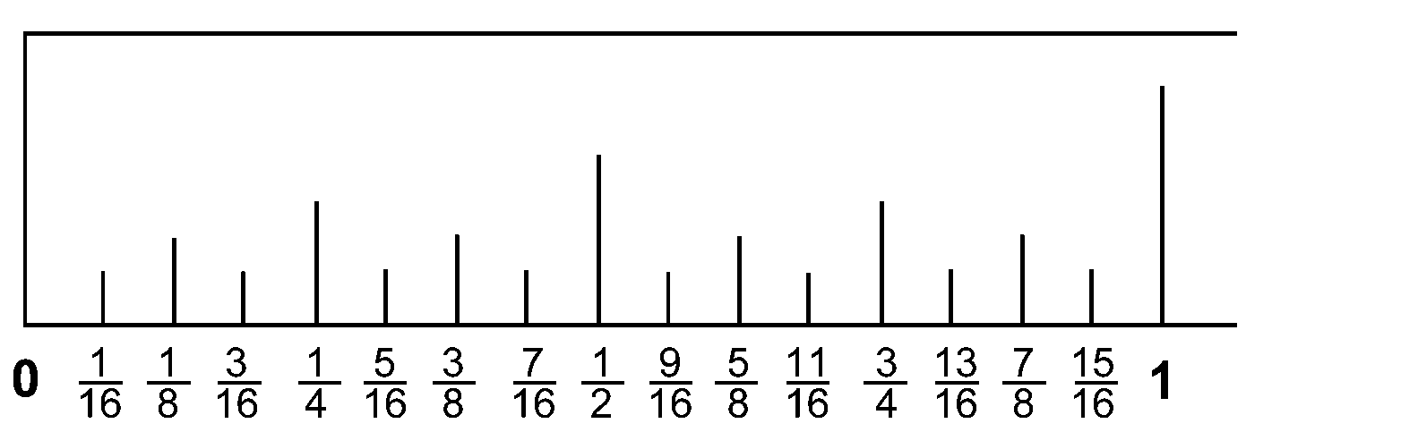

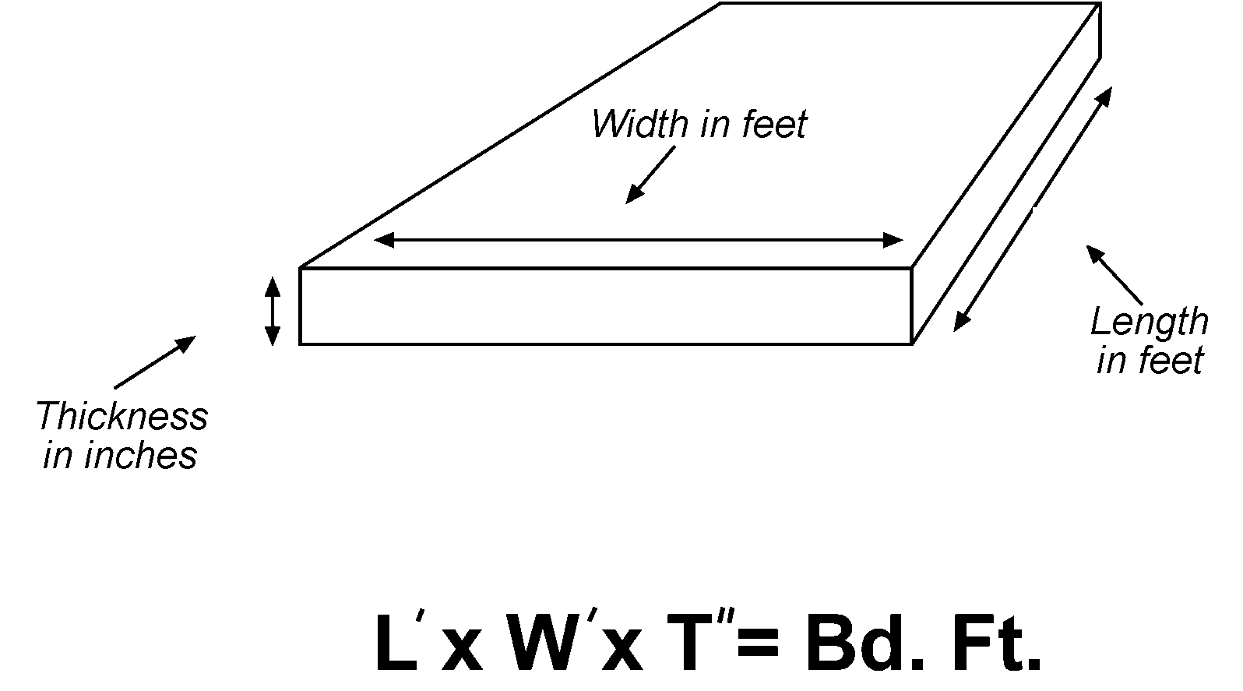

TM 2.2

Measures of Length, Area, Volume,
and Weight

ENGLISH
Measures of Length

12 in. = 1 ft.
3 ft. = 1 yd.
5 ½ yd = 1 rod
320 rods = 1 mile
5,280 ft. = 1 mile
1,760 yd. = 1 mile
6,080 ft. = 1 knot

Measures of Area

144 sq. in. = 1 sq. ft.
9 sq. ft. = 1 sq. yd.
30 ¼ sq. yd = 1 sq. rod
160 sq. rods = 1 acre

Measures of Volume

(solids)
1,728 cu. in = 1 cu. ft.
27 cu. ft = 1 cu. yd.
128 cu. ft. = 1 cord

(liquids)
16 fluid oz. = 1 pt.
2 pt. = 1 qt.
32 fl. oz. = 1 qt.
4 qt. = 1 gal.
31 ½ gal. = 1 bbl.
231 cu. in = 1 gal.
7 ½ gal. = 1 cu. ft.

Measures of Weight

7,000 grains (gr.) = 1 lb.
16 oz. = 1.lb.
100 lbs. = 1 cwt.
2,000 lbs. = 1 short ton
2,240 lbs. = 1 long ton
METRIC
Measures of Length

10 millimeters = 1 centimeter
10 centimeters = 1 decimeter
100 centimeters = 1 meter
1000 meter = 1 kilometer

Measures of Volume

100 cubic centimeters = 1 liter
100 liters = 1 hectoliter

Measures of Weight

100 milligrams = 1 gram
1000 grams = 1 kilogram
1000 kilograms = 1 metric ton

UNIT VII - BASIC HOME AND FARMSTEAD SAFETY AND MAINTENANCE AS 2.1

Lesson 2: Common Measurements and Their Uses Name__________________________

Reading a Ruler

Objective: Students will practice reading an English ruler.

Directions: Fill in the blanks on the accompanying figure with the correct inch readings in the simplest terms.

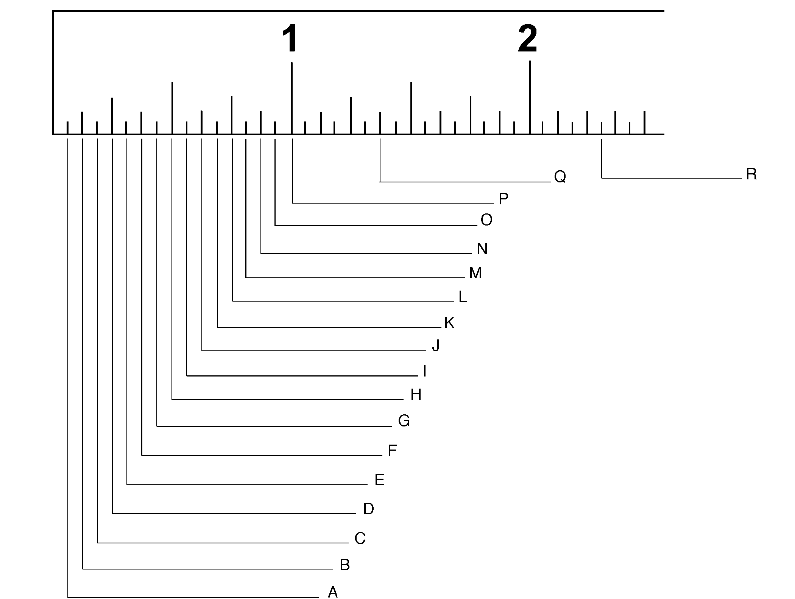

UNIT VII - BASIC HOME AND FARMSTEAD SAFETY AND MAINTENANCE AS 2.2

Lesson 2: Common Measurements and Their Uses Name__________________________

Area Calculations

Objective: Students will calculate areas to determine the amount of materials needed.

Directions: Correctly calculate each problem. (Show your work.)

When purchasing materials to complete a home maintenance project, the exact amount of materials cannot always be purchased because of the way materials are packaged. Therefore accurate calculations are important in order to purchase enough materials without purchasing too much. The following information is provided:

Floor area = length x width
Wall area = length x height
9 sq. ft. = 1 sq. yd.

1. If 1 gallon of paint covers 200 sq. ft., how many gallons of paint will you need to purchase to completely cover a room that has two walls that measure 8 feet tall by 16 feet long and two walls that measure 8 feet tall by 12 feet long? There is one window that measures 2 feet by 3 feet and one door that measures 3 feet by 6 feet that will not need painting.

a. Total square feet of wall space =

b. Total square feet to be painted =

c. Total gallons of paint required =

2. You have decided to carpet the living room. The room measures 18 feet wide by 20 feet long. You will need padding and carpet. The padding costs $1.00 per square yard and the carpet costs $6.00 per square yard.

a. How many square yards of carpet will be needed?

- How many square yards of padding will be needed?

- How much will the materials cost?

3. You want to panel two walls in a room in your house. One wall measures 10 feet long by 8 feet tall. The other wall measures 15 feet long by 8 feet tall. Your paneling comes in sheets 4 feet by 8 feet and costs $9.00 per sheet.

a. How many square feet have to be covered by paneling?

b. How many sheets of paneling would you need to purchase to cover these areas?

c. What is the cost for the paneling only?

UNIT VII - BASIC HOME AND FARMSTEAD SAFETY AND MAINTENANCE AS 2.3

Lesson 2: Common Measurements and Their Uses Name__________________________

Volume Calculations

Objective: Students will calculate volume.

Directions: Calculate the following problems.

1. If a flower bed is 5 feet long, 3 feet wide, and 1 foot thick, how many cubic feet of potting soil must be purchased to fill the bed?

2. You are doing a landscaping project and have calculated that you need 150 cubic feet of topsoil to complete the project. The local supplier sells topsoil in bags with 2 cubic yards of soil per bag. How many bags will you need?

3. The home supply store is having a sale on cedar mulch for $4.99 a bag with 3 cubic yards. The discount store is also selling cedar mulch for $6.50 for a bag with 81 cubic feet. Who has the best buy on cedar mulch?

4. When mulching a garden that is 5 yards long, 2 yards wide, and 3 feet deep, how many cubic yards of mulch would you need to buy?

5. Steve used 20 cubic yards of mulch on Garden A and Andy used 500 cubic feet of mulch on Garden B. Who used the most mulch?

UNIT VII - BASIC HOME AND FARMSTEAD SAFETY AND MAINTENANCE AS 2.4

Lesson 2: Common Measurements and Their Uses Name__________________________

Calculating Board Feet

Objective: Students will accurately calculate board feet.

Directions: Calculate the number of board feet in the following list of lumber materials for a hayrack.

ITEM | NUMBER | SIZE | BD. FT. EACH | TOTAL BD. FT.
Sills | 2 | 14’ x .67' x 2”
Joists | 8 | 8’ x .5' x 2”
Side rails | 2 | 14’ x .33' x 2”
Floor | 16 | 14’ x .5' x 1”
Standards | 4 | 6’ x .33' x 2”
Standards | 4 | 5’ x .33' x 2”
Ends | 10 | 8’ x .5' x 1”
Braces | 4 | 6’ x .5' x 1”
TOTAL BOARD FEET

UNIT VII - BASIC HOME AND FARMSTEAD SAFETY AND MAINTENANCE AS 2.5

Lesson 2: Common Measurements and Their Uses Name__________________________

Weight Calculations

Objective: Students will apply and understand weight calculations.

Directions: Calculate the following problems.

      - If you buy 2 pounds of chicken from the store, how many ounces of chicken would you have?

      - Susan purchased 55 ounces of cat food at the local pet store. This cat food sold for $1.50/pound. How many dollars' worth of cat food did she buy?

      - The local grocery store is selling shrimp for $5 per pound. Another store uptown had a special on shrimp that ran $0.25 per ounce. Which store offered the better buy on shrimp?

4. Vikki needed 6.5 pounds of chocolate chips for a recipe she was making. The store sold chocolate chips in 8-ounce bags. How many bags of chocolate chips must Vikki buy?

5. If the local Super Discount Warehouse sells mega bags of chips with 1.5 kilograms per bag, how many grams of chips are in each bag?

