UNIT VII - BASIC HOME AND FARMSTEAD SAFETY AND MAINTENANCE

Lesson 5: Safety and Maintenance Procedures for Lawn and Garden Equipment

Competency/Objective: Identify safety and maintenance procedures for lawn and garden equipment.

Study Questions

1. What are common lawn and garden hand tools?

2. What are examples of common power lawn and garden equipment?

3. What is the difference between a two- and four-stroke engine?

4. What safety guidelines should be followed when using hand lawn equipment?

5. What safety guidelines should be followed when using power lawn equipment?

6. What are maintenance procedures for hand lawn equipment?

7. What are maintenance procedures for power lawn equipment?

References

- Exploring Agriculture in America (Student Reference). University of Missouri-Columbia: Instructional Materials Laboratory, 2000, Unit VII.

2. Activity Sheets

AS 5.1 Hand Lawn Tool Identification
AS 5.2 Power Lawn Tool Identification
AS 5.3 Two- vs. Four-Stroke Engines
AS 5.4 Mower Safety Demonstration (Instructor)
AS 5.5 Mowing Obstacle Course (Instructor)
AS 5.6 Lawn Mower Safety Guidelines

UNIT VII - BASIC HOME AND FARMSTEAD SAFETY AND MAINTENANCE

Lesson 5: Safety and Maintenance Procedures for Power Lawn and Garden Equipment

TEACHING PROCEDURES

A. Review

Review the previous lesson and inform students that safety applications are crucial in many operations around the home and farm. This lesson stresses proper safety procedures used when working with hand and power lawn and garden equipment.

B. Motivation

Bring several different types of hand and power lawn tools to the classroom. Divide students into
groups. Have each group identify as many tools as they can and describe the use for each tool.
Reward the group with the most correct answers.

C. Assignment

D. Supervised Study

E. Discussion

Q1. What are common lawn and garden hand tools?

A1.
- Turf edger
- Weed cutter
c) Garden hoe
d) Push hoe
e) Lawn or leaf rake
f) Garden rake
g) Pitchfork
h) Spading fork
i) Cultivators
j) Pruning shears
k) Hedge shears
l) Hand trowel
m) Round-pointed shovel
n) Wheelbarrow
o) Sod roller

Refer to the drawings in the Student Reference. Explain to students that hand tools work well where large power tools cannot fit. Stress the importance of keeping hand tools clean and well maintained to ensure the safety of the operator and the longevity of the tool. Have students complete AS 5.1 to identify hand lawn tools.

Q2. What are examples of common power lawn and garden equipment?

A2.
a) Walk-behind mower
b) Riding mower
c) Leaf blower
d) String trimmer
e) Hedge trimmer
g) Tiller

Refer to the drawings in the Student Reference and describe the various types of power lawn and garden equipment. Ask students which types they have at home and which types they have personally operated. Have students complete AS 5.2 to identify power lawn tools.

Q3. What is the difference between a two- and four-stroke engine?

A3. The two-stroke engine requires an oil-fuel mixture directly in the fuel chamber whereas the four-stroke engine strictly requires fuel in the fuel tank and oil in the oil reservoir.

Refer to Table 5.1 in the Student Reference, which displays the differences between a two- and four-stroke engine. Discuss the differences, making it clear that one is not necessarily better than another. They are both extremely useful for different power requirements. Be sure that students clearly understand that two- and four-stroke engines have extremely different fuel requirements. Regular fuel cannot be used in a weed-eater, and conversely, fuel-oil mixture for a weed-eater cannot be used in a riding lawn mower. Demonstrate the correct mixing of a two-stroke fuel-oil mixture. Have students complete AS 5.3 to identify differences between two- and four-stroke engines.

Q4. What safety guidelines should be followed when using hand lawn equipment?

A4.
a) Use the appropriate tool for the job.
b) Avoid baggy, loose-fitting clothing.
c) Wear safety glasses, particularly when sharpening tools.
d) Wear gloves to protect the hands.
e) Inspect the tool to ensure that it is sharp and in good working condition.
f) Be conscious of others’ locations before swinging sharp tools to avoid injuring others.

Review the safety guidelines and express the importance of safety. Explain that even though the equipment is not power equipment, it can still be dangerous.

Q5. What safety guidelines should be followed when using power lawn equipment?

A5.
a) Carefully read the instructions and operating procedures in the owner’s manual before attempting to operate any power lawn tool.
b) Avoid loose or baggy clothing because it may become entangled in moving parts of the equipment.
c) Wear safety goggles to protect the eyes.
d) Inspect tools before use to be sure they are sharp and in good working condition.
e) Alert others that a power tool is in use.
f) Keep hands and feet away from all moving parts.
g) Remove debris and large objects from areas where mowers and trimmers will be operated.
h) Never smoke or attempt to refill the fuel tank while the tool is running.
i) Keep all safety shields in their proper places.
j) Use caution when mowing on slopes to avoid falling or overturning equipment.
k) Mow only dry grass and cut grass 1 1/2 to 3 inches depending upon time of year and type of grass.

Review the safety guidelines and discuss the importance of safe operations for power lawn equipment. Perform AS 5.4, the mower safety demonstration and AS 5.5, the mower obstacle course. When questions are answered and students have mastered safety, have them complete AS 5.6 to identify mower safety guidelines.

Q6. What are maintenance procedures for hand lawn equipment?

A6.
a) Clean and inspect hand tools for any damage after each use.
b) Restore rough, dry, and splintered wooden handles by sanding and rubbing with linseed oil.
- Prevent rusting by keeping all metal surfaces dry.
- Remove existing rust by wire brushing metal surfaces and then shining with light oil.
e) Sharpen blades with files, stones, or grinders.

Discuss maintenance procedures for hand-operated lawn equipment. Continue to emphasize the use of safe handling while maintaining the tools.

Q7. What are maintenance procedures for power lawn equipment?

A7.
- Check air cleaners and filters every 25 hours of operation or sooner when working in extremely dusty conditions.
- Check oil in four-stroke engines before each use and change oil every 25 hours of use.
- Always use the correct fuel-oil mixture in a two-stroke engine.
- Check spark plugs frequently and change after 100 hours of use.
- Follow proper procedures when storing power tools for long periods of time.
- Drain the fuel tank.
- Change oil and filters.
- Clean and lubricate the exterior and chains.
- Loosen the belts.

Discuss maintenance procedures for power lawn equipment. Always consult the owner’s manual. If equipment is available, illustrate the necessary procedures to the students. After procedures have been explained and they understand safety precautions to be followed, have them perform the procedures.

F. Other Activities

1. Have students perform a general power lawn maintenance procedure whereby they clean an air filter, clean a spark plug, and change the oil.

2. Demonstrate to students how to correctly mix fuel for a particular two-stroke tool such as a weed eater.

3. Invite a guest speaker from a local lawn and garden dealership to speak about different types of lawn equipment and their safety.

4. Have students create lawn safety posters to display in the shop, around the school, or at various locations throughout the community.

G. Conclusion

It is very important as a homeowner to know the proper use, maintenance, and safety procedures for lawn and garden equipment. Appropriate practices will help ensure the safety of the operator, the ease of operation, and the longevity of the tool.
H. Answers to Activity Sheets

AS 5.1 Hand Lawn Tool Identification

1. c
2. f
3. h
4. d
5. a
6. m
7. b
8. l
9. k
10. i
11. n
12. o
13. j
14. e
15. g

AS 5.2 Power Lawn Tool Identification

1. c
2. b
3. d
4. e
5. a

AS 5.3 Two- vs. Four-Stroke Engines

 | Four-Cycle Engine  (equal hp)  One Cylinder | Two-Cycle  (equal hp)  One Cylinder
Number of moving parts | Nine | Three
Running | Cooler running | Hotter running
Overall | Larger | Smaller
Engine | Heavier construction | Lighter in weight
Fuel and Oil | No mixture required | Must be premixed
Fuel Consumption | Fewer gallons per hour | More gallons per hour
Oil Consumption | Oil recirculates and stays in engine | Oil is burned with fuel
Sound | Generally quiet | Louder in operation
Operation | Smoother | More erratic
Acceleration | Slower | Very quick
General maintenance | Greater | Less
Initial Cost | Greater | Less
Versatility of operation | Limited slope operation (Receives less lubrication when tilted) | Lubrication not affected at any angle of operation

AS 5.4 Mower Safety Demonstration

There are no answers to this exercise.

AS 5.5 Mowing Obstacle Course

There are no answers to this exercise.

AS 5.6 Lawn Mower Safety Guidelines

1. a) No loose/baggy clothing
b) Safety goggles

2. a) Inspect for sharpness/good condition
b) Alert others
- c) Remove debris from the area
d) Read instructions/owner’s manual

3. a) Keep hands and feet away from moving parts.
b) Use caution on slopes
- c) Mow dry grass and cut 1 ½ to 3 inches
d) Keep safety shields in place

4. a) Don’t smoke.
b) Turn off engine.

I. Answers to Evaluation

1. b
2. c
3. a
4. d
5. b
6. b
7. a
8. c
9. d
10. b
11. c
12. c
13. b
14. a
15. d
16. a
17. d
18. d
19. b
20. a
21. a
22. c
23. c
24. a
25. d
26. b
27. e
28. e
29. c
30. a
31. b
32. d
33. a
34. d
35. e
36. c
37. b
38. a
39. d
40. e
41. c
42. b
43. Any two of the following:
a. Protect eyes and clothes.
b. Use right tool for the job.
c. Inspect tool for damages.
d. Know how to use correctly.
- Store in proper place after use.
- Be sure tool is clean and undamaged before storing.

44. Any two of the following:
a. Get permission.
b. Inspect tool.
c. Protect eyes and clothes.
d. Master the safety and operating techniques.
e. Let others know.
f. Make adjustments with the tool unplugged.
- Clean and store after use.

45. Any three of the following:
a. Do not wear loose, baggy clothing.
b. Wear safety glasses.
c. Wear gloves.
d. Inspect tool before use.
- Be aware of others when using sharp tools.

46. Any three of the following:
a. Do not wear baggy clothes.
b. Wear safety goggles.
c. Inspect tool for sharpness and condition.
d. Alert others.
e. Hands away from moving parts.
f. Remove debris from area to be mowed.
g. Never smoke when fueling a running engine.
h. Keep safety shields in place.
i. Know owner's manual operating procedures.
j. Use caution on slopes.
- Mow dry grass only.

47. One of the following:
a. Clean after each use and inspect for damage.
b. Rub linseed oil on rough, dry handles.
c. Remove rust on metal surfaces with a wire brush and apply oil.
d. Keep tools dry to prevent rust.
e. Sharpen blades with files, stones, or grinders.

48. Any two of the following:
a. Check air filters every 25 hours of use or after very dusty conditions.
b. Check oil in 4-stroke engines before each use and change oil every 25 hours of use.
c. Use correct fuel-oil mix in a 2-stroke engine.
d. Check spark plugs frequently and change every 100 hours of use.
e. Follow correct steps for winter storage of power tools.

UNIT VII - BASIC HOME AND FARMSTEAD SAFETY AND MAINTENANCE AS 5.1

Lesson 5: Safety and Maintenance Procedures for Lawn Name_________________
and Garden Equipment

Hand Lawn Tool Identification

Objective: Students will identify common lawn and garden hand tools.

Directions: Match the correct hand lawn tool with the correct picture on the following page.

_____ 1. Garden hoe

_____ 2. Lawn or leaf rake

_____ 3. Garden rake

_____ 4. Spading fork

_____ 5. Pitchfork

_____ 6. Cultivator

_____ 7. Turf edger

_____ 8. Hedge shears

_____ 9. Scissor-type pruning shears

_____10. Weed cutters

_____11. Hand trowel

_____12. Wheelbarrow

_____13. Sod roller

_____14. Round-pointed shovel

_____15. Push hoe

UNIT VII - BASIC HOME AND FARMSTEAD SAFETY AND MAINTENANCE AS 5.1 (Cont.)

Lesson 5: Safety and Maintenance Procedures for Lawn and Garden Equipment

c.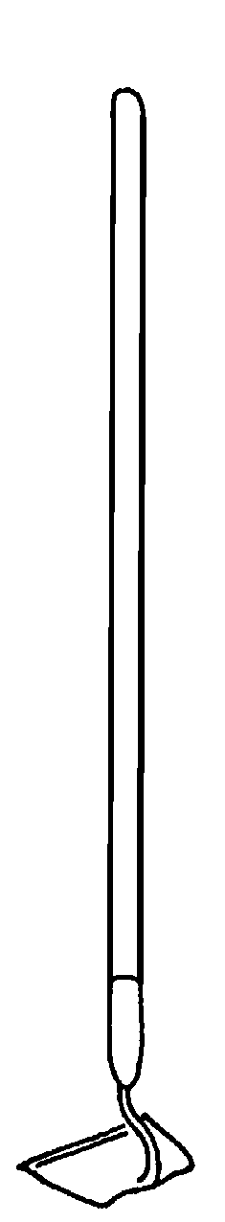
f.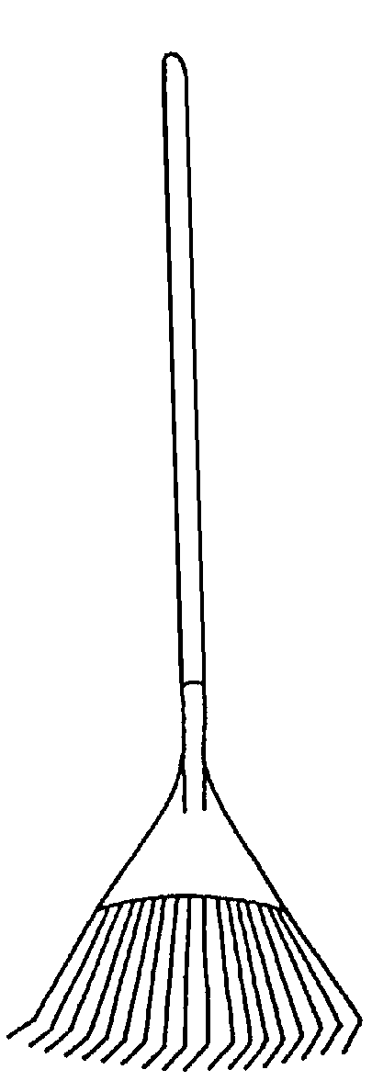
d.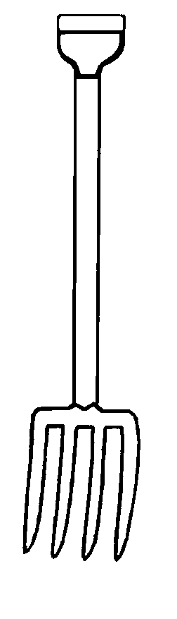
a.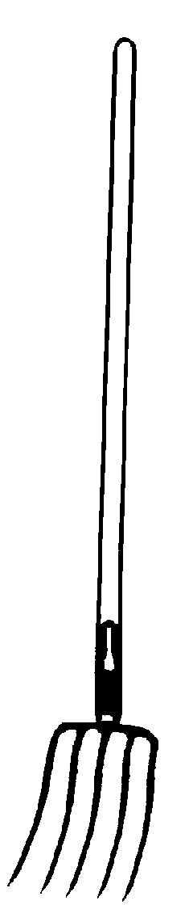
b.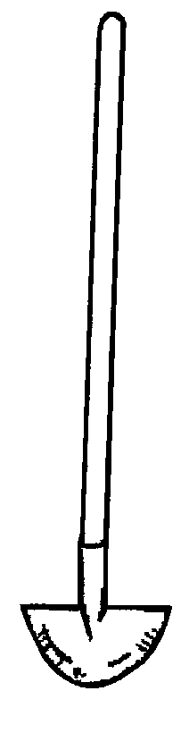
e.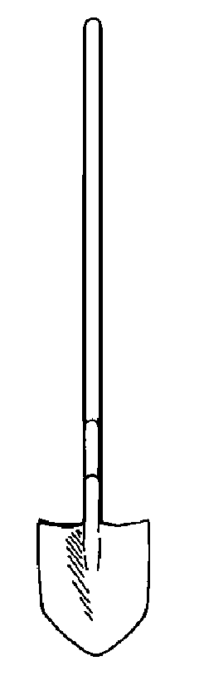

k.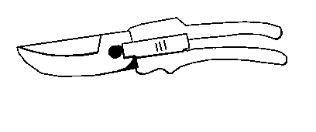
h.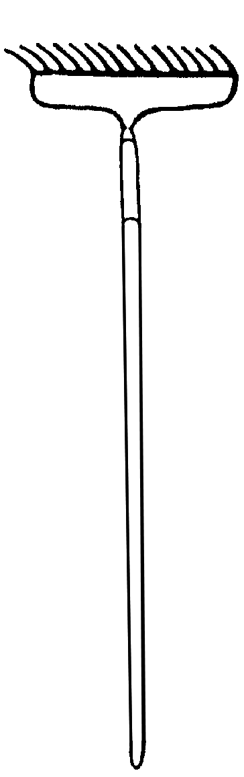
o.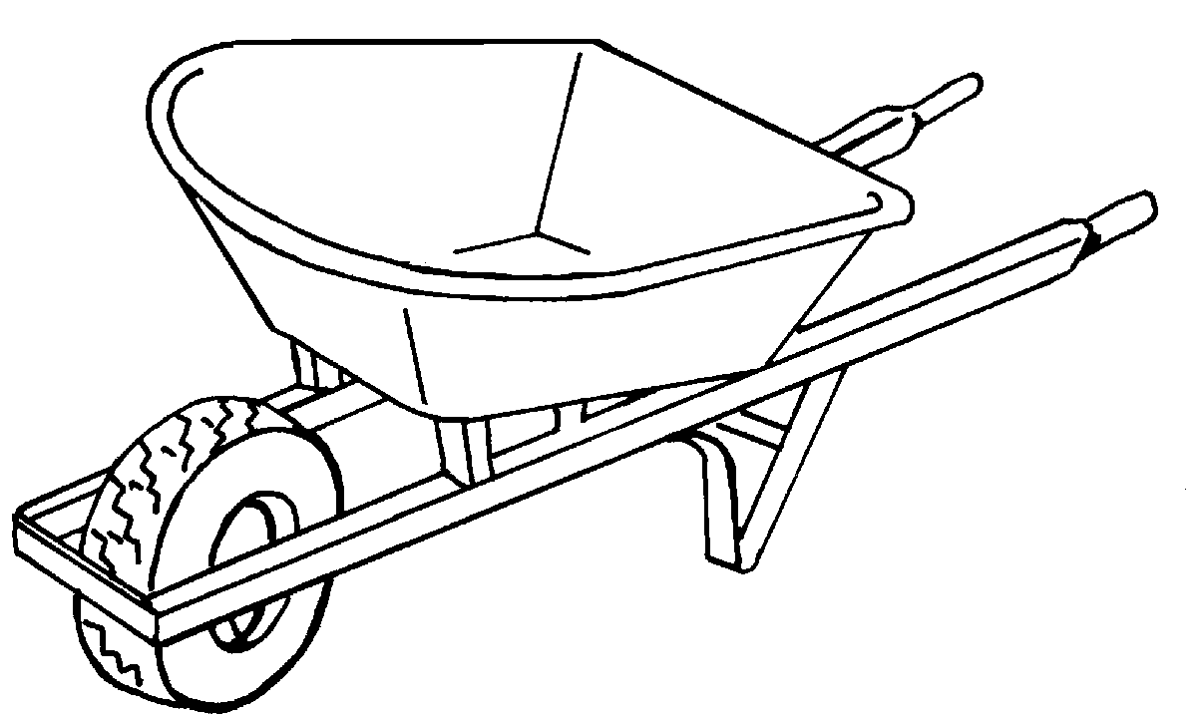
m.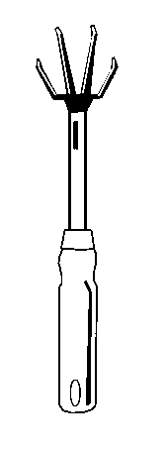
g.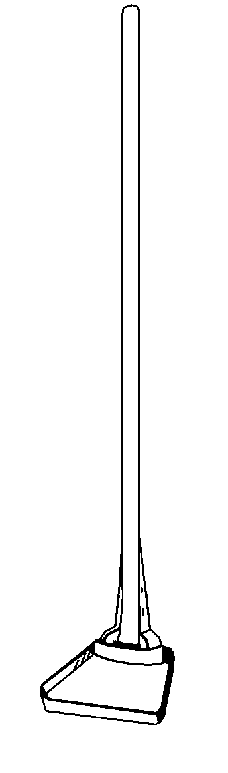
i.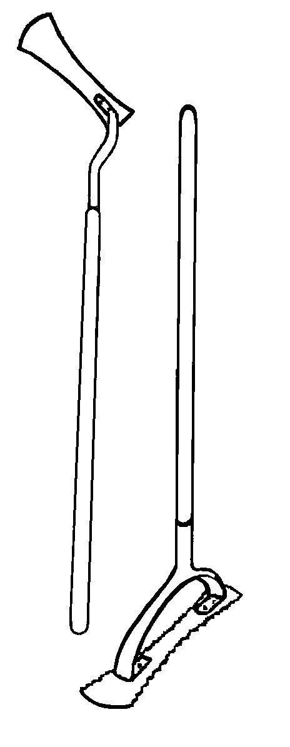
j.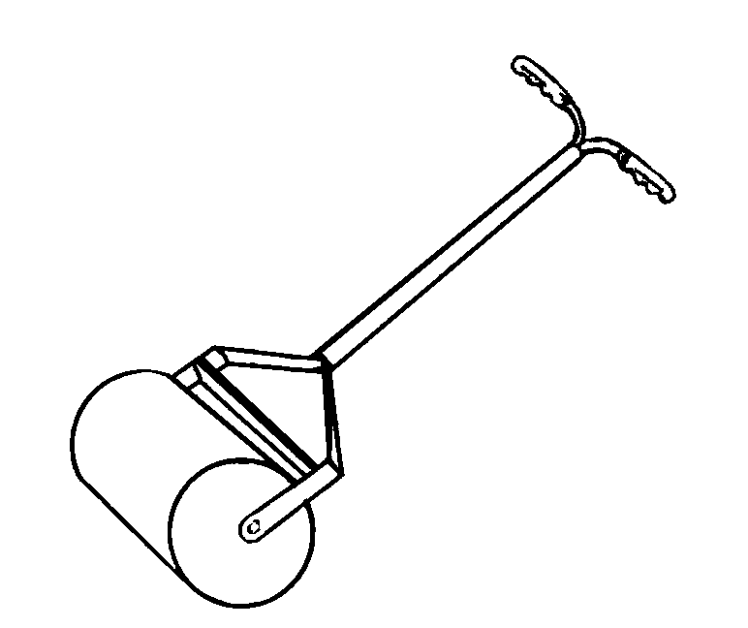
n.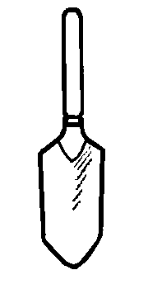
l.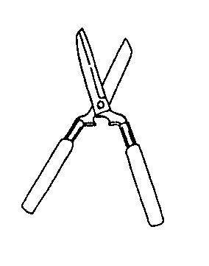

UNIT VII - BASIC HOME AND FARMSTEAD SAFETY AND MAINTENANCE AS 5.2

Lesson 5: Safety and Maintenance Procedures for Lawn Name_________________
and Garden Equipment

Power Lawn Tool Identification

Objective: Students will identify common power lawn equipment.

Directions: Match the correct power lawn equipment with the correct picture.

_____ 1. Walk-behind mower

_____ 2. Hedge trimmer

_____ 3. Line or string trimmer

_____ 4. Leaf blower

_____ 5. Riding lawn mower

c.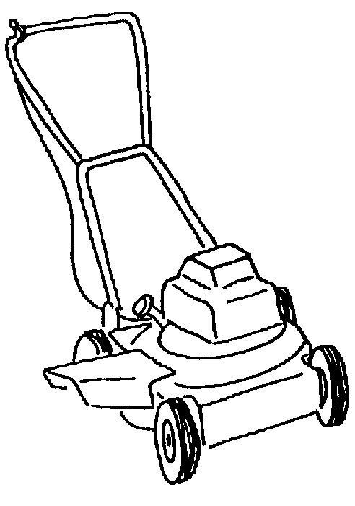
e.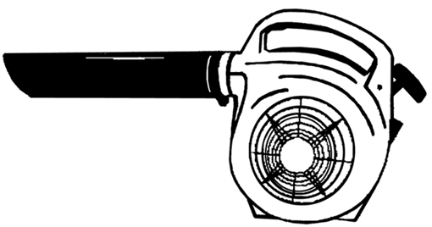
d.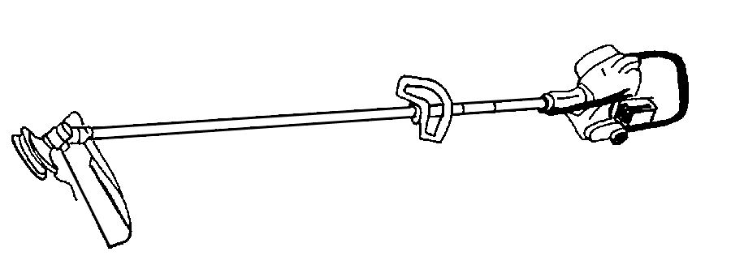
b.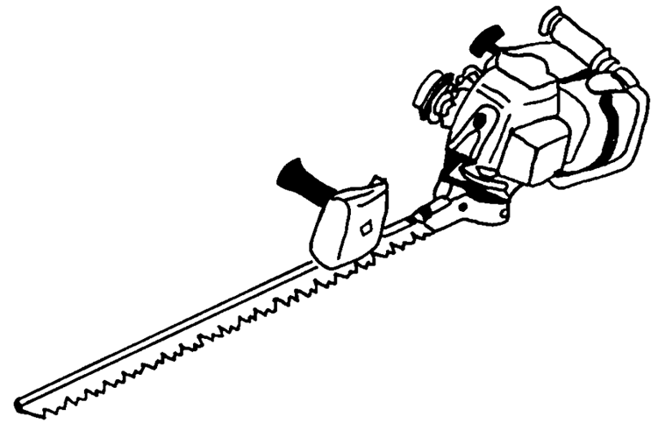
a.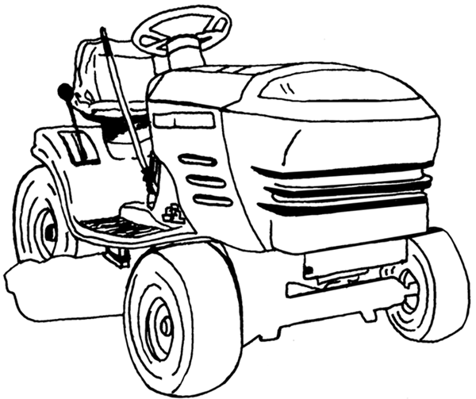

UNIT VII - BASIC HOME AND FARMSTEAD SAFETY AND MAINTENANCE AS 5.3

Lesson 5: Safety and Maintenance Procedures for Lawn Name_________________
and Garden Equipment

Two- vs. Four-Stroke Engines

Objective: Students will identify differences between two- and four-stroke engines.

Directions: Place the appropriate characteristic in the appropriate blank.

 | FOUR-CYCLE ENGINE  (EQUAL HP)  ONE CYLINDER | TWO-CYCLE  (EQUAL HP)  ONE CYLINDER
Number of moving parts

Running

Overall

Engine

Fuel and oil

Fuel consumption

Oil consumption

Sound

Operation

Acceleration

General maintenance

Initial cost

Versatility of operation

UNIT VII - BASIC HOME AND FARMSTEAD SAFETY AND MAINTENANCE AS 5.4

Lesson 5: Safety and Maintenance Procedures for Lawn Instructor
and Garden Equipment

Mower Safety Demonstration

Objective: Students will observe why safety features are so important on lawn mowers.

Directions: Use a lawn mower equipped with the four safety features, including the rear guard, to demonstrate how objects can be thrown from a lawn mower.

Materials and Equipment:

Lawn mower
Safety goggles or safety glasses (for all students and the instructor)
2 stakes
6' of paper
Soft vegetable or fruit (tomato)

Procedure:

CAUTION: Emphasize to students that they should not try this at home. This is only a demonstration.

- The instructor and students should wear goggles to prevent injury.

- Students should be a safe distance away from the demonstration and on the opposite side of the discharge chute.

- Using two stakes set 6 feet apart, stretch paper across alongside the mowing area to emphasize the effect of the thrown object.

- Use a soft vegetable or fruit such as a tomato as the object to be run over.

- Adjust the mower deck at a low setting. (Make sure the mower is off when adjusting.)

- Mow over the vegetable or fruit.

- Discuss what would happen if the object had been a rock, stick, or toy.

8. Discuss what would happen to a foot or hand that was accidentally run over.

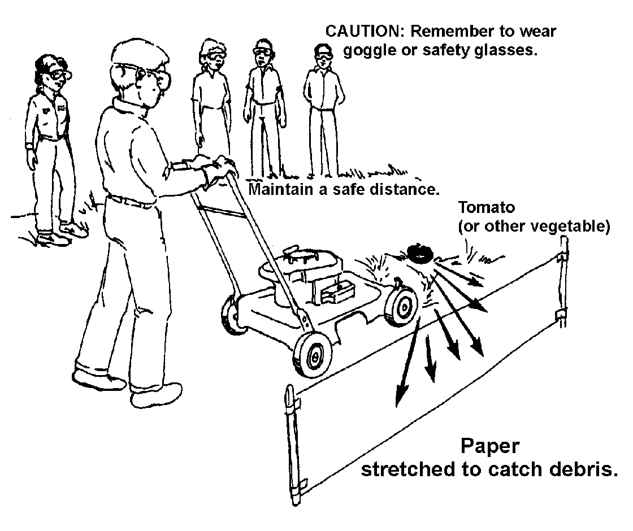

UNIT VII - BASIC HOME AND FARMSTEAD SAFETY AND MAINTENANCE AS 5.5

Lesson 5: Safety and Maintenance Procedures for Lawn Instructor
and Garden Equipment

Mowing Obstacle Course

Objective: Students will be able to put the mower through a mowing obstacle course.

Directions: Set up a mowing obstacle course to enable students to know how to properly use a lawn mower. The instructor needs to determine if students will go through the course with the mower running. If students go through the course without the mower running, explain starting and stopping procedures instead of doing them. The course should not be timed.

The obstacle course should include:

1. Adjusting mower height

2. Clearing the mowing area of people and objects

3. Starting the mower

4. Mowing around trees or posts

5. Mowing around a curved bed

6. Stopping the mower

UNIT VII - BASIC HOME AND FARMSTEAD SAFETY AND MAINTENANCE AS 5.6

Lesson 5: Safety and Maintenance Procedures for Lawn Name_________________
and Garden Equipment

Lawn Mower Safety Guidelines

Objective: Students will be able to identify mower safety guidelines.

Directions: Use owner manuals and basic lawn mower books to help find the following information. Describe safety guidelines that should be followed for each of the following power mower operations.

PROCEDURE | SAFETY GUIDELINES
Selecting proper attire | a.  b.
Pre-operational  procedures | a.  b.  c.  d.
Operational  procedures | a.  b.  c.  d.
Refueling | a.  b.
PROCEDURE | MAINTENANCE GUIDELINES
Changing oil | a.  b.
Sharpening blades | a.  b.
Check spark plug | a.  b.
Lubricating parts | a.  b.

UNIT VII - BASIC HOME AND FARMSTEAD SAFETY AND MAINTENANCE
Name ____________________

Date _____________________

UNIT EVALUATION

Circle the letter that corresponds to the best answer.

1. Select the correct definition of electricity.

a. An uncontrolled burst of energy
b. The flow of negatively charged atoms
c. Lightning
d. The flow of a substance under pressure

2. Which of the following is a form of power used to generate electricity?

a. Battery power
b. Horse power
c. Steam power
d. Human power

3. Select the unit of measurement commonly used to measure electricity usage.

a. Kilowatt-hour
b. Kilogram
c. Amperage
d. Ohms

4. Select the statement that best describes the difference between a fuse and a circuit breaker.

a. A blown fuse indicates a problem in a circuit whereas a tripped circuit can be ignored.
b. Fuses can be replaced with a fuse of any amperage whereas circuits are exact.
c. Circuits must be replaced on a regular basis whereas fuses last permanently.
d. A fuse is replaced when blown whereas a circuit is switched to the “on” position when tripped.

5. Select the common hazard associated with the uses of electricity.

a. Drowning
b. Electric shock
c. Electric stroke
d. Electric hazard

6. What piece of safety equipment must be worn to protect the eyes while working?

a. Gloves
b. Safety glasses or goggles
c. Contacts
d. Safety shield

7. Identify the safety equipment worn for protection from dust and fumes.

a. Face mask
b. Safety goggles
c. Safety shield
d. Dust buster
8. Identify the type of shoe that provides the best protection from injury.

a. Moccasins
b. High-topped sneakers
c. High-topped leather, steel-toed boots
d. Cowboy boots

9. What method is safest for wearing long hair in a shop or work area?

a. Braided
b. Left long
c. Teased
d. Pulled back and tied up

10. Tools strewn about on the floor _______________________________________.

a. Can be stolen.
b. Create a safety hazard.
c. Will not work.
d. Can be easily located.

11. Select the answer that best describes the difference between a two-stroke and a four-stroke engine.

a. The two-stroke engine is a battery and the four-stroke is a motor.
b. The two-stroke is fast and the four-stroke is slow.
c. The two-stroke uses a fuel-oil mixture and the four-stroke has separate compartments for fuel and oil.
d. The four-stroke engine does not require oil and the two-stroke relies on diesel.

Match the light bulb to its appropriate description.

12. _____ Fluorescent

13. _____ Halogen

14. _____ Metal-halide

15. _____ Sodium
a. Contains compounds of metal and halogen with a basic two-bulb design.

b. A mixture of gases inside the bulb forms a very bright, hot light.

c. Radiates light from a gas inside the bulb, commonly used in greenhouses.

d. Composed of an aluminum oxide arc tube containing a mixture of sodium and mercury.

Match each type of measurement with the appropriate category.

16. _____ Inch

17. _____ Gram

18. _____ Ounce

19. _____Square foot

20. _____ Yard

21. _____ Meter

22. _____ Board feet
a. Linear

b. Area

c. Volume

d. Weight

Match the name with the correct hand tool.
a.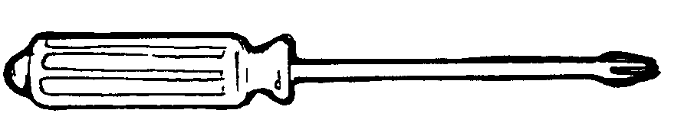
c.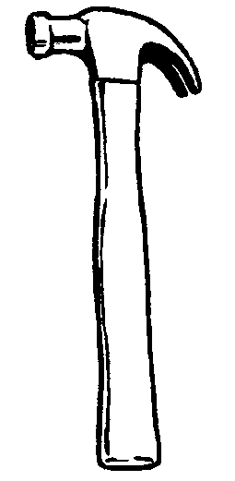
b.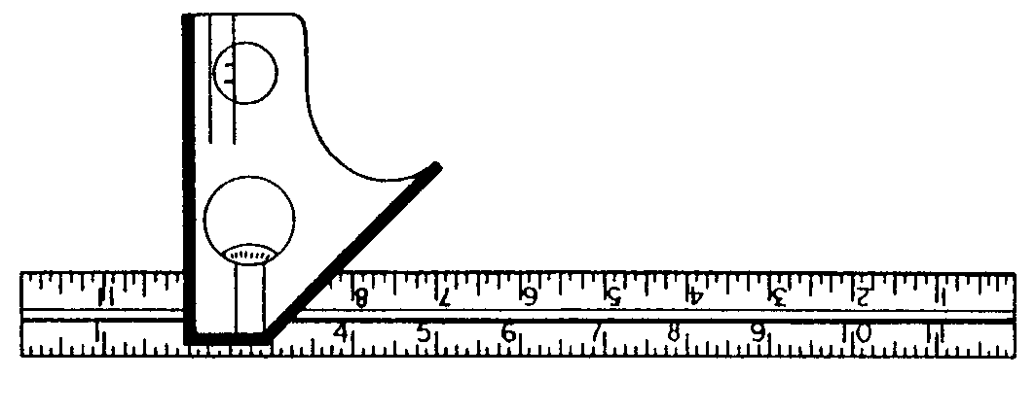

23. _____ Curved claw hammer

24. _____ Phillips screwdriver

25. _____ Combination wrench
d.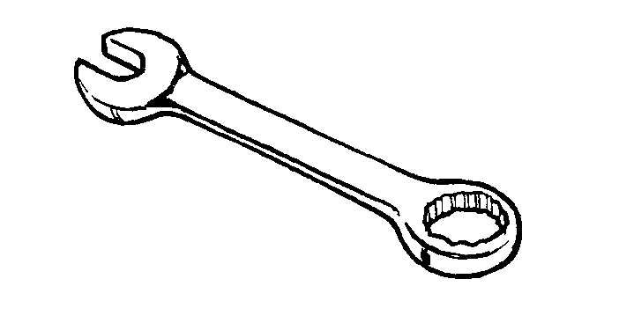
e.

26. _____ Combination square

27. _____ Level

Match the name with the correct power tool.

28. _____ Portable drill
b.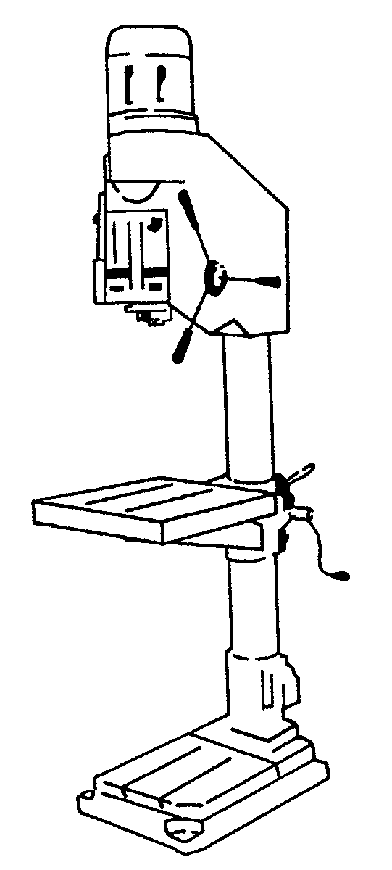
c.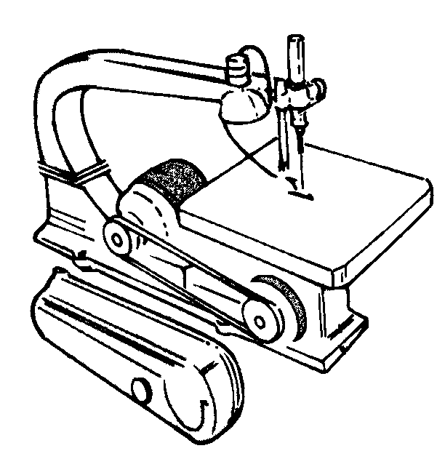
a.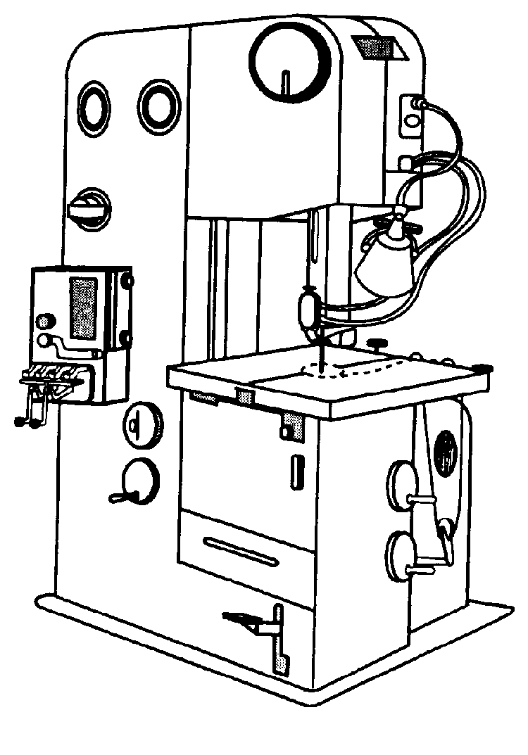

29. _____ Jig saw

30. _____ Band saw

31. _____ Drill press

32. _____ Router

e.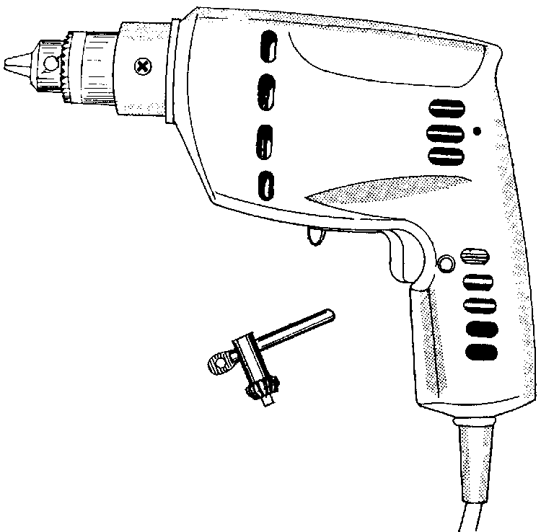
d.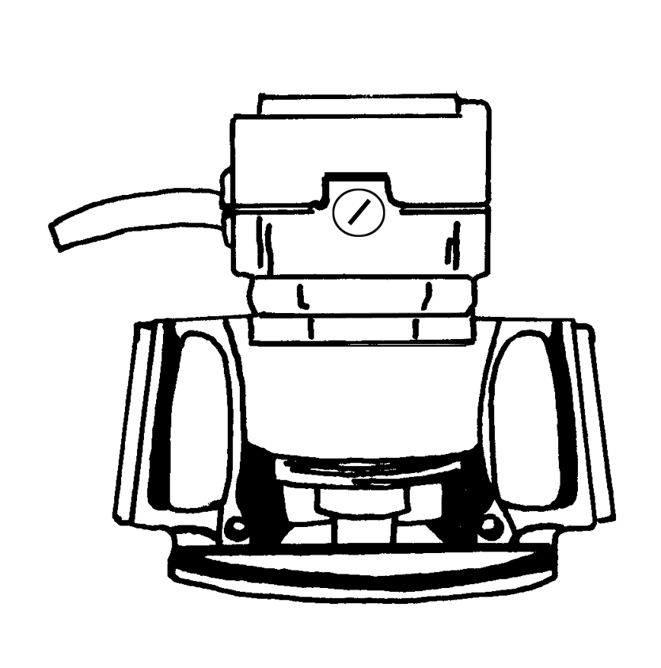

Match the name with the correct lawn tool.
a.
b.
e.
c.
d.

33. _____ Garden hoe

34. _____ Pitchfork

35. _____ Wheelbarrow

36. _____ Garden rake

37. _____ Lawn rake

Match the name with the correct power lawn equipment.
a.
b.

38. _____ Riding mower

39. _____ Leaf blower

40. _____ String trimmer

41. _____ Hedge trimmer

42. _____ Walk-behind mower

c.
d.

e.

Complete the following short answer questions.

43. List two important safety tips for using hand tools.

a.

b.

44. List two important safety tips for the use of power tools.

a.

b.

45. List three safety guidelines for lawn and garden hand tools.

a.

b.

c.

46. List three safety guidelines for power lawn and garden tools.

a.

b.

c.

47. List one proper maintenance procedure for hand lawn equipment.

48. List two maintenance procedures for power lawn equipment.

a.

b.

