Lesson 2: Food Product Development

The Big Mac, tater tots, catsup in a squeezable bottle, and microwavable TV dinners were all once just ideas. Today these are common foods. People expect new food products to provide good taste and good nutrition and be easy to prepare. Many food scientists are called product developers. Their jobs are to take good ideas and turn them into reality.

New Food Products

Research in food science is a continual process. Reports of new ingredients, processes, and preservation techniques fill the pages of many journals every month. Product development scientists study these advances with an interest to use them to make new and different food products. Changes in nutritional information and new keys to the role of diet and health also provide impetus to scientists trying to provide foods that consumers want. It is a complex and difficult task. The success rate for new food products is less than 0.1 percent, measured as products that make it to national market for longer than three years.

Where do new food product ideas come from? Often consumer complaints about an existing product to sales staff result in significant changes in food products. Other times the sales staff themselves will see a market they could fill, if only there was a product that did what the customer wanted. Sometimes old products can be reintroduced to the market, capitalizing on nostalgia, often coupled with new ways to make the product more convenient to prepare. Even laboratory mistakes may become successful products, if the scientists are creative enough to see an application. Most new products are called "line extensions." These are products created by making small changes in existing products, like putting fruit color and flavors into a plain corn puff breakfast cereal and marketing it to children. Similarly, a successful product introduction by one food company may result in the introduction of many "me-too" products by their competitors. However they happen, every new food product begins with an idea.
Where the idea goes next is a complex series of steps that do not always follow in any particular order (Figure 2.1). Nevertheless, all these elements will be part of the process in one form or another. Bench-top development is the production of prototypes of new products on a small scale. These laboratories often look like very large kitchens, but if you were to spend some time there you would find many specialized instruments not found in most home kitchens.
Figure 2.1 - Development Process
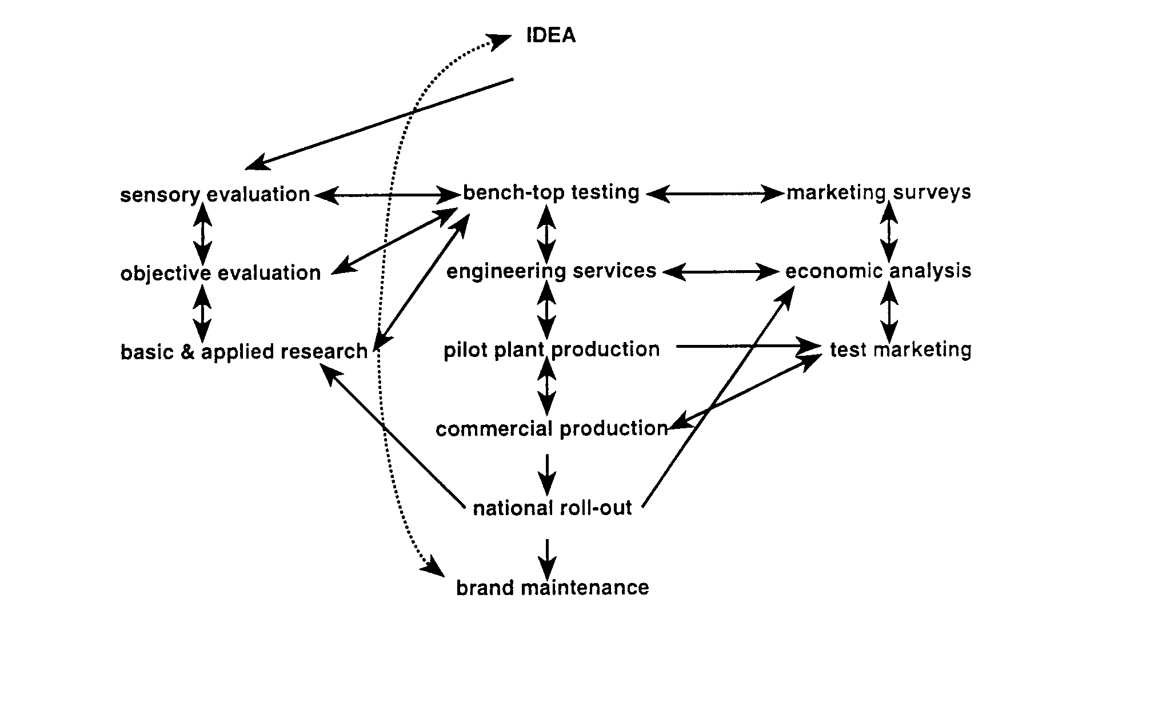

Objective testing involves discovering if the idea can be produced to have enough shelf-life and safety to allow successful marketing. Sensory evaluation is required to find out if consumers like the taste, color, and other characteristics of the product. Often objective testing and sensory evaluation require basic and applied research to solve specific problems uncovered in their studies. Pilot plant production evaluates the production processes using equipment that is very much like miniature equipment used in the production facility. Usually engineering services are required to modify existing processing facilities, or to design new ones to fit the specific requirements of the new product. Marketing surveys may be employed to refine the product to meet the desires of specific consumers. Economic analysis is needed to learn the costs of the product, and if the new product will make a profit for the company. Each of these pieces of the product development puzzle must be fit together in order for the product to be successful in the highly competitive food market.

Finally, a new product is born. At this point there may be as many as three years of effort by several different groups of researchers invested in the product. But the job is not over yet. Test marketing will be required to figure out if consumers will really buy the product when they see it on store shelves or on restaurant menus. National roll-outs are the ultimate test of a new food product. The national roll-out of a product occurs when a company makes a commitment to sell the product throughout their marketing system. Usually these national roll-outs are accompanied by complex, carefully orchestrated advertising campaigns. Even at this point the process is not complete. Careful brand maintenance is required to make sure the product performs the way the consumer expects. Careful evaluation of sales figures, consumer comments and complaints, and good market analysis help to prevent a product from failing. Adjusting a product to meet changing market demands may require new product development, and so the process begins again.

A Good Example: Margarine

During World War I, there was a shortage of butter available to consumers living in the U.S. Most of the nation's butter was being served to the military men and women who "deserved nothing but the best." Those people left to support the war effort stateside were without this very commonly used food ingredient. There was a need for a new product.

Butter is a complex food that consists of water, oil, protein, and several other components. The oil and water mixture is stabilized into an emulsion, so that the two layers do not separate as they often do in a homemade salad dressing. Stabilization requires the presence of an emulsifier. Emulsifiers can dissolve in both oil and water, creating micelles. These micelles can be made small enough that the natural tendency of oil and water to separate can be overcome. In butter, proteins and glyceride molecules serve as the natural emulsifiers, preventing the emulsion breakdown. The goal of the product developer was to simulate this food using ingredients that were readily available, even during wartime.

The soybean provides almost all of the ingredients used in the production of margarine. Soybean oil serves as the lipid source and lecithin, a natural product extracted from the soy oil, is the principal emulsifier. The fatty acids in soybeans are very different from those found in milk, so a process known as hydrogenation was employed to change the melting point of the soybean lipids. Hydrogenation adds hydrogen atoms to the unsaturated double bonds on the fatty acids. As the fatty acids become more saturated (with hydrogen atoms) their melting point increases. By careful control of the amount of hydrogenation used, soybean oil can be made to melt very much like butter. The next step was to get the oil and water emulsion to form. By blending hydrogenated oil, water, and lecithin together in something very similar to a blender, the desired emulsion could be formed.

Unfortunately, the resulting product looked (and tasted) very much like vegetable oil shortening. By adding various colors, flavors and vitamins, margarine began to be a reasonable substitute for butter. In the early days, it was very easy to tell the difference, but as margarine development continued the product became more like butter all of the time. Since it was made from very inexpensive ingredients, and these ingredients were more consistent in composition than milk, margarine could be produced at a much lower cost than butter, contributing to its popularity. Because margarine is a completely formulated product, it is easy to make changes like "low-fat" margarine, flavored margarines and squeezable margarine, just to name a few.

Summary

Food product development is a complex process involving many different people. However, the product always begins with an idea, which may have come from a consumer, a breakthrough in basic science, or just a mistake in the laboratory. Lots of creativity and hard work are necessary to get a food product to a national market.

Margarine is a good example of a product invented to meet a need. Margarine is a completely formulated product, replacing most of the dairy components with ingredients derived from soybeans. It is easier and cheaper to produce than butter. Many other new products have been developed from margarine because of its unique properties.

Credits

Food Technology. Instructional Materials Service, College Station, TX: Texas A & M, 1990.

Frick, Marty. Food Science, Safety and Nutrition. The National Council for Agricultural Education, 1993.

Fuller, Gordon W. 1994. New Food Product Development: From Concept to Marketplace. CRC Press, Boca Raton, Florida.

Gaman, P.M.; K.B. Sherrington. The Science of Food: An Introduction to Food Science, Nutrition and Microbiology. 3rd ed. Elmsford, NY: Pergamon Press, Inc., 1990.

Graf, Ernst and Israel S. Saguy. 1991. Food Product Development: From Concept to Marketplace. Van Nostrand Reinhold, New York

Henry, Arba L.; Gared K. Tyson; David L. Howell. Agricultural Products I. Vol. 19, 5th ed. University Park, PA: Pennsylvania State University, 1978.

Hollingsworth, Pierce. 1994. The perils of product development. Food Technology 48(6):80-88.

Mehas, Kay; Sharon Rodgers. Food Science and You. 1st ed. Mission Hills, CA: Glencoe Publishing, 1989.

Riepma, S.F. 1970. The Story of Margarine. Public Affairs Press, Washington, D.C.

