Lesson 5: Processing Egg Products

Eggs are one of the few foods that are popular in almost every culture. They have been a part of the human diet since the dawn of recorded history. In the United States, eggs play an important role in breakfast and baking and are responsible for employment of thousands of people. The consumption of eggs in the U.S. has declined since 1951, when the average person consumed 387 eggs a year.

Egg Products

Eggs are useful in a variety of ways. About 80 percent of all eggs produced are retailed as shell eggs. Another egg product is refrigerated liquid eggs. These eggs are broken, and separated if necessary, by machines. The liquid product is usually pasteurized to kill Salmonella and other microorganisms prior to being packaged. They may be shipped to bakeries or to other plants for further processing. Under refrigerated conditions, 40°F or below, liquid eggs have a shelf life of 10 days. Liquid egg may be frozen for greater shelf life. Egg blends with sugar, corn syrup, or salt added are available for special uses. Another egg product is dried eggs. These may also be called egg solids. World War II created a huge demand for dried eggs. Current demand for dried eggs comes from production of convenience foods as well as the food service industry. Specialty products include pre-peeled hard-boiled eggs, frozen omelets, egg patties, and quiches.

Quality Characteristics

Egg quality is based on exterior and interior characteristics. The egg's exterior, or shell, should be clean and have a smooth texture. The shell is checked for soundness (i.e., the presence of any cracks). The egg should be oval-shaped with one end larger than the other. Misshapen eggs are generally used for the production of liquid egg products.

The interior quality of an egg is determined by candling. Candling allows the grader to look inside the egg without breaking it. Years ago this was done by holding the egg up to a candle, hence the name. Today, high intensity lights reveal the interior of each egg as it passes on rollers. Inspectors, sometimes called candlers, determine air cell depth, the clarity of the albumen, and the size, shape, and color of the egg yolk. New machines are being invented to automate the candling process. If the egg contains a blood spot, it is revealed during candling and the egg is discarded. Figure 5.1 details the physical structure of an egg.

Another means for determining interior egg quality is the breakout method. Sample eggs are selected at random and broken out on a level surface. The height of the albumen (egg white) is measured with a micrometer. The highest quality eggs will stand up tall and have a firm yolk. Also, the surface area covered by the albumen is small in high quality eggs.
Figure 5.1 - Egg Physical Structure
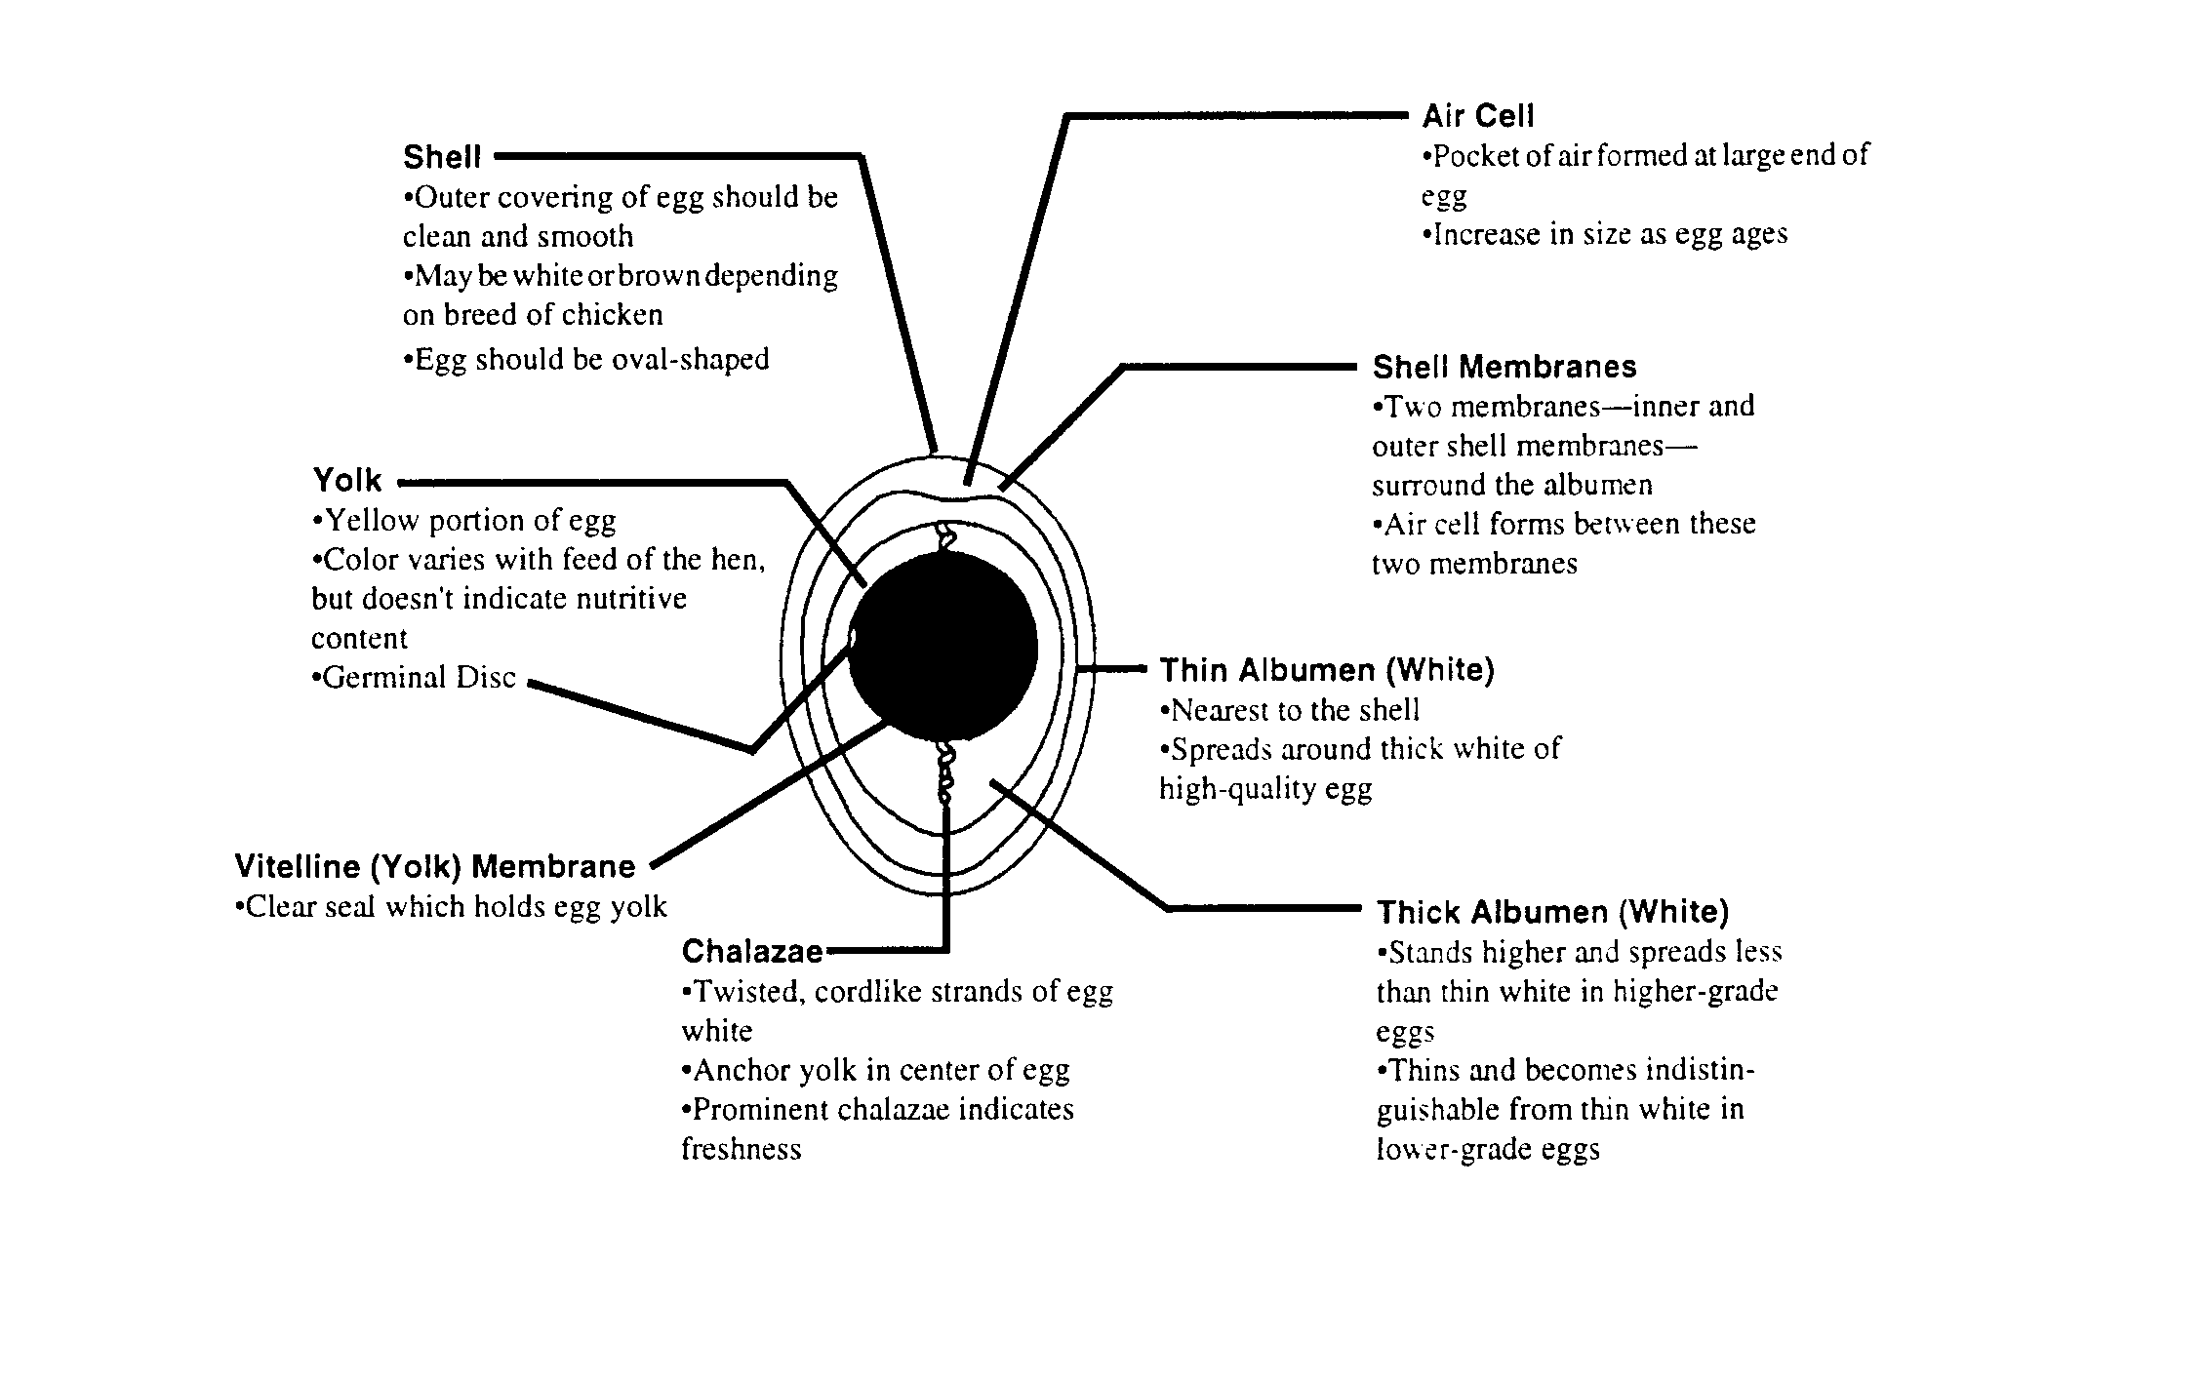
Quality Influences

Egg quality can be influenced by several factors. The equipment and method used to handle a freshly laid egg can affect internal and external qualities. Rough handling can result in shell breakage. Vibration of an egg can result in a thinner albumen or a free air cell. The type of animal housing often determines the method of handling as well as the frequency of egg collection. Proper temperature, humidity, and lighting in the facility affects egg quality.

The hen's diet is another factor that influences egg quality. Shell strength is determined by the presence of adequate amounts of vitamin D, calcium, and other minerals. A lack of vitamin A can result in blood spots. Maximum egg size requires an adequate amount of protein and essential fatty acids in the ration. Yolk color is influenced by the amount of xanthophylls, or yellow-orange plant pigments, in the diet. A ration of yellow corn and alfalfa meal will result in a yellow yolk while a wheat based ration will produce a lighter colored yolk. Often, producers will include dried marigold petals in the ration to increase the yellow color of the yolk. While important, yolk color is not the only factor considered when determining egg quality.

Egg shell thickness is an important characteristic in quality eggs. Research suggests that the greater number of eggs a hen lays, the thinner the shell. Because some breeds produce more eggs per year than others, the breed of hen influences quality. As a hen ages, her egg size increases which demands the same amount of shell material to be stretched to cover the larger egg. This results in thinner shells. The status of a hen's reproductive tract influences the formation of blood spots. Blood spots, also called meat spots, result from a ruptured vessel on the surface of the yolk during ovulation (the release of the yolk into the oviduct).

Egg quality is influenced by the age of the egg. Prompt gathering, washing, oiling, and cooling to 45°F or below are essential to maintain freshness and to prevent growth of salmonellae bacteria that may be deposited inside the egg by infected hens, a condition known as transovarian salmonella. Oiling the process where a film of odorless, tasteless mineral oil that is sprayed on shell eggs after washing and before cartoning. It replaces the natural cuticle, known as the bloom, that is removed during washing. Genetics also plays a role in egg quality; certain egg defects can be traced to specific genetic lines of hens.

Egg Grading

The Egg Products Inspection Act of 1970 provides for USDA grading of all eggs carrying the official grade shield. Based on interior and exterior quality, eggs are graded by USDA graders and are designated AA, A, or B. All eggs must be clean and have sound shells. Grade AA and A eggs must be oval shaped. Abnormal shell shape or faulty texture are permitted under B quality. The albumen is judged on the basis of clarity and firmness. Grade AA eggs when broken out stand up tall, have a firm yolk, and have a large proportion of thick albumen. Grade A eggs are medium in height, have a firm yolk, and have an albumen that begins to spread (flatten) out. Grade B eggs have a flat yolk and a thin albumen. Air cell depth ranges from 1/8 inch in AA grade to 3/16 inch in B grade eggs.

Egg Processing

Grade AA and A eggs are regularly retailed as shell eggs. Grade B eggs and surplus Grade A eggs are processed into egg products. These include refrigerated liquid, frozen, dried, and specialty products. Convenience foods such as cake and pudding mixes, pasta, mayonnaise, and bakery goods utilize egg products. The food service industry often prefers egg products to shell eggs because of convenience, uniformity, and stability. All egg products are USDA inspected and pasteurized. Pasteurized egg products are preferred because they have been treated to kill salmonellae bacteria, pathogens common in the hen and her environment.

Egg Size

Egg size is not related to quality grades. Eggs are sized based on the number of ounces per dozen. They are shown in Figure 5.2.

Figure 5.2 - Egg Size
Egg Size Ounce per Dozen
Jumbo 30
Extra Large 27
Large 24
Medium 21
Small 18
Peewee 15
Egg Processing Industry

The egg production/processing industry in the United States is vertically integrated, which refers to the business structure in which the company that owns the processing plant may also own the feed company and the birds. Producers contract with large companies to produce the eggs, while the companies supply the birds, feed, and fuel. The producer usually provides the housing and the labor. Often the contract producer receives a graduated fee that reflects bird performance and management skills.

Egg production is the greatest in the Southeast portion of the United States. Production is also concentrated near population centers such as California and Pennsylvania.

Summary

Eggs are a wonderful source of protein and can be used to make hundreds of foods. Whether they are in the shell, liquid, frozen, salted, or sugared, eggs undergo exterior and interior inspections. Egg quality is influenced by a variety of factors ranging from the hen's diet to the facilities where the hen's lay eggs. The USDA grades eggs AA, A, and B based on interior and exterior factors. Eggs are sized according to weight per dozen. The egg production/processing industry is a vertically integrated industry.

Credits

Cotterill, Owen J.; William J. Stadelman. Egg Science and Technology. 2nd ed. Westport, CT: AVI Publishing Co., Inc., 1977.

Eggcyclopedia. 2nd ed. Park Ridge, IL: American Egg Board, 1989.

Minnesota Turkey Research and Promotion Council The Turkey Foodservice Manual. 1st ed. St. Paul, 1987.

Parkhurst, Carmen R.; George J. Mountney. Poultry Meat and Egg Production. 1st ed. New York: AVI, Van Nostrand Reinhold Co., 1988.

Potter, Norman N. Food Science. 4th Ed. Westport, CT: AVI Publishing Co. Inc., 1986.

