Lesson 6: Products and By-Products From Meat Animals

The meat processing industry is one of the largest employers in the diverse field of agriculture. This lesson examines the products and the by-products of meat processing.

Major Meat Animals

Our meat supply originates from five major meat animal species. Beef and veal are products of cattle. Pork is a product of swine. Sheep produce lamb and mutton. Poultry is from chicken or turkey. Fish and shellfish are another major meat source.

Fresh Meat Products

Fresh meat products are classified as either primal (wholesale) or subprimal (retail). Primal cuts are large regions of the carcass whereas subprimal cuts are cut to portion size, much like what you would find in the grocery store. Beef, pork, and lamb carcasses are divided into four primal cuts. They are: chuck/shoulder, rib, loin, round/ham/leg. Primal cuts of poultry consist of a whole fryer or turkey. Whole fish and fish fillets are primal cuts.

Subprimal cuts for beef, pork and lamb include shoulder/chuck blade, shoulder/chuck arm, breast, rib, leg/round, short loin, and sirloin. Figures 6.1, 6.2, 6.3, and 6.4 further detail the various subprimal cuts of beef, veal, pork, and lamb. Poultry subprimal cuts include half/quarter portions, breasts, and boneless strips. Fish may be retail cut into sticks, squares, or fillets.

Processed Meat Products

Historical evidence suggests that the Babylonians made and ate sausage some 3,500 years ago, and that the ancient Chinese also made sausage. Sausages frequently took the name of their town of origin: bologna from Bologna, Italy; frankfurters from Frankfurt, Germany; and Vienna sausage from Vienna, Austria. Immigrants to the U.S. continued to make sausage to satisfy their ethnic tastes which has led to more than 200 different varieties in America's processed meat industry.

Processed meat products are popular today due to their long shelf life, convenience, low waste, and controlled portion size. Processed meat also provides variety in the diet. Approximately 35 percent of beef, veal, pork, and lamb produced in the U.S. is processed. Of this, 75 percent is pork. Examples of processed meat products include sausages, cured whole muscle cuts, restructured, and breaded. Sausages are classified as follows: fresh, uncooked and smoked (kielbasa), cooked (braunschweiger, liverwurst), cooked and smoked (bologna, frankfurters), dry and/or semi-dry (pepperoni), fermented (summer sausage, salami), and loaves (pickle loaf, Vienna sausage loaf). Cured whole muscles include hams, corned beef brisket, bacon, pastrami, and pork shoulder. Restructured processed meats include boneless hams and smoked/sliced beef. Restructured products are similar to sausage but are formed to look and taste like whole muscle products. Fish sticks and chicken patties are examples of breaded processed meats.

Meat By-products

"We use all parts of the pig except the squeal and the curl in its tail." You may have heard this expression. The by-product industry is an integral part of meat animal processing, both historically and today.

Meat by-products (offal) are classified as either edible or non-edible. Edible by-products include liver, heart, tongue, brain, sweetbread, tripe, oxtail, chitterlings, mountain oysters, and lard.

Inedible by-products include a myriad of examples and uses. Table 6.1 details these inedible by-products.

Summary

Our meat supply chiefly comes from cattle, swine, sheep, chickens, turkeys, fish, and shellfish. The meat is processed first into primal cuts, consisting of the chuck, rib, loin, and round region along with whole carcasses and fillets. Subprimal (retail) cuts are usually smaller in portion than primal cuts and are therefore more numerous. Processed meat products are attractive to today'sconsumer due to their ease of preparation, controlled portions, shelf life, and low waste.
About 35 percent of our meat supply is marketed as processed meat. Processed meats range from whole muscle cuts to restructured, breaded and sausage types. Most processed meat is in the form of sausage. Meat by-products (offal) are an integral part of the processing industry. Edible and non-edible by-products are useful as food, feed, pharmaceuticals, clothing, and household supplies.

Credits

Exploring Meat and Health. Chicago: National Live Stock and Meat Board, 1991.

Forrest, Aberle, Hedrick, Judge, Merkel. Principles of Meat Science. 1st ed. San Francisco, CA: W.H. Freeman and Co., 1975.

Frick, Marty. Food Science, Safety and Nutrition. The National Council for Agricultural Education, 1993.

Inside Research. Vol 2, 1st ed. Chicago: National Live Stock and Meat Board, 1992.

Jelen, Panel. Introduction to Food Processing. 1st ed. Reston, VA: Prentice-Hall, 1985.

Lessons on Meat. Chicago: National Live Stock and Meat Board, 1991.

Minnesota Turkey Research and Promotion Council. The Turkey Foodservice Manual. 1st ed. St. Paul, 1987.

Potter, Norman N. Food Science. 4th Ed. Westport, CT: AVI Publishing Co. Inc., 1986.

Romans, Jones, Costello, Carlson, Ziegler. The Meat We Eat. 12th ed. Danville, IL: Interstate Printers and Publishers, 1985.

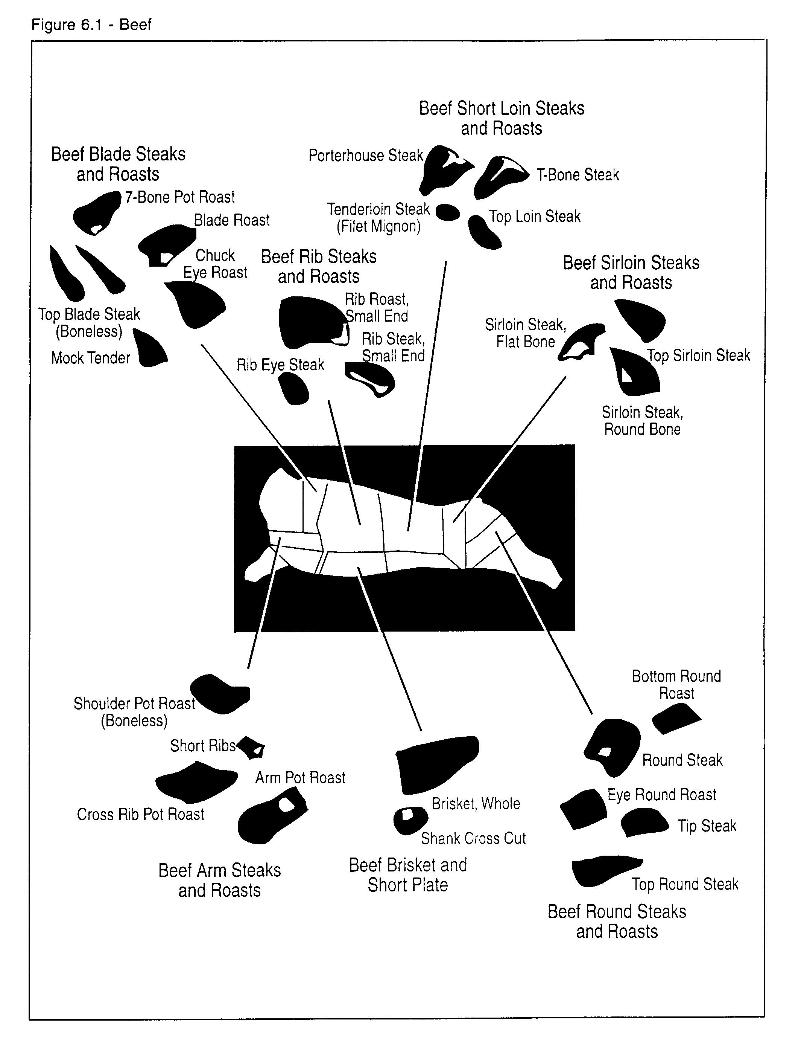
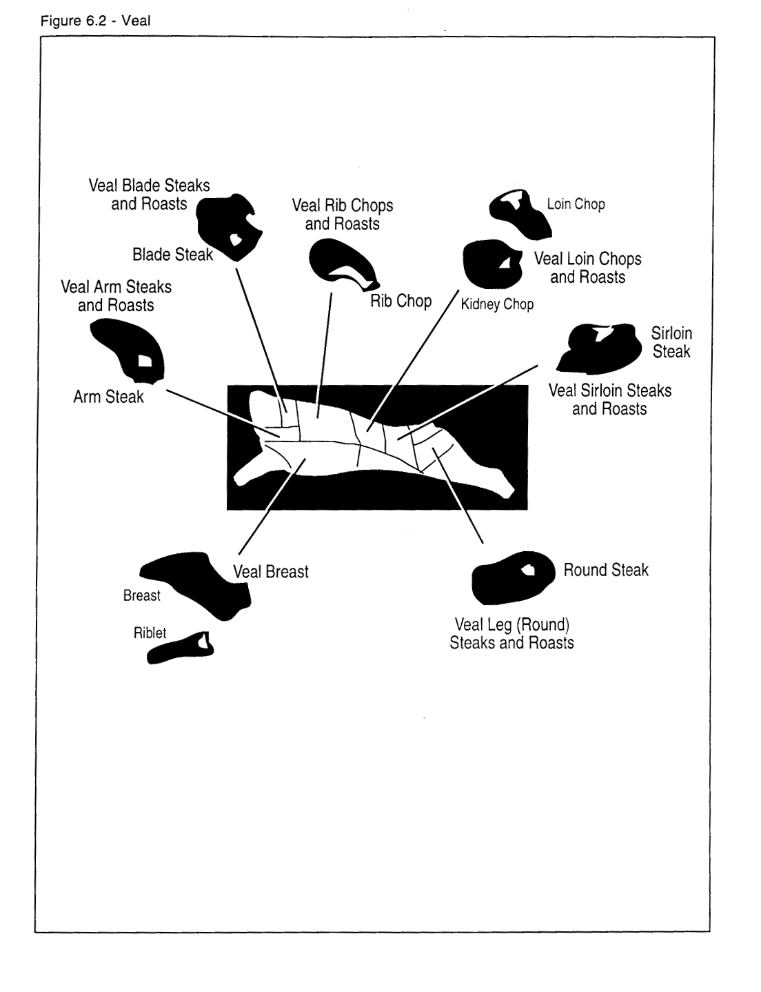
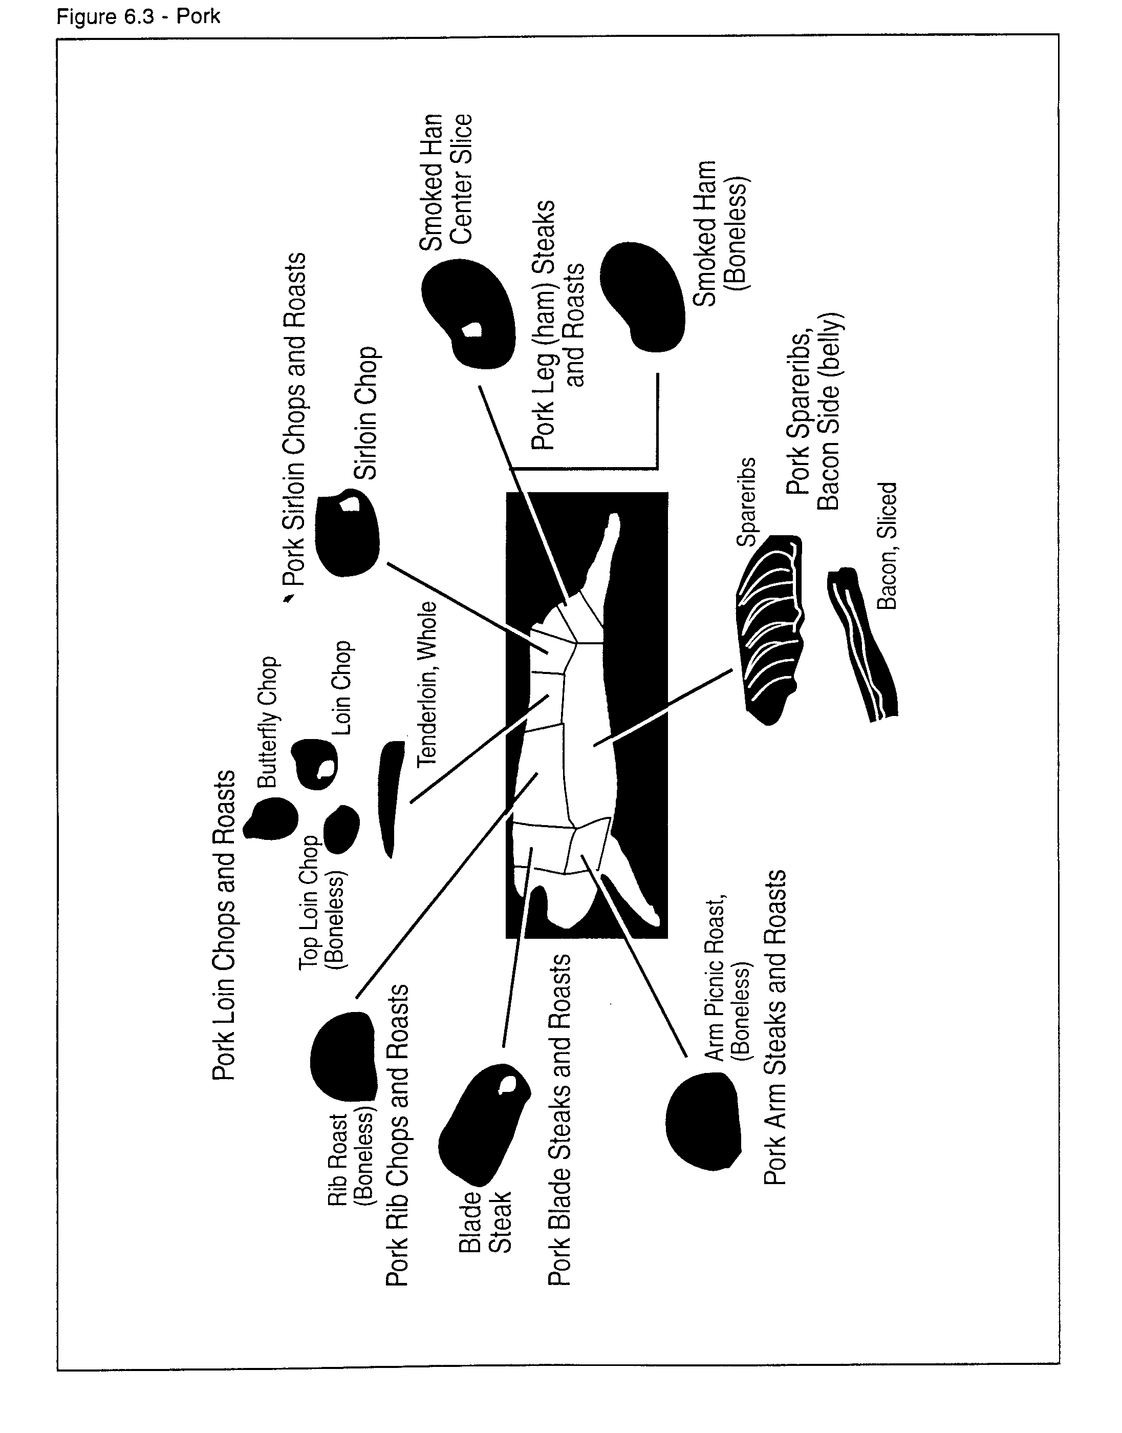
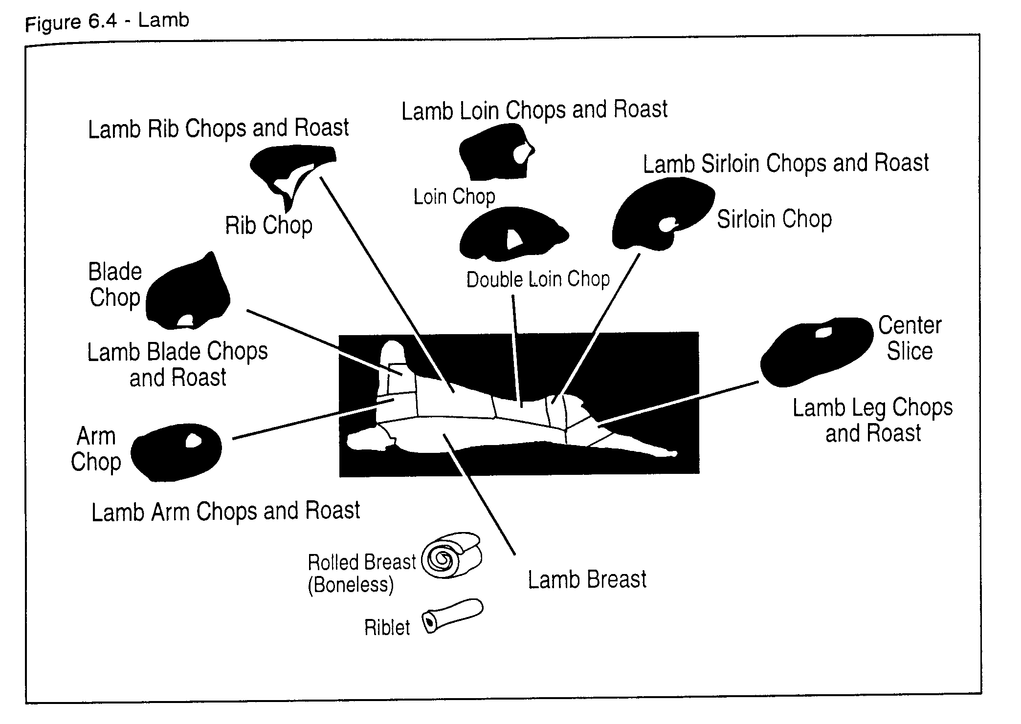

Table 6.1 - Animal By-Products
By-product | Used for
fats | soap, animal feeds, oils, fatty acids
tankage | soft tissue processed in a wet-rendering system used for protein, Ca, P source in feed
bone meal | used for protein, Ca, P source in feed
feather meal | used for protein, Ca, P source in feed
blood meal | used for protein, Ca, P source in feed
fish meal | protein source
hides and pelts | clothing, leather
adrenals | epinephrine*, corticosteroids*
blood | plasmin*, thrombin*, fertilizer, hair conditioner
brain | vitamin D₃*, thromboplastin*
gall bladder | cortisone*, chenodeoxycholic acid*
intestines | heparin* and casings
pancreas | insulin*
ovaries | estrogen*, progesterone*
parathyroid | hormones*, proteases*
pineal gland | melatonin*
pituitary gland | prolactin*, adrenocorticotropic hormone*, growth hormones*
skin | gelatin, glue
spleen | splenin fluid* (affects capillary permeability)
stomach | antacids
thyroid | thyroxin*
feathers | pillows
hair | brushes, upholstering
bones | dice, crochet needles, buttons

*pharmaceuticals

