Lesson 8: Quality Grades, Inspections, and Brand Names in the Meat Industry

What do the words prime, choice, and select, mean to you? How are carcasses graded andwhat do their grades mean? The answers to these questions and others are found in the following lesson.

Inspection and Grading

The Federal Meat Inspection Act of 1906 made inspection mandatory for all meat that crossed state lines. The Wholesome Meat Act of 1967 required that meat sold within a state must meet inspection requirements at least as stringent as the federal system. Federal meat inspection is the responsibility of a division of the United States Department of Agriculture (USDA) called the Food Safety and Inspection Service (FSIS). State meat inspection is the responsibility of each state government. The federal government subsidizes each state's inspection efforts.

These inspection programs assure that only healthy animals are used for meat and that the processing facilities and equipment meet certain standards. The FSIS monitors the temperature of meat being processed, examines the labels and packaging, controls the use of additives, and controls imported meat.

A round stamp of approval is placed on each primal cut when it passes inspection. This purple ink stamp contains the abbreviation for "United States Inspected and Passed" and the official establishment number assigned to that packing/processing plant. See Figure 8.1.
Figure 8.1 - Federal Meat Stamp
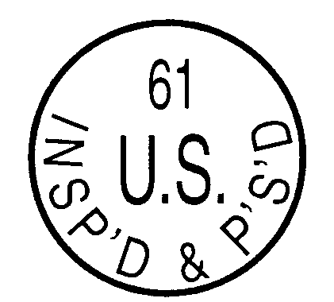
Some states have state inspection stamps, which also use purple ink and are usually the shape of the state itself. See Figure 8.2 for example. Missouri does not have a state inspection stamp.
Figure 8.2 - State Meat Stamp
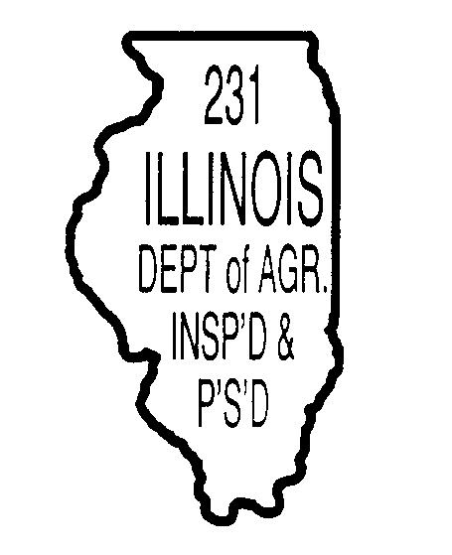

Qualified USDA inspectors do the inspecting. In the case of a Kosher plant, Kosher inspectors who meet USDA standards do the work. See Figure 8.3 for Kosher stamp.

Figure 8.3 - Kosher Stamp

Meat grading was established in 1927 when the USDA set standards for quality and cutability. Participation is voluntary on a fee-for-service basis, and is administered by the USDA. The USDA quality grade is indicated by a shield-shaped stamp which also uses purple ink. See Figure 8.4.
Figure 8.4 - Quality Grade Stamp
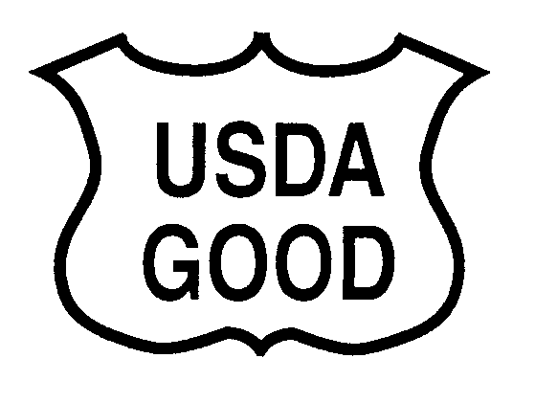
Grading costs are paid for by the consumer with other processing costs.

Not All Inspected

Not all meat in the U.S. is inspected. Currently there is no law requiring fresh fish to be inspected. Meat that is processed "Not for Sale" is also exempt from inspection. Also, squabs (pigeon), gamebirds, rabbits, and most wild game are exempt.

Quality Grades

Carcasses are quality graded so that packers can sort carcasses and primal cuts into groups of similar grade, and retailers can buy the appropriate grades for their markets. Quality grading assures consumers that the product conforms to an established set of standards which predict palatability and/or cutability (amount of lean).

Beef quality grading is based on marbling and maturity. Marbling is intramuscular fat viewed in the ribeye muscle. Intramuscular fat contributes to meat juiciness, tenderness, and flavor. The higher the degree of marbling the higher the quality grade assigned. Younger cattle qualify for prime, choice, select, and standard. Older cattle qualify only for commercial, utility, cutter, or canner grades. The USDA inspector determines the animal's age based on skeletal characteristics, and the color and texture of the ribeye muscle. Younger animals have red-colored bones and bright red lean (muscling). Older cattle show white bones and dark red lean.

Veal carcasses are graded on color, shape, and the amount of feathering (i.e., fat intermingled with the rib lean). The quality grades are: prime, choice, good, standard, utility, and cull.

Pork carcasses are graded on their leanness and meat quality (color, texture, etc.). Pork quality grades are acceptable and utility.

Sheep are graded on their maturity, color, and fat streaking. Lamb, yearling mutton, and mutton are three maturity classes based on differences that occur in the development of the muscular and skeletal systems. Fat streaking in the flank area and flank firmness are evaluated when grading. Prime, choice, good, and utility are the quality grades in lamb. The quality grades of yearling mutton are prime, choice, good, and utility. Mutton quality grades are choice, good, utility, and cull.

Poultry grading is based on several factors: conformation, fleshing, fat covering, presence of pin feathers, and exposed flesh. Disjointing, broken bones, and missing parts are also considered during grading. Poultry are graded into Grade A, Grade B, and Grade C poultry.

Inspection Detail

Inspectors must consider a variety of factors before they pass or condemn a carcass or primal cut. They inspect for unwholesome or adulterated carcasses, a sanitary processing plant, honest labeling, correct temperatures, correct use of additives, and a lab analysis that meets their microorganism specifications.

Quality Grade Versus Brand Name

Quality grade is independent from the brand name used. Many companies may use specific brand names to designate different grades of meat. The terms "star," "gold," or "lean" can be found on particular quality packages. These terms are the company's label not a quality grade determined by the USDA grader. Remember that the quality grade will be stamped with purple ink. The brand name may vary from company to company and from one location to another.

Summary

The citizens of the United States enjoy a safe and abundant meat supply. The safety of the meat is the responsibility of the USDA Food Safety and Inspection Service. Inspection is performed by qualified inspectors. Fresh fish, "not for sale" meat, certain game birds, and rabbits are not inspected. Quality grading is based on carcass cutability, color, and marbling/feathering. Quality grades and brand names are independent of one another. Many processing companies market their meat products under a variety of brand names, some of which designate a particular grade.

Credits

Exploring Meat and Health. Chicago: National Live Stock and Meat Board, 1991.

Forrest, Aberle, Hedrick, Judge, Merkel. Principles of Meat Science. 1st ed. San Francisco, CA: W.H. Freeman and Co., 1975.

Frick, Marty. Food Science, Safety and Nutrition. The National Council for Agricultural Education, 1993.

Inside Research. Vol 2, 1st ed. Chicago: National Live Stock and Meat Board, 1992.

Jelen, Panel. Introduction to Food Processing. 1st ed. Reston, VA: Prentice-Hall, 1985.

Lessons on Meat. Chicago: National Live Stock and Meat Board, 1991.

Minnesota Turkey Research and Promotion Council The Turkey Foodservice Manual. 1st ed. St. Paul, 1987.

Parkhurst, Carmen R.; George J. Mountney. Poultry Meat and Egg Production. 1st ed. New York: AVI, Van Nostrand Reinhold Co., 1988.

Potter, Norman N. Food Science. 4th Ed. Westport, CT: AVI Publishing Co. Inc., 1986.

Romans, Jones, Costello, Carlson, Ziegler. The Meat We Eat. 12th ed. Danville, IL: Interstate Printers and Publishers, 1985.

