Lesson 9: Products from Grain Crops

Grains have been an important aspect of the human diet since recorded history. Grains provide the world with most of its food calories and about half of its protein. Grains may be consumed directly or fed to livestock, which converts the grain to meat, milk, and eggs.
Figure 9.1 - Components of Wheat Grain
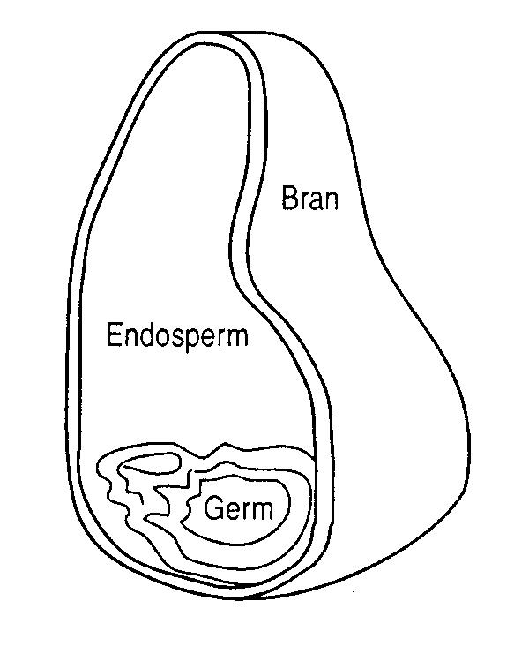

Primary Food Grains

Cereal grains include: wheat, corn, oats, barley, rice, rye, grain sorghum, and buckwheat.

Oil-bearing grains include: soybeans, sunflower, peanut, cottonseed, and canola (rapeseed).

While not strictly grains, dry legumes such as dry peas, lentils, and various beans (navy, pinto, black, etc.) are often processed in similar ways.

Primary Food Products

The major use of cereal grains is milling them into flour. Flour is processed into bread, pasta, bakery products, and other flour-based foods. Cereal grains are also used as raw material for a variety of breakfast foods and for direct consumption in the case of rice and corn (corn meal, corn flakes).

Wheat varieties are grouped into two major categories: hard wheat and soft wheat. Hard wheat is higher in protein, and yields a stronger, more elastic dough which is better for breadmaking. Duram wheat, a hard wheat, is the primary flour source for pasta products. Soft wheat is primarily used in cake and cookie making. Wheat is milled to separate the hull, germ, and endosperm. See Figure 9.1.

Corn is consumed in a variety of ways. Popcorn, for example, is a special variety that puffs or explodes when sufficient heat is applied causing the internal moisture to convert to steam. Corn is also milled to separate the hull, germ, and endosperm. See Figure 9.2. The majority of food corn undergoes milling. The endosperm or starchy component, is the most useful food component. Corn may be milled to produce corn
meal, corn flour, corn starch, corn oil, and corn syrups (a variety of sweeteners).

Oats are processed into flour or rolled into the familiar rolled oats breakfast cereals. Oatbran is a good fiber source.
Figure 9.2 - Components of Corn Grain
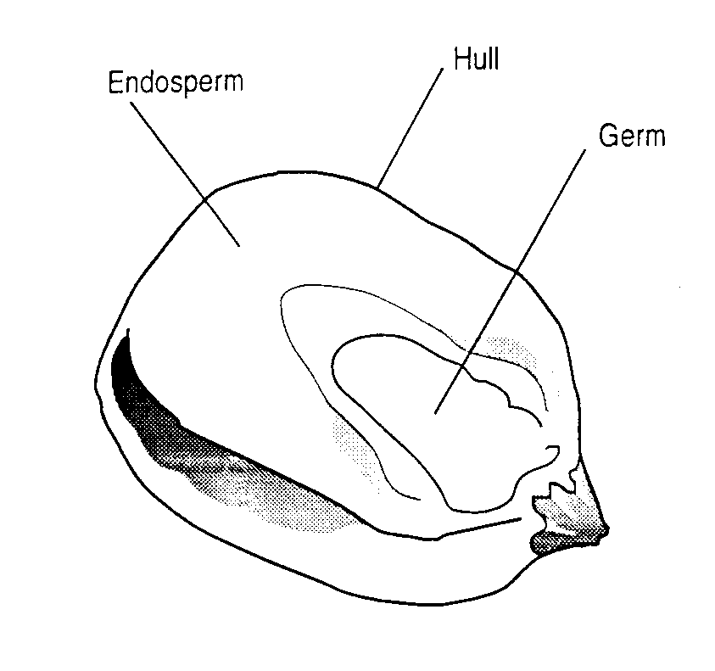

Barley is milled primarily to produce malt. Malt is produced after the barley germ has sprouted. Sprouted barley is high in enzymatic activity, especially a starch digesting enzyme called amylase. It is an essential element in the production of beer and many liquors. Dried, sprouted barley (malt) is used as a flavor agent in some breakfast cereals and malted-milk concentrates. Barley may also be milled into flour or eaten whole.
Rice is the most important human food crop because of the billions of people who rely on rice as their staple food. Rice is primarily consumed as the intact grain, minus the hull, bran, and germ. Rice is ground into flour and can also be consumed as whole grain rice, which maintains a higher vitamin and mineral content than milled and polished rice.

Rye flour is mixed with wheat flour in the production of rye bread.

Oil-bearing grains are a source of edible oil as well as a substantial protein source. Soybeans are the most important oil seed. Soybeans are 20 percent oil. Soybean oil meal is 44-48 percent protein that contains amino acids necessary for a human diet. Soybean protein is often used to fortify other foods. Soybeans may also be roasted, converted to soy milk, soy flour, tofu or soy cheese, lecithin, and soy sauce.

Sunflowers are consumed whole or converted to oil. A sunflower is 50 percent oil.

Peanuts may be roasted and salted, or they may be processed into peanut butter or peanut oil.

Canola is an important oil seed in countries with cool climates. Canada produces many times more canola (rapeseed) than soybeans. Canola is processed into cooking oil.

Lastly, dry legumes are an important part of the human diet. Beans and dried peas are high in protein and low in oil content. Legumes are converted to flour and used in baking in many parts of the world.

By-Products

By-products, or non-principal use products, from food grain processing are important ingredients in livestock feeds and pet food. Wheat bran, corn gluten, rice hulls, germ, distiller's grain (wet remains of grain following malting), peanut hulls, and midlings (the oily germ) are some examples.

Non-Food Products

Food/feed grains are the subject of research to determine new uses. There are hundreds of uses for grains. Corn starch can be used to make a biodegradable substitute for plastic. It is used in diapers, packing nuts, ethanol, paper production, encapsulated herbicides, etc. Corn is also used in the production of ethanol, lecithins, paints, antibiotics, dyes, paper, linoleum, etc. Soybeans can be converted to soy diesel, soy ink, soaps, pesticides, cosmetics, animal feeds, paints, etc. Peanut hulls are used as "cinders" on slick roads.

Summary

Grains have always played a major role in the human diet. Cereal grains include wheat, corn, oats, barley, rice, rye, grain sorghum, and buckwheat. Cereal grains are normally ground into flour before further processing. Oil-bearing grains include soybeans, sunflowers, peanuts, cotton-seed, and canola. Oil-bearing crops produce an edible, high protein oil when cooked. Dry legumes are represented by dry peas, lentils, and various beans. Dry beans are an important low oil, high protein food.

Food grains produce several by-products when they are processed. Animal feeds are the primary beneficiary. Non-food products derived from food grains are a rapidly expanding field. Corn and soybeans are the two major grains used for numerous industrial products.

Credits

Jelen, Panel. Introduction to Food Processing. 1st ed. Reston, VA: Prentice-Hall, 1985.

Potter, Norman N. Food Science. 4th Ed. Westport, CT: AVI Publishing Co. Inc., 1986.

Schoeff, Robert W.; Tim Herrman. U.S. Grain Grading Handbook. Manhattan: Kansas State University, 1993.

