Lesson 2: Interpreting the Food Label

You may be familiar with the old saying: You can't judge a book by its cover. However, for a food product, the cover says a lot. By careful analysis of the food label, you can get information about what is inside, how much is there, what ingredients were used to make the product, and finally how nutritious the product will be to eat.

Many people believe that information on the food label is false and misleading. If the information is false or misleading, then officials from the Food and Drug Administration and the Federal Trade Commission would put the food scientists in jail for mislabeling the product. The food labeling law requires that everything on the label be the truth. However, a discerning consumer can spot efforts at misdirection and confusion on some food labels.

In 1990, Congress passed the most comprehensive food labeling law in the world. This law is known as the Nutritional Labeling and Education Act of 1990. Included in this law were changes in many elements of a food label. These changes were designed to assure that the consumer would have access to accurate, easily understood information. Hopefully consumers will use this information to improve their eating habits. This in turn should improve health, reducing costs paid to physicians and hospitals to take care of people who did not eat correctly.

Parts of the Food Label

A food label is divided into two parts. The largest part, at least 40% of the total package area is known as the principal display panel (PDP). This is the part of the label that the consumer is most likely to see when the package is placed on the grocery store shelf. Thus, it may be the top of an ice-cream carton, or the large side panel of a box of cereal. The PDP must contain information to identify the food, either by a real name (e.g., green beans) or a made-up name (e.g., Cherrios). If a picture appears, it must look like the food in the box. Sometimes, if the food will require cooking before eating, the picture may say "serving suggestion." This says that it requires some additional work to get the product to look like it does on the package. The PDP must also state how much of the product is in the container, usually reported as net weight. The net weight is the weight of the food in the container, minus any liquid or other component that would not normally be consumed. The net weight must be reported in avoirdupois (ounces, pounds, and gallons) and metric (grams and milliliters) units.

The second part of the food label is the information panel (IP). The IP is the part of the label that is immediately to the right of the PDP. There are three elements that must appear on the IP. These include the name and address of the manufacturer, a list of ingredients, and a nutrition facts panel. The address must be present so that a consumer could get additional information about the product, or complain if they wanted to. The list of ingredients must be in order by descending weight. That is, the ingredient present in the greatest amount appears first, then the next greatest amount and so on until all ingredients are listed. There have been many changes in the ingredient listing so that consumers can know what they are eating. The original source of ingredients is sometimes listed, such as "animal fat" or "protein from soybeans." This allows consumers to avoid animal products for religious reasons or soybeans because of allergic reactions for example. They can carefully read the ingredient statement and discover what raw products were used in the food. Artificial ingredients are identified as such in the ingredient listing.

Finally there is the nutritional facts panel. In a very few instances, the nutrition facts panel may be omitted, but all of the other elements must appear on every food product offered for sale to the public. To understand the nutritional facts panel, we must understand something about the way nutrition information is being made available to the average consumer.

Daily Dietary Requirements

While some people may say they live to eat, in reality all people eat to live. Our body cells need a constant supply of many different elements to use as building blocks. Sometimes, these cells need entire molecules to do their functions. These elements and molecules are supplied by the food eaten. Since most people do not want to do a complete chemical analysis before every meal, nutritionists usually talk about food groups and serving sizes. These are easily estimated by most people. Correctly understanding the food groups will be helpful in planning a healthy diet.
Nutritionists and other scientists working for the USDA have classified foods into six groups. Five of the groups are: 1) bread, cereal, rice and pasta; 2) fruits; 3) vegetables; 4) meat, poultry, fish, dry beans, eggs and nuts; 5) milk, yogurt and cheese. The sixth group is called the fats, oils, and sweets. This group of food products provides few of the building blocks necessary for proper function of the body, so it is not generally considered a food group. To maintain optimal health, it is necessary to eat some of all of the five food groups each day. But how much?

To help organize these groups in your mind, the USDA has developed a food pyramid (Figure 2.1). The size of each food group block in the pyramid represents how much of each group you should eat each day. For example, the bread group is the largest block, and is located on the bottom of the pyramid. The bread, cereal, rice, and pasta group of foods should serve as the foundation of your diet. Depending on several factors, including your age, sex, and weight, you should eat between 6 and 11 servings of these foods each day. While there are some exceptions, a serving of a food is generally about one-half cup. The foods in the bread group provide the carbohydrates needed for energy, many water-soluble vitamins, and trace minerals needed for proper cell function.
Figure 2.1 - Food Pyramid
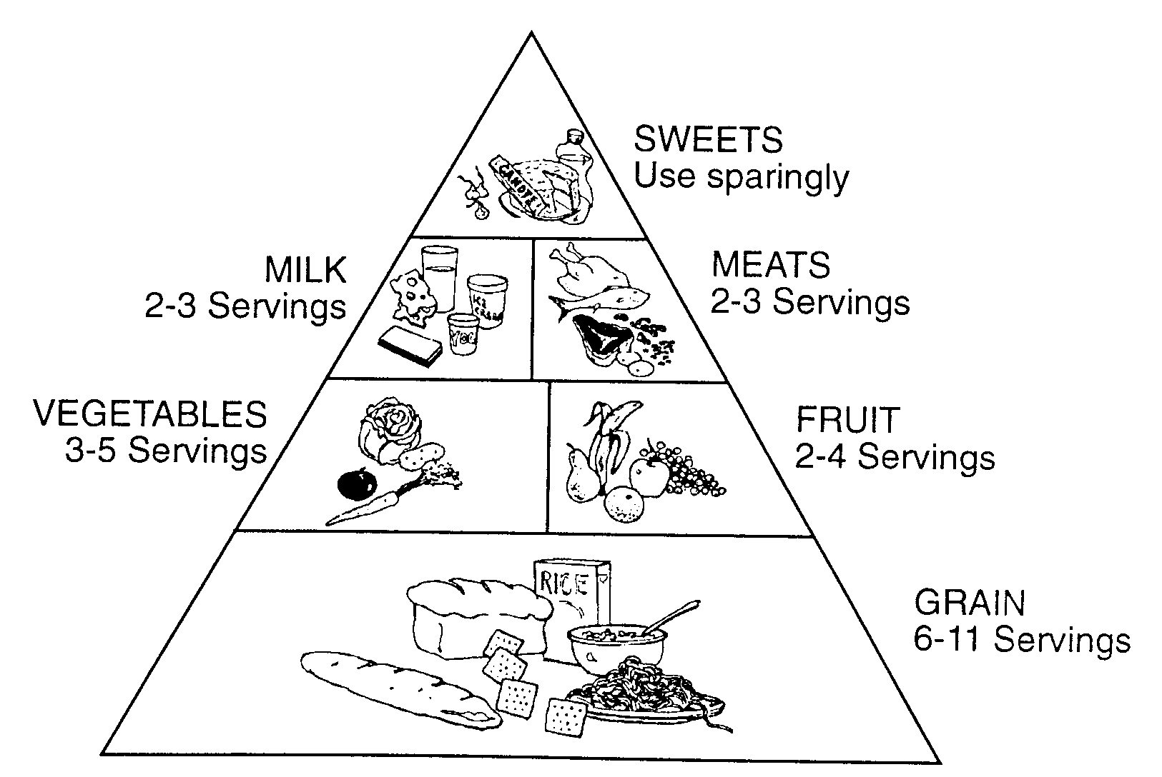

The fruit group and the vegetable group provide many vitamins that the body needs. The milk group provides calcium, vitamins and protein, while the meat, poultry, dry beans, eggs and nuts group provides protein and some vitamins. By combining foods from all these groups every day, you will be more assured of eating a healthy diet.

Nutrition Facts Panel

Many people eat foods in which the food groups are combined. Consider a pizza. It contains food from the bread, vegetable, milk, and meat groups (sometimes even the fruit group!) How many servings of each are in a slice? This is why the food label contains specific information on individual nutrients important in the American diet. To make things simpler, the nutrient content of foods is reported in both grams and Percent Daily Value. The Nutrition Facts panel includes total calories, calories from fat, total fat, saturated fat, cholesterol, sodium, total carbohydrate, dietary fiber, sugars, protein, vitamin A, vitamin C, calcium, and iron. (Figure 2.2)

The Percent Daily Value assumes a 2000 calorie per day diet. This is the average calorie needs for most American women. (Men usually need about 500 calories more per day to maintain their weight.) Not all nutrients have to appear on a nutritional label. To keep the label simple, only nutrients known to be a problem for Americans are required to appear on the food label. In the American diet there are some nutrients that people should be sure to eat, such as carbohydrates, dietary fiber, and some vitamins and minerals. There are other nutrients that are important, but it is so easy to get enough of these that they are not included on the label. Unfortunately, there are some nutrients that Americans eat too much of, such as fat, cholesterol, and sodium. The amount of each nutrient in a specific food is calculated as a percentage of the total amount of that nutrient that should be consumed each day. By keeping track of the percentage of each nutrient consumed, when 100 percent is reached, you will know that you have gotten enough (of things like carbohydrates, dietary fiber, and vitamin C) or that you should not eat any more (fat, cholesterol, or sodium).
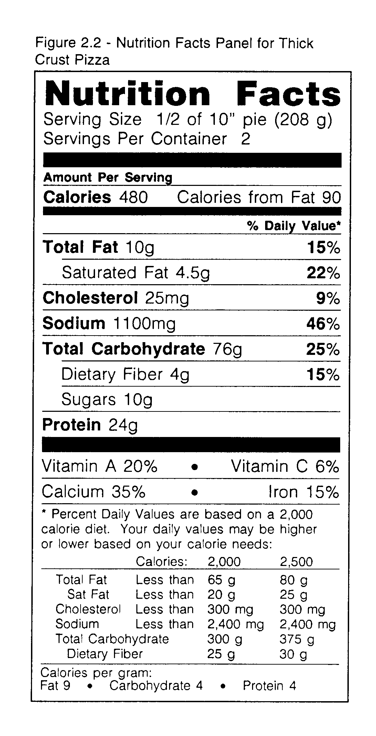

You may wonder why the daily value for protein does not appear on some labels. The first reason is that proteins have different quality. Foods like meat, eggs, and milk have very high quality protein, while other products like gelatin are very low quality. Other foods like grains, need to be combined with legumes (dry beans) in order for the protein to be of high quality. This would be very difficult to express on the food label. Since protein amount and quality is not a problem for most Americans, the daily value is not required. When you see a daily value for protein on a label, the value is adjusted for the protein quality.

The serving size on a food label is determined by comparison to a standard serving size. Serving sizes were found in a US government survey by interviewing thousands of people all over the United States. This is not necessarily the same serving size that is used on the Food Pyramid, but it is based on real amounts of food consumed at one meal by many Americans. The actual serving size on a label must compare to the standard serving size, the size of the package, and the weight of the food itself. It is a complicated process, but it is designed to make it easier to compare similar foods while shopping.

Unless you have an identical twin, there is no one else in the world exactly like you. Just as people look different, their nutritional requirements are different. It would be impossible to put all of the information necessary to figure out one's exact nutritional needs on every food label, so the information there is only an average for all Americans.

If a person wants to be more specific, he/she can use the information about the grams of each nutrient to calculate specific nutritional requirements. The information necessary to do this is included in the bottom portion of the food label, called the footnote section (see Figure 2.2). Additional information on the changing nutritional requirements for different ages can be found in almost any textbook on nutrition.

Most people are better nutritionists than they might think. As long as people eat a broad variety of foods, in moderation, the body does a good job of selecting what it needs, and disposing of the rest. Nutritional health is decided in the average over a long time, not just what you eat each day. For example, if you "pig out" on a high fat pizza today and get 200 percent of Daily Value for saturated fat you may think your diet is ruined. By limiting your intake of saturated fat from other foods over the next few weeks, there will be no harm done. However, if you consume 200 percent of the Daily Value every day for several months, you probably will find that you have gained a few unwanted pounds and may be at greater risk for heart disease and cancer in the future.

Nutrition, like most sciences, changes almost daily. At universities and research institutes all over the world, scientists are struggling to understand the role of food in health and disease. This means that nutritional recommendations may change as new evidence is uncovered. The food pyramid and the food label reflect the knowledge gained over the past 100 years, and are unlikely to change dramatically in your lifetime. But you never know.

Nutrient Level and Health Claims

Until 1990, words like "lite," "high," "low," and "good source "of" on a food label were hard to understand. There were no standards so food companies could use anything they wanted. Now these words, known as nutrient content claims, are defined by comparison to the Percent Daily Value. Foods that are "good sources" of a nutrient must contain at least 10% of the Daily Value for a nutrient per serving. Foods that are "high" must contain at least 20% per serving. There are similar rules for other descriptors such as lite, low, and free.

Usually foods that contain high levels of fat, sodium, or cholesterol may not claim to be a good source of some other nutrient. It is very complicated for a food company to be sure they can make a nutrition level claim. However, specific rules for using nutrient content claims assures the consumer the claim is meaningful in a real diet.

Some food labels will have health claims. These are sentences that remind the consumer that certain nutrients affect the development of specific diseases. The claims are monitored by government scientists. They must be true and they must be related to some disease that is important to Americans. There are currently (1994) seven different types of health claims allowed:

•high calcium levels may prevent osteoporosis (a loss of calcium from bones)
•low sodium levels may reduce high blood pressure
•low fat levels may decrease problems with cardiovascular disease
•low fat levels may reduce the risks of some types of cancer
•high levels of dietary fiber may reduce the risks of some types of cancer
•high levels of dietary fiber may decrease problems with cardiovascular disease
•high levels of folic acid may reduce risks of some types of birth defects (neural tube defects)

Foods that make health claims must be "high" (calcium, fiber or folic acid) or "low" (fat, sodium) in the specific nutrient. In addition, the levels of other nutrients in the food are considered. For example, whole milk is high in calcium, but it is also a significant source of fat and cholesterol, so it cannot make a health claim. Skim milk on the other hand, may make calcium and fat claims. Again, the rules are complicated, but they assure the consumer that the food making a health claim really is part of a healthy diet.

Summary

The food label is designed to communicate to the consumer. There are four required parts of the food label: 1) the name of the food; 2) the amount of the food in the container; 3) the name of the manufacturer; 4) the ingredient list. Almost all foods also require a Nutrition Facts Panel. Some foods may also have nutrient content or health claims. These parts of the food label are carefully controlled.
Nutritional requirements are illustrated by the Food Pyramid. This graphic representation of the five food groups is very helpful in choosing an adequate diet. However, more complex foods that contain many food groups are difficult to place on the Pyramid. The food label reports a Percent Daily Value that is very helpful.

Proper nutrition depends on the individual. Specific recommendations can be found by combining information from several sources including the food label. Fortunately, by using variety and moderation in food choices, most people do not have to become professional nutritionists to eat a balanced diet.

Credits

Focus on Food Labeling. An FDA Consumer Special Report. Rockville, MD: Food and Drug Administration, May, 1993.

Hamilton, Whitney, Sizer. Nutrition. 4th ed. St. Paul: West Publishers, 1988.

