Lesson 4: Relationship Between Diet and Health

Food labels are highlighted with eye-catching slogans such as: "contains no cholesterol" or "high fiber" or "fat-free." Do these influence you? Are you conscious about your diet? Whether you are or are not, you can be sure that your diet does influence your health. This lesson highlights a few of today's issues.

Cholesterol

Cholesterol is a popular topic of conversation. Do you know what it really is? How does it work? Is it true that the body actually makes cholesterol? What are HDL and LDL?

Cholesterol is a waxy, fat-like substance necessary for building membranes, particularly in the brain and nervous system. Cholesterol plays a vital role in bile synthesis and in the production of adrenal and sex hormones. A derivative of cholesterol found in the skin is converted by sunlight to vitamin D. If insufficient amounts of cholesterol are in a person's diet, the liver will produce cholesterol.

Cholesterol found in the blood is called serum cholesterol, or blood cholesterol. Dietary cholesterol is present in foods. Cholesterol is only found in foods of animal origin, like eggs, meat, fish, poultry and cheese. Dietary cholesterol is spread throughout the food, it is not isolated in the skin or fat portions.

Blood cholesterol levels are affected by many factors including diet, heredity, age, and gender. Blood cholesterol levels are measured in milligrams per deciliter. Standards are set as: less than 200 mg/dl - desirable; 200-239 mg/dl - borderline; greater than 240 mg/dl - high. A high blood cholesterol level is a major risk factor for a person developing coronary heart disease. Cholesterol is carried in the blood by molecules called lipoproteins. Low-Density Lipoprotein (LDL) is referred to as "bad" cholesterol because it carries cholesterol to the tissues. High-Density Lipoprotein (HDL) is referred to as "good" cholesterol because it is transported from the tissues to the liver for elimination.
Cholesterol is often discussed in connection with dietary fat, even though they are two different substances. A diet that is high in total fats and saturated fats will tend to increase blood cholesterol levels. The connection between dietary cholesterol and blood cholesterol levels is less certain. This area of nutrition is changing rapidly as we learn more about the role of diet in health.
Figure 4.1 - Fatty Acids
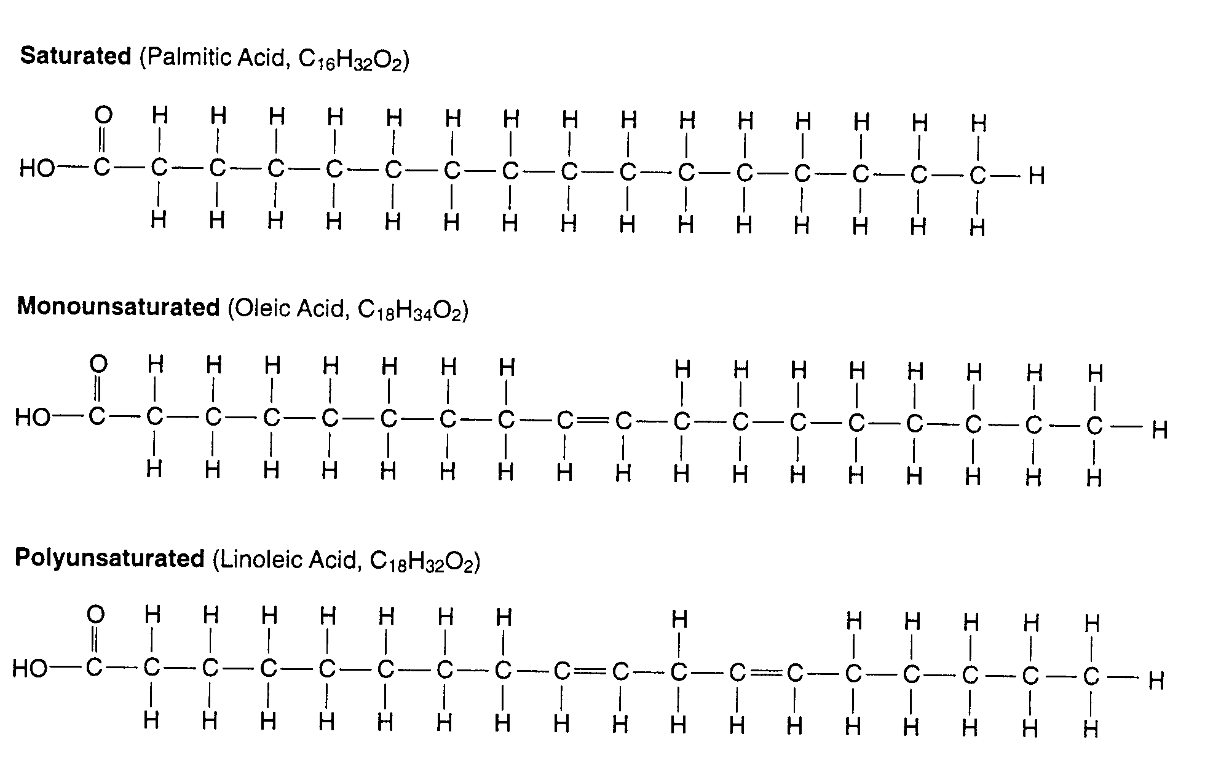

Fats

Fats in food are responsible for many of the flavors, textures, and aromas we find desirable. Fat also influences the degree of fullness and satisfaction (satiety) of a meal. Fats are the most concentrated source of food energy, supplying nine Calories per gram. They are needed to transport and absorb the fat-soluble vitamins: A, D, E, and K.

Fats are composed of fatty acids, which can be classified as saturated, monounsaturated, or polyunsaturated. Three fatty acids attached to a glycerol molecule constitute a triglyceride. Most triglycerides have a chemical structure composed of a long, straight chain of carbon atoms (Figure 4.1). If the carbon atoms are linked together by single bonds, the molecule is a saturated fatty acid. If one double bond connecting carbon atoms is present, it is a monounsaturated fatty acid. If two or more double bonds are present, the fatty acid is polyunsaturated. Their chemical structure determines their behavior in your digestive system and in your body cells.

Saturated fatty acids predominantly come from animal sources and coconut, palm, palm kernel, and vegetable oils. Bear in mind that fats and oils contain many types of fatty acids. They are classified according to their predominant acid type. Because saturated fatty acids can raise blood cholesterol levels, it is recommended that they compose 1/3 or less of total fat intake.

Monounsaturated fatty acids are found in animal and plant fats, especially in olive, canola, and peanut oils. These may help lower blood cholesterol levels. Recommendations call for 1/3 or less of total fat intake to be supplied by monounsaturated fatty acids.

Polyunsaturated fatty acids come from sunflower, safflower, corn, sesame, and soybean oils. These can help lower blood cholesterol. Linoleic acid, which is one example of a polyunsaturated fatty acid, is an essential fatty acid needed for normal growth.

The proportion of saturated to unsaturated fatty acids give fats and oils their individual physical properties. Fats containing more saturated than unsaturated fatty acids are typically solid at room temperature. Fats which are more unsaturated than saturated are typically liquid at room temperature. The exceptions are the mostly saturated palm and coconut oils which are liquids at room temperature.

It is recommended that fats should contribute no more than 30 percent of total calories in your diet.

Fiber and Health

It has long been recognized that fiber contributes to a healthy intestine. Cellulose, pectins, lignin, and other plant substances that are not readily digested, constitute fiber. Fiber holds water, loosens the stool, and decreases the stool transit time through the large intestine.

Research also has shown that adequate dietary fiber may lower serum cholesterol, decrease the incidence of colon cancer, and lower the insulin requirements of diabetics. Fiber from different sources varies in its proportion of the different indigestible components and is not equal in its physiological effect. Grinding and other processes also influence fiber's effectiveness. Excessive fiber may bind minerals and make them unavailable for absorption.

Health Issues and Nutrition

One of the privileges of living in America is the vast supply of high quality, low-cost foods. Americans have a longer life expectancy than many other countries. One of the reasons for this is the availability of good nutritious foods. However, the availability of low fiber, high fat foods contributes to poor health among Americans. Most nutritional diseases in the United States are diseases of excess, but nutritional deficiencies do occur. Many health issues are tied to nutrition.

Anorexia is a disease where the individual refuses to eat, even though they are starving.

Bulimia is a disease characterized by a person vomiting food before it provides nourishment. Bulimia results in starvation and other physiological complications.

Diverticulitis is the condition of an inflamed colon, which can be initiated by certain foods as well as being treated with fibrous foods.

Heart disease is characterized by problems associated with blood circulation. Consumption of high levels of fat seem to increase the risk of developing this problem.

Malnourishment is defined as the lack of, or an insufficient amount of an essential nutrient. There are several diseases caused from malnourishment. Most vitamins and minerals are associated with some nutritional deficiency.

Obesity is almost the opposite of starvation. Obesity occurs when more calories are ingested than spent. An accumulation of calories leads to fat deposits and extra weight. Obesity is a contributing factor to many other diseases including heart disease, arthritis, and diabetes.

Starvation is a condition of being without food for an extended period of time. The body's energy stores are also depleted and the body begins to break down in an attempt to supply energy to the brain, heart, and lungs.

Ulcers are lesions in the stomach lining. Ulcers can be caused by specific foods and treated by specific foods.

Beri-beri is a thiamin deficiency. Osteoporosis is a softening of the bone tissue linked to a calcium deficiency. Night blindness is a vitamin A (carotene) deficiency. Neuritis is a thiamin deficiency. Photophobia is caused by a riboflavin shortage. Anemia is caused by a lack of iron or vitamin B₁₂. Pellagra is caused by a lack of niacin. Scurvy is caused by a shortage of vitamin C. Rickets is a defective bone formation caused by a vitamin D deficiency. And hemophilia is caused by a vitamin K shortage.

A final health-related issue affected by nutrition is a person's recovery time following an illness or surgery. People in good health, who have a balanced diet and lifestyle, require less recovery time.

Health Problems Can be Minimized by Nutrition

The human body is an intricate creation. Its physiological functions depend on hundreds of factors. One of the most important factors is proper nutrition. A balanced diet accompanied by sufficient regular exercise is a great start. Eating habits that follow the Recommended Dietary Allowance (RDA's) and are appropriate in caloric intake in order to remain in weight range for age and height are highly encouraged. And finally, if diet modification is recommended to correct or prevent a health problem, following a doctor's or dietician's suggestions is recommended.

Summary

There is a direct relationship between diet and health. Issues about cholesterol, fat composition, grams of fat, and others are popular topics. Cholesterol is a necessary part of normal health. The type and amount consumed can be controlled by what a person eats. Fats are either saturated, monounsaturated, or polyunsaturated depending on the number of double bonds between carbon atoms. A balance of all three types in the diet is recommended. Fiber influences intestinal health and is therefore very important. There are many diseases related to dietary deficiencies, imbalances, and over indulgence. Many of these health problems can be minimized by a balanced diet that includes an appropriate caloric intake.

Credits

Exploring Meat and Health. Chicago: National Live Stock and Meat Board, 1991.

Focus on Food Labeling. An FDA Consumer Special Report. Rockville, MD: Food and Drug Administration, May, 1993.

Guyton, Arthur C. Human Physiology and Mechanisms of Disease. 4th ed. Philadelphia: W.B. Saunders Co., 1987.

Lessons on Meat. Chicago: National Livestock and Meat Board, 1991.

Mehas, Kay; Sharon Rodgers. Food Science and You. 2nd ed. New York: Glencoe, 1994.

Potter, Norman N. Food Science. 4th Ed. Westport, CT: AVI Publishing Co. Inc., 1986.

