UNIT II - FOOD PROCESSING

Lesson 3: Milk Processing

Objective

The student will be able to identify products produced from different grades of raw milk.

I. Study Questions

A. What are the quality grades of milk?

B. What major products can be produced from raw milk?

C. What by-products result from milk processing?

D. What factors affect milk taste and composition?

II. References

A. Martin, Phillip R. Food Science and Technology (Student Reference). University of Missouri-Columbia: Instructional Materials Laboratory, 1994. Unit II.

B. Activity Sheets

1. AS 3.1: Determining Thresholds for Off-flavors in Milk Using a Triangle Sensory Test (Instructor)
2. AS 3.1: Determining Thresholds for Off-flavors in Milk Using a Triangle Sensory Test (Student)

UNIT II - FOOD PROCESSING

Lesson 3: Milk Processing

TEACHING PROCEDURES

A. Review

In Lesson 2, the difference between margarine and butter was discussed. This lesson will discuss how raw milk is processed into milk products.

B. Motivation

1. Show video,"The Dairy Plant," available from Creative Educational Video (CEV).

2. Have students taste test different types of milk: whole milk, 2 percent milk, 1 percent milk, cultured buttermilk, evaporated milk, sweetened condensed milk, milk substitute, and dried/reconstituted milk.

C. Assignment

D. Supervised Study

E. Discussion

1. Discuss the quality grades of milk.

What are the quality grades of milk?

a. Grade A raw milk
b. Manufacturing grade (can be referred to as Grade B or Grade C)
c. Reject

2. Discuss what major products are produced from raw milk.

What major products can be produced from raw milk?

a. Fluid milk (must be made from grade A milk only)
1. Whole milk - greater than or equal to 3.25 percent fat (raw milk is usually 3.6-3.7 percent fat)
2. Low-fat milk
a. 2 percent fat
b. 1.5 percent fat
c. 1 percent fat
d. 1/2 percent fat
3. Non-fat milk - less than 0.5 percent fat (skim milk)
4. Chocolate milk - a combination of chocolate flavoring with whole, low-fat, or skim milk
b. Fermented milk (must be made from grade A milk)
1. Cultured buttermilk - skim milk that has been pasteurized, inoculated with lactic acid-producing bacteria, and held at 72°F.
2. Yogurt
3. Acidophilus milk
c. Creams (must be made from grade A milk)
1. Half-and-half - about 11 percent fat
2. Cream - 18 percent fat
3. Whipping cream - 30 percent fat
4. Coffee cream - 18 percent fat
5. Heavy whipping cream - 36 percent fat
6. Sour cream - cultured, 18 percent fat
d. Butter
e. Canned milk
1. Evaporated milk - 60 percent water removed
2. Sweetened condensed milk
f. Dried milk - usually nonfat dried milk
g. Cheeses
h. Ice cream

3. Discuss what by-products result from milk processing.

What by-products result from milk processing?

a. Buttermilk - from butter making; usually is dried for sale to bakers
b. Whey - liquid remaining after the curd develops and is separated and removed; it can be dried, demineralized, and concentrated

4. Discuss what factors affect milk flavor and/or composition.

What factors affect milk taste and composition?

a. Antibiotics - may inhibit growth of bacterial cultures
b. Added water
c. Sediment
d. Pesticide contamination - are not known to change flavor; only minutely change composition
e. Radionuclides - are not known to change flavor; only minutely change composition
f. High bacterial counts
g. Fat content
h. Age of milk
i. Species, breed, individuality of animal, age, stage of lactation, season of year, feed, time of milking, period of time between milkings, physiological condition of cow (calm or excited)
j. Facilities - unlikely to affect flavor or composition in today's operations
k. Temperature of milk and rate of cooling
l. Offensive feeds that could be in cow's feed

F. Other activities

1. Use the IML Dairy Foods contest slide set to help students in evaluating off flavors in milk.

2. Have student discuss their opinions on the different milks tasted. The instructor could cover the labels and relabel with "A," "B," "C," etc. to see if students are able to identify the different products.

G. Conclusion

Milk is a balanced food that plays a vital role in a healthy diet. Milk grades reflect differences in requirements for facilities and operations at the farm, during assembly and in processing as well as in permitted bacteria counts. Milk is very versatile and can be made into many different products.

H. Competency

1. Identify products produced from different grades of raw milk.

2. Related Missouri Core Competencies and Key Skills: None

I. Answers to Evaluation

1. Grade A raw milk, manufacturer's grade (Grade B or C)
2. Grade A
3. Whole - 3.25 percent or greater milk fat
Low-fat - 2 percent, 1.5 percent, 1 percent, or 0.5 percent milk fat
Chocolate - chocolate flavoring has been added to either whole or low-fat milk

4. Cultured buttermilk is skim milk that has been pasteurized, and then inoculated with lactic acid-producing bacteria and held at 72°F.

5. Whipping cream
6. b
7. a
8. d

UNIT II - FOOD PROCESSING Name ______________________

Lesson 3: Milk Processing Date _______________________

EVALUATION

Complete the following short answer questions.

1. Name the two quality grades of milk.

2. Which quality grade is used for fluid milk processing?

3. How much milk fat is contained in each of the following types of milk: whole, low-fat, and chocolate milk?

4. How is cultured buttermilk produced?

5. Which has a higher fat content, half-and-half or whipping cream?

Circle the letter that corresponds to the best answer.

6. From what product is whey a by-product?

a. Cultured buttermilk
b. Cheese
c. Ice cream
d. Butter

7. What has the greatest impact on milk composition?

a. Breed of cow
b. Age of cow
c. Facilities
d. Time of milking

8. A cow with mastitis would be discovered with which test?

a. Pesticide test
b. Sediment test
c. Mycotoxin test
d. Somatic cell count

UNIT II - FOOD PROCESSING AS 3.1
Instructor
Lesson 3: Milk Processing

Determining Thresholds for Off-flavors in Milk
Using a Triangle Sensory Test

Objective: Students will determine thresholds for off-flavors in milk using a Triangle sensory test.

Materials and Equipment:

Note: These are needed to make the samples for 10 students; not one set for each student.

1/2 pt. of cultured buttermilk
1/2 gal. pasteurized, homogenized milk
1/3 cup silage
1/4 tsp. table salt
Garlic salt or fresh onion
5 flasks or containers, 500 ml or 1 pint, with closures or covers
1-one liter Erlenmeyer flask fitted with a one-hole rubber stopper into which a glass or plastic tube is inserted to the bottom of the stopper. Attach a 15-inch (40 cm) hose to the tube for delivery of vapors from the silage sample to milk
Tripod or ring stand and wire gauze and Bunsen burner
Fluorescent lamp without cover or shield
4 oz. cups - 3 for each test per number of students

Procedure:

A. Preparation:

1. The formulas that follow are designed for 10 individuals and will provide more than 20 ml per person for tasting. If more than 10 students will be testing the samples, increase the amount of flavors in proportion to the number of students.

2. Flavors to be prepared are feed, high acid (sour), garlic/onion, oxidized and salty. These are chosen because they represent important flavors of milk and some other foods. Furthermore, they can be tasted within a 50-min. period. It is suggested that the flavorings be prepared before class. Prepare samples at the beginning of class. For Phase I, use the strengths included under each test preparation.

a. Test A - Feed: this defect is prepared by boiling a suspension of silage in water and collecting in milk the steam that contains volatiles from the silage. Add about 1/3 cup of silage to about 125 ml (1/2 cup) of water in the 1-liter Erlenmeyer flask. Insert into the top of the flask the stopper with the tube and hose. Place on stand and heat with the Bunsen burner (see Figure 3.1). Collect steam volatiles in about 200 ml of milk in a 400 ml beaker or flask by inserting the hose into the milk while boiling the silage-water suspension. Collect volatiles for about 5 min. after boiling has started.
Figure 3.1 - Bunsen Burner Setup
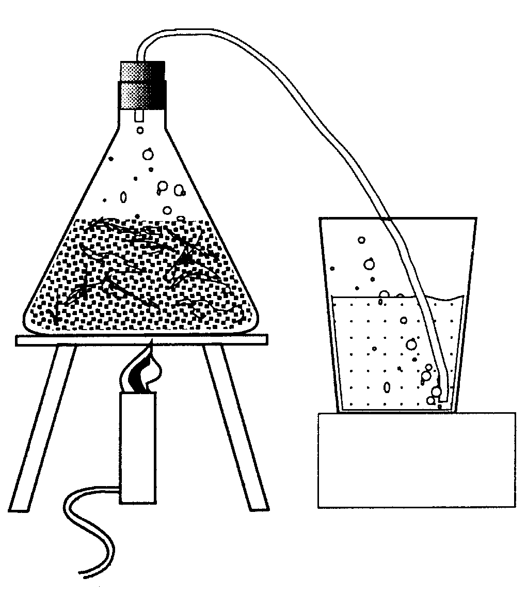

To stop the operation remove the hose from the milk and turn off the burner at the same time. Do not leave the hose in the milk after the burner is off. To do so allows vacuum created in the flask, as it cools, to suck milk into the silage. Do not allow the hose to kink or to restrict air flow through the tube after the burner is off. A vacuum created in the flask can cause a defective flask to burst or can pull a slightly too small stopper into the flask.

Use this milk to flavor the sample to be tasted. The amount to use varies with the silage used. Start with 10 ml of silage-flavored milk in 200 ml of fresh milk. Adjust amount added after comparing the flavor and odor to that of an untreated portion of fresh milk.

b. Test B - High acid: Add 15 ml (1 tablespoon) of cultured buttermilk to 220 ml of fresh milk and stir. Compare flavor to that of fresh milk control and adjust amount added to increase or decrease flavor and odor intensity.

c. Test C - Garlic or onion: Add a sprinkle of garlic salt (about 50 grains estimated) to 220 ml of milk. Mix well, let set 5 min., mix again. Compare flavor and odor to that of untreated control. If flavor is too high, use this sample to treat fresh milk adding 10-20 ml each time until the flavor is slight, definite and pronounced.

Alternatively, press juice from a section of the interior of an onion and add single drops to 220 ml of milk until the flavor is slight, definite and/or pronounced.

d. Test D - Oxidized: This flavor is emphasized because of its high incidence in milk packaged in "see-through" plastic jugs that are displayed for sale under fluorescent light.

Place 220 ml of milk in a glass container and expose the sample for 20-30 min. to direct rays from a fluorescent lamp. Sample and lamp should be within 6 inches of each other. The reaction rate can be accelerated by addition of a washed copper penny or by a drop of 1% copper sulfate.

A similar flavor is produced in milk exposed to direct high intensity sunlight for 15 to 30 min.

Milks vary in their susceptibility to oxidation, so prolonged exposure to light or sample dilution may be necessary. Compare flavor of treated and untreated samples to make sure the off flavor is definitely discernible.

e. Test E - Salty: Place 0.1 g of salt in 9.9 ml of fresh milk. Use this 1:100 solution to add 1 ml to 100 ml of milk making the equivalent of 100 parts per million or 100 mg/liter. Compare the flavor to that of fresh milk. Adjust the flavor intensity upward by adding 1 ml at a time until the saltiness is slight, definite and/or pronounced.

B. Testing: Thresholds for flavor detection vary among individuals. It is essential to know that the flavor intensity is high enough for all individuals to recognize it. Of course, no one wants to taste a sample that is very pronounced in its off flavor, so do not over-flavor.

A good way to determine whether the flavor intensity is high enough is to do a triangle test. Here is the procedure.

Number small cups, such as 4 oz styrofoam, with 3-digit numbers. Numbers have been selected and included in the student form of AS 3.1. If different numbers are selected, a different record needs to be made for students.

For each off flavor to be tested you need 3 cups per person. For example, to test the salty sample with a group of 10 prepare 30 cups. Pour about 20 ml of the treated sample into about 15 cups and 20 ml of untreated sample into the remainder. NOW the critical part is to make a chart showing how each of these samples is distributed to the students. Each person gets 2 cups of one set and 1 cup of the other set. Half the students will have two treated samples and the other half will have two untreated samples. They are served in random order. You must record the number and content of each cup for each student.

Present these "blindfold" samples to the group asking each person to indicate which two samples are alike. A table for record keeping has been provided in the student copy.

Indicate to students what they should do with samples after tasting. Also, you will need to let students know if they selected the correct samples for each test.

For Phase II, dilute or double the strength of the flavoring based on student results from Phase I. If all students selected the correct samples, dilute the strength of the flavoring. If less than seven students selected the correct samples, double the strength of the flavoring.

Credit: Robert T. Marshall, Professor Food Science and Nutrition, University of Missouri.

UNIT II - FOOD PROCESSING AS 3.1
Student
Lesson 3: Milk Processing Name _____________________________

Determining Thresholds for Off-flavors in Milk
Using a Triangle Sensory Test

Objective: Students will determine thresholds for off-flavors in milk using a triangle sensory test.

Activity Length: 1 class period

Background Information: In phase I, you will be testing five (5) different off-flavors. In each test, you will be tasting three different samples. All samples will be coded with numbers (420, 062, etc.) by your instructor. Depending on your instructor, you may be asked to complete Phase II which calls for tasting five additional sets.

Materials and Equipment:

Milk samples - provided by instructor
Container to discard tasted milk samples

Procedure:

1. Obtain the first samples (Test A) from your instructor.

2. Taste the milk in each cup in order presented, left to right. Do not swallow the milk. Put it in waste container. This is standard for a Triangle Sensory Test.

3. Answer the question, which two samples are the same by marking an "X" by the appropriate numbers in the table.
PHASE I | Sample on Left | Sample in Middle | Sample on Right
Test A | 420 | 062 | 153
Test B | 091 | 579 | 221
Test C | 656 | 892 | 356
Test D | 129 | 442 | 056
Test E | 718 | 389 | 978
PHASE II | Sample on Left | Sample in Middle | Sample on Right
Test F | 329 | 011 | 921
Test G | 756 | 423 | 291
Test H | 152 | 625 | 867
Test I | 024 | 372 | 735
Test J | 922 | 543 | 231
4. Return samples to instructor or dispose of samples as directed.

5. Give your responses to your instructor.

Note: Your instructor will tabulate results.

6. Repeat steps 1-5 for Tests B, C, D, and E.

7. If directed by your instructor, complete Phase II by repeating steps 1 through 5 for Tests F, G, H, I, and J.

Key Questions:

1. In Phase I, did you select the correct samples in each test? Explain why you think you were able or not able to select the correct samples in each test.

2. How did you do compared to other students in the class?

3. If not all students selected the correct samples, why do you think there were differences?

4. If Phase II was completed, how did you do in selecting the correct samples in each test? Explain why you think you were able or not able to select the correct samples in each test.

5. In Phase II, how did you do compared to other students in the class?

6. If not all students selected the correct samples in Phase II, why do you think there were differences?

Credit: Robert T. Marshall, Professor of Food Science and Nutrition, University of Missouri-Columbia.

