UNIT II - FOOD PROCESSING

Lesson 5: Processing Egg Products

Objective

The student will be able to compare egg processing techniques to egg products.

I. Study Questions

A. What are the major product forms of eggs?

B. What are the quality characteristics of eggs?

C. What factors influence egg quality?

D. How are eggs graded?

E. How are the different grades of eggs processed?

F. What are the sizes of eggs?

G. How is the egg processing industry organized?

II. References

A. Martin, Phillip R. Food Science and Technology (Student Reference). University of Missouri-Columbia: Instructional Materials Laboratory, 1994. Unit II.

B. Transparency Master

TM 5.1: Egg Structure

C. Activity Sheet

AS 5.1: Candling Eggs

UNIT II - FOOD PROCESSING

Lesson 5: Processing Egg Products

TEACHING PROCEDURES

A. Review

Just as a cow's diet influences milk quality, Vitamin D, calcium, and xanthophyll influence egg quality. This lesson looks at egg processing from hen to grocer.

B. Motivation

1. Store an egg at room temperature for 1-3 days. Break onto a sheet of glass or a mirror. Compare to an egg stored at refrigeration temperatures. Notice yolk height, albumen height and thickness, albumen spread, yolk color, present of chalazae cords.

2. Make an egg white foam with eggs stored at two different temperatures. Add a pinch of cream of tarter to another egg before whipping. Put egg white foam in glass beaker and observe over a class period. How does temperature and pH affect foaming ability of eggs?

C. Assignment

D. Supervised Study

E. Discussion

1. Discuss what major products come from eggs.

What are the major product forms of eggs?

a. Shell eggs
b. Refrigerated liquid eggs
c. Frozen eggs
d. Dried eggs
e. Specialty products

2. Discuss the quality characteristics of eggs. Candling is passing eggs on rollers over high intensity lights to evaluate the interior. Haugh Unit System measures albumen height with a micrometer. Have students complete AS 5.1, Candling Eggs. TM 5.1 illustrates the physical structure of eggs.

What are the quality characteristics of eggs?

a. Exterior shell
1. Cleanliness
2. Soundness
3. Texture
4. Shape
b. Interior - candling process or Haugh Unit System used
1. Air cell depth
2. Albumen - clarity and firmness
3. Yolk - outline distinctness, size, shape, blemishes

3. Discuss what factors influence egg quality. Brown eggs are laid by hens with red ear lobes (e.g., Rhode Island Red, New Hampshire, Plymouth Rock). White eggs are laid by hens with white ear lobes. Egg color does not affect egg quality, except for consumer's perception. (Brown eggs almost always command higher prices.)

What factors influence egg quality?

a. Facilities, equipment, and handling
b. Hen's diet
1. Minerals and vitamins influence shell strength
2. Feeds with xanthophyll result in a medium, yellow yolk
c. Breed of hen
d. Hen's age - older hens lay eggs with thinner shells
e. Hen's physiology - ruptured blood vessel may result in a blood spot
f. Time after laying (age of egg)
g. Genetics

4. Discuss how eggs are graded. The Egg Products Inspection Act of 1970 certifies USDA grading of all eggs carrying the official grade shield.

How are eggs graded?

Eggs are graded by a USDA grading service based on:
a. AA - stands up tall; yolk is firm and there is a large proportion of thick albumen to thin albumen; shell is clean, sound, oval shaped, smooth texture
b. A - medium in height, yolk is still firm while albumen begins to spread out, shell is clean, sound, oval shaped, smooth texture
c. B - yolk is flat, more thin albumen than thick albumen; shell is clean, but possibly misshapened, rough or faulty textured

5. Discuss how the different grades of eggs are processed. All liquid and dried egg products must be pasteurized in the U.S.

How are the different grades of eggs processed?

a. Grade AA and A are regularly marketed as shell eggs. Surplus are processed.
b. Grade B - processed, rarely sold as shell eggs

6. Discuss how eggs are sized. Size is not related to the quality grade.

What are the sizes of eggs?

a. Jumbo - 30 oz/dozen
b. Extra Large - 27 oz/dozen
c. Large - 24 oz/dozen
d. Medium - 21 oz/dozen
e. Small - 18 oz/dozen
f. Peewee - 15 oz/dozen

7. Discuss how the egg processing industry is organized.

How is the egg processing industry organized?

Vertical integration - contracts between producers and large companies

F. Other activities

1. Hard boil 1 egg per 2 students. Have students dissect the egg and weigh its components. Refer students to Figure 5.1, Egg Composition in student reference.

2. Have students do "Easy Eggsperiments" from the American Egg Board.

G. Conclusion

Eggs are a valuable part of the human diet. Eggs are versatile in that they may be processed into a variety of forms. Egg quality is based on both interior and exterior characteristics of the egg. These characteristics are determined by a combination of the hen's genetics as well as her environment. This vertically integrated business grades eggs before they reach the grocer and processes them accordingly.

H. Competency

1. Compare egg processing techniques to egg products.

2. Related Missouri Core Competencies and Key Skills: None

I. Answers to Evaluation

1. b
2. a
3. a
4. b
5. a
6. A
7. B
8. AA
9. b
10. d
11. Three of the following: shell eggs, refrigerated liquid eggs, frozen eggs, dried eggs, or specialty products.
12. Instructor's discretion

J. Answers to Activity Sheet

AS 5.1

1. Instructor's discretion

2. 0₂ supply for embryo, should it develop

3. Normally the large end

UNIT II - FOOD PROCESSING Name __________________________

Lesson 5: Processing Egg Products Date __________________________

EVALUATION

Identify which characteristics are used to determine exterior quality or interior quality.

____1. Air cell depth a. Exterior quality characteristics

____2. Shape b. Interior quality characteristics

____3. Cleanliness

____4. Albumen clarity

____5. Shell texture

Match the characteristic with the type of grade.

____6.. Medium yolk height, normal shell AA

____7. Flat yolk, thin albumen A

____8. Tall yolk, firm albumen B

9. What grade or grades of eggs are sold as shell eggs?

a. Grade AA
b. Grade AA and A
c. Grade A
d. Grade A and B

10. In the processing industry, producer's contract with large companies to produce eggs. What does the producer supply?

a. Housing and feed
b. Birds and feed
c. Feed and labor
d. Housing and labor

11. Name three major products made from eggs.

12. Discuss how a hen's diet can influence egg characteristics. Use xanthophyll, calcium, and vitamin D in your discussion.

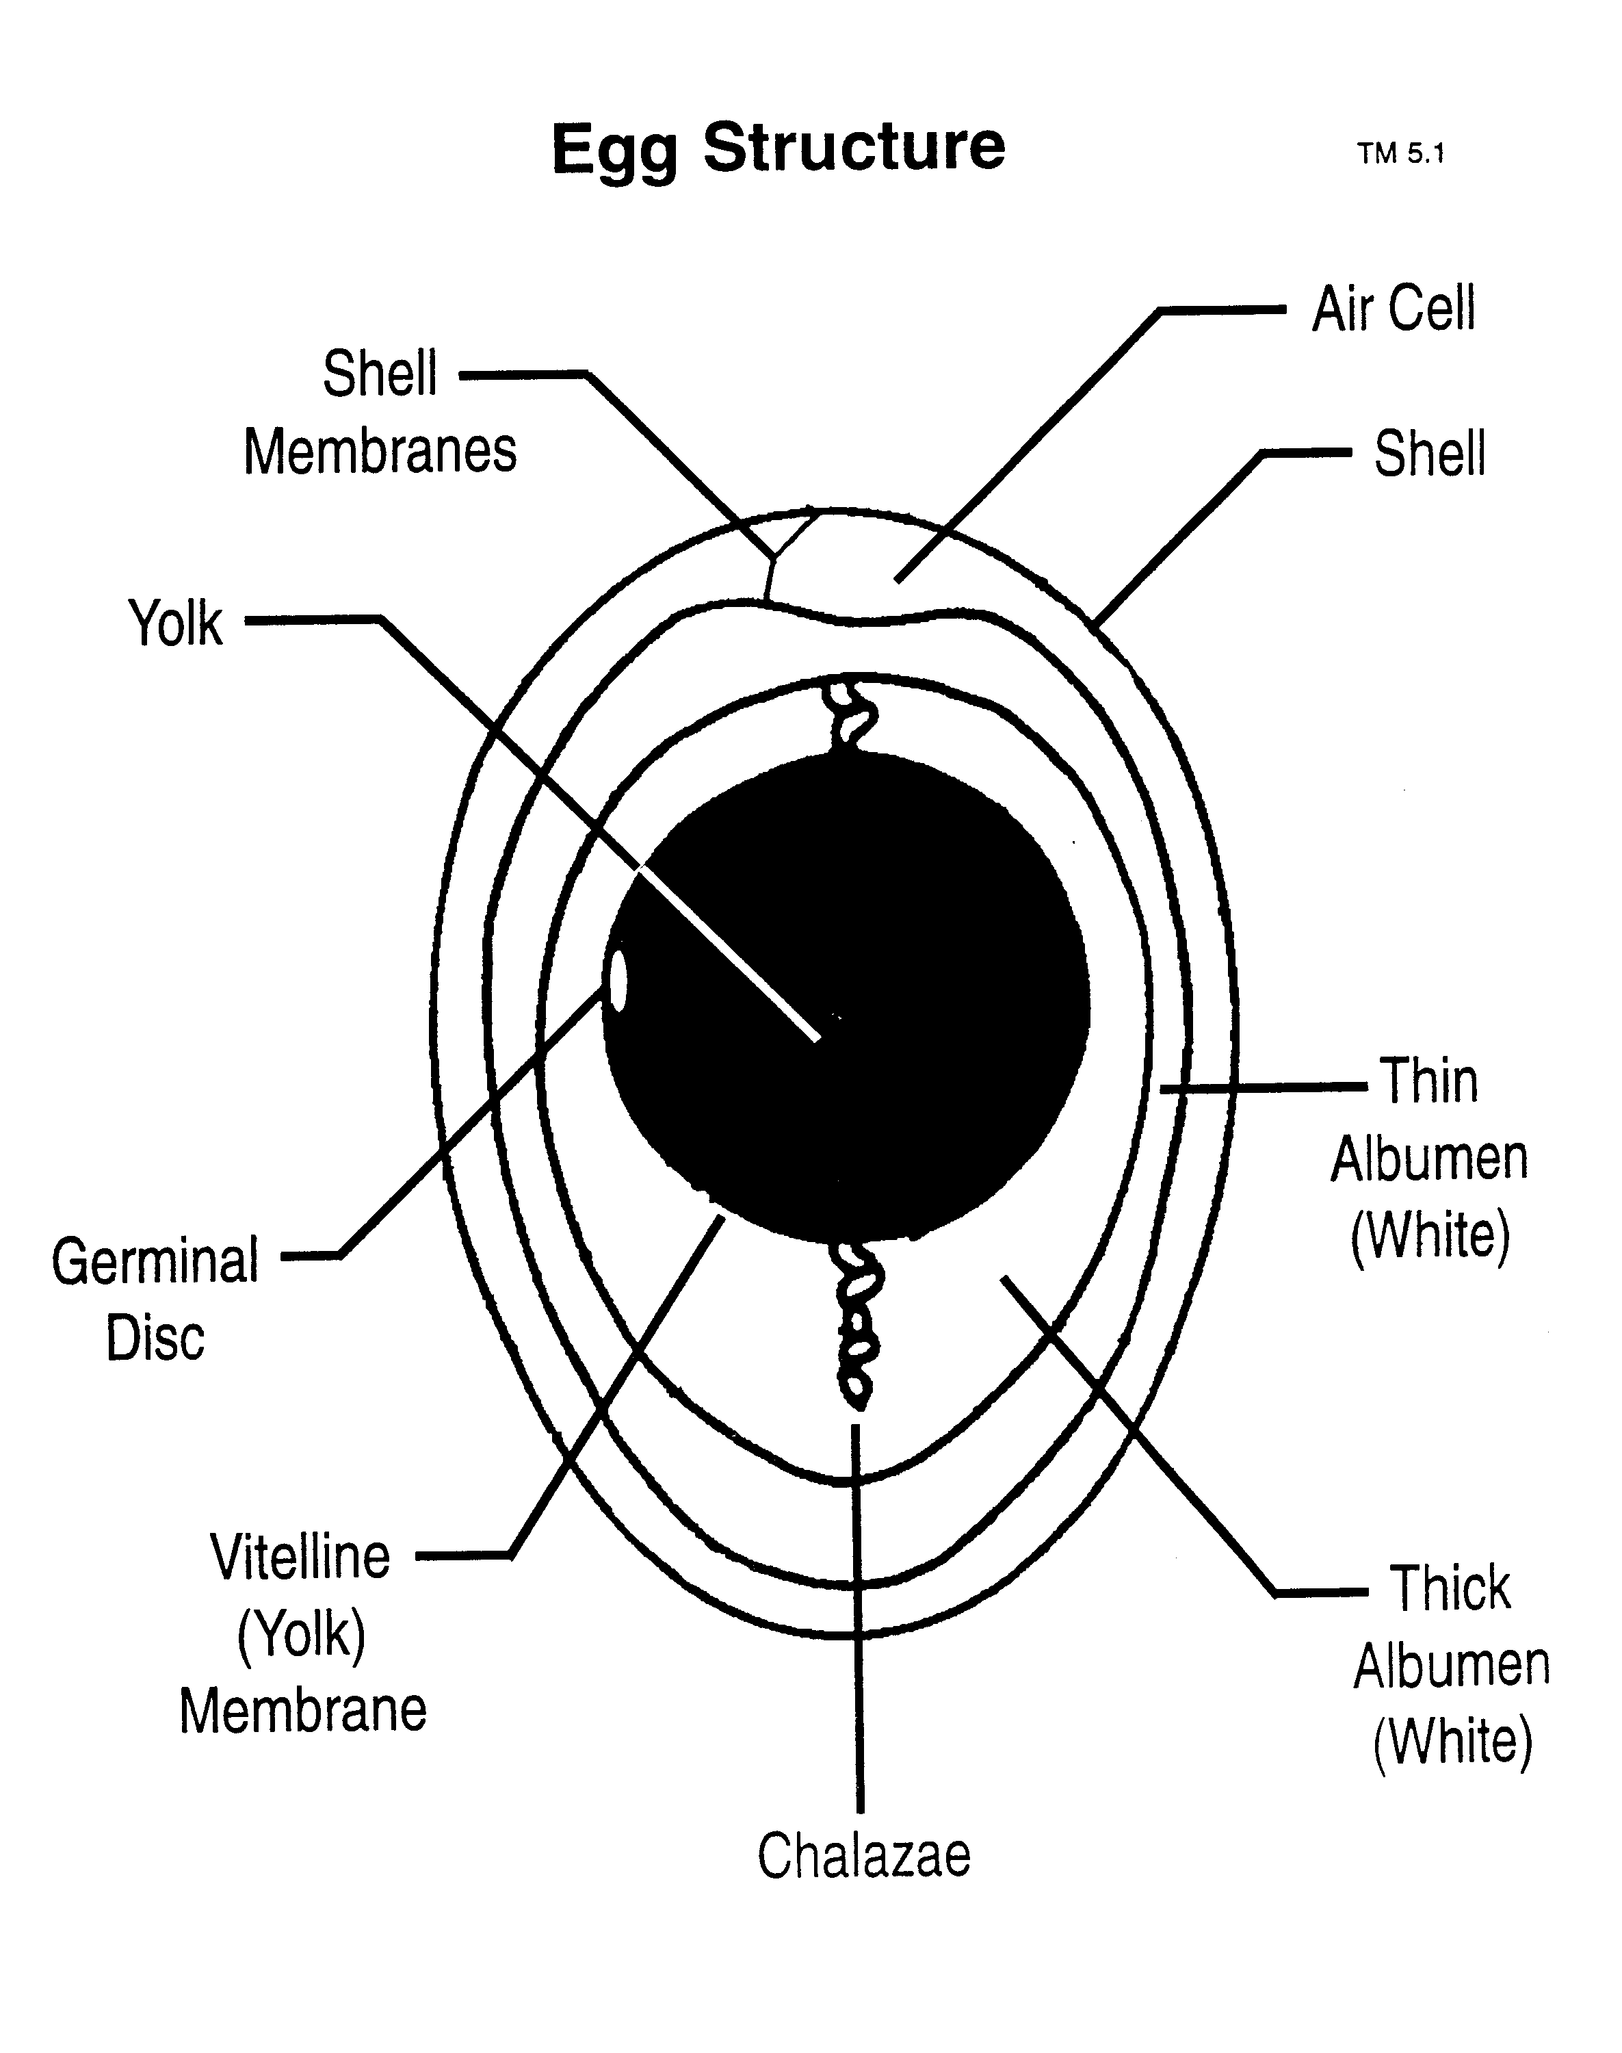

UNIT II - FOOD PROCESSING AS 5.1

Lesson 5: Processing Egg Products Name________________________

Candling Eggs

Objective: Students will candle an egg to determine its interior quality, thus teaching them an understanding of egg grading.

Activity Length: 30 minutes

Materials and Equipment:

Aged eggs (store at room temperature 1-3 days, or buy 2 weeks in advance)
Fresh eggs
Candling lights (a strong flashlight works well)
Egg cartons
Break-out tray (paper plate will work), sheet of glass or a mirror
Ruler

Procedure:

NOTE: Complete the procedure with fresh eggs. Then use aged eggs.

1. Hold the egg up to the candling light in a slanting position.

2. Notice the air cell, the yolk, and the white. The air cell is nearly always in the large end of the egg. Therefore, put the large end next to the candling light.

3. Hold the egg between your thumb and first two fingers.

4. Then by turning your wrist quickly, you can cause the inside of the egg to whirl. This will tell you a great deal about the yolk and white. NOTE: When you are learning to candle, you will find it helpful to break (on break-out tray) and observe the eggs. Notice the viscosity of white, flattening of yolk, air sac size and location and presence of any blood spots.

Key Questions:

1. Draw a diagram of one aged egg and one fresh egg noting their air cell size and location.

2. What purpose does the air cell serve?

3. On which end of the egg is the air cell located for each egg candled? Large or small.

