UNIT II - FOOD PROCESSING

Lesson 6: Products and By-Products From Meat Animals

Objective

The student will be able to list the products and by-products from meat animals.

I. Study Questions

A. What are the major meat animal species?

B. What are examples of fresh meat products?

C. What are examples of processed meat products?

D. What are examples of meat by-products?

II. References

A. Martin, Phillip R. Food Science and Technology (Student Reference). University of Missouri-Columbia: Instructional Materials Laboratory, 1994. Unit II.

B. Transparency Master

TM 6.1: Anatomical Regions on Swine

C. Activity Sheets

1. AS 6.1: Cutting up a Chicken
2. AS 6.2: Bratwurst Production

UNIT II - FOOD PROCESSING

Lesson 6: Products and By-Products From Meat Animals

TEACHING PROCEDURES

A. Review

So far in this unit, an examination of processing techniques for milk and eggs has taken place. The largest industry to be studied is the meat industry.

B. Motivation

Have each student select an index card listing one of the following anatomical regions on a swine carcass: skin, ear, bone, adrenal gland, blood, brain, intestine, pituitary gland, hair, spleen, stomach, gall bladder, pancreas, and thyroid. Display TM 1.1. Display visual aids: soap, bone meal, leather article, hair conditioner, vitamins, ointment with cortisone as an ingredient, casings, glue, antacid, a brush, and dice. Include pictures or items depicting epinephrine, insulin, melatonin, and a hormone (i.e., implant). Have each student match the index card to the appropriate anatomical region on TM 1.1 and to the by-product visual aids. Answers follow:

A pineal gland - melatonin
B pituitary gland - hormones
C ear - leather articles
D hide/skin/leather - leather articles, glue
E stomach - antacid
F adrenal gland - epinephrine
G bone - bone meal, dice
H spleen
I intestine - casings
J pancreas - insulin
K gall bladder - cortisone
L hair - brush
M blood - hair conditioner
N thyroid gland - thyroxin

C. Assignment

D. Supervised study

E. Discussion

1. Discuss the major meat animal species.

What are the major meat animal species?

a. Cattle - beef and veal
b. Swine - pork
c. Sheep - lamb and mutton
d. Chicken and turkey - poultry
e. Fish/shellfish

2. Discuss examples of fresh meat products? Display National Live Stock and Meat Board meat carcass posters.

What are examples of fresh meat products?

a. Primal cuts (wholesale)
1. Chuck/shoulder
2. Rib
3. Loin
4. Round/ham/leg
5. Whole fish or fish fillets
6. Whole fryers or turkeys
b. Subprimal cuts (retail)
1. Loin (short loin); toploin steak, tenderloin steak, T-Bone, porterhouse loin chop, butterfly chop
2. Sirloin; sirloin steak, sirloin chop
3. Leg (ham)/round; round steak, eye of round roast, top round steak, ham center slice, center slice
4. Shoulder/chuck blade; 7-bone pot roast, blade roast, top blade steak, mock tender, bladesteak, blade chop
5. Shoulder/chuck arm - arm pot roast, cross rib pot roast, short ribs, arm steak, arm picnic roast, arm chop
6. Breast - brisket, shank cross cut, breast, riblet, spareribs, bacon, rolled breast
7. Rib - ribeye steak, rib roast, rib chop
8. Half or quarter portions of poultry; chicken breasts, fillets, sliced turkey breast
9. Fish - sticks, squares, or fillets

3. Discuss examples of processed meat products. Approximately 35 percent of beef, veal, pork, and lamb produced in the U.S. is processed. Seventy-five percent of this is pork.

What are examples of processed meat products?

a. Sausages
1. Fresh - fresh pork sausage
2. Uncooked and smoked - kielbasa
3. Cooked - braunschweiger, liverwurst
4. Cooked and smoked - bologna, frankfurters
5. Dry and/or semi-dry - pepperoni
6. Fermented - salami
7. Loaves - pickle loaf, Vienna sausage loaf
b. Cured whole muscle cut
1. Ham
2. Corned beef
3. Bacon
4. Pastrami
5. Pork shoulder
c. Restructured
1. Boneless ham
2. Smoked, sliced beef
d. Breaded
1. Fish sticks
2. Chicken patties

4. Discuss examples of meat by-products also called offal.

What are examples of meat by-products?

a. Edible (variety meats): liver, heart, tongue, brain, sweetbread, tripe, oxtail, chitterlings, mountain oysters, lard
b. Inedible
1. Fats - soap, animal feeds, oils, fatty acids
2. Tankage - soft tissue by-products processed in wet-rendering system
3. Bone meal
4. Feather meal
5. Blood meal
6. Fish meal
7. Hides and pelts
8. Adrenals - epinephrine, corticosteroids
9. Blood - plasmin, thrombin, fertilizers, hair conditioner
10. Brain - vitamin D₃ production, thromboplastin
11. Gall bladder - cortisone, chenodeoxycholic acid
12. Intestines - heparin and casings
13. Pancreas - insulin
14. Ovaries - estrogen, progesterone
15. Parathyroid - hormone and protease
16. Pineal gland - melatonin
17. Pituitary - growth hormones, prolactin, adrenocorticotropic hormone
18. Skin - gelatin, glue
19. Spleen - splenin fluid
20. Stomach - antacid
21. Thyroid - thyroxin
22. Hair - brushes, upholstering
23. Feathers - pillows
24. Bones - dice, crochet needles, buttons

F. Other activities

1. Students research and report current per capita trends in meat consumption in the U.S. Compare U.S. figures to third world countries' statistics.

2. Identify the primal cut regions on a carcass.

3. Show video, "Introduction to Meat Judging." (31 min.) available from IML. Discuss retail cuts.

G. Conclusion

The meat industry is the largest segment of the food processing industry. Beef, pork, chicken and turkey, lamb, and fish are the major meats. Meat is retailed as fresh or processed products. Meat by-products play a significant role as well.

H. Competency

List the products and by-products from meat animals.

Related Missouri Core Competencies and Key Skills: None

I. Answers to Evaluation

1. b
2. e
3. d
4. a
5. c
6. a
7. f
8. b
9. c
10. f
11. a
12. d
13. a
14. c
15. a
16. a
17. b
18. b
19. c
20. d
21. a
22. d
23. Beef, pork, veal, lamb, mutton, chicken, turkey, fish
24. Chuck, rib, loin, round
25. Edible - liver, heart, tongue, brain, etc.
non-edible - fats (soaps), tankage, meat meal, etc.

J. Answers to Activity Sheets

AS 6.1

1. class discretion
2. added value
3. neck, wings, back, etc.

AS 6.2

No questions

UNIT - FOOD PROCESSING Name________________________

Lesson 6: Products and By-Products From Meat Animals Date

EVALUATION

Match primal cuts with the appropriate subprimal cuts.

1. Tenderloin a. Whole fryer
2. Rib-eye steak
3. Brisket b. Loin
4. Drumstick
5. Top round steak c. Round/ham/leg
6. Thigh
7. Blade steak d. Breast
8. T-bone steak
9. Ham center slice e. Rib
10. Arm roast
f. Chuck/shoulder

Circle the letter that corresponds to the best answer.

11. Subprimal cuts are usually portions than primal cuts.

a. Smaller
b. Larger
c. Fatter
d. Thinner

12. What is the majority of processed meat?

a. Veal
b. Poultry
c. Beef
d. Pork

Match the example on the left with the type of processed meat on the right

13. Pepperoni a. Sausage

14. Boneless ham b. Whole muscle

15. Vienna sausage c. Restructured

16. Bratwurst c. Restructured

17. Bacon d. Breaded

18. Corned beef

19. Smoked, sliced beef

20. Fish sticks

21. Bologna

22. Chicken patties

Complete the following short answer questions.

23. Name five major sources of meat.

24. What are the four primal cuts on a beef carcass?

25. Name the two classes of meat by-products and give two examples of each.

TM 6.1

Anatomical Regions on Swine

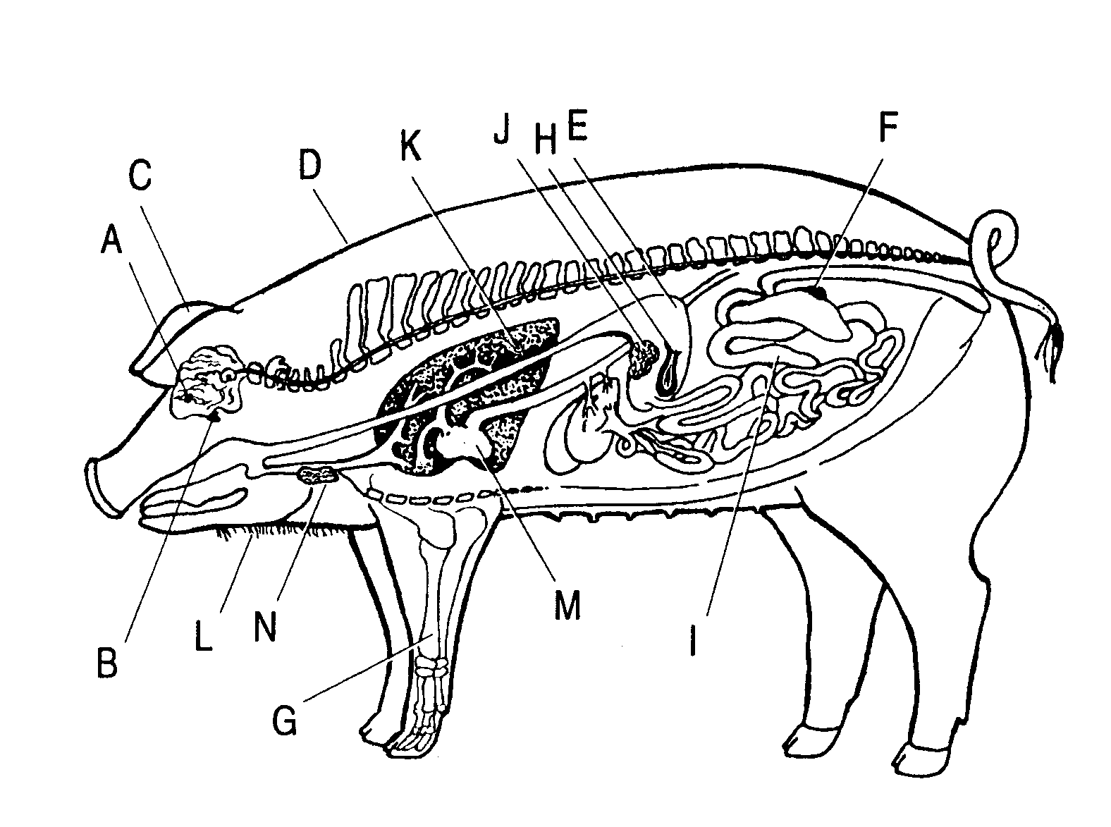

UNIT II - FOOD PROCESSING AS 6.1

Lesson 6:Products and By-Products From Meat Animals Name__________________

Cutting Up A Chicken

Objective: Students will perform a processing technology, in this case making boneless retail cuts, that improve the efficiency of cooking.

Activity Length: 2 class periods

Background Information: Bone-in chicken parts provide food service operators with a multitude of product options. Bone-in parts can be cut in-house or purchased from processors. Because so many further processed products are available, it is important to evaluate costs carefully, considering labor requirements as well as cost per pound and cost per serving. Pre-cut parts or further processed products may be a better value.

Materials and Equipment:

Whole chicken
Sharp knife (boning knife, short chef's knife, or medium chef's knife)
Cutting board
Freezer bags
Scales

Procedure:

Cutting Tips

•Chicken should be very cold and slightly stiff for easy cutting.
•Cover and refrigerate parts as soon as they have been cut.

Cutting the Whole Body Chicken into Parts

1. Thoroughly clean work area.

2. Wash hands.

3. Remove chicken from the refrigerator or freezer. If frozen, thaw partially before cutting.

NOTE: It is easier, and safer, to cut a chicken into parts while the meat is still very cold and slightly stiff. It does not need to be completely thawed.

4. Lay chicken on its back on a cutting board with neck cavity facing away.

5. Remove giblets and neck from the chicken's body cavity.

6. Cut tail off.
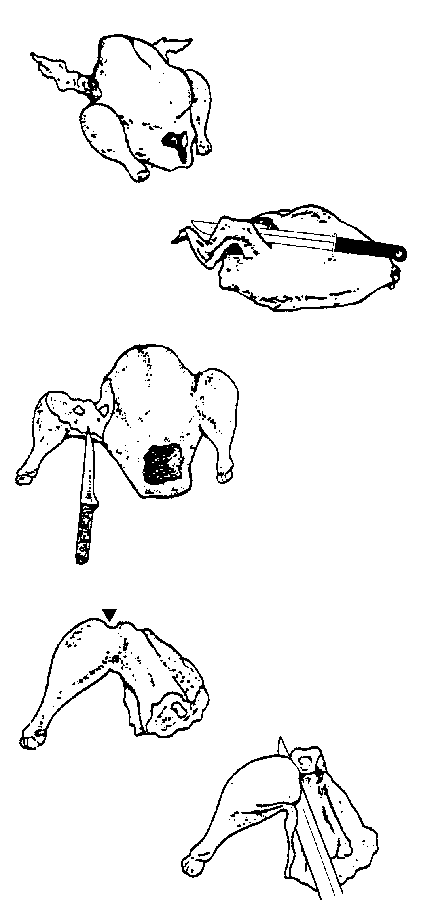
7. Put chicken on its side, then forcefully pull the wing away from the body. Cut into the hollow between the breast and wing.

8. Continue pulling the wing away from the body. Cut around the wing joint.

9. Bend wing back, exposing the joint. Cut through. Repeat for other wing.

10. Separate each wing into three parts: Slice skin around joint at the small bony end. Bend back, exposing joint and cut through. Repeat for other joint.

11. Place chicken on side, then pull drumstick away from the body.

12. Cut through skin between the back and thigh.

13. Cut down to the joint where thigh connects to back.

14. Push on drumstick and thigh to open joint at the back bone and cut through. Repeat for other leg.

15. Find the natural fat line between the drumstick and thigh, then pull skin tightly over top of leg, feeling for a small indentation to find the joint.

16. Lay thigh skin side down and cut through joint, bending drumstick back gently while cutting.

17. Stand chicken up on neck joints and locate cartilage line running down ribs.

18. Cut down ribcage to neck joints on both sides, bending the two parts away from each other to expose the joints.

19. Cut through shoulder joints on each side and cut through skin, separating breast and

Skinning and Boning the Breast

20. Cut membrane between skin and meat. Pull off skin.

21. Start at neck cavity and cut along top edge of breast bone.

22. Cut along edge of wishbone, peeling breast from bones, leaving as little meat on the bones as possible.

23. Remove half-breast and repeat for other side.

Boning the Thigh

24. Place the thigh skin-side down. Cut down to the bone, then along the full length of the bone.

25. To free the ends, slip the knife under the bone halfway down its length.

26. Cut away from your hand, freeing one end of the bone from the flesh.

27. Turn the thigh around, lift the free end of the bone with one hand, and cut the other end free.

Key Questions:

1. What was the most difficult processing technique of this lab?

2. Why do processors debone chicken breasts and thighs?

3. What chicken parts do you think are processed into boneless breaded chicken patties?

UNIT II - FOOD PROCESSING AS 6.2

Lesson 6:Products and By-Products From Meat Animals Name __________________

Bratwurst Production

Objective: Students will experience firsthand the processing techniques used to transfer a fresh meat into a processed meat by making an emulsion.

Activity Length: 2 periods

Materials and Equipment:

70%-80% lean pork Black pepper
Salt Mace spice
Nonfat dry milk Coriander spice
Water Hot mustard
Stove Meat grinder
Blender Cellulose casings
Scale Stuffer (optional)

Procedure:

1. Grind 5 lbs. of 70-80 percent lean pork and place in blender.

2. Add: 1.5 oz salt
.75 oz water
.16 oz black pepper
.08 oz mace
.08 oz coriander
.08 oz hot mustard

3. Blend for 5 minutes.

4. To complete the emulsion, add .75 oz water and 1.5 oz nonfat dry milk to the ingredients in the blender.

5. Blend for 5 minutes.

6. Place emulsion into a stuffer (a plastic funnel with a push stick will substitute).

7. Attach casing to stuffer.
8. Stuff casings.

9. Link casing see figure 6.1.
Figure 6.1
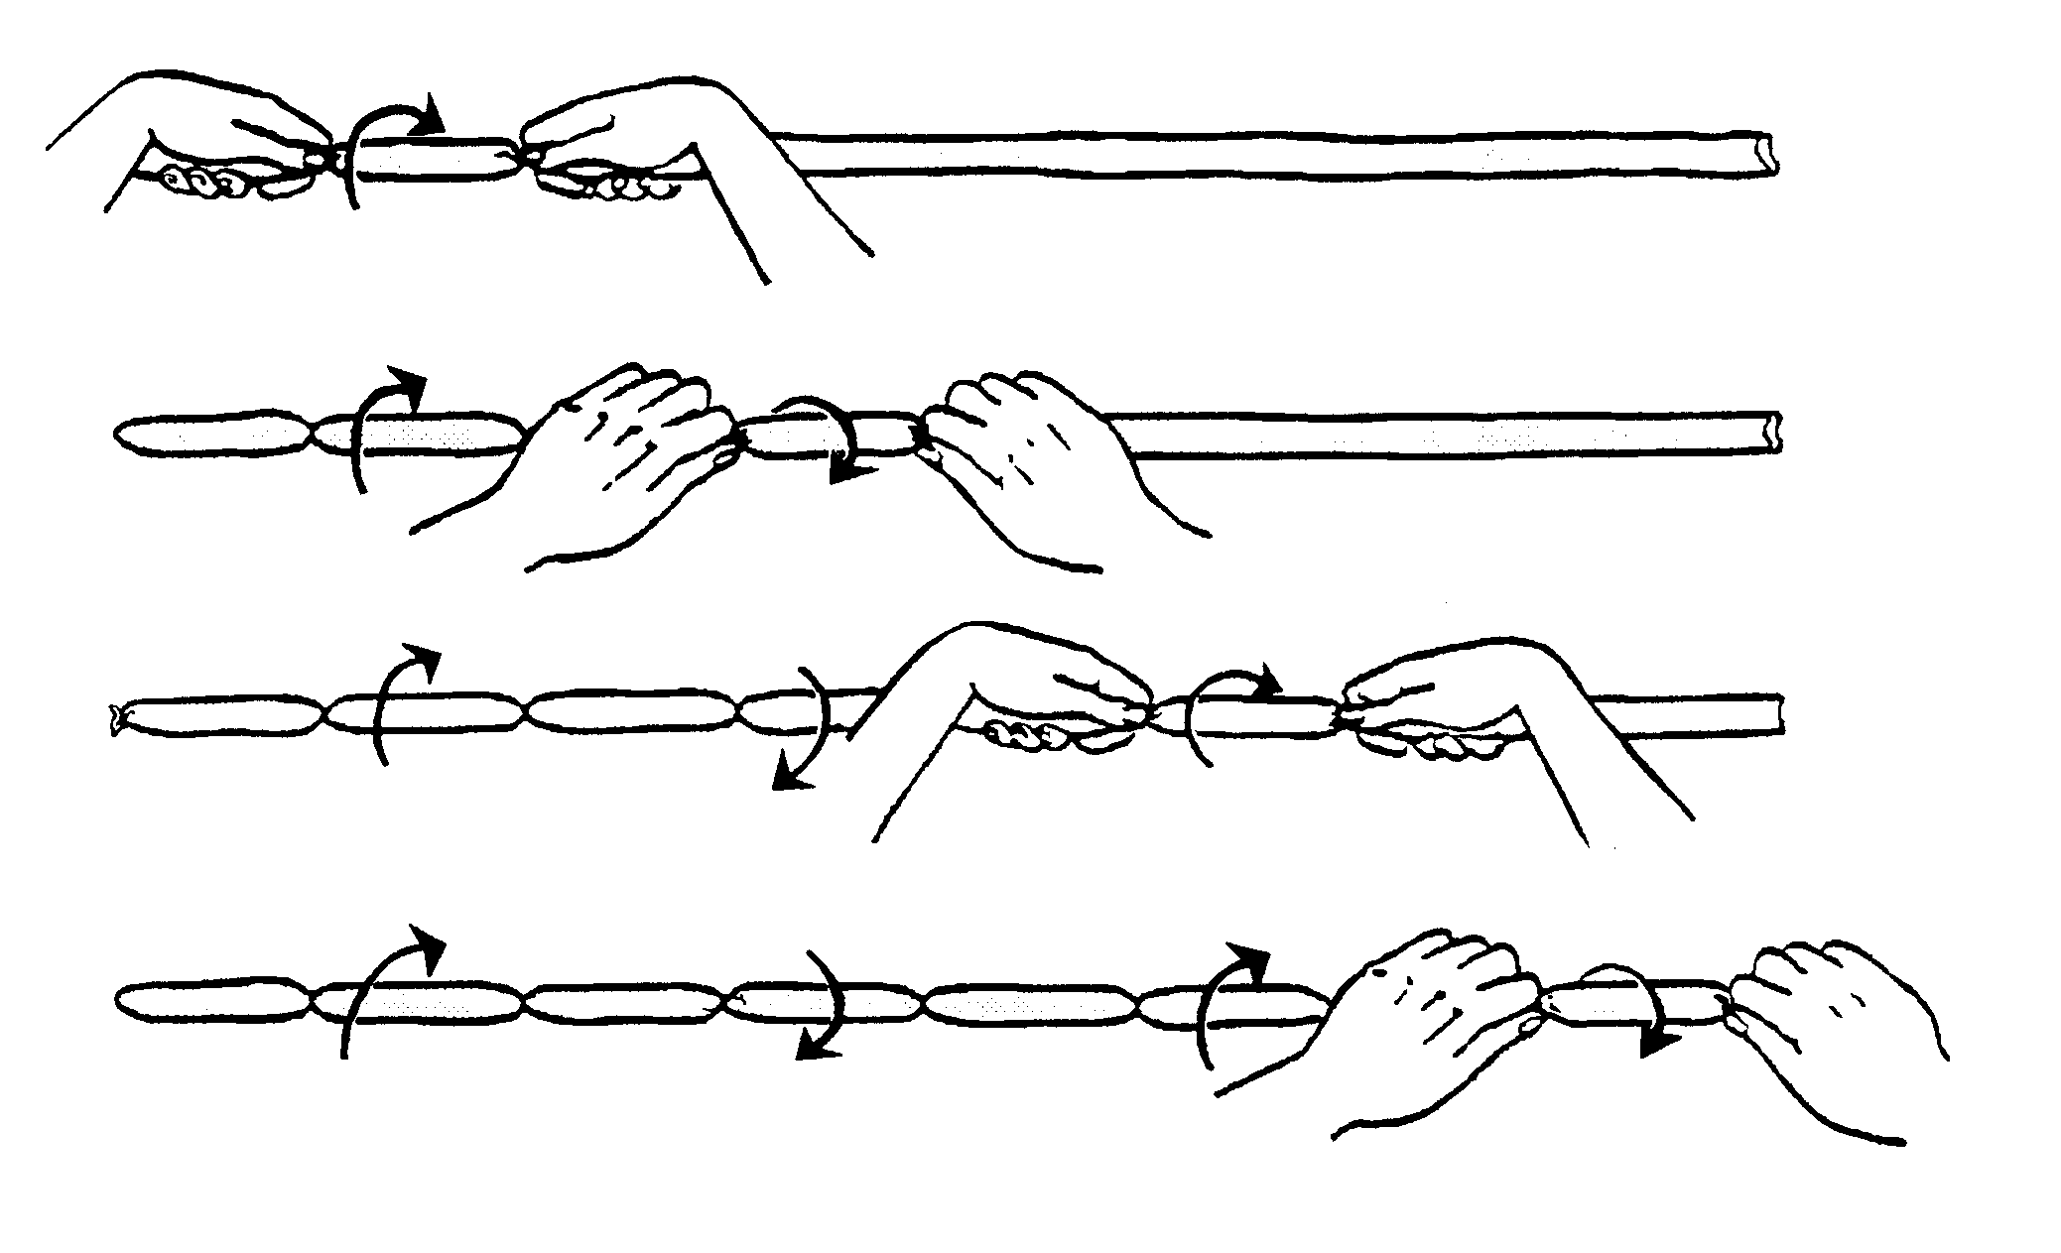

In handlinking bratwurst using a twist method, the casing can be virtually any length 1) start on one end and pinch the casing between thumb and forefinger at points 5 and 10 inches from the end. Using both hands, twist the link between your hands away from yourself; 2) pinch the casing at 5-inch intervals from the same end, except this time twist the link between your hands toward yourself 3) and 4) continue twisting every other link in the opposite direction as the preceding twist until the end of the casing is reached.

10. Cook bratwurst. Bratwurst can be pan fried, braised, broiled or grilled.

Adapted from: Romans, Jones, Costello, Carlson, Ziegler. The Meat We Eat. 12th ed. Danville, IL: Interstate Printers and Publishers, 1985.

